1. **ESSAY (30%)**
2. During the interview process, there are the terms of closed questions and open-ended questions, explain the differences and give examples! **(weight 10%)**

**Answer :**

* **Open**-**ended questions**
* are **questions** that allow someone to **give** a free-form answer.
* Prompt people to answer with sentences, lists, and stories, giving deeper and new insights.
* When conducting usability studies or field studies, it's a great idea to ask lots of open-ended questions.
* **Closed**-**ended questions**
* can be answered **with** "Yes" or "No," or **they** have a limited set of possible answers (such as: A, B, C, or etc.).
* Closed-ended questions limit answers: thus tighter stats.
* Closed-ended questions are often good for surveys, because you get higher response rates when users don't have to type so much.
* Also, answers to closed-ended questions can easily be analyzed statistically, which is what you usually want to do with survey data.

**EXAMPLE :**

In one-on-one usability testing, you want to get richer data than what's provided from simple yes/no answers. If you test with 5 users, it's not interesting to report that, say, 60% of users answered "yes" to a certain question. No statistical significance, whatsoever.

If you can get users to talk in depth about a question, however, you can absolutely derive valid information from 5 users. Not statistical insights, but qualitative insights.

1. When selecting a software project, describe in detail the issues that are considered when evaluating a project’s technical feasibility. **(weight 10%)**

**Answer :**

When selecting a software project, the issues that are considered when evaluating a project's techinal feasibility are as follows :

1. Issue as to relevancy of technology mature enough to be easliy applied
2. Issue as to avaliability of given software constraints.
3. Issue as to project feasibility within the limits of current technology.
4. Issue as to software development environment.
5. Issue with system developing process & application area.
6. Issue as to number of organizational units involved.
7. Issue as to incorporating any multimedia aspect.
8. Issue as to estimated size of the product in line of codes.
9. Issue as to size of database colated or used by the product.
10. Issue as to legal ramifications.
11. In the behavioral models, describe the different elements of the sequence diagrams. **(weight 10%)**

**Answer :**

1. **Actors**

* Represents a type of role where it interacts with the system and its objects.
* Figure :C:\Users\Acer\Desktop\Actors.jpg

1. **Lifelines**

* Named element which depicts an individual participant in a sequence diagram
* Figure : 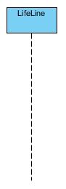

1. **Messages**

* Communication between objects
* Figure : C:\Users\Acer\Desktop\Message.jpg

1. **Reply Message**

* Show the message being sent from the receiver to the sender.
* Figure : C:\Users\Acer\Desktop\ReplyMessage.jpg

1. **Self Message**

* Certain scenarios might arise where the object needs to send a message to itself.
* Figure : C:\Users\Acer\Desktop\SelfMessage.jpg

1. **CASE (70%)**

An entertainment company "UBINUS Enterprise" builds an online application. The application is called Video Online Apps. With this application, the company expect to be able to deliver better services to customers, that customers can subscribe the Videos or Films by online. The application consists of several business activities as follows:

1. **Membership**
   * 1. To use the application, customers must register, with the user profile data consisting of: username, password, nik(ssn), name, email, telephone number, and choice of membership type.
     2. The application will check whether the username is already registered or not. If the user name is already used, a notification will be sent that the username is already in use and the user will be asked to enter another username. If the registration entry is successful, the user will be given a virtual account to be used for subscription payments.
     3. There are 2 types of membership, Regular or Premium. Regular membership is the default membership, without any payment, but the customers can only watch the old videos of previous episodes of the running month, of course with interlude advertisements. Regular membership can only watch at maximum of 60 films per month. Whereas for premium membership customers must pay a certain fee every month, and the payment done by money transfer through a debit card or by using a credit card. With premium membership customers can watch the latest videos without advertisements. And for premium membership, the number of videos that can be watched is unlimited.
2. **Setting Selection**
3. The setting option is used to select the language that the customer want to use in the application. There are 3 language choices, namely Indonesian, English or Mandarin. The default language option is English.
4. The setting can also selects the subtitle preferences (the text displayed at the bottom of the film). Choices also consist of the three languages mentioned above.
5. Channel selection, allows customers to choose three video channels or TV series. The choices are Indonesian, Asian, Korean, Japanese, Indian, Arabic and European films.
6. **Film Searching** 
   * + 1. Customers can search (browse) movies, based on the channel selection settings above.
       2. To display the movie title to be watched, customers simply click on the movie icon displayed when browsing. Or, customers can also used the "Search" box and fill in the keywords that the film database might recognize.
       3. While the user watching a movie, he or she can change the subtitle settings.
7. **Customer Payment**
8. For Premium membership, payment is made by the customer every month, not later than one week after the registration date (if the registration date is 1st day of the month, then the monthly payment cannot be later then the 8th day of the following month). Late payment will cause a Premium membership account to be blocked and its status to become a regular membership.
9. Payment can be made by cash transferring using debit card into the virtual account provided at the time of registration. Whereas customers with a credit card must send data including the credit card number, cardholder's name, valid date, and CCV number which will then the payment be processed to the bank. The credit card payment is displayed on the payment menu of the application.
10. For each payment, a notification will be sent to the customer in the form of a receipt via the user's email.
11. At the end of each month Binus Enterprise's financial manager will receive the income reports, the reports on the number of the premium type new users, and the number of regular members.

**Your Task:**

In order to develop the application system (may add assumptions that you think is needed), you are asked to arrange an object-oriented system modeling:

1) Develop the use case diagram based on the requirements outlined above. **(weight 10%)**

2) Develop use case description for each use case showing step by step of actor activity. **(weight 20%)**

3) Develop the class diagram to show structural model. **(weight 20%)**

4) Develop a sequence diagram for each use case. **(weight 20%)**

**Answer :**

1. **USE CASE DIAGRAM :**

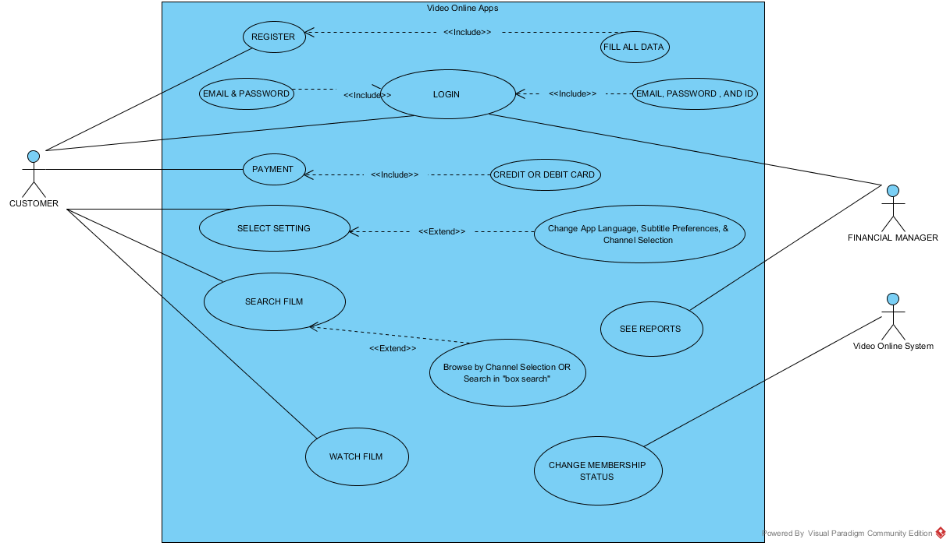

1. **USE CASE DESCRIPTION :**

**For Customer:**

1. Customer can **SIGN UP** but need to fill **CUSTOMER DATA**.
2. Customer can **LOGIN** but need to provide **EMAIL** and **PASSWORD** for **LOGIN**.
3. Customer can **SELECT SETTING** either Change App Language, Subtitle Preferences or Channel Selection.
4. Customer with **PREMIUM MEMBER** MUST **MAKE PAYMENT** and Custome can **PAY** by **DEBIT OR CREDIT CARD**.
5. Customer can do **SEARCH MOVIE** by **BROWSE BY CHANNEL SELECTION OR SEARCH in BOX SEARCH**.
6. Customer with **PREMIUM MEMBER** can **WATCH LATEST MOVIES AND UNLIMITED WATCH/MONTH** from their **ACCOUNT,** But **REGULAR MEMBER** only watch **OLD MOVIES AND 60 WATCH/MONTH**.

**For Financial Manager:**

1. FINANCIAL MANAGER can **LOGIN** by providing detail **USERNAME** and **PASSWORD WITH THEIR ID.**
2. FINANCIAL MANAGER can **SEE REPORT**. In see report, FINANCIAL MANAGER can see following reports:
3. Can see **INCOME REPORT**
4. Can see **NUMBER OF NEW PREMIUM MEMBER REPORT**
5. Can see **NUMBER OF REGULAR MEMBER REPORT**

**For Video Online System:**

1. System can **CHANGE CUSTOMER MEMBERSHIP STATUS** when Customer **LATE to PAY** for PREMIUM SUBSCRIPTION.
2. **CLASS DIAGRAM (PLEASE ZOOM TO 200% to Clear View of Diagram):**

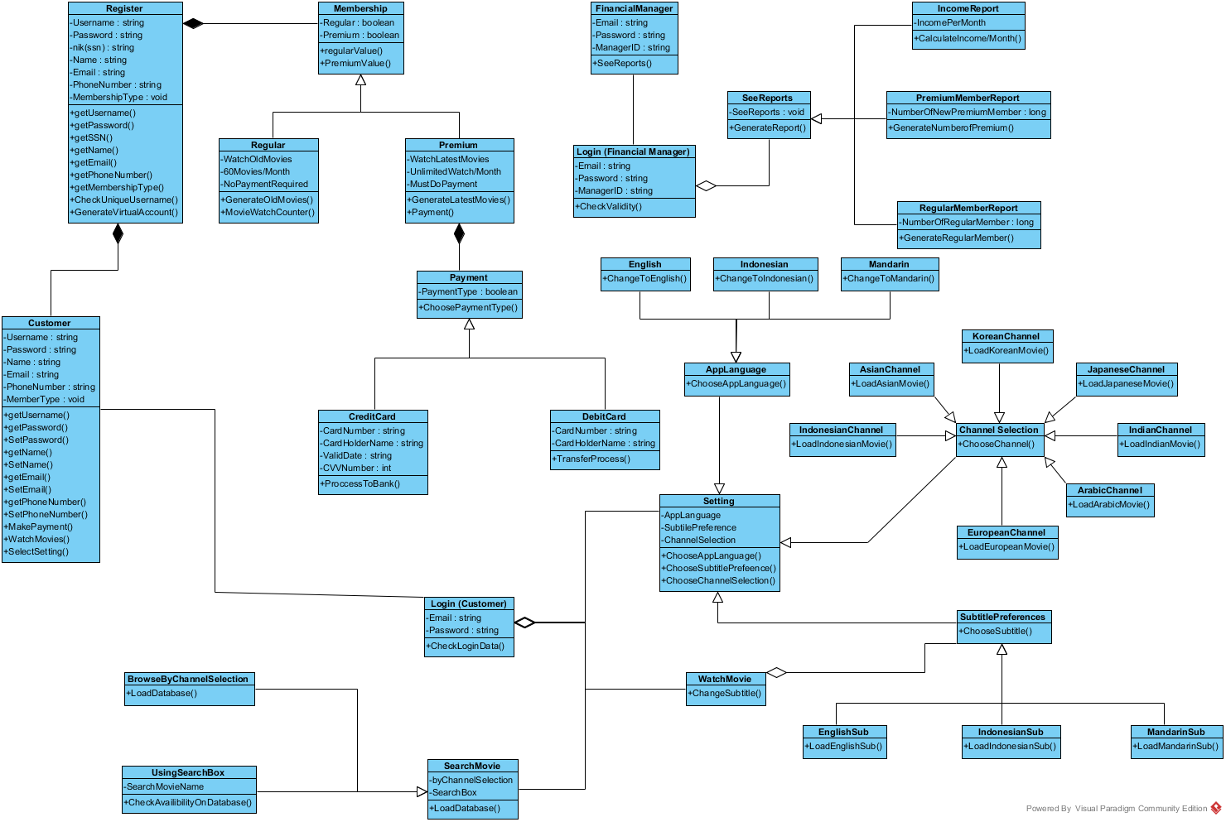

1. **SEQUENCE DIAGRAM ( REGISTER )**

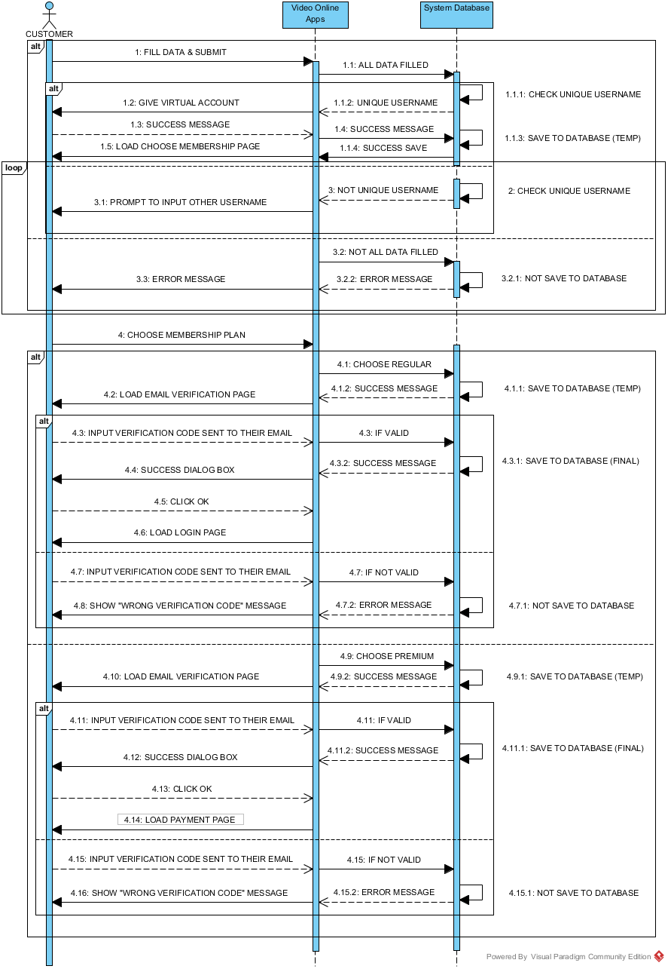

**SEQUENCE DIAGRAM ( CUSTOMER LOGIN )**

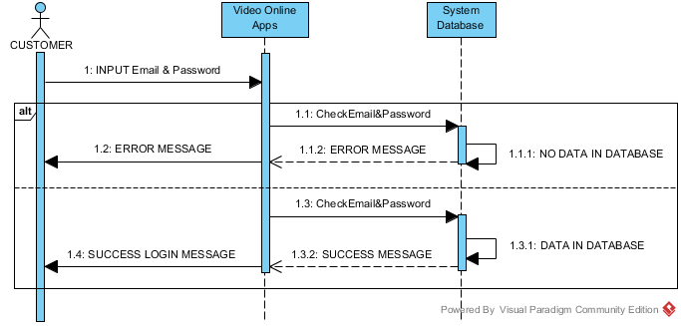

**SEQUENCE DIAGRAM ( FINANCIAL MANAGER LOGIN )**

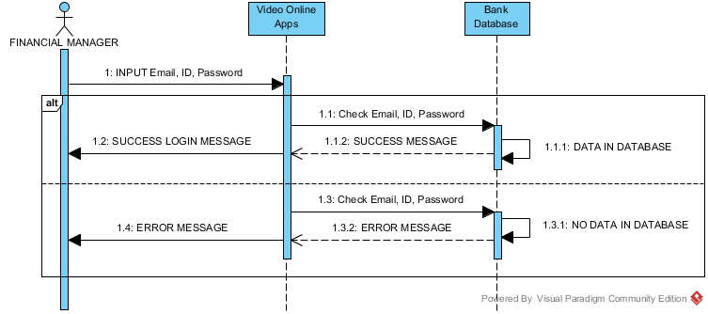

**SEQUENCE DIAGRAM ( PAYMENT )**

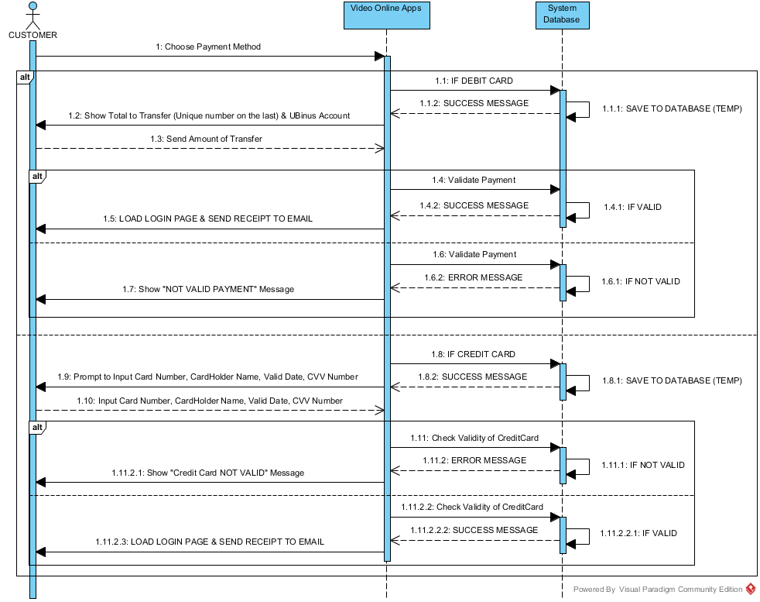

**SEQUENCE DIAGRAM ( SEE REPORT )**

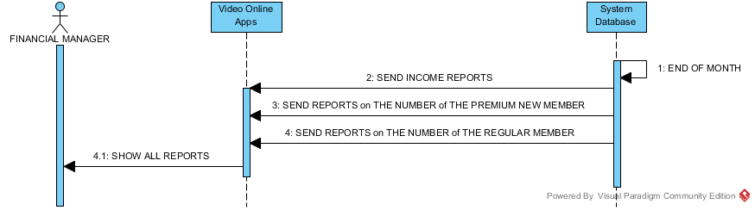

**SEQUENCE DIAGRAM ( SELECT SETTING )**

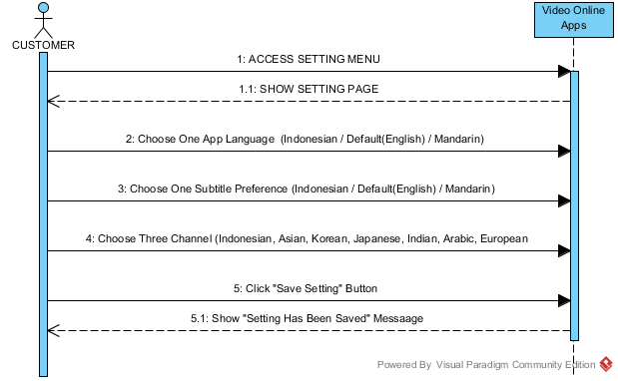

**SEQUENCE DIAGRAM ( WATCH FILM )**

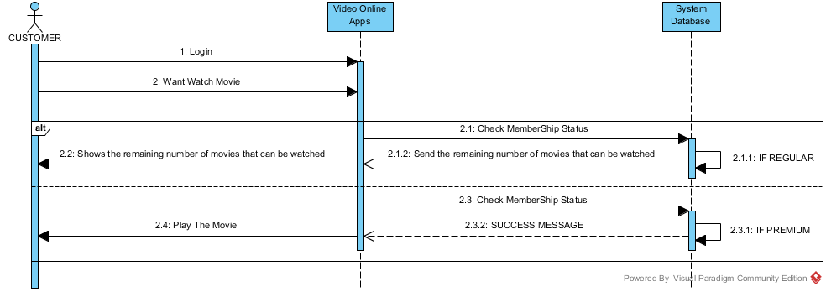

**SEQUENCE DIAGRAM ( SEARCH FILM )**

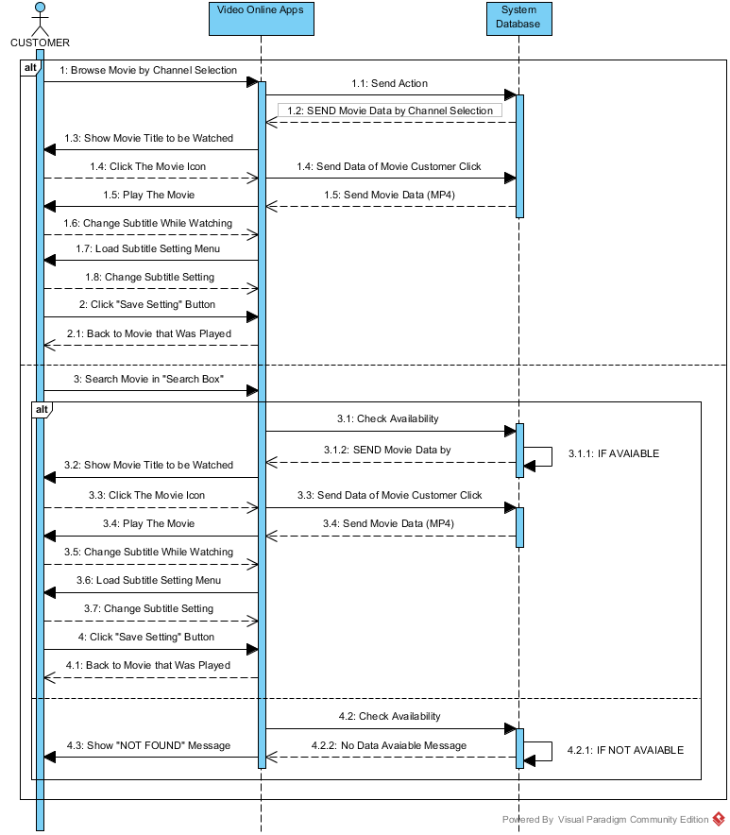

**SEQUENCE DIAGRAM ( CHANGE MEMBERSHIP )**

