Ujian Akhir Praktikum - Semester Genap 2019/2020
Practicum Final Exam - Even Semester Year 2019/2020
Matakuliah  Subject |  |  | COMP6175 - Object Oriented Programming  MOBI6002 - Mobile Object Oriented Programming |  |  | 
Kelas  Class | : | B301 / B501 / B801 / BA02 / BB01 / BB08 / BB26 / BC08 / BH01 / BJ01 / BK01 / BO01 / BR01 / BV01 / BW01 / SA01 |  | Tanggal Mulai  Start Date | : 18 June 2020
Kelas  Class | : |  |  | Waktu Mulai  Start Time | : 15:20
Dosen  Lecturer | : | D0208 - Drs. Agus Prahono, M.Eng.Sc.  D1828 - Hendra, S.Kom., M.T.  D2425 - Ir. Yasri, M.T.  D3174 - Dr. Budi Yulianto, S.Kom., M.M., CBA.  D3757 - Tegar Aryo Sulthon Musthofa, S.Kom, M.MSI  D4653 - Eka Cahyadi, S.Kom., M.TI  D4985 - Novita Hanafiah, S.Kom.,M.Sc.  D5094 - Aswin Wibisurya, S.Kom, M.TI  D5358 - Livia Ashianti, S.Kom., M.TI |  | Tanggal Selesai  End Date | : 18 June 2020
Dosen  Lecturer | : |  |  | Waktu Selesai  End Time | : 15:20

PERATURAN UJIAN:
Exam Regulations:
- Mahasiswa tidak diperbolehkan berdiskusi dan/atau bekerja sama dengan peserta ujian lainnya
Student is not allowed to discuss and/or work together with other exam participants
- Mahasiswa tidak diperbolehkan menyalin jawaban dari intenet
Student is not allowed to copy answer from the intenet
- Asisten BERHAK memberi nilai 0 (NOL) bagi peserta ujian yang melakukan segala bentuk kecurangan
Assistant is able to give 0 (ZERO) score for exam participant who does any cheating actions
- Kumpulkan jawaban tepat pada waktunya di https://laboratory.binus.ac.id/lab
Submit the answer on time at https://laboratory.binus.ac.id/lab
- Bila Anda tidak membaca peraturan ini, maka Anda dianggap telah membaca dan menyetujuinya
If you have missed to read these regulations, so you are considered to have read and agreed on it

SOFTWARE YANG DIGUNAKAN:
Software will be used:
- Java 8
- Eclipse Neon 3

FILE YANG DIKUMPULKAN:
File must be collected:
- Folder Project:
- Bin Folder (.CLASS)
- Src Folder (.JAVA)

PERHATIAN!
Attention!
- Bagi yang mengerjakan tidak sesuai dengan soal, maka akan diberikan nilai NOL (0)
For those who do not work in accordance with the exam case will be marked as ZERO (0)
- Bagi yang mengerjakan tidak sesuai dengan software dan versi yang telah ditetapkan, maka akan tetap dikoreksi dengan software dan versi yang telah ditetapkan
For those who do not work in accordance with the software and specific version will be corrected by the predefined software and version
- Kompres semua jawaban yang akan diunggah. Pastikan format pengumpulan nama file dan ekstensi sesuai dengan format berikut: [NIM]-[NAMA].zip
Compress all file that will be uploaded. Make sure the format for collecting file name and extension according to the following format: [NIM]-[NAME].zip

Soal
Case

Vi Shop
Criteria:
- Abstract Class
You need to design at least three classes, one abstract class, and two concrete classes. Abstract class consists of all common attributes and behavior that both of concrete class had. Concrete class consist of specific attribute and behavior that not common between the concrete classes
- Encapsulation
To hide the data of a class from an illegal direct access, all of the attributes of the class must be encapsulated and will be accessed using an accessor and mutator that may perform validation before accessing the encapsulated attribute
- Inheritance
All of the concrete class must inherit all attribute and behavior from the abstract class
- Polymorphism
If the concrete class has a specific implementation of the inherited behavior (method) that differ from the abstract class, the concrete class can override or overload the behavior from the abstract class
- Composition
The composition concept in OOP is a strong relationship between objects that means some object must coexist together and cannot exist independently. The type of relationship with the composition concept is ‘part-of’. If any of the class contains other classes, then composition concept should be used to implement the feature
- Multi-Threading
Some of the processes must use multi-threading to make sure the process requirement runs smoothly. The multi-threading allows the program to run with different process timeline or simply run in the background

Vi Shop is an Online Shop Company that sells skincare products offline. Vi Shop wants to expand its company by opening an online shop so that it could ship nation-wide through a couple of shipping expeditions, which are ViCepat and VeDex. They ask you to create a program that will help their customers to manage the purchasement and also all the shipping statuses. As a good programmer, you must make this program based on the following criteria using Java Base Programming:
- For the first time, the programmer will initialize dummy product data. The products are inserted by the programmer using dummy data provided bellow. Each product shown in this menu includes its Name, Price, and Available Stocks.
Product Name | Product Price | Product Stocks
The Aubree Niacinamide Serum | 99000 | Random 20~50
Tiff Body Cacao Coffee Scrub | 150000 | Random 20~50
Kleveru Glass Skin Serum | 143000 | Random 20~50
Sensatia Botanicals Unscented Facial-C Serum | 180000 | Random 20~50
Mineral Botanicals Vanila Lip Scrub | 55000 | Random 20~50
Think Hale Let's Mask | 129000 | Random 20~50
Faith In Face Cica Jelly Mask | 29000 | Random 20~50
Lacoco Swallow Facial Foam | 165000 | Random 20~50
Everwhite Brightening Essence Serum | 125000 | Random 20~50

- In the beginning, the program will ask you to input your name with some validations:
- Name, which must be minmum three characters
- Name must contain two words, separated by ' ' (space)
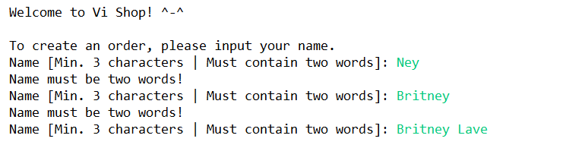
Figure 1. Input Name
- Then, when the user has finished inputting his/her name, the program will show the user’s history purchase. If there’s no history purchase, then ‘No purchase history.’ will be written, followed with 4 menus:
- Shop at Vi
- Refresh My Shipping Status
- View Purchase History
- Exit
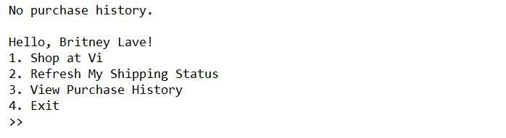
Figure 2. Main Menu

- If the user chooses menu 1, then:
- If there’s no available product then display:
Figure 3. Empty Available Product List
- Otherwise:
- The program will ask the user to input the index of the product user wants to buy. The index will be validated from 1 to the number of available products.
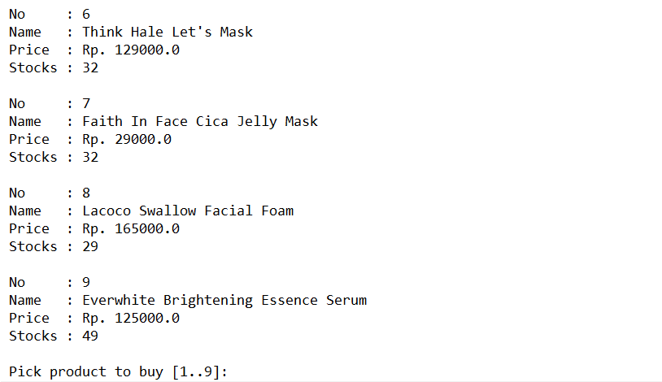
Figure 4. Available Product List
- Once the user picks the product they want to buy, they'll be asked to input the quantity as well. The quantity will be validated based on the available stocks:
- If user input more than the available stocks, then the program will tell the user that the quantity inputted is insufficient.
Figure 5. Validate Quantity

- Else, the products will be added to the user’s cart and the program will decrease the chosen product’s stocks (the product should be removed from the list if the quantity equals zero). At last, the program will ask the user either they want to add another product or no (‘Y’/‘N’, case sensitive). If the user chooses to add more products, then the same steps will be redoing until the user chooses no.
Figure 6. Add more Product Validation
- After the user chooses not to add any more product to their cart, the program will ask the user to input their address and shipping service. There are some validations included:
  - The address should start with 'Jl. ' (using space ‘ ’) and is longer than 10 characters.
  - The currently available shipping service is only ViCepat and VeDex, both are the only option for user and is case insensitive. Once the user chooses any of these options, the process will be done using threading, which means multi-processing (background process). When the packet has arrived at the user's place safely (Finished Order), then the order will be moved to the history list. The failed ones will remain on top of the menu and there’ll be a message about the insurance fee.
- ViCepat
ViCepat offers fast shipping 1x24hrs (a day) with only Rp. 12.000,- of shipping fee, and they do guarantee the products’ safety as well.
- VeDex
VeDex offers FREE SHIPPING FEE with a minimum purchase of Rp. 150.000,-. If the user purchases less than Rp. 150.000,- then the user has to pay Rp. 10.000,- for the shipping fee. The estimation of the shipping is strictly 2x24 hour (two days), but they don’t guarantee the products’ safety (chance of losing products is 10%). They do offer an insurance fee of 110% of the total products' prices.
Ps. A day equals to ten seconds of lifetime.
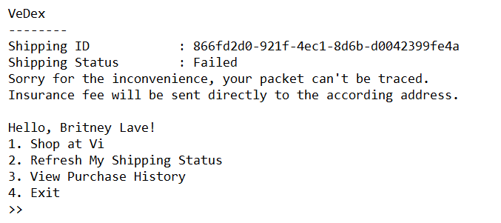
Figure 7. Display History (if exists) above Main Menu
- After then, the program will generate a Purchase ID using UUID (syntax: UUID.randomUUID()) to make the order unique and display the total price of the products bought (Products’ Prices), Shipping Fee based on the chosen service, and also the Grand Total with the following formula:
Products’ Prices = Product Price 1 + Product Price 2 + …. + Product Price N

Grand Total: Products’ Prices + Shipping Fee
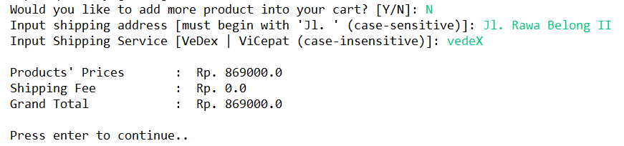
Figure 8. Display Total Price based on the Formula above

- If the user chooses menu 2, then the program will refresh the shipping history on top of the menu. The history orders that will be displayed on top of the menu is only the on going & failed ones. Here’s the before and after refresh:
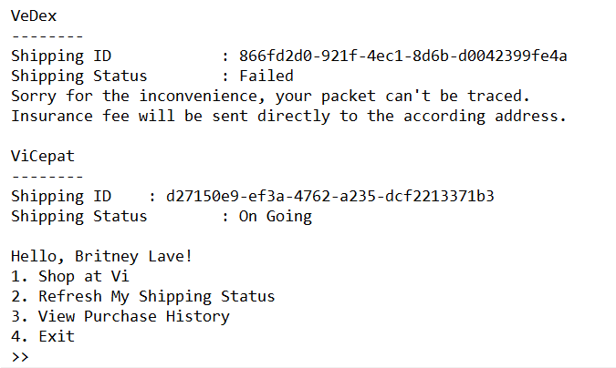
Figure 9. Before Refresh
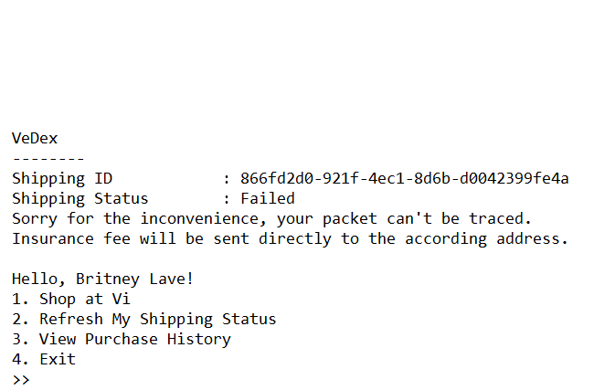
Figure 10. After Refresh

- If the user chooses menu 3, then the program will display all the users’ finished orders. Each order includes its Shipping ID, the user’s inputted Address, Total Price, and all the Products bought followed by its quantity. The display will be as follow:
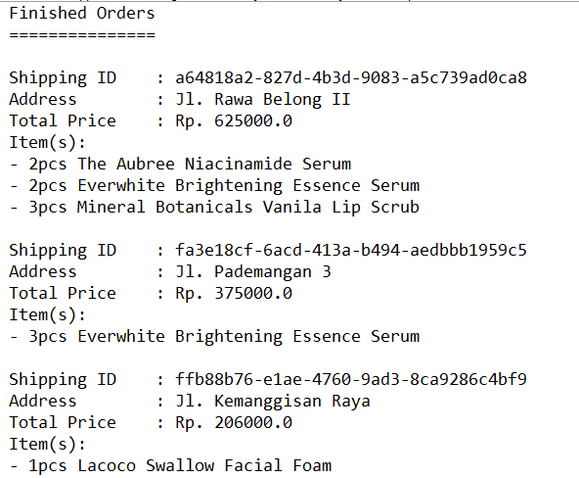
Figure 11. View Success Order History
- If the user chooses menu 4, then the program will be closed.

If there is something you don’t understand, feel free to ask your Assistant!

