

Alandi (D), Pune Affiliated to

Savitribai Phule Pune University A

IT PROJECT REPORT ON

**“Hospital Management System”**

BY

**Kirti A. Ghadge**

Under the guidance of

**Prof. Mandar Parale**

in Partial fulfilment of

**SYMSC(CS)**

Academic Year 2022-2023

# CERTIFICATE

This is to certify that, the project report entitled **“Hospital Management System’’** which is submitted by **Miss. Kirti Ashok Ghadge** in partial fulfilment of Masters of Science - Computer Science has satisfactorily completed the project work under our guidance and supervision.

We wish our best wishes for her future endeavor.

**Prof. Mandar Parale Prof. Sangeeta Birajdar**

**Project guide HOD of MSC(CS)**

**Internal Examiner External Examiner**

**ACKNOWLEDGEMENT**

I hereby, submit the project report on "Hospital Management System".I am also thankful to Prof. Dr. B. B. Waphare, Principal MIT Arts Commerce and Science College Alandi, Pune and also to Prof. Sangeeta Birajdar, HOD BSC(CS) & MSC(CS) for providing me this opportunity

A successful project is a result of good term work, which contains not only the people who put in their logic and hard work but also the people who guide them.

We are extremely grateful for the necessary information, with support provided by Prof. Mandar Parale. It is just because of him that we could complete the project which we envisaged couple of weeks before We would also like to thank for his constant encouragement and guidance.

Last but not the least we would like to thank all our fellows who have helped us directly and indirectly in our project

**ABSTRACT**

**In this project we aim to solve the traditional issues of hospital management. The existing system provided paper based solution for keeping OPD records of the patients and hospital staff , but it gives overload to Doctor , Receptionist and Administrator . The main issues were inappropriate data keeping ,time wastage in storage ,retrieval also patients were unable to understand the prescription etc.**

**These issues are solved by providing a separate user account for doctors and other staff . keeping each pat*ient’s data separate and track previews visits in a single click.**

**This project uses MYSQL as backend and is developed in java so it provides features such as platform independence ,high performance and security. It is a web application which mainly uses Spring MVC and Hibernate frameworks.**

**It provides some enhanced features such as easy interface to add, remove employees as well as it provides PDF of prescription. Thus, reducing need to manually write and sign by doctor.**

**INTRODUCTION**

**Human body is a very complex and sophisticated structure and comprises of millions of functions. All these complicated functions have been understood by man , part-by-part through their research and experiments.**

**As science and technology progressed , medicine became an integral part of the research . Gradually, medical science became an entirely new branch of science. As of today, the Health sector comprises of Medical institutions i.e. Hospitals, research and development institutions and medical colleges.**

**Thus the “saru hospital “ system aims at providing the best medical facilities to the common man needs.**

* 1. **Existing System :**
* **The existing system was paper-based.**
* **Keeping track of all the activities (like records of patients , doctors and pathology tests ) and their records on paper is very cumbersome and error prone.**
* **It was very inefficient and a time-consuming process observing the continuous increase in population and number of people visiting in the clinic. Recording nd maintaining all these records on paper was highly unreliable,inefficient and error-prone.**
* **It is too slow and cannot provide updated lists of required things within reasonable timeframe.**
* **It is also not economically & technically feasible to maintain these records on paper.**
  1. **Existing System Drawbacks :** 
     + **Chances of data loss and inadequany.**
     + **Too slow and cannot provide updated lists of patients within reasonable timeframe.**
     + **Also, management of clinic was cumbersome and error prone .**
     + **Modifying previous mistake wasn’t easy.**
     + **No reliable storage and backup facilities.**
     + **It is also not economically and technically feasible to maintain these records on paper.**

**1.3 Purpose /objective and goals :**

**Hospital are the essential part of our lives , providing best medical facilities to people suffering from the various ailments ,which may be due to change in the climatic conditions , increased work-load, emotional trauma , stress etc. it is necessary for the hospital to keep track of its day to day activities and records of its patients , doctors that keep the hospital running smoothly and successfully. Our objective is to digitalize all the version of the manual system and we named it as “SARU Hospital”.**

**The main aim of the project is to provide a paper less hospital up to 90%.it also aims at providing low cost reliable digitalization of the existing system . the proposed system also provides excellent security of the data at every level of the user-system interactions and also provides robust and reliable storage facility .the purpose of this project is to digitalize , the process of day-to-day activities like Registering new patients ,assigning a doctor to new patients, adding new staff members and finally compute the bill etc.**

**1.4Literature Survey :**

* + Explore studies on clinic workflow optimization, appointment scheduling, patient flow management, and queueing theory in healthcare settings.
  + Investigate the use of electronic health records (EHR) and health information systems (HIS) in clinic management.
  + Examine research on patient satisfaction, quality improvement initiatives, and patient-centered care in clinics.
  + Identify studies on telemedicine applications, remote monitoring, and virtual clinics.

**1.5 Project Scope and limitation :**

**Make prescription readable and understandable to patients.**

**Reduce the time wasted in the retrieving data specially in finding a past health records .**

**Able to quickly collect and edits data , summarize result and adjust as well as collect errors promptly.**

**Eliminate Redundancy in terms of data storage . data will be stored in a computer not in the files.**

**No need to live queue means there is no live queue feature.**

**SYSTEM ANALYSIS**

**Comparative study of Existing system :**

**Modified System: Computerized systems enable accurate and timely medication orders, reducing the risk of medication errors. Decision support tools provide alerts and reminders for clinical guidelines and patient safety measures.**

**Existing system : Handwritten orders and paper-based processes increase the potential for errors, such as illegible handwriting or miscommunication. Patient safety measures may rely more on man**

**System Design :**

**UML Diagrams:**

**Class Diagram:**

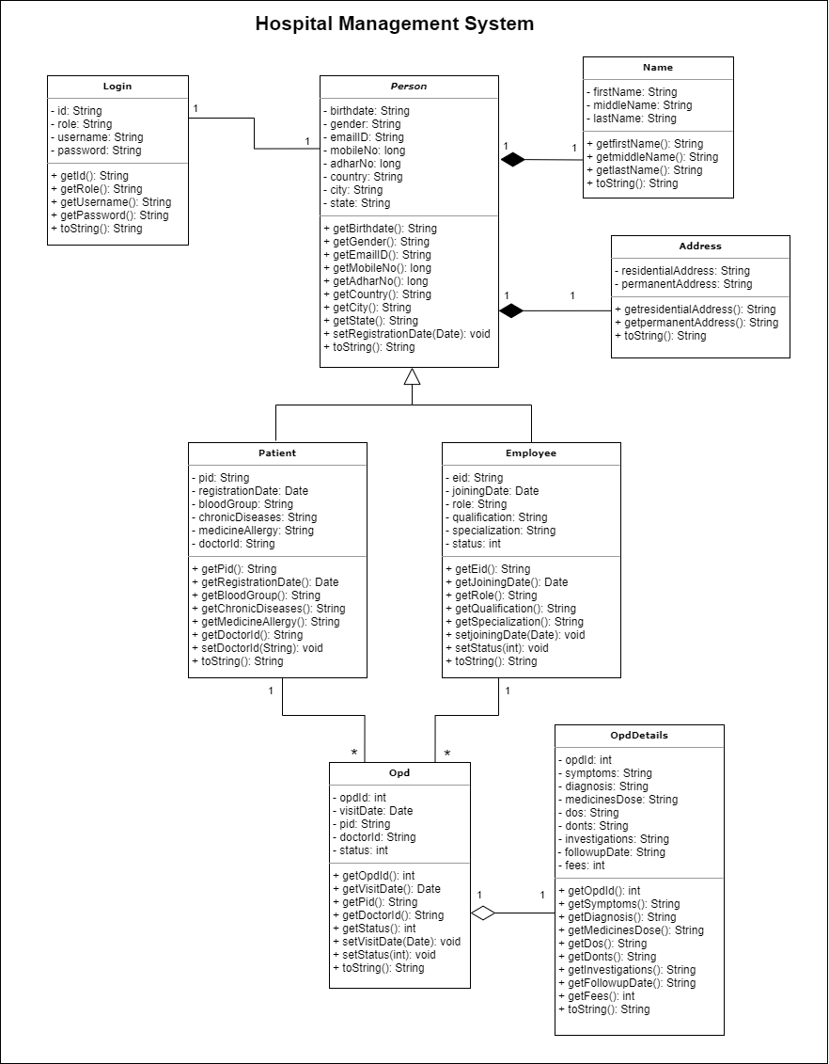

**Use Case Diagram:**

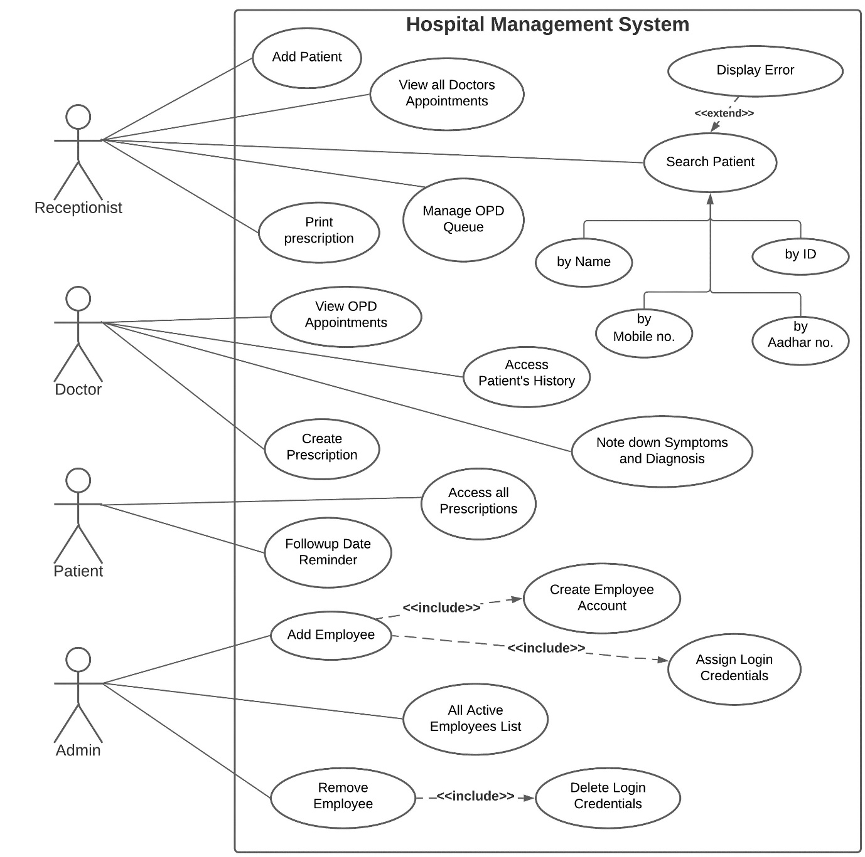

**E-R Diagram:**

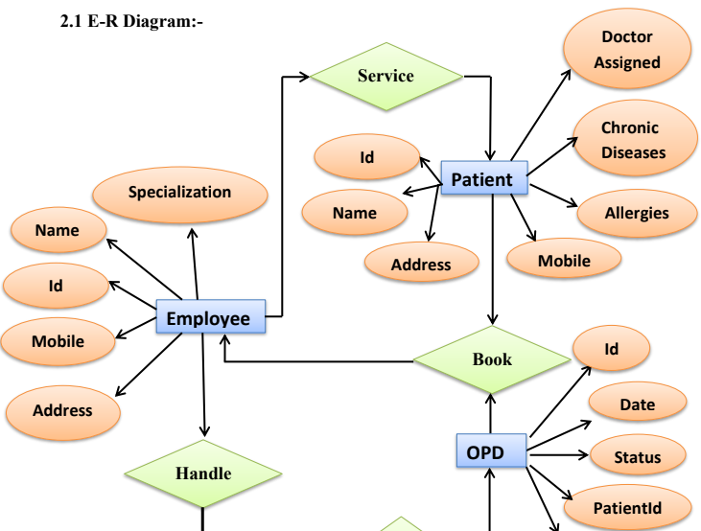

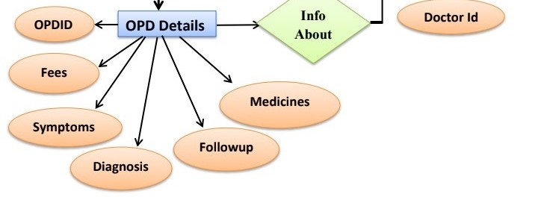

**1**

**Activity Diagram(Admin):**

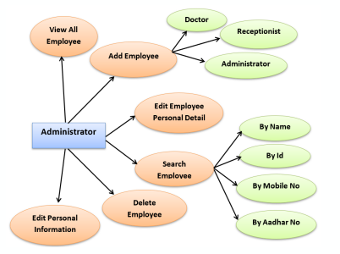

**Activity Diagram(Receptionist):**

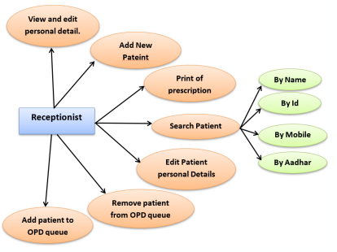

**Activity Diagram(Doctor):**

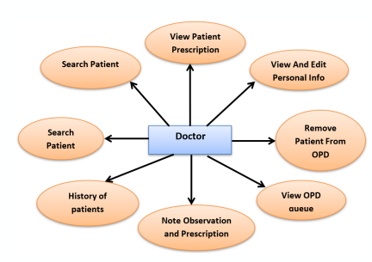

**hardware specifications :**

|  |  |
| --- | --- |
| **Content** | **Description** |
| **Processors** | **i5 , i7 any** |
| **Hard Drive** | **1 GB minimum** |
| **Operating System** | **Windows 10,windows 11** |

**Software speicification :**

|  |  |
| --- | --- |
| **Content** | **Description** |
| **Language** | **HTML,JSP,CSS,JAVA** |
| **Database** | **Mysql** |
| **Framework** | **Hibernate** |
| **Dependency manager** | **Maven** |
| **Server** | **Apache Tomcat** |

**Project user interface designing:**

**Homepage :**

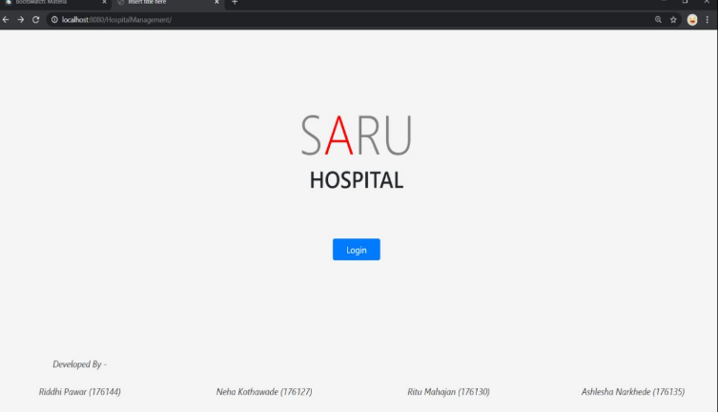

**Login page :**

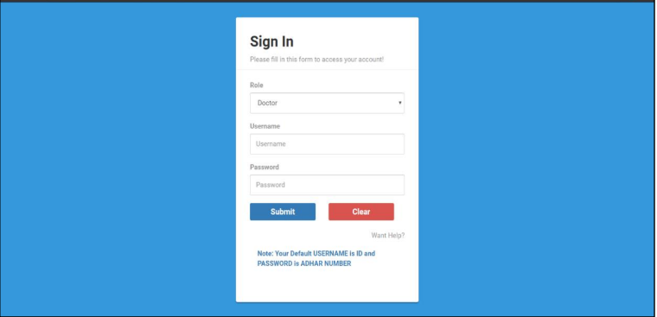

**Receptionist Dashboard :**

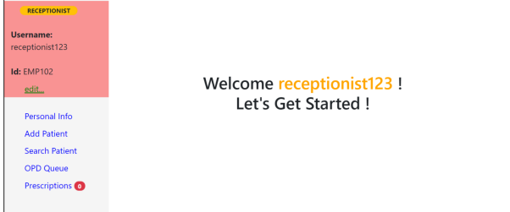

**Add Patient :**

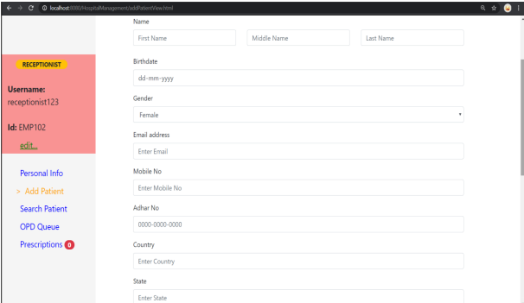

**Search Patient:**

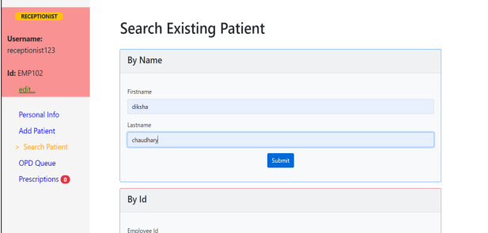

**OPD queue:**

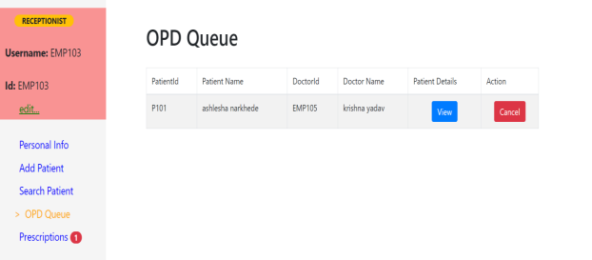

**Doctor DashBoard:**

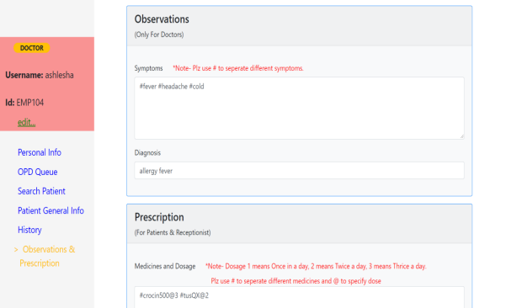

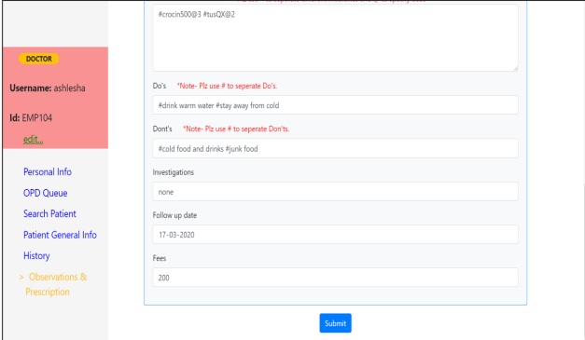

**Prescription:**

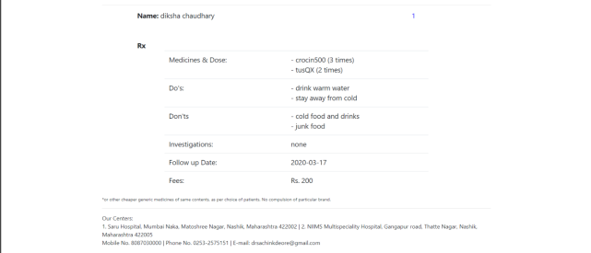

**Admin DashBoard:**

