**DIGITAL STETHOSCOPE**

**ABSTRACT:**

This project focuses on developing a digital stethoscope designed to enhance auscultation accuracy through IoT-enabled data analysis and machine learning. The digital stethoscope prototype integrates sensors with a high-fidelity microphone and a microcontroller to capture heart and lung sounds. These sounds are digitized and transmitted wirelessly to a cloud platform for real-time analysis. By leveraging signal processing algorithms and machine learning models, the device can provide automated diagnostics and visualizations, aiding healthcare providers in identifying cardiac and respiratory anomalies more effectively. This design aims to offer a cost-effective, portable solution for remote and rural healthcare settings, contributing to accessible and improved patient care

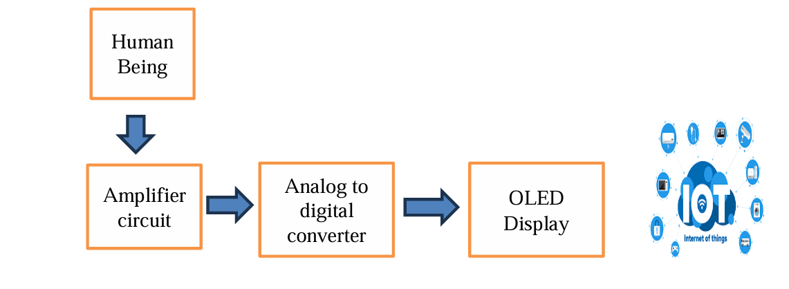

**CONCLUSION:**

The development of our digital stethoscope demonstrates significant potential for advancing auscultation technology through the integration of IoT and machine learning. By capturing high-quality audio data and enabling real-time, automated analysis, our device enhances diagnostic accuracy and reduces reliance on subjective interpretation. This is particularly beneficial for early detection of cardiac and respiratory abnormalities, providing critical support to healthcare providers and increasing accessibility to diagnostic care in remote and resource-limited settings.