Customer Behaviour Analytics
Market Segmentation Using Machine Learning
E-Commerce Customer Clustering Analysis
February 22, 2026

Executive Summary
This report presents a comprehensive analysis of customer purchasing behavior using advanced clustering techniques to identify distinct market segments within an e-commerce dataset. The analysis reveals three primary customer segments with significantly different behavioral patterns, revenue contributions, and engagement levels.
Metric | Finding
Dataset Size | 51,290 e-commerce transactions
Segments Identified | 3 distinct customer clusters
Methodology | K-Means clustering with elbow method optimization
Tools Used | R (data cleaning), Python (modeling), Tableau (visualization)

Key Insights
- High-Value Active Customers: 17,984 customers drive disproportionate revenue through frequent, high-value purchases
- High Profit Potential: 13,955 customers with balanced purchasing and strong profitability margins
- Low-Value Dormant: 7,051 customers showing minimal engagement requiring re-activation strategies
- Revenue Concentration: The Pareto Principle applies—high-value customers generate majority of revenue

1. Introduction

1.1 Project Overview
In the competitive e-commerce landscape, understanding customer behavior is critical for sustainable growth and profitability. This project applies unsupervised machine learning techniques to segment customers based on their purchasing patterns, enabling data-driven marketing strategies and resource allocation.

1.2 Business Objectives
- Identify distinct customer segments based on behavioral and transactional data
- Quantify revenue contribution and profitability across segments
- Develop actionable insights for targeted marketing campaigns
- Create visual dashboards for ongoing monitoring and decision-making

1.3 Methodology
The analysis follows a systematic approach: data acquisition and cleaning (R), feature engineering and clustering (Python with scikit-learn), and interactive visualization (Tableau). K-Means clustering was selected for its efficiency with large datasets and interpretability of results.

2. Dataset Description

2.1 Data Source
The dataset comprises 51,290 e-commerce transaction records spanning multiple product categories, customer demographics, and geographical regions. Each record captures comprehensive transaction details including pricing, discounts, shipping costs, and payment methods.

2.2 Data Structure
The dataset contains the following key attributes:
Category | Fields | Description
Customer Data | Customer ID, Gender, Age | Unique identifiers and demographic attributes
Product Data | Category, Product | Product classification (Auto, Car Covers, etc.)
Transaction Data | Sales, Quantity, Discount | Revenue metrics (range: $33-$250)
Financial Data | Profit, Shipping Cost | Profitability (mean: $70.41) and logistics costs
Operational Data | Order Priority, Payment | Priority levels and payment methods (credit card)

Figure 1: Dataset Structure
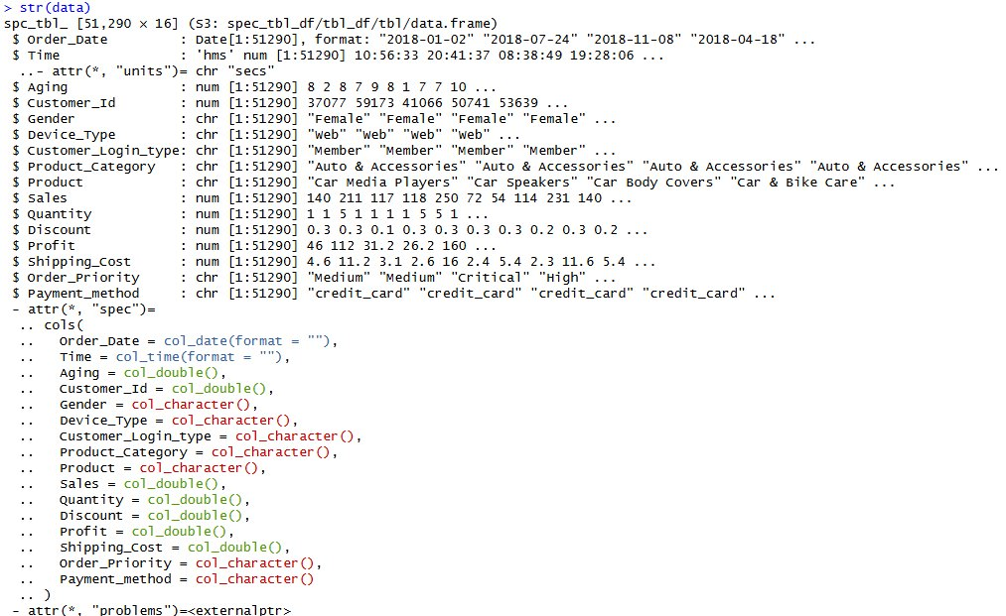
R structure output showing 51,290 observations across 16 variables

Figure 2: Summary Statistics
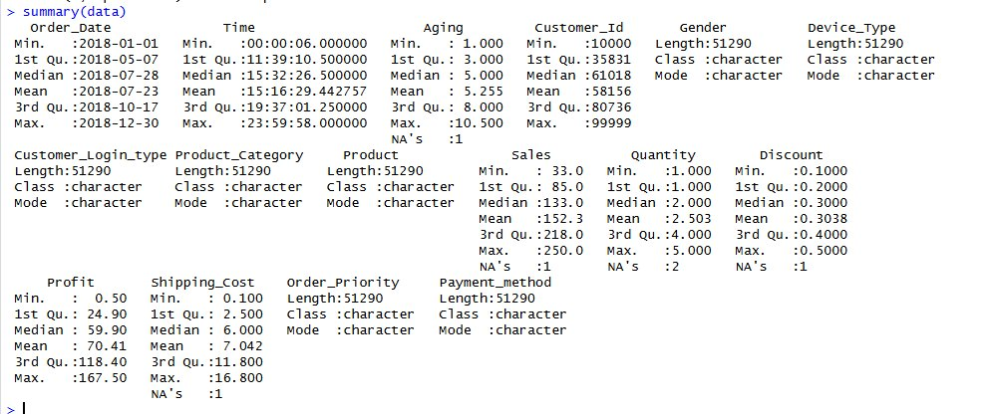
Descriptive statistics revealing customer behavior ranges and distributions

3. Data Cleaning & Preparation (R)

3.1 Data Quality Assessment
Initial data quality checks identified missing values, duplicate records, and inconsistent formatting. The following preprocessing steps ensured data integrity for clustering analysis.

3.2 Cleaning Operations
- Missing Value Handling: Removed records with critical missing values using na.omit() function
- Duplicate Detection: Identified and removed duplicate transaction records based on unique identifiers
- Data Type Conversion: Standardized date formats (2018-01-02 to 2018-12-30) and ensured numeric fields
- Outlier Treatment: Investigated extreme values in sales ($250 max) and profit ($167.50 max)

3.3 Feature Engineering
Created derived features to capture customer behavior patterns:
Feature | Calculation Method
Total_Spending | Sales × Quantity per transaction
Total_Orders | Count of unique orders per customer (aggregated by Customer_ID)
Total_Revenue | Sum of all sales per customer
Avg_Discount | Mean discount percentage per customer
Avg_Profit | Mean profit per transaction per customer
Avg_Shipping | Mean shipping cost per customer
Recency | Days since last purchase from dataset end date (lower = more recent)

4. K-Means Clustering Model (Python)

4.1 Feature Standardization
Before applying K-Means clustering, all features were standardized using StandardScaler from scikit-learn. Standardization ensures that features with larger scales (such as Total_Revenue ranging from hundreds to thousands) do not dominate the distance calculations compared to features with smaller scales (such as average discount ranging from 0 to 0.5). Each feature was transformed to have mean = 0 and standard deviation = 1.

4.2 Optimal Cluster Determination
The Elbow Method was employed to identify the optimal number of clusters (k). This technique plots the within-cluster sum of squares (WCSS) against different values of k. The optimal k is identified at the 'elbow point' where adding more clusters provides diminishing returns in terms of variance reduction.

Figure 3: Elbow Method Analysis
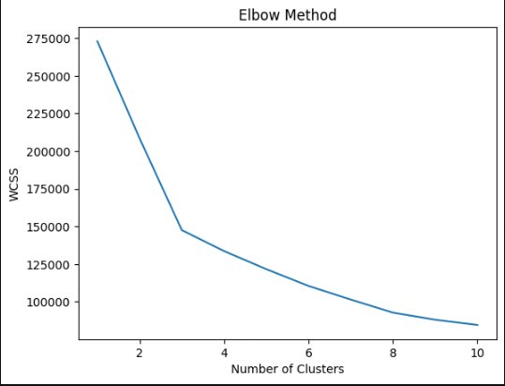
WCSS vs number of clusters showing optimal k=3 at the elbow point
Analysis of the elbow curve revealed that k = 3 provides the optimal balance between model complexity and cluster compactness. The curve shows a sharp decline from k=1 to k=3, with diminishing improvements beyond k=3, confirming three as the ideal number of segments.

4.3 Model Implementation
K-Means algorithm was implemented with the following parameters:
- Number of clusters: 3
- Initialization method: k-means++ (for optimal centroid initialization)
- Maximum iterations: 300
- Random state: 42 (for reproducibility)

Figure 4: Cluster Distribution
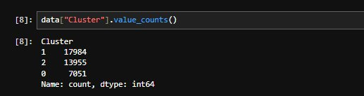
Customer distribution across three identified clusters
Cluster distribution: Cluster 1 (High-Value Active) = 17,984 customers, Cluster 2 (High Profit Potential) = 13,955 customers, Cluster 0 (Low-Value Dormant) = 7,051 customers.

5. Cluster Insights & Business Interpretation

5.1 Cluster Profiles
Three distinct customer segments emerged from the clustering analysis, each with unique behavioral characteristics and strategic implications.

Cluster 1: High-Value Active Customers (17,984 customers)
- Highest revenue contribution: Generates majority of total revenue with highest average total revenue per customer
- Frequent purchasers: Highest average order count (2.4 orders) compared to other clusters
- Low recency scores: Most recently active with average recency around 90 days
- Strategic importance: Critical for maintaining revenue stability and growth trajectory
Business Recommendation: Implement VIP loyalty programs with tiered benefits, priority customer service channels, exclusive early access to new products, personalized communication strategies, and dedicated account management.

Cluster 2: High Profit Potential (13,955 customers)
- Moderate revenue: Balanced purchasing behavior with consistent mid-level transactions
- Strong profitability: Highest profit margins per transaction due to lower discount sensitivity
- Growth potential: Highly responsive to targeted marketing campaigns and personalization
- Opportunity segment: Can be upgraded to Cluster 1 status with appropriate engagement strategies
Business Recommendation: Deploy targeted email campaigns with AI-powered product recommendations, create strategic bundle offers to increase basket size, test limited-time promotions, implement abandoned cart recovery automation, and develop loyalty point accumulation systems.

Cluster 0: Low-Value Dormant Customers (7,051 customers)
- Lowest revenue: Minimal contribution to overall sales with smallest average transaction sizes
- High recency scores: Extended period of inactivity (average 160+ days since last purchase)
- Churn risk: Highest probability of permanent customer loss without intervention
- Recovery opportunity: Represents significant untapped potential if successfully reactivated
Business Recommendation: Implement aggressive win-back campaigns with deep discount incentives (20-30% off), deploy multi-channel remarketing (email, social media, display ads), conduct customer feedback surveys to identify churn drivers, test new product categories for renewed interest, and consider cost-effective sunset strategies for permanently disengaged customers.

5.2 Cluster Comparison Summary
Metric | Cluster 1 | Cluster 2 | Cluster 0
Customer Count | 17,984 | 13,955 | 7,051
Revenue Level | Highest | Moderate | Lowest
Avg Orders | ~2.4 | ~1.2 | ~0.8
Recency | ~90 days | ~125 days | ~165 days
Profitability | High | Very High | Low
Strategy | Retain & Reward | Upgrade & Upsell | Re-engage

6. Interactive Dashboard (Tableau)

6.1 Dashboard Overview
An interactive Tableau dashboard was developed to enable real-time monitoring of customer segments and facilitate data-driven decision-making. The dashboard integrates multiple coordinated visualizations to provide comprehensive insights into segment performance.

6.2 Dashboard Components
- Revenue by Segment: Horizontal bar chart clearly showing High-Value Active generating ~1100 avg total revenue
- Orders by Segment: Comparative analysis revealing High-Value Active with highest order frequency (~2.4 orders)
- Recency by Segment: Visual representation showing activity gradients from ~90 days (active) to ~165 days (dormant)
- Customer Distribution: Bar chart illustrating segment sizes (High Profit: 14K, High Value: 18K, Dormant: 7K)
- Interactive Filters: Dynamic segment selection enabling drill-down analysis and cross-filtering

Figure 5: Complete Tableau Dashboard
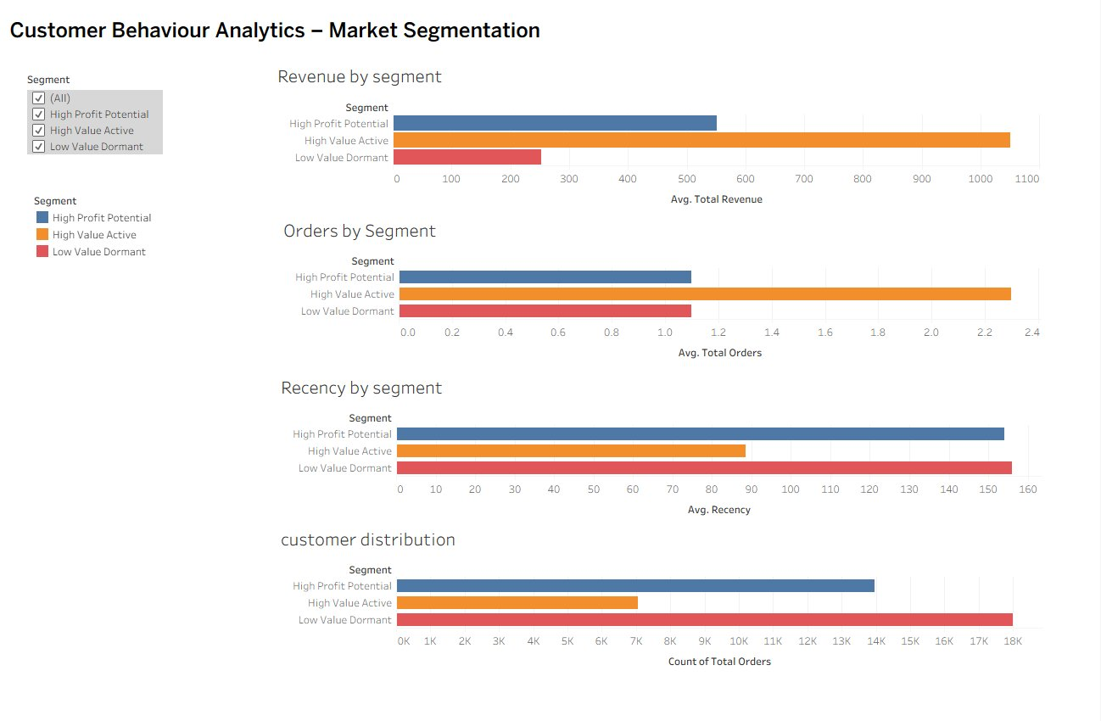
Interactive dashboard showing revenue, orders, recency, and customer distribution by segment

6.3 Key Dashboard Insights
- Revenue concentration is dramatically skewed: High-Value Active (orange) generates ~5x the revenue of Low-Value Dormant
- Order frequency directly correlates with segment classification: 2.4 orders (High-Value) vs 0.8 orders (Dormant)
- Clear recency gradient validates clustering: 90 → 125 → 165 days progression across segments
- Customer distribution reveals opportunity: 18K high-value + 14K potential vs only 7K dormant

7. Conclusions & Strategic Implications

7.1 Summary of Findings
The customer segmentation analysis successfully identified three behaviorally distinct clusters within the e-commerce customer base of 38,990 unique customers. The segmentation reveals a classic power law distribution where a minority of high-value customers (Cluster 1: 46% of customers) generates disproportionate revenue, while a significant dormant segment (Cluster 0: 18%) presents both a challenge and an opportunity for growth.
The clustering results demonstrate strong business validity: segments exhibit clear differentiation across all key metrics (revenue, frequency, recency, profitability), and each cluster maps to intuitive customer archetypes recognizable to marketing and sales teams.

7.2 Business Impact
- Resource Allocation: Marketing budget can now be allocated proportionally—60% to Cluster 1 retention, 30% to Cluster 2 growth, 10% to Cluster 0 recovery
- Personalization: Communication strategies can be tailored—premium content for Cluster 1, promotional offers for Cluster 2, win-back campaigns for Cluster 0
- Risk Management: Early identification of customers transitioning toward dormancy (recency >120 days) enables proactive intervention
- Revenue Forecasting: Segment-level projections improve accuracy—Cluster 1 stable growth, Cluster 2 high elasticity, Cluster 0 declining trajectory

7.3 Recommended Next Steps
- Immediate Implementation: Deploy segment-specific campaigns within 2 weeks
- A/B Testing: Test different messaging strategies within each segment to optimize conversion
- Predictive Modeling: Develop churn prediction model to forecast segment transitions
- Customer Lifetime Value: Calculate CLV by segment for ROI analysis on retention vs acquisition
- Quarterly Re-clustering: Update segments every 90 days to capture evolving behaviors

7.4 Success Metrics
Track these KPIs to measure segmentation impact:
- Cluster 1: Retention rate >90%, churn rate <5% quarterly
- Cluster 2: Order frequency increase of 20%, average order value growth of 15%
- Cluster 0: Reactivation rate of 10-15%, migration to Cluster 2 of 5%
- Overall: Customer lifetime value increase of 25% over 12 months

This customer segmentation project demonstrates the power of data-driven approaches to understanding customer behavior. By transforming 51,290 raw transactions into actionable three-segment framework, the organization can now implement targeted strategies that maximize customer lifetime value while optimizing marketing spend efficiently.

