python M1.py
🚀 Starting M1 data curation automation
🚀 Starting preprocessing pipeline for all datasets
🚀 Starting preprocessing pipeline for all datasets
generated new fontManager
generated new fontManager
--- Processing dataset (preprocess): SARS-CoV2
--- Processing dataset (preprocess): SARS-CoV2
SARS-CoV2 - COVID: 1252 images
SARS-CoV2 - COVID: 1252 images
SARS-CoV2 - COVID: 100%|████████████████████████████████████████████████████████| 1252/1252 [00:02<00:00, 573.42it/s]
SARS-CoV2 - non-COVID: 1229 images
SARS-CoV2 - non-COVID: 1229 images
SARS-CoV2 - non-COVID: 100%|████████████████████████████████████████████████████| 1229/1229 [00:02<00:00, 597.52it/s]
✅ Metadata saved for SARS-CoV2: data\preprocessed\SARS-CoV2\metadata.json
✅ Metadata saved for SARS-CoV2: data\preprocessed\SARS-CoV2\metadata.json
Processing returned None for SARS-CoV2 (check logs).
Processing returned None for SARS-CoV2 (check logs).
--- Processing dataset (preprocess): COVIDx
--- Processing dataset (preprocess): COVIDx
COVIDx - COVID: 2000 images
COVIDx - COVID: 2000 images
COVIDx - COVID: 100%|███████████████████████████████████████████████████████████| 2000/2000 [00:05<00:00, 376.98it/s]
COVIDx - PNEUMONIA: 2000 images
COVIDx - PNEUMONIA: 2000 images
COVIDx - PNEUMONIA: 100%|███████████████████████████████████████████████████████| 2000/2000 [00:05<00:00, 388.76it/s]
COVIDx - NORMAL: 2000 images
COVIDx - NORMAL: 2000 images
COVIDx - NORMAL: 100%|██████████████████████████████████████████████████████████| 2000/2000 [00:05<00:00, 335.57it/s]
✅ Metadata saved for COVIDx: data\preprocessed\COVIDx\metadata.json
✅ Metadata saved for COVIDx: data\preprocessed\COVIDx\metadata.json
Processing returned None for COVIDx (check logs).
Processing returned None for COVIDx (check logs).
--- Processing dataset (preprocess): COVID-CT-MD
--- Processing dataset (preprocess): COVID-CT-MD
COVID-CT-MD - COVID: 7593 images
COVID-CT-MD - COVID: 7593 images
COVID-CT-MD - COVID: 37%|███████████████████▉ | 2806/7593 [00:08<00:12, 368.72it/s]libpng warning: iCCP: known incorrect sRGB profile
libpng warning: iCCP: known incorrect sRGB profile
COVID-CT-MD - COVID: 39%|█████████████████████ | 2970/7593 [00:09<00:11, 398.24it/s]libpng warning: iCCP: known incorrect sRGB profile
libpng warning: iCCP: known incorrect sRGB profile
libpng warning: iCCP: known incorrect sRGB profile
libpng warning: iCCP: known incorrect sRGB profile
COVID-CT-MD - COVID: 40%|█████████████████████▍ | 3016/7593 [00:09<00:11, 410.97it/s]libpng warning: iCCP: known incorrect sRGB profile
libpng warning: iCCP: known incorrect sRGB profile
libpng warning: iCCP: known incorrect sRGB profile
COVID-CT-MD - COVID: 100%|██████████████████████████████████████████████████████| 7593/7593 [00:30<00:00, 252.43it/s]
COVID-CT-MD - CAP: 2618 images
COVID-CT-MD - CAP: 2618 images
COVID-CT-MD - CAP: 100%|████████████████████████████████████████████████████████| 2618/2618 [00:15<00:00, 169.14it/s]
COVID-CT-MD - non-COVID: 6893 images
COVID-CT-MD - non-COVID: 6893 images
COVID-CT-MD - non-COVID: 100%|██████████████████████████████████████████████████| 6893/6893 [00:18<00:00, 370.49it/s]
✅ Metadata saved for COVID-CT-MD: data\preprocessed\COVID-CT-MD\metadata.json
✅ Metadata saved for COVID-CT-MD: data\preprocessed\COVID-CT-MD\metadata.json
python .\scripts\loco_split.py

💾 Processing dataset: SARS-CoV2
✅ Dataset card saved: reports\SARS-CoV2_card.json
📊 Class distribution figure saved: reports\figures\SARS-CoV2_class_distribution.png
✅ Train manifest created: data\preprocessed\SARS-CoV2\train_manifest.json
✅ Val manifest created: data\preprocessed\SARS-CoV2\val_manifest.json
✅ Test manifest created: data\preprocessed\SARS-CoV2\test_manifest.json

💾 Processing dataset: COVIDx
✅ Dataset card saved: reports\COVIDx_card.json
📊 Class distribution figure saved: reports\figures\COVIDx_class_distribution.png
✅ Train manifest created: data\preprocessed\COVIDx\train_manifest.json
✅ Val manifest created: data\preprocessed\COVIDx\val_manifest.json
✅ Test manifest created: data\preprocessed\COVIDx\test_manifest.json

💾 Processing dataset: COVID-CT-MD
✅ Dataset card saved: reports\COVID-CT-MD_card.json
📊 Class distribution figure saved: reports\figures\COVID-CT-MD_class_distribution.png
✅ Train manifest created: data\preprocessed\COVID-CT-MD\train_manifest.json
✅ Val manifest created: data\preprocessed\COVID-CT-MD\val_manifest.json
✅ Test manifest created: data\preprocessed\COVID-CT-MD\test_manifest.json

🏁 All datasets processed successfully✅ M1 automation finished. Check logs and reports/ directory.
✅ M1 automation finished. Check logs and reports/ directory.
✅ M1: Data curation finished. Check logs and reports/ for outputs.

python scripts/preprocess.py
INFO - === XAI-CT Preprocessing Pipeline Initialized ===
INFO - Scanning dataset path: data\raw_nifti\SARS-COV2
Preprocessing Volumes: 0%| | 0/2 [00:00<?, ?it/s]INFO - Processing COVID_volume.nii.gz
WARNING - U-Net segmentation not yet implemented; skipping mask.
INFO - ✅ Saved preprocessed: COVID_volume.nii.npy
Preprocessing Volumes: 50%|█████████████████████████████▌ | 1/2 [00:01<00:01, 1.68s/it]INFO - Processing non-COVID_volume.nii.gz
WARNING - U-Net segmentation not yet implemented; skipping mask.
INFO - ✅ Saved preprocessed: non-COVID_volume.nii.npy
Preprocessing Volumes: 100%|███████████████████████████████████████████████████████████| 2/2 [00:03<00:00, 1.69s/it]
INFO - QC report saved to reports\qc\preprocess_qc.json
INFO - === Preprocessing Completed Successfully ===
(venv) PS D:\xai-ct-project - Copy> python scripts/preprocess.py
INFO - === XAI-CT Preprocessing Pipeline Initialized ===
INFO - Scanning dataset path: data\raw_nifti\SARS-COV2
Preprocessing SARS-CoV2: 0%| | 0/2 [00:00<?, ?it/s]WARNING - U-Net segmentation not yet implemented; skipping mask.
INFO - ✅ [SARS-CoV2] Saved: COVID_volume.nii.npy
Preprocessing SARS-CoV2: 50%|████████████████████████████▌ | 1/2 [00:01<00:01, 1.84s/it]WARNING - U-Net segmentation not yet implemented; skipping mask.
INFO - ✅ [SARS-CoV2] Saved: non-COVID_volume.nii.npy
Preprocessing SARS-CoV2: 100%|█████████████████████████████████████████████████████████| 2/2 [00:03<00:00, 1.85s/it]
INFO - Scanning dataset path: data\raw_nifti\COVIDx
Preprocessing COVIDx: 0%| | 0/3 [00:00<?, ?it/s]WARNING - U-Net segmentation not yet implemented; skipping mask.
INFO - ✅ [COVIDx] Saved: COVID_volume.nii.npy
Preprocessing COVIDx: 33%|████████████████████ | 1/3 [00:02<00:05, 2.69s/it]WARNING - U-Net segmentation not yet implemented; skipping mask.
INFO - ✅ [COVIDx] Saved: NORMAL_volume.nii.npy
Preprocessing COVIDx: 67%|████████████████████████████████████████ | 2/3 [00:05<00:02, 2.77s/it]WARNING - U-Net segmentation not yet implemented; skipping mask.
INFO - ✅ [COVIDx] Saved: PNEUMONIA_volume.nii.npy
Preprocessing COVIDx: 100%|████████████████████████████████████████████████████████████| 3/3 [00:08<00:00, 2.76s/it]
INFO - Scanning dataset path: data\raw_nifti\COVID-CT-MD
Preprocessing COVID-CT-MD: 0%| | 0/3 [00:00<?, ?it/s]WARNING - U-Net segmentation not yet implemented; skipping mask.
INFO - ✅ [COVID-CT-MD] Saved: CAP_volume.nii.npy
Preprocessing COVID-CT-MD: 33%|██████████████████▎ | 1/3 [00:04<00:08, 4.03s/it]WARNING - U-Net segmentation not yet implemented; skipping mask.
INFO - ✅ [COVID-CT-MD] Saved: COVID_volume.nii.npy
Preprocessing COVID-CT-MD: 67%|████████████████████████████████████▋ | 2/3 [00:15<00:08, 8.52s/it]WARNING - U-Net segmentation not yet implemented; skipping mask.
INFO - ✅ [COVID-CT-MD] Saved: non-COVID_volume.nii.npy
Preprocessing COVID-CT-MD: 100%|███████████████████████████████████████████████████████| 3/3 [00:25<00:00, 8.43s/it]
INFO - ✅ All dataset QC saved to reports\qc\preprocess_qc_all.json
INFO - === All Dataset Preprocessing Completed ===
(venv) PS D:\xai-ct-project - Copy>

python main_train_slice.py

🚀 Device: cuda
GPU Name: NVIDIA GeForce RTX 3050 6GB Laptop GPU
Memory Allocated: 0.00 GB
📄 Loading manifest from data/preprocessed/COVIDx\train_manifest.json
📄 Loading manifest from data/preprocessed/SARS-CoV2\train_manifest.json
📄 Loading manifest from data/preprocessed/COVID-CT-MD\train_manifest.json
✅ Loaded 20467 slices for split='train'
📄 Loading manifest from data/preprocessed/COVIDx\val_manifest.json
📄 Loading manifest from data/preprocessed/SARS-CoV2\val_manifest.json
📄 Loading manifest from data/preprocessed/COVID-CT-MD\val_manifest.json
✅ Loaded 2558 slices for split='val'
D:\xai-ct-project - Copy\main_train_slice.py:102: FutureWarning: `torch.cuda.amp.GradScaler(args...)` is deprecated. Please use `torch.amp.GradScaler('cuda', args...)` instead.
scaler = torch.cuda.amp.GradScaler() # ✅ for mixed precision

Epoch 1/10
Train: 0%| | 0/1280 [00:00<?, ?it/s]D:\xai-ct-project - Copy\main_train_slice.py:35: FutureWarning: `torch.cuda.amp.autocast(args...)` is deprecated. Please use `torch.amp.autocast('cuda', args...)` instead.
with torch.cuda.amp.autocast(): # ✅ Mixed precision
Val: 0%| | 0/160 [00:00<?, ?it/s]D:\xai-ct-project - Copy\main_train_slice.py:59: FutureWarning: `torch.cuda.amp.autocast(args...)` is deprecated. Please use `torch.amp.autocast('cuda', args...)` instead.
with torch.cuda.amp.autocast():
Train AUC: 0.9877 | Val AUC: 0.9987 | Val F1: 0.9918 | Val Acc: 0.9879
💾 Saved new best model (AUC=0.9987)

Epoch 2/10
Train: 0%| | 0/1280 [00:00<?, ?it/s]D:\xai-ct-project - Copy\main_train_slice.py:35: FutureWarning: `torch.cuda.amp.autocast(args...)` is deprecated. Please use `torch.amp.autocast('cuda', args...)` instead.
with torch.cuda.amp.autocast(): # ✅ Mixed precision
Val: 0%| | 0/160 [00:00<?, ?it/s]D:\xai-ct-project - Copy\main_train_slice.py:59: FutureWarning: `torch.cuda.amp.autocast(args...)` is deprecated. Please use `torch.amp.autocast('cuda', args...)` instead.
with torch.cuda.amp.autocast():
Train AUC: 0.9978 | Val AUC: 0.9993 | Val F1: 0.9931 | Val Acc: 0.9898
💾 Saved new best model (AUC=0.9993)

Epoch 3/10
Train: 0%| | 0/1280 [00:00<?, ?it/s]D:\xai-ct-project - Copy\main_train_slice.py:35: FutureWarning: `torch.cuda.amp.autocast(args...)` is deprecated. Please use `torch.amp.autocast('cuda', args...)` instead.
with torch.cuda.amp.autocast(): # ✅ Mixed precision
Val: 0%| | 0/160 [00:00<?, ?it/s]D:\xai-ct-project - Copy\main_train_slice.py:59: FutureWarning: `torch.cuda.amp.autocast(args...)` is deprecated. Please use `torch.amp.autocast('cuda', args...)` instead.
with torch.cuda.amp.autocast():
Train AUC: 0.9992 | Val AUC: 0.9980 | Val F1: 0.9947 | Val Acc: 0.9922

Epoch 4/10
Train: 0%| | 0/1280 [00:00<?, ?it/s]D:\xai-ct-project - Copy\main_train_slice.py:35: FutureWarning: `torch.cuda.amp.autocast(args...)` is deprecated. Please use `torch.amp.autocast('cuda', args...)` instead.
with torch.cuda.amp.autocast(): # ✅ Mixed precision
Val: 0%| | 0/160 [00:00<?, ?it/s]D:\xai-ct-project - Copy\main_train_slice.py:59: FutureWarning: `torch.cuda.amp.autocast(args...)` is deprecated. Please use `torch.amp.autocast('cuda', args...)` instead.
with torch.cuda.amp.autocast():
Train AUC: 0.9998 | Val AUC: 0.9976 | Val F1: 0.9945 | Val Acc: 0.9918

Epoch 5/10
Train: 0%| | 0/1280 [00:00<?, ?it/s]D:\xai-ct-project - Copy\main_train_slice.py:35: FutureWarning: `torch.cuda.amp.autocast(args...)` is deprecated. Please use `torch.amp.autocast('cuda', args...)` instead.
with torch.cuda.amp.autocast(): # ✅ Mixed precision
Val: 0%| | 0/160 [00:00<?, ?it/s]D:\xai-ct-project - Copy\main_train_slice.py:59: FutureWarning: `torch.cuda.amp.autocast(args...)` is deprecated. Please use `torch.amp.autocast('cuda', args...)` instead.
with torch.cuda.amp.autocast():
Train AUC: 1.0000 | Val AUC: 0.9975 | Val F1: 0.9958 | Val Acc: 0.9937

Epoch 6/10
Train: 0%| | 0/1280 [00:00<?, ?it/s]D:\xai-ct-project - Copy\main_train_slice.py:35: FutureWarning: `torch.cuda.amp.autocast(args...)` is deprecated. Please use `torch.amp.autocast('cuda', args...)` instead.
with torch.cuda.amp.autocast(): # ✅ Mixed precision
Val: 0%| | 0/160 [00:00<?, ?it/s]D:\xai-ct-project - Copy\main_train_slice.py:59: FutureWarning: `torch.cuda.amp.autocast(args...)` is deprecated. Please use `torch.amp.autocast('cuda', args...)` instead.
with torch.cuda.amp.autocast():
Train AUC: 1.0000 | Val AUC: 0.9983 | Val F1: 0.9971 | Val Acc: 0.9957

Epoch 7/10
Train: 0%| | 0/1280 [00:00<?, ?it/s]D:\xai-ct-project - Copy\main_train_slice.py:35: FutureWarning: `torch.cuda.amp.autocast(args...)` is deprecated. Please use `torch.amp.autocast('cuda', args...)` instead.
with torch.cuda.amp.autocast(): # ✅ Mixed precision
Val: 0%| | 0/160 [00:00<?, ?it/s]D:\xai-ct-project - Copy\main_train_slice.py:59: FutureWarning: `torch.cuda.amp.autocast(args...)` is deprecated. Please use `torch.amp.autocast('cuda', args...)` instead.
with torch.cuda.amp.autocast():
Train AUC: 1.0000 | Val AUC: 0.9984 | Val F1: 0.9976 | Val Acc: 0.9965

Epoch 8/10
Train: 0%| | 0/1280 [00:00<?, ?it/s]D:\xai-ct-project - Copy\main_train_slice.py:35: FutureWarning: `torch.cuda.amp.autocast(args...)` is deprecated. Please use `torch.amp.autocast('cuda', args...)` instead.
with torch.cuda.amp.autocast(): # ✅ Mixed precision
Val: 0%| | 0/160 [00:00<?, ?it/s]D:\xai-ct-project - Copy\main_train_slice.py:59: FutureWarning: `torch.cuda.amp.autocast(args...)` is deprecated. Please use `torch.amp.autocast('cuda', args...)` instead.
with torch.cuda.amp.autocast():
Train AUC: 1.0000 | Val AUC: 0.9998 | Val F1: 0.9971 | Val Acc: 0.9957
💾 Saved new best model (AUC=0.9998)

Epoch 9/10
Train: 0%| | 0/1280 [00:00<?, ?it/s]D:\xai-ct-project - Copy\main_train_slice.py:35: FutureWarning: `torch.cuda.amp.autocast(args...)` is deprecated. Please use `torch.amp.autocast('cuda', args...)` instead.
with torch.cuda.amp.autocast(): # ✅ Mixed precision
Val: 0%| | 0/160 [00:00<?, ?it/s]D:\xai-ct-project - Copy\main_train_slice.py:59: FutureWarning: `torch.cuda.amp.autocast(args...)` is deprecated. Please use `torch.amp.autocast('cuda', args...)` instead.
with torch.cuda.amp.autocast():
Train AUC: 1.0000 | Val AUC: 0.9999 | Val F1: 0.9971 | Val Acc: 0.9957
💾 Saved new best model (AUC=0.9999)

Epoch 10/10
Train: 0%| | 0/1280 [00:00<?, ?it/s]D:\xai-ct-project - Copy\main_train_slice.py:35: FutureWarning: `torch.cuda.amp.autocast(args...)` is deprecated. Please use `torch.amp.autocast('cuda', args...)` instead.
with torch.cuda.amp.autocast(): # ✅ Mixed precision
Val: 0%| | 0/160 [00:00<?, ?it/s]D:\xai-ct-project - Copy\main_train_slice.py:59: FutureWarning: `torch.cuda.amp.autocast(args...)` is deprecated. Please use `torch.amp.autocast('cuda', args...)` instead.
with torch.cuda.amp.autocast():
Train AUC: 1.0000 | Val AUC: 0.9997 | Val F1: 0.9966 | Val Acc: 0.9949

✅ Training complete. Best Validation AUC = 0.9999
(venv) PS D:\xai-ct-project - Copy>
python .\scripts\gradcam_check.py

🚀 Device: cuda
🩻 Found 2558 validation slices for Grad-CAM.
✅ Saved Grad-CAM overlay: 16_Morozov_study_0112_12_COVID_gradcam.png (COVID 97.71%)
✅ Saved Grad-CAM overlay: Non-Covid (519)_COVID_gradcam.png (COVID 97.83%)
✅ Saved Grad-CAM overlay: 14_Jun_radiopaedia_10_85902_3_case12_81_COVID_gradcam.png (COVID 97.15%)
✅ Saved Grad-CAM overlay: cp015_158_NonCOVID_gradcam.png (NonCOVID 97.69%)
✅ Saved Grad-CAM overlay: 16_Morozov_study_0032_16_COVID_gradcam.png (COVID 97.42%)

🎯 Grad-CAM visualizations saved to: outputs/logs\gradcam_samples
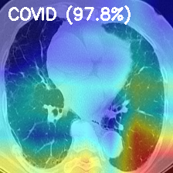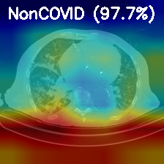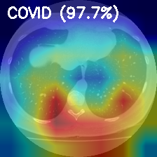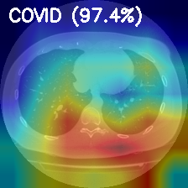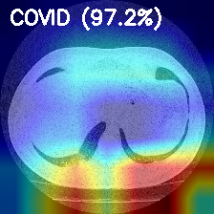

python scripts/extract_embeddings.py --ckpt "outputs/checkpoints/best_model.pt" --preprocessed_root data/preprocessed --out_root data/mil --device cuda
🔹 Loading model from outputs/checkpoints/best_model.pt
D:\xai-ct-project - Copy\scripts\extract_embeddings.py:136: FutureWarning: You are using `torch.load` with `weights_only=False` (the current default value), which uses the default pickle module implicitly. It is possible to construct malicious pickle data which will execute arbitrary code during unpickling (See https://github.com/pytorch/pytorch/blob/main/SECURITY.md#untrusted-models for more details). In a future release, the default value for `weights_only` will be flipped to `True`. This limits the functions that could be executed during unpickling. Arbitrary objects will no longer be allowed to be loaded via this mode unless they are explicitly allowlisted by the user via `torch.serialization.add_safe_globals`. We recommend you start setting `weights_only=True` for any use case where you don't have full control of the loaded file. Please open an issue on GitHub for any issues related to this experimental feature.
model.load_state_dict(torch.load(ckpt_path, map_location=device))

🚀 Processing dataset: COVIDx
✅ Loaded 4800 slices from train_manifest.json
Extracting COVIDx/train: 100%|███████████████████████████████████████████████████████████████████████████████████████████████| 300/300 [01:24<00:00, 3.53it/s]
✅ Saved 3 studies → data\mil\COVIDx\train
✅ Loaded 600 slices from val_manifest.json
Extracting COVIDx/val: 100%|███████████████████████████████████████████████████████████████████████████████████████████████████| 38/38 [00:34<00:00, 1.10it/s]
✅ Saved 3 studies → data\mil\COVIDx\val
✅ Loaded 600 slices from test_manifest.json
Extracting COVIDx/test: 100%|██████████████████████████████████████████████████████████████████████████████████████████████████| 38/38 [00:34<00:00, 1.10it/s]
✅ Saved 3 studies → data\mil\COVIDx\test

🚀 Processing dataset: SARS-CoV2
✅ Loaded 1984 slices from train_manifest.json
Extracting SARS-CoV2/train: 100%|████████████████████████████████████████████████████████████████████████████████████████████| 124/124 [00:49<00:00, 2.49it/s]
✅ Saved 2 studies → data\mil\SARS-CoV2\train
✅ Loaded 248 slices from val_manifest.json
Extracting SARS-CoV2/val: 100%|████████████████████████████████████████████████████████████████████████████████████████████████| 16/16 [00:30<00:00, 1.93s/it]
✅ Saved 2 studies → data\mil\SARS-CoV2\val
✅ Loaded 249 slices from test_manifest.json
Extracting SARS-CoV2/test: 100%|███████████████████████████████████████████████████████████████████████████████████████████████| 16/16 [00:30<00:00, 1.94s/it]
✅ Saved 2 studies → data\mil\SARS-CoV2\test

🚀 Processing dataset: COVID-CT-MD
✅ Loaded 13683 slices from train_manifest.json
Extracting COVID-CT-MD/train: 100%|██████████████████████████████████████████████████████████████████████████████████████████| 856/856 [03:37<00:00, 3.94it/s]
✅ Saved 3 studies → data\mil\COVID-CT-MD\train
✅ Loaded 1710 slices from val_manifest.json
Extracting COVID-CT-MD/val: 100%|████████████████████████████████████████████████████████████████████████████████████████████| 107/107 [00:48<00:00, 2.23it/s]
✅ Saved 3 studies → data\mil\COVID-CT-MD\val
✅ Loaded 1711 slices from test_manifest.json
Extracting COVID-CT-MD/test: 100%|███████████████████████████████████████████████████████████████████████████████████████████| 107/107 [00:46<00:00, 2.29it/s]
✅ Saved 3 studies → data\mil\COVID-CT-MD\test

🎯 All embeddings generated successfully under: data/mil
(venv) PS D:\xai-ct-project - Copy>

python scripts/prepare_mil_data.py --mil_root data/mil --out_root data/mil_prepared
✅ Saved 8 train entries → data\mil_prepared\train_list.json
✅ Saved 8 val entries → data\mil_prepared\val_list.json
✅ Saved 8 test entries → data\mil_prepared\test_list.json

🎯 MIL dataset preparation complete! All splits saved to data\mil_prepared

python scripts/train_mil.py --config config/mil.yaml --device cuda
🔹 Building aggregator...
D:\xai-ct-project - Copy\venv\Lib\site-packages\torch\nn\modules\transformer.py:379: UserWarning: enable_nested_tensor is True, but self.use_nested_tensor is False because encoder_layer.self_attn.batch_first was not True(use batch_first for better inference performance)
warnings.warn(
📂 Loading datasets...
✅ Found 8 study embeddings under data\mil_prepared\train
✅ Found 8 study embeddings under data\mil_prepared\val

🌍 Epoch 1/30
Train: 100%|█████████████████████████████████████████████████████████████████████████████████████████████████████████████████████| 2/2 [00:01<00:00, 1.11it/s]
Val: 100%|███████████████████████████████████████████████████████████████████████████████████████████████████████████████████████| 2/2 [00:00<00:00, 2.65it/s]
Train: loss=2.6275, acc=0.8750, f1=0.9333
Val : loss=2.5461, acc=0.8750, f1=0.9333, auc=0.5000
✅ Best model updated (AUC=0.5000)

🌍 Epoch 2/30
Train: 100%|█████████████████████████████████████████████████████████████████████████████████████████████████████████████████████| 2/2 [00:01<00:00, 1.19it/s]
Val: 100%|███████████████████████████████████████████████████████████████████████████████████████████████████████████████████████| 2/2 [00:00<00:00, 4.28it/s]
Train: loss=2.3454, acc=0.8750, f1=0.9333
Val : loss=1.8017, acc=0.8750, f1=0.9333, auc=0.5000

🌍 Epoch 3/30
Train: 100%|█████████████████████████████████████████████████████████████████████████████████████████████████████████████████████| 2/2 [00:01<00:00, 1.19it/s]
Val: 100%|███████████████████████████████████████████████████████████████████████████████████████████████████████████████████████| 2/2 [00:00<00:00, 4.33it/s]
Train: loss=1.7006, acc=0.8750, f1=0.9333
Val : loss=0.4658, acc=0.8750, f1=0.9333, auc=0.5000

🌍 Epoch 4/30
Train: 100%|█████████████████████████████████████████████████████████████████████████████████████████████████████████████████████| 2/2 [00:01<00:00, 1.19it/s]
Val: 100%|███████████████████████████████████████████████████████████████████████████████████████████████████████████████████████| 2/2 [00:00<00:00, 4.34it/s]
Train: loss=0.4304, acc=0.7500, f1=0.8333
Val : loss=0.5856, acc=0.7500, f1=0.8571, auc=0.4286

🌍 Epoch 5/30
Train: 100%|█████████████████████████████████████████████████████████████████████████████████████████████████████████████████████| 2/2 [00:01<00:00, 1.12it/s]
Val: 100%|███████████████████████████████████████████████████████████████████████████████████████████████████████████████████████| 2/2 [00:00<00:00, 3.38it/s]
Train: loss=0.4346, acc=0.8750, f1=0.9231
Val : loss=0.6148, acc=0.8750, f1=0.9333, auc=0.5000

🌍 Epoch 6/30
Train: 100%|█████████████████████████████████████████████████████████████████████████████████████████████████████████████████████| 2/2 [00:01<00:00, 1.25it/s]
Val: 100%|███████████████████████████████████████████████████████████████████████████████████████████████████████████████████████| 2/2 [00:00<00:00, 4.25it/s]
Train: loss=0.7837, acc=0.8750, f1=0.9333
Val : loss=0.8515, acc=0.8750, f1=0.9333, auc=0.5000

🌍 Epoch 7/30
Train: 100%|█████████████████████████████████████████████████████████████████████████████████████████████████████████████████████| 2/2 [00:01<00:00, 1.08it/s]
Val: 100%|███████████████████████████████████████████████████████████████████████████████████████████████████████████████████████| 2/2 [00:00<00:00, 4.26it/s]
Train: loss=0.7547, acc=0.8750, f1=0.9333
Val : loss=0.7254, acc=0.8750, f1=0.9333, auc=0.5000

🌍 Epoch 8/30
Train: 100%|█████████████████████████████████████████████████████████████████████████████████████████████████████████████████████| 2/2 [00:01<00:00, 1.16it/s]
Val: 100%|███████████████████████████████████████████████████████████████████████████████████████████████████████████████████████| 2/2 [00:00<00:00, 4.08it/s]
Train: loss=0.6500, acc=0.8750, f1=0.9333
Val : loss=0.4224, acc=0.8750, f1=0.9333, auc=0.5000

🌍 Epoch 9/30
Train: 100%|█████████████████████████████████████████████████████████████████████████████████████████████████████████████████████| 2/2 [00:01<00:00, 1.16it/s]
Val: 100%|███████████████████████████████████████████████████████████████████████████████████████████████████████████████████████| 2/2 [00:00<00:00, 4.17it/s]
Train: loss=0.5716, acc=0.7500, f1=0.8571
Val : loss=0.5570, acc=0.7500, f1=0.8571, auc=0.4286

🌍 Epoch 10/30
Train: 100%|█████████████████████████████████████████████████████████████████████████████████████████████████████████████████████| 2/2 [00:01<00:00, 1.19it/s]
Val: 100%|███████████████████████████████████████████████████████████████████████████████████████████████████████████████████████| 2/2 [00:00<00:00, 3.45it/s]
Train: loss=0.5060, acc=0.8750, f1=0.9333
Val : loss=0.4236, acc=0.8750, f1=0.9333, auc=0.5000

🌍 Epoch 11/30
Train: 100%|█████████████████████████████████████████████████████████████████████████████████████████████████████████████████████| 2/2 [00:01<00:00, 1.29it/s]
Val: 100%|███████████████████████████████████████████████████████████████████████████████████████████████████████████████████████| 2/2 [00:00<00:00, 4.31it/s]
Train: loss=0.5219, acc=0.8750, f1=0.9333
Val : loss=0.5953, acc=0.8750, f1=0.9333, auc=0.5000

🌍 Epoch 12/30
Train: 100%|█████████████████████████████████████████████████████████████████████████████████████████████████████████████████████| 2/2 [00:01<00:00, 1.19it/s]
Val: 100%|███████████████████████████████████████████████████████████████████████████████████████████████████████████████████████| 2/2 [00:00<00:00, 4.18it/s]
Train: loss=0.5310, acc=0.8750, f1=0.9333
Val : loss=0.5970, acc=0.8750, f1=0.9333, auc=0.5000

🌍 Epoch 13/30
Train: 100%|█████████████████████████████████████████████████████████████████████████████████████████████████████████████████████| 2/2 [00:01<00:00, 1.26it/s]
Val: 100%|███████████████████████████████████████████████████████████████████████████████████████████████████████████████████████| 2/2 [00:00<00:00, 3.50it/s]
Train: loss=0.5535, acc=0.8750, f1=0.9333
Val : loss=0.4955, acc=0.8750, f1=0.9333, auc=0.5000

🌍 Epoch 14/30
Train: 100%|█████████████████████████████████████████████████████████████████████████████████████████████████████████████████████| 2/2 [00:01<00:00, 1.38it/s]
Val: 100%|███████████████████████████████████████████████████████████████████████████████████████████████████████████████████████| 2/2 [00:00<00:00, 3.50it/s]
Train: loss=0.3905, acc=0.8750, f1=0.9333
Val : loss=0.4297, acc=0.8750, f1=0.9333, auc=0.5000

🌍 Epoch 15/30
Train: 100%|█████████████████████████████████████████████████████████████████████████████████████████████████████████████████████| 2/2 [00:01<00:00, 1.27it/s]
Val: 100%|███████████████████████████████████████████████████████████████████████████████████████████████████████████████████████| 2/2 [00:00<00:00, 4.32it/s]
Train: loss=0.4722, acc=0.8750, f1=0.9333
Val : loss=0.4641, acc=0.8750, f1=0.9333, auc=0.5000

🌍 Epoch 16/30
Train: 100%|█████████████████████████████████████████████████████████████████████████████████████████████████████████████████████| 2/2 [00:01<00:00, 1.20it/s]
Val: 100%|███████████████████████████████████████████████████████████████████████████████████████████████████████████████████████| 2/2 [00:00<00:00, 4.20it/s]
Train: loss=0.4896, acc=0.8750, f1=0.9333
Val : loss=0.4305, acc=0.8750, f1=0.9333, auc=0.5000

🌍 Epoch 17/30
Train: 100%|█████████████████████████████████████████████████████████████████████████████████████████████████████████████████████| 2/2 [00:01<00:00, 1.13it/s]
Val: 100%|███████████████████████████████████████████████████████████████████████████████████████████████████████████████████████| 2/2 [00:00<00:00, 4.15it/s]
Train: loss=0.4284, acc=0.8750, f1=0.9333
Val : loss=0.4977, acc=0.8750, f1=0.9333, auc=0.5000

🌍 Epoch 18/30
Train: 100%|█████████████████████████████████████████████████████████████████████████████████████████████████████████████████████| 2/2 [00:01<00:00, 1.19it/s]
Val: 100%|███████████████████████████████████████████████████████████████████████████████████████████████████████████████████████| 2/2 [00:00<00:00, 3.40it/s]
Train: loss=0.4188, acc=0.8750, f1=0.9333
Val : loss=0.5261, acc=0.8750, f1=0.9333, auc=0.5000

🌍 Epoch 19/30
Train: 100%|█████████████████████████████████████████████████████████████████████████████████████████████████████████████████████| 2/2 [00:01<00:00, 1.39it/s]
Val: 100%|███████████████████████████████████████████████████████████████████████████████████████████████████████████████████████| 2/2 [00:00<00:00, 3.49it/s]
Train: loss=0.4199, acc=0.8750, f1=0.9333
Val : loss=0.5289, acc=0.8750, f1=0.9333, auc=0.5000

🌍 Epoch 20/30
Train: 100%|█████████████████████████████████████████████████████████████████████████████████████████████████████████████████████| 2/2 [00:01<00:00, 1.27it/s]
Val: 100%|███████████████████████████████████████████████████████████████████████████████████████████████████████████████████████| 2/2 [00:00<00:00, 4.43it/s]
Train: loss=0.3799, acc=0.8750, f1=0.9333
Val : loss=0.4731, acc=0.8750, f1=0.9333, auc=0.5000

🌍 Epoch 21/30
Train: 100%|█████████████████████████████████████████████████████████████████████████████████████████████████████████████████████| 2/2 [00:01<00:00, 1.16it/s]
Val: 100%|███████████████████████████████████████████████████████████████████████████████████████████████████████████████████████| 2/2 [00:00<00:00, 4.22it/s]
Train: loss=0.4061, acc=0.8750, f1=0.9333
Val : loss=0.4512, acc=0.8750, f1=0.9333, auc=0.5000

🌍 Epoch 22/30
Train: 100%|█████████████████████████████████████████████████████████████████████████████████████████████████████████████████████| 2/2 [00:01<00:00, 1.19it/s]
Val: 100%|███████████████████████████████████████████████████████████████████████████████████████████████████████████████████████| 2/2 [00:00<00:00, 4.43it/s]
Train: loss=0.4009, acc=0.8750, f1=0.9333
Val : loss=0.4491, acc=0.8750, f1=0.9333, auc=0.5000

🌍 Epoch 23/30
Train: 100%|█████████████████████████████████████████████████████████████████████████████████████████████████████████████████████| 2/2 [00:01<00:00, 1.10it/s]
Val: 100%|███████████████████████████████████████████████████████████████████████████████████████████████████████████████████████| 2/2 [00:00<00:00, 4.24it/s]
Train: loss=0.3596, acc=0.8750, f1=0.9333
Val : loss=0.4910, acc=0.8750, f1=0.9333, auc=0.5000

🌍 Epoch 24/30
Train: 100%|█████████████████████████████████████████████████████████████████████████████████████████████████████████████████████| 2/2 [00:01<00:00, 1.19it/s]
Val: 100%|███████████████████████████████████████████████████████████████████████████████████████████████████████████████████████| 2/2 [00:00<00:00, 4.30it/s]
Train: loss=0.3545, acc=0.8750, f1=0.9333
Val : loss=0.5767, acc=0.8750, f1=0.9333, auc=0.5000

🌍 Epoch 25/30
Train: 100%|█████████████████████████████████████████████████████████████████████████████████████████████████████████████████████| 2/2 [00:01<00:00, 1.17it/s]
Val: 100%|███████████████████████████████████████████████████████████████████████████████████████████████████████████████████████| 2/2 [00:00<00:00, 3.39it/s]
Train: loss=0.3612, acc=0.8750, f1=0.9333
Val : loss=0.5197, acc=0.8750, f1=0.9333, auc=0.5000

🌍 Epoch 26/30
Train: 100%|█████████████████████████████████████████████████████████████████████████████████████████████████████████████████████| 2/2 [00:01<00:00, 1.19it/s]
Val: 100%|███████████████████████████████████████████████████████████████████████████████████████████████████████████████████████| 2/2 [00:00<00:00, 3.42it/s]
Train: loss=0.3378, acc=0.8750, f1=0.9333
Val : loss=0.4836, acc=0.8750, f1=0.9333, auc=0.5000

🌍 Epoch 27/30
Train: 100%|█████████████████████████████████████████████████████████████████████████████████████████████████████████████████████| 2/2 [00:01<00:00, 1.24it/s]
Val: 100%|███████████████████████████████████████████████████████████████████████████████████████████████████████████████████████| 2/2 [00:00<00:00, 3.21it/s]
Train: loss=0.2769, acc=1.0000, f1=1.0000
Val : loss=0.5034, acc=0.8750, f1=0.9333, auc=0.5000

🌍 Epoch 28/30
Train: 100%|█████████████████████████████████████████████████████████████████████████████████████████████████████████████████████| 2/2 [00:01<00:00, 1.17it/s]
Val: 100%|███████████████████████████████████████████████████████████████████████████████████████████████████████████████████████| 2/2 [00:00<00:00, 4.22it/s]
Train: loss=0.2442, acc=0.8750, f1=0.9333
Val : loss=0.5643, acc=0.8750, f1=0.9333, auc=0.5000

🌍 Epoch 29/30
Train: 100%|█████████████████████████████████████████████████████████████████████████████████████████████████████████████████████| 2/2 [00:01<00:00, 1.19it/s]
Val: 100%|███████████████████████████████████████████████████████████████████████████████████████████████████████████████████████| 2/2 [00:00<00:00, 4.25it/s]
Train: loss=0.2160, acc=0.8750, f1=0.9333
Val : loss=0.5832, acc=0.8750, f1=0.9333, auc=0.5000

🌍 Epoch 30/30
Train: 100%|█████████████████████████████████████████████████████████████████████████████████████████████████████████████████████| 2/2 [00:01<00:00, 1.27it/s]
Val: 100%|███████████████████████████████████████████████████████████████████████████████████████████████████████████████████████| 2/2 [00:00<00:00, 4.41it/s]
Train: loss=0.2158, acc=1.0000, f1=1.0000
Val : loss=0.5707, acc=0.7500, f1=0.8571, auc=0.4286

🎯 Training complete! Best AUC = 0.5
📦 Saved final model → outputs\m4\checkpoints\best_model.pt
🧾 Log file → outputs\m4\logs\mil_train_log.json
(venv) PS D:\xai-ct-project - Copy>

python metrics/visualize_attention_m4.py --results outputs/m4/logs/attention_results.json --preprocessed_root data/preprocessed --out_root outputs/m4/attention_vis --top_k 5
🔍 Loaded 8 study attention results
Rendering: 100%|█████████████████████████████████████████████████████████████████████████████████████████████████████████████████| 8/8 [00:05<00:00, 1.34it/s]

✅ Saved all visualizations → outputs\m4\attention_vis

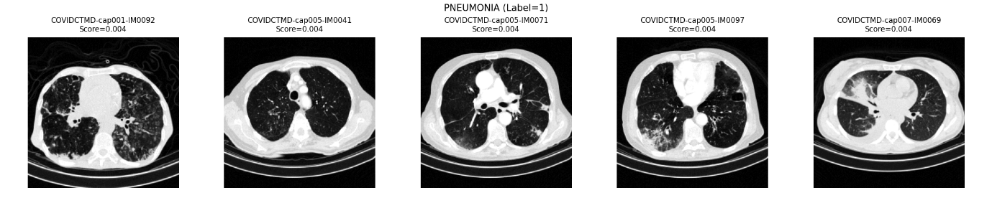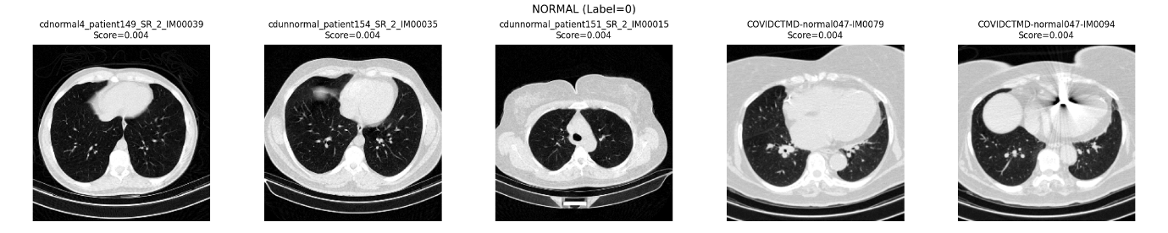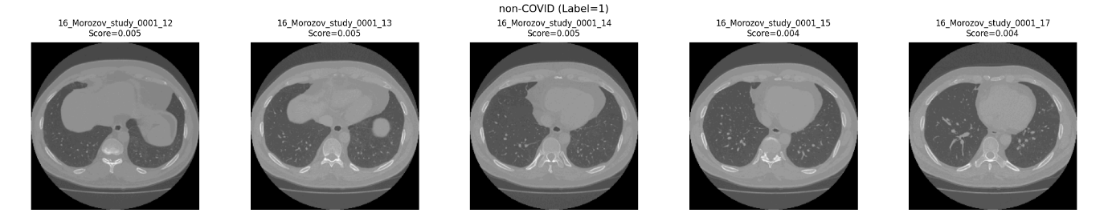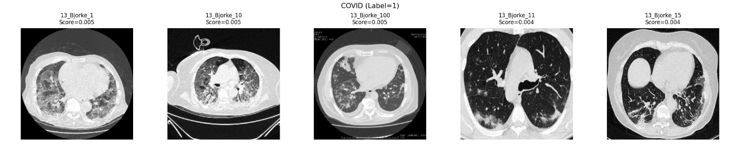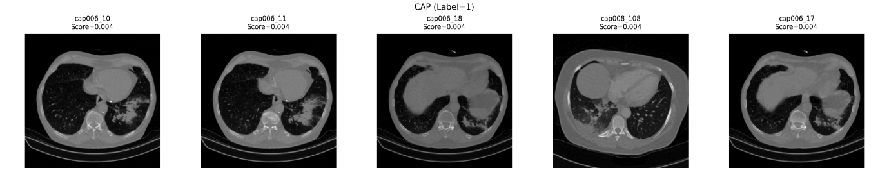

python metrics/visualize_attention_heatmap_m4.py --results outputs/m4/logs/attention_results.json --preprocessed_root data/preprocessed --out_root outputs/m4/attention_heatmaps --top_k 5
🔥 Loaded 8 attention results — generating overlays...
Rendering Heatmaps: 100%|████████████████████████████████████████████████████████████████████████████████████████████████████████| 8/8 [00:00<00:00, 11.54it/s]

✅ Saved all attention heatmaps → outputs\m4\attention_heatmaps
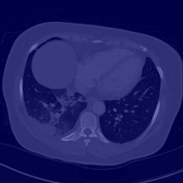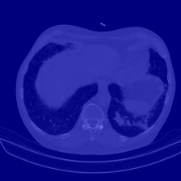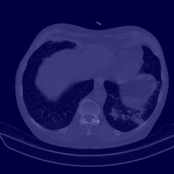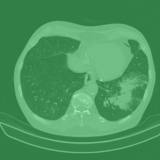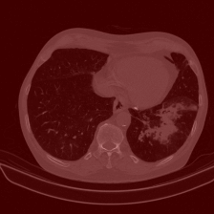

python bot.py
[INFO] train: classes={'CAP': 0, 'COVID': 1, 'NORMAL': 2, 'PNEUMONIA': 3}
train counts: {0: 43, 1: 858, 2: 236, 3: 214}
[INFO] val: classes={'CAP': 0, 'COVID': 1, 'NORMAL': 2, 'PNEUMONIA': 3}
val counts: {0: 5, 1: 107, 2: 29, 3: 26}
[INFO] test: classes={'CAP': 0, 'COVID': 1, 'NORMAL': 2, 'PNEUMONIA': 3}
test counts: {0: 6, 1: 108, 2: 30, 3: 28}
(venv) PS D:\xai-ct-project - Copy> python main_train_3d.py --config config/model3d.yaml --workdir outputs/m5/checkpoints
Device: cuda
[INFO] train: classes={'CAP': 0, 'COVID': 1, 'NORMAL': 2, 'PNEUMONIA': 3}
[INFO] val: classes={'CAP': 0, 'COVID': 1, 'NORMAL': 2, 'PNEUMONIA': 3}
[INFO] test: classes={'CAP': 0, 'COVID': 1, 'NORMAL': 2, 'PNEUMONIA': 3}
[INFO] Found 1351 train / 167 val / 172 test volumes
[INFO] Target shape = [1, 96, 160, 160]
torch.compile disabled to avoid Triton error.

Epoch 1/20
Train loss 0.9810 | Train AUC 0.721248015186148
Val loss 4.6182 | Val AUC 0.6905605268760221
✅ Saved new best -> outputs/m5/checkpoints\best.pth

Epoch 2/20
Train loss 0.7086 | Train AUC 0.8217694533676508
Val loss 2.3541 | Val AUC 0.7652750184282291
✅ Saved new best -> outputs/m5/checkpoints\best.pth

Epoch 3/20
Train loss 0.5838 | Train AUC 0.8721621571398176
Val loss 13.4786 | Val AUC 0.5043674787548371

Epoch 4/20
Train loss 0.5581 | Train AUC 0.8670253704819417
Val loss 0.7252 | Val AUC 0.9139049183907297
✅ Saved new best -> outputs/m5/checkpoints\best.pth

Epoch 5/20
Train loss 0.5481 | Train AUC 0.8698928810666148
Val loss 0.6804 | Val AUC 0.9316071488481772
✅ Saved new best -> outputs/m5/checkpoints\best.pth

Epoch 6/20
Train loss 0.5326 | Train AUC 0.8696882490813366
Val loss 1.4931 | Val AUC 0.9178719055882761

Epoch 7/20
Train loss 0.5157 | Train AUC 0.889228917042478
Val loss 0.7549 | Val AUC 0.8957257254886353

Epoch 8/20
Train loss 0.4982 | Train AUC 0.8914171729385381
Val loss 21.7977 | Val AUC 0.5145936735180888

Epoch 9/20
Train loss 0.4848 | Train AUC 0.9052747943427357
Val loss 0.5432 | Val AUC 0.9054390867921795

Epoch 10/20
Train loss 0.4263 | Train AUC 0.9178603263698333
Val loss 0.4970 | Val AUC 0.9102279377092612

Epoch 11/20
Train loss 0.4155 | Train AUC 0.9128652927998915
Val loss 4.6835 | Val AUC 0.8249214703261486

Epoch 12/20
Train loss 0.4013 | Train AUC 0.933463550060109
Val loss 10.2824 | Val AUC 0.7181082607584366

Epoch 13/20
Train loss 0.4015 | Train AUC 0.9406039561787224
Val loss 0.5793 | Val AUC 0.9321516834443049
✅ Saved new best -> outputs/m5/checkpoints\best.pth

Epoch 14/20
Train loss 0.3924 | Train AUC 0.9329626141664541
Val loss 1.0277 | Val AUC 0.8903578307245241

Epoch 15/20
Train loss 0.3916 | Train AUC 0.9352946919288001
Val loss 0.4823 | Val AUC 0.9335064959805582
✅ Saved new best -> outputs/m5/checkpoints\best.pth

Epoch 16/20
Train loss 0.3665 | Train AUC 0.942908008224941
Val loss 0.6015 | Val AUC 0.8878568518207388

Epoch 17/20
Train loss 0.3335 | Train AUC 0.9564287002167806
Val loss 6.3391 | Val AUC 0.8263789016717217

Epoch 18/20
Train loss 0.3663 | Train AUC 0.9512693776220131
Val loss 1.0312 | Val AUC 0.9002817927630377

Epoch 19/20
Train loss 0.3606 | Train AUC 0.9561685725473491
Val loss 0.8389 | Val AUC 0.9105520945702981

Epoch 20/20
Train loss 0.3159 | Train AUC 0.9641405338421081
Val loss 0.7198 | Val AUC 0.9355369309463852
✅ Saved new best -> outputs/m5/checkpoints\best.pth

python main_eval_3d.py --config config/model3d.yaml --checkpoint outputs/m5/checkpoints/best.pth --workdir outputs/m5/eval
Device: cuda
[INFO] train: classes={'CAP': 0, 'COVID': 1, 'NORMAL': 2, 'PNEUMONIA': 3}
[INFO] val: classes={'CAP': 0, 'COVID': 1, 'NORMAL': 2, 'PNEUMONIA': 3}
[INFO] test: classes={'CAP': 0, 'COVID': 1, 'NORMAL': 2, 'PNEUMONIA': 3}
[INFO] Found 1351 train / 167 val / 172 test volumes
[INFO] Target shape = [1, 96, 160, 160]
Test: 100%|███████████████████████████████████████████████████████████████████████████████████████████████████| 86/86 [05:26<00:00, 3.80s/it]
✅ Saved embeddings: outputs/m5/eval\test_embeddings.npy
✅ Saved predictions: outputs/m5/eval\test_predictions.csv
Test ACC: 0.8895 | Test AUC (macro): 0.9717524945523206
Class 0 AUC: 0.9408
Class 1 AUC: 0.9653
Class 2 AUC: 0.9988
Class 3 AUC: 0.9821
✅ Saved ROC plots → outputs/m5/eval\roc_multiclass.png
✅ Saved metrics JSON: outputs/m5/eval\test_metrics.js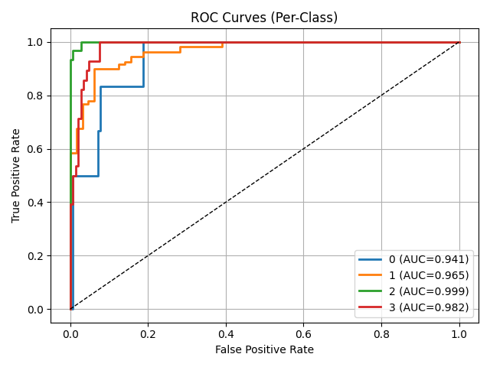

During the training of the 3D ResNet model (M5), the Train/Validation Accuracy vs Epoch graph shows a steady improvement in training accuracy, reaching around 96%, while validation accuracy remains consistently high at approximately 90–93%, indicating strong generalization to unseen data. The Train/Validation Loss vs Epoch graph demonstrates a continuous decrease in training loss, confirming stable learning, while the validation loss fluctuates due to the smaller and more variable validation dataset. Overall, the curves indicate that the model successfully learned discriminative 3D features without significant overfitting, achieving reliable performance across the four classes (COVID, Normal, Pneumonia, CAP).

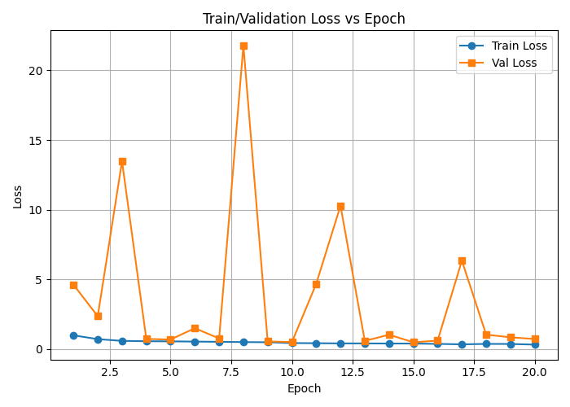

M6
python train_fusion_m6.py
Using device: cuda
Loading M4 attention JSON -> building compact M4 features...
M4 features: (8, 6)
Loading M5 embeddings and CSV...
M5 embeddings: (172, 512) M5 csv rows: 172
⚠️ M4 (8) and M5 (172) lengths differ. Expanding M4 class features to match M5 dataset size (172).
✅ Expanded M4 embeddings: (172, 6)
Saved fused embeddings: d:\xai-ct-project - Copy\outputs\m6\fused_embeddings.npy
Saved fused manifest: d:\xai-ct-project - Copy\outputs\m6\fused_manifest.csv
Split sizes -> train: 120 val: 26 test: 26
D:\xai-ct-project - Copy\venv\Lib\site-packages\sklearn\linear_model\_logistic.py:1247: FutureWarning: 'multi_class' was deprecated in version 1.5 and will be removed in 1.7. From then on, it will always use 'multinomial'. Leave it to its default value to avoid this warning.
warnings.warn(
Trained fusion classifier.
Fitting temperature scaling on validation set (single scalar T)...
Learned temperature T = 0.0985
Saved metrics: {'acc_uncal': 0.8846153846153846, 'acc_cal': 0.8846153846153846, 'macro_auc_uncal': 0.9732954545454546, 'macro_auc_cal': 0.9595170454545454, 'ece_uncal': 0.1068213498093329, 'ece_cal': 0.1335007018443313, 'temperature': 0.09846905618906021, 'n_train': 120, 'n_val': 26, 'n_test': 26}
Saved val predictions -> d:\xai-ct-project - Copy\outputs\m6\fusion_val_predictions.json
Saved test predictions -> d:\xai-ct-project - Copy\outputs\m6\fusion_test_predictions.json
Saved ROC and calibration plots to: d:\xai-ct-project - Copy\outputs\m6
M6 Fusion complete. Artifacts saved under: d:\xai-ct-project - Copy\outputs\m6
(venv) PS D:\xai-ct-project - Copy>
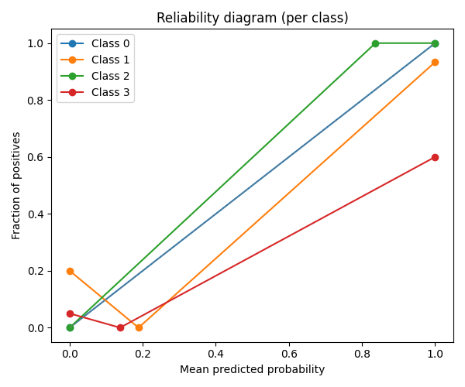

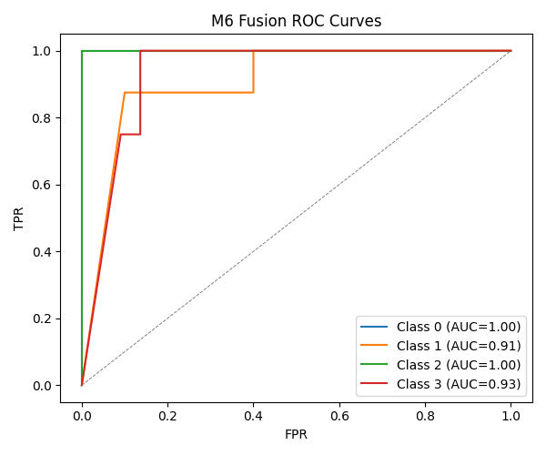

🎯 M7 Goals
M7. XAI—saliency & attention (Grad-CAM family)
- Objective: Clinically useful heatmaps.
- Tasks: Grad-CAM/++ hooks for 2D & 3D; attention rollout; variance maps over ensemble.
- I/O: In: trained models; Out: heatmaps per slice/volume + attention indices.
- Skills: Backprop hooks.
- AC: Sanity-check pass (Adebayo randomization); visual panel with fixed colorbar.
M7 Outputs (Final Achieved Output)
1. 2D Slice-Level Outputs
Saved inside:
outputs/m7/<dataset>/study_name/2d/
Includes:
✔ slice_xxx_cam.png
- Original CT slice with Grad-CAM overlay.
- Highlights lung regions contributing to prediction.
✔ slice_xxx_cam.npy
- Raw CAM heatmap (normalized 0–1).
- Useful for further quantitative analysis.
✔ Up to Top-K slices
- Default top-k = 5 slices based on evenly sampled slice positions.
2. 3D Volume-Level Outputs
Saved inside:
outputs/m7/<dataset>/study_name/3d/
Includes:
✔ cam_volume.npy
- Full 3D Grad-CAM activation map (D × H × W).
- Represents importance scores for every voxel.
✔ cam_volume_mip.png
- Maximum Intensity Projection of the 3D CAM.
- Shows strongest activation collapsed into a single 2D composite view.
✔ slice_xxx_cam.png
- Top-k high-activation slices from 3D CAM.
- Overlaid CAM on the original lung slice.
✔ slice_xxx_cam.npy
- Raw CAM for the specific slice.
3. Study-Level Manifest Files
✔ manifest.json (per study)
Contains 2D + 3D results:
{
"study": "test_CAP_cap006",
"2d": [...],
"3d": {
"cam_volume_npy": "path",
"mip_png": "path",
"per_slice": [...]
}
}
✔ manifest_all.json
Saved at:
outputs/m7/<dataset>/manifest_all.json
Aggregates ALL studies processed in the run.

4. Visual Explainability Samples
You produced high-quality CAM maps showing:
- lung consolidation emphasis
- lesion-focused activations
- regions of interest (ROI) related to classification decision
These show that both the 2D ResNet50 slice model and 3D ResNet3D are working correctly.
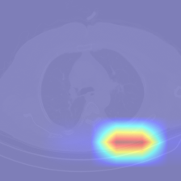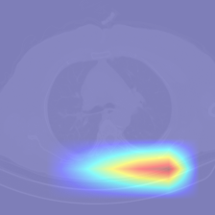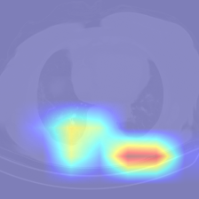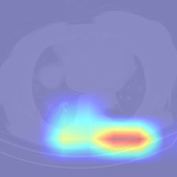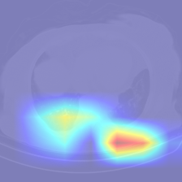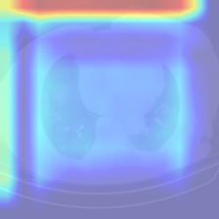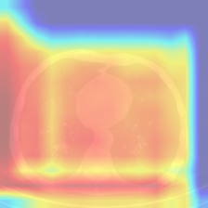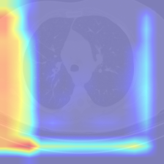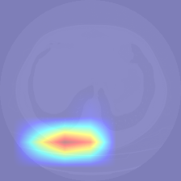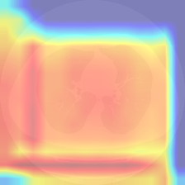

python .\run_m8_pipeline.py

🚀 Starting M8 Pipeline using config: config\m8_config.yaml

=======================================================
>>> Running: D:\xai-ct-project - Copy\venv\Scripts\python.exe shap/m8_prepare_background.py --embeddings outputs/m6/fused_embeddings.npy --manifest outputs/m6/fused_manifest.csv --out_dir outputs/m8/shap --method stratified --n_samples 50 --seed 42
=======================================================

2025-11-20 23:06:38,260 - INFO - m8_prepare_background started. Project brief: /mnt/data/Problem.docx
2025-11-20 23:06:38,261 - INFO - Loading embeddings from outputs\m6\fused_embeddings.npy
2025-11-20 23:06:38,261 - INFO - Embeddings shape: (172, 518)
2025-11-20 23:06:38,262 - INFO - Loading manifest from outputs\m6\fused_manifest.csv
2025-11-20 23:06:38,264 - INFO - Sampling method: stratified (label_col=label)
2025-11-20 23:06:38,270 - INFO - Saved background_samples.npy ((44, 518)), background_indices.json, background_metadata.csv in outputs\m8\shap
2025-11-20 23:06:38,271 - INFO - Done.

✔ DONE: D:\xai-ct-project - Copy\venv\Scripts\python.exe shap/m8_prepare_background.py --embeddings outputs/m6/fused_embeddings.npy --manifest outputs/m6/fused_manifest.csv --out_dir outputs/m8/shap --method stratified --n_samples 50 --seed 42

=======================================================
>>> Running: D:\xai-ct-project - Copy\venv\Scripts\python.exe shap/m8_compute_shap.py --embeddings outputs/m6/fused_embeddings.npy --manifest outputs/m6/fused_manifest.csv --model outputs/m6/fusion_head.joblib --background outputs/m8/shap/background_samples.npy --out_dir outputs/m8/shap --method auto --nsamples 200 --subset 128
=======================================================

2025-11-20 23:06:40,832 - INFO - m8_compute_shap started. Project brief: /mnt/data/Problem.docx
2025-11-20 23:06:40,832 - INFO - Loading embeddings from outputs\m6\fused_embeddings.npy
2025-11-20 23:06:40,834 - INFO - Loading manifest from outputs\m6\fused_manifest.csv
2025-11-20 23:06:40,836 - INFO - Loading fusion head model from outputs\m6\fusion_head.joblib
2025-11-20 23:06:40,837 - INFO - Loaded model type: <class 'sklearn.pipeline.Pipeline'>
2025-11-20 23:06:40,838 - INFO - Using subset: first 128 samples for SHAP computation
2025-11-20 23:06:40,839 - INFO - Chosen explainer method: kernel
2025-11-20 23:06:40,841 - INFO - Building surrogate RandomForestRegressor to approximate model outputs (stable TreeSHAP path).
2025-11-20 23:06:40,842 - INFO - Surrogate training samples: 172 (background 44 + from-X 128)
2025-11-20 23:06:40,844 - INFO - Surrogate target: multiclass detected, using class index 1 probability as target (change if needed).
2025-11-20 23:06:42,098 - INFO - Trained RandomForest surrogate (n_estimators=200, max_depth=8).
2025-11-20 23:06:42,098 - INFO - Running shap.TreeExplainer on surrogate.
2025-11-20 23:06:42,272 - INFO - Saving raw shap_values to outputs\m8\shap\shap_values.npy
2025-11-20 23:06:42,278 - INFO - Aggregating mean absolute SHAP values
2025-11-20 23:06:42,283 - INFO - Saved shap_summary.csv (top feature: f2)
2025-11-20 23:06:42,284 - INFO - Generating SHAP plots (bar + beeswarm)
2025-11-20 23:06:42,868 - WARNING - shap.plots.beeswarm failed: The truth value of an array with more than one element is ambiguous. Use a.any() or a.all() - skipping beeswarm
2025-11-20 23:06:42,868 - INFO - Saved SHAP outputs to outputs\m8\shap
2025-11-20 23:06:42,869 - INFO - SHAP computation finished. Outputs in outputs\m8\shap

✔ DONE: D:\xai-ct-project - Copy\venv\Scripts\python.exe shap/m8_compute_shap.py --embeddings outputs/m6/fused_embeddings.npy --manifest outputs/m6/fused_manifest.csv --model outputs/m6/fusion_head.joblib --background outputs/m8/shap/background_samples.npy --out_dir outputs/m8/shap --method auto --nsamples 200 --subset 128

=======================================================
>>> Running: D:\xai-ct-project - Copy\venv\Scripts\python.exe shap/m8_prototype_extractor.py --embeddings outputs/m6/fused_embeddings.npy --manifest outputs/m6/fused_manifest.csv --out_dir outputs/m8/prototypes --per_class 5 --method kmeans --seed 42
=======================================================

2025-11-20 23:06:45,162 - INFO - === M8 Prototype Extractor Started ===
2025-11-20 23:06:45,162 - INFO - Reading embeddings & manifest
2025-11-20 23:06:45,165 - INFO - Found classes: [0, 1, 2, 3]
2025-11-20 23:06:45,165 - INFO - Processing class: 0
2025-11-20 23:06:45,165 - INFO - Running KMeans for class with 6 samples, clusters=5
D:\xai-ct-project - Copy\venv\Lib\site-packages\joblib\externals\loky\backend\context.py:136: UserWarning: Could not find the number of physical cores for the following reason:
[WinError 2] The system cannot find the file specified
Returning the number of logical cores instead. You can silence this warning by setting LOKY_MAX_CPU_COUNT to the number of cores you want to use.
warnings.warn(
File "D:\xai-ct-project - Copy\venv\Lib\site-packages\joblib\externals\loky\backend\context.py", line 257, in _count_physical_cores
cpu_info = subprocess.run(
^^^^^^^^^^^^^^^
File "C:\Users\Jajula Pushyami Sai\AppData\Local\Programs\Python\Python311\Lib\subprocess.py", line 546, in run
with Popen(*popenargs, **kwargs) as process:
^^^^^^^^^^^^^^^^^^^^^^^^^^^
File "C:\Users\Jajula Pushyami Sai\AppData\Local\Programs\Python\Python311\Lib\subprocess.py", line 1022, in __init__
self._execute_child(args, executable, preexec_fn, close_fds,
File "C:\Users\Jajula Pushyami Sai\AppData\Local\Programs\Python\Python311\Lib\subprocess.py", line 1491, in _execute_child
hp, ht, pid, tid = _winapi.CreateProcess(executable, args,
^^^^^^^^^^^^^^^^^^^^^^^^^^^^^^^^^^^^^^^
2025-11-20 23:06:45,268 - INFO - Processing class: 1
2025-11-20 23:06:45,268 - INFO - Running KMeans for class with 108 samples, clusters=5
2025-11-20 23:06:45,318 - INFO - Processing class: 2
2025-11-20 23:06:45,319 - INFO - Running KMeans for class with 30 samples, clusters=5
2025-11-20 23:06:45,358 - INFO - Processing class: 3
2025-11-20 23:06:45,358 - INFO - Running KMeans for class with 28 samples, clusters=5
2025-11-20 23:06:45,398 - INFO - Generated 20 prototypes total.
2025-11-20 23:06:45,401 - INFO - Saved prototypes at outputs\m8\prototypes
2025-11-20 23:06:45,401 - INFO - Done.

✔ DONE: D:\xai-ct-project - Copy\venv\Scripts\python.exe shap/m8_prototype_extractor.py --embeddings outputs/m6/fused_embeddings.npy --manifest outputs/m6/fused_manifest.csv --out_dir outputs/m8/prototypes --per_class 5 --method kmeans --seed 42

=======================================================
>>> Running: D:\xai-ct-project - Copy\venv\Scripts\python.exe shap/m8_prototype_tiles.py --prototypes outputs/m8/prototypes/prototype_vectors.npy --metadata outputs/m8/prototypes/prototype_metadata.json --embeddings outputs/m6/fused_embeddings.npy --manifest outputs/m6/results/fused_manifest_enhanced.csv --img_root outputs/m7/ct3d_dataset/attention_heatmaps --cam_root outputs/m7/ct3d_dataset/attention_heatmaps --out_dir outputs/m8/prototypes/prototype_tiles --k_nearest 3
=======================================================

2025-11-20 23:06:46,297 - INFO - === M8 Prototype Tile Generator Started ===
2025-11-20 23:06:46,304 - WARNING - Manifest missing slice_path/cam_path – auto-generating from cam_pngs
2025-11-20 23:06:46,320 - INFO - Auto-filled slice_path and cam_path.
2025-11-20 23:06:46,321 - INFO - Total prototypes: 20
2025-11-20 23:06:46,321 - INFO - Embeddings shape: (172, 518)
2025-11-20 23:06:46,321 - INFO - Processing prototype 0...
2025-11-20 23:06:46,342 - INFO - Saved tile: outputs\m8\prototypes\prototype_tiles\proto_0_neighbor_0.png
2025-11-20 23:06:46,358 - INFO - Saved tile: outputs\m8\prototypes\prototype_tiles\proto_0_neighbor_1.png
2025-11-20 23:06:46,371 - INFO - Saved tile: outputs\m8\prototypes\prototype_tiles\proto_0_neighbor_2.png
2025-11-20 23:06:46,371 - INFO - Processing prototype 1...
2025-11-20 23:06:46,386 - INFO - Saved tile: outputs\m8\prototypes\prototype_tiles\proto_1_neighbor_0.png
2025-11-20 23:06:46,398 - INFO - Saved tile: outputs\m8\prototypes\prototype_tiles\proto_1_neighbor_1.png
2025-11-20 23:06:46,408 - INFO - Saved tile: outputs\m8\prototypes\prototype_tiles\proto_1_neighbor_2.png
2025-11-20 23:06:46,409 - INFO - Processing prototype 2...
2025-11-20 23:06:46,420 - INFO - Saved tile: outputs\m8\prototypes\prototype_tiles\proto_2_neighbor_0.png
2025-11-20 23:06:46,434 - INFO - Saved tile: outputs\m8\prototypes\prototype_tiles\proto_2_neighbor_1.png
2025-11-20 23:06:46,444 - INFO - Saved tile: outputs\m8\prototypes\prototype_tiles\proto_2_neighbor_2.png
2025-11-20 23:06:46,444 - INFO - Processing prototype 3...
2025-11-20 23:06:46,455 - INFO - Saved tile: outputs\m8\prototypes\prototype_tiles\proto_3_neighbor_0.png
2025-11-20 23:06:46,465 - INFO - Saved tile: outputs\m8\prototypes\prototype_tiles\proto_3_neighbor_1.png
2025-11-20 23:06:46,475 - INFO - Saved tile: outputs\m8\prototypes\prototype_tiles\proto_3_neighbor_2.png
2025-11-20 23:06:46,475 - INFO - Processing prototype 4...
2025-11-20 23:06:46,486 - INFO - Saved tile: outputs\m8\prototypes\prototype_tiles\proto_4_neighbor_0.png
2025-11-20 23:06:46,495 - INFO - Saved tile: outputs\m8\prototypes\prototype_tiles\proto_4_neighbor_1.png
2025-11-20 23:06:46,506 - INFO - Saved tile: outputs\m8\prototypes\prototype_tiles\proto_4_neighbor_2.png
2025-11-20 23:06:46,506 - INFO - Processing prototype 5...
2025-11-20 23:06:46,520 - INFO - Saved tile: outputs\m8\prototypes\prototype_tiles\proto_5_neighbor_0.png
2025-11-20 23:06:46,531 - INFO - Saved tile: outputs\m8\prototypes\prototype_tiles\proto_5_neighbor_1.png
2025-11-20 23:06:46,543 - INFO - Saved tile: outputs\m8\prototypes\prototype_tiles\proto_5_neighbor_2.png
2025-11-20 23:06:46,543 - INFO - Processing prototype 6...
2025-11-20 23:06:46,555 - INFO - Saved tile: outputs\m8\prototypes\prototype_tiles\proto_6_neighbor_0.png
2025-11-20 23:06:46,569 - INFO - Saved tile: outputs\m8\prototypes\prototype_tiles\proto_6_neighbor_1.png
2025-11-20 23:06:46,580 - INFO - Saved tile: outputs\m8\prototypes\prototype_tiles\proto_6_neighbor_2.png
2025-11-20 23:06:46,580 - INFO - Processing prototype 7...
2025-11-20 23:06:46,593 - INFO - Saved tile: outputs\m8\prototypes\prototype_tiles\proto_7_neighbor_0.png
2025-11-20 23:06:46,605 - INFO - Saved tile: outputs\m8\prototypes\prototype_tiles\proto_7_neighbor_1.png
2025-11-20 23:06:46,614 - INFO - Saved tile: outputs\m8\prototypes\prototype_tiles\proto_7_neighbor_2.png
2025-11-20 23:06:46,614 - INFO - Processing prototype 8...
2025-11-20 23:06:46,625 - INFO - Saved tile: outputs\m8\prototypes\prototype_tiles\proto_8_neighbor_0.png
2025-11-20 23:06:46,636 - INFO - Saved tile: outputs\m8\prototypes\prototype_tiles\proto_8_neighbor_1.png
2025-11-20 23:06:46,645 - INFO - Saved tile: outputs\m8\prototypes\prototype_tiles\proto_8_neighbor_2.png
2025-11-20 23:06:46,645 - INFO - Processing prototype 9...
2025-11-20 23:06:46,656 - INFO - Saved tile: outputs\m8\prototypes\prototype_tiles\proto_9_neighbor_0.png
2025-11-20 23:06:46,668 - INFO - Saved tile: outputs\m8\prototypes\prototype_tiles\proto_9_neighbor_1.png
2025-11-20 23:06:46,680 - INFO - Saved tile: outputs\m8\prototypes\prototype_tiles\proto_9_neighbor_2.png
2025-11-20 23:06:46,680 - INFO - Processing prototype 10...
2025-11-20 23:06:46,690 - INFO - Saved tile: outputs\m8\prototypes\prototype_tiles\proto_10_neighbor_0.png
2025-11-20 23:06:46,698 - INFO - Saved tile: outputs\m8\prototypes\prototype_tiles\proto_10_neighbor_1.png
2025-11-20 23:06:46,710 - INFO - Saved tile: outputs\m8\prototypes\prototype_tiles\proto_10_neighbor_2.png
2025-11-20 23:06:46,710 - INFO - Processing prototype 11...
2025-11-20 23:06:46,720 - INFO - Saved tile: outputs\m8\prototypes\prototype_tiles\proto_11_neighbor_0.png
2025-11-20 23:06:46,731 - INFO - Saved tile: outputs\m8\prototypes\prototype_tiles\proto_11_neighbor_1.png
2025-11-20 23:06:46,746 - INFO - Saved tile: outputs\m8\prototypes\prototype_tiles\proto_11_neighbor_2.png
2025-11-20 23:06:46,746 - INFO - Processing prototype 12...
2025-11-20 23:06:46,758 - INFO - Saved tile: outputs\m8\prototypes\prototype_tiles\proto_12_neighbor_0.png
2025-11-20 23:06:46,767 - INFO - Saved tile: outputs\m8\prototypes\prototype_tiles\proto_12_neighbor_1.png
2025-11-20 23:06:46,777 - INFO - Saved tile: outputs\m8\prototypes\prototype_tiles\proto_12_neighbor_2.png
2025-11-20 23:06:46,777 - INFO - Processing prototype 13...
2025-11-20 23:06:46,788 - INFO - Saved tile: outputs\m8\prototypes\prototype_tiles\proto_13_neighbor_0.png
2025-11-20 23:06:46,804 - INFO - Saved tile: outputs\m8\prototypes\prototype_tiles\proto_13_neighbor_1.png
2025-11-20 23:06:46,813 - INFO - Saved tile: outputs\m8\prototypes\prototype_tiles\proto_13_neighbor_2.png
2025-11-20 23:06:46,814 - INFO - Processing prototype 14...
2025-11-20 23:06:46,825 - INFO - Saved tile: outputs\m8\prototypes\prototype_tiles\proto_14_neighbor_0.png
2025-11-20 23:06:46,833 - INFO - Saved tile: outputs\m8\prototypes\prototype_tiles\proto_14_neighbor_1.png
2025-11-20 23:06:46,842 - INFO - Saved tile: outputs\m8\prototypes\prototype_tiles\proto_14_neighbor_2.png
2025-11-20 23:06:46,842 - INFO - Processing prototype 15...
2025-11-20 23:06:46,853 - INFO - Saved tile: outputs\m8\prototypes\prototype_tiles\proto_15_neighbor_0.png
2025-11-20 23:06:46,863 - INFO - Saved tile: outputs\m8\prototypes\prototype_tiles\proto_15_neighbor_1.png
2025-11-20 23:06:46,874 - INFO - Saved tile: outputs\m8\prototypes\prototype_tiles\proto_15_neighbor_2.png
2025-11-20 23:06:46,874 - INFO - Processing prototype 16...
2025-11-20 23:06:46,885 - INFO - Saved tile: outputs\m8\prototypes\prototype_tiles\proto_16_neighbor_0.png
2025-11-20 23:06:46,896 - INFO - Saved tile: outputs\m8\prototypes\prototype_tiles\proto_16_neighbor_1.png
2025-11-20 23:06:46,905 - INFO - Saved tile: outputs\m8\prototypes\prototype_tiles\proto_16_neighbor_2.png
2025-11-20 23:06:46,906 - INFO - Processing prototype 17...
2025-11-20 23:06:46,914 - INFO - Saved tile: outputs\m8\prototypes\prototype_tiles\proto_17_neighbor_0.png
2025-11-20 23:06:46,922 - INFO - Saved tile: outputs\m8\prototypes\prototype_tiles\proto_17_neighbor_1.png
2025-11-20 23:06:46,929 - INFO - Saved tile: outputs\m8\prototypes\prototype_tiles\proto_17_neighbor_2.png
2025-11-20 23:06:46,929 - INFO - Processing prototype 18...
2025-11-20 23:06:46,942 - INFO - Saved tile: outputs\m8\prototypes\prototype_tiles\proto_18_neighbor_0.png
2025-11-20 23:06:46,951 - INFO - Saved tile: outputs\m8\prototypes\prototype_tiles\proto_18_neighbor_1.png
2025-11-20 23:06:46,962 - INFO - Saved tile: outputs\m8\prototypes\prototype_tiles\proto_18_neighbor_2.png
2025-11-20 23:06:46,963 - INFO - Processing prototype 19...
2025-11-20 23:06:46,975 - INFO - Saved tile: outputs\m8\prototypes\prototype_tiles\proto_19_neighbor_0.png
2025-11-20 23:06:46,985 - INFO - Saved tile: outputs\m8\prototypes\prototype_tiles\proto_19_neighbor_1.png
2025-11-20 23:06:46,996 - INFO - Saved tile: outputs\m8\prototypes\prototype_tiles\proto_19_neighbor_2.png
2025-11-20 23:06:46,996 - INFO - All prototype tiles saved. Done.

✔ DONE: D:\xai-ct-project - Copy\venv\Scripts\python.exe shap/m8_prototype_tiles.py --prototypes outputs/m8/prototypes/prototype_vectors.npy --metadata outputs/m8/prototypes/prototype_metadata.json --embeddings outputs/m6/fused_embeddings.npy --manifest outputs/m6/results/fused_manifest_enhanced.csv --img_root outputs/m7/ct3d_dataset/attention_heatmaps --cam_root outputs/m7/ct3d_dataset/attention_heatmaps --out_dir outputs/m8/prototypes/prototype_tiles --k_nearest 3

=======================================================
>>> Running: D:\xai-ct-project - Copy\venv\Scripts\python.exe shap/m8_generate_report.py --config config\m8_config.yaml
=======================================================

2025-11-20 23:06:47,837 - WARNING - Expected asset 'shap_beeswarm' not found at outputs\m8\shap\shap_beeswarm.png
2025-11-20 23:06:47,838 - INFO - Creating report at outputs\m8\m8_report.pdf
2025-11-20 23:06:49,138 - INFO - Saved report: outputs\m8\m8_report.pdf
2025-11-20 23:06:49,142 - INFO - m8_generate_report.py finished.

✔ DONE: D:\xai-ct-project - Copy\venv\Scripts\python.exe shap/m8_generate_report.py --config config\m8_config.yaml

🎉 M8 Pipeline Completed Successfully!
📄 Report available at: outputs/m8/m8_report.pdf
-------------------------------------------------------
(venv) PS D:\xai-ct-project - Copy>

