1. @Contactpage ===>@succesfully_creatingcontact_validation

2) @Contactpage ===>*@Invalid_firstname_validation*

3) @Contactpage===>*@Invalid_lastname_validation*

4) @Contact===>*@Invalid_firstname_lastname_validation*

5) @Contact===>*@filling_all_the_fields*

6) @Contact===>*@leaving_some_of_the_fields*

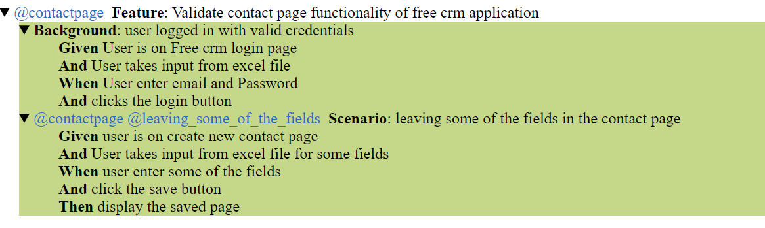

@Contact===>@Loginfullscreenshot

