**LAB EXPERIMENTS** DAY-2

**11.AIM:-**To implement UML diagrams for Conference management system..

**DESIGN:-**

1.USE CASE:

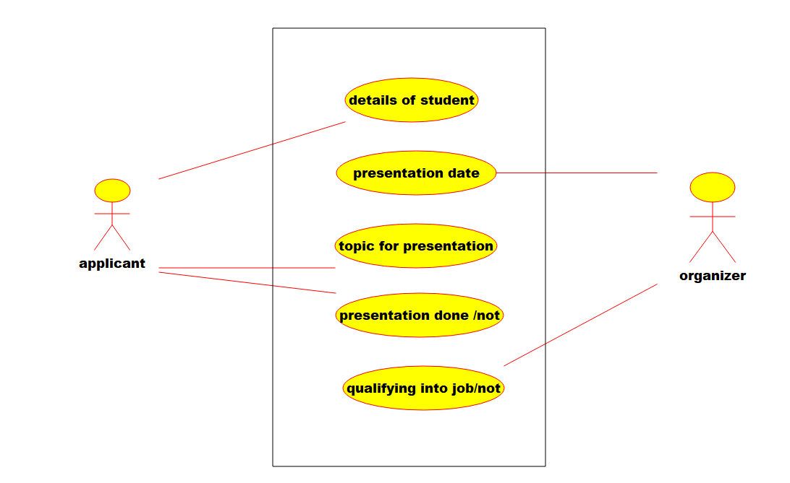

2.Deployment diagram:-

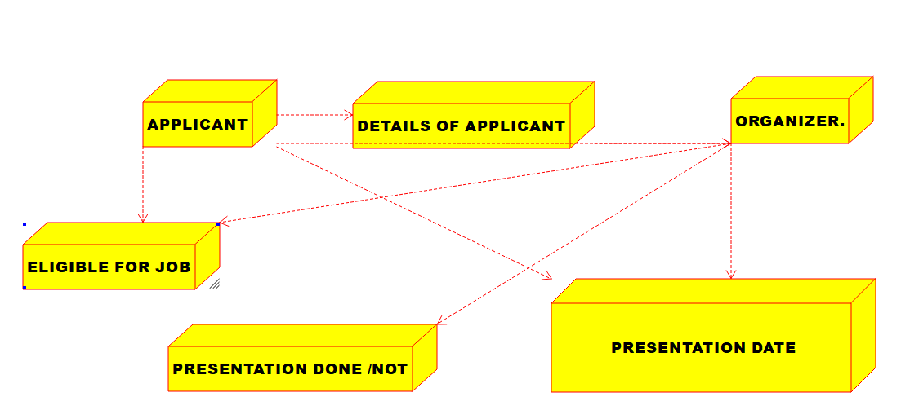

3.PACAKAGE DIAGRAM.:-

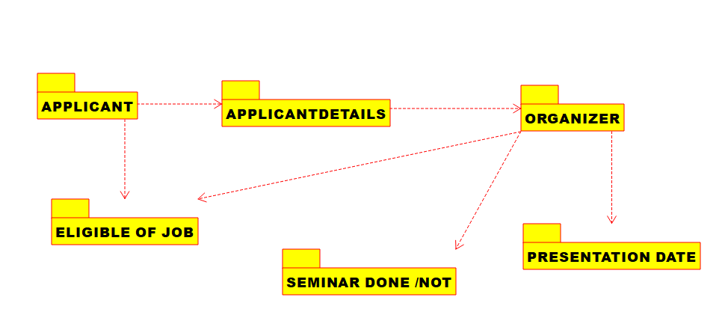

**12.AIM:-**To implement UML diagrams for Foreign Trading System..

**DESIGN:-**

1.SEQUENCE DIAGRAM:

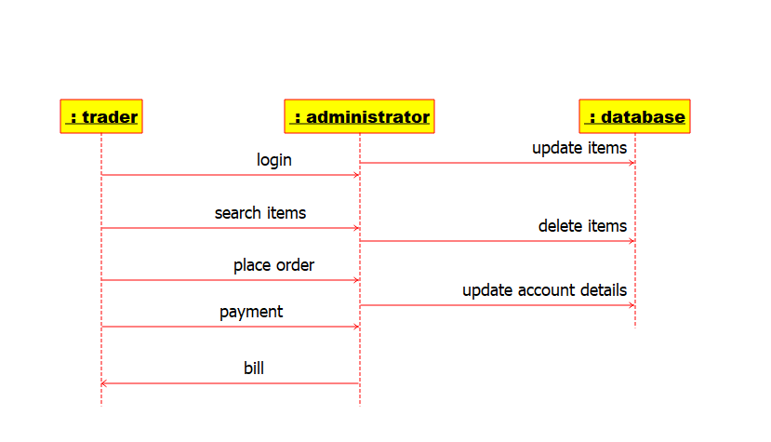

2.ACTIVITY DIAGRAM:-

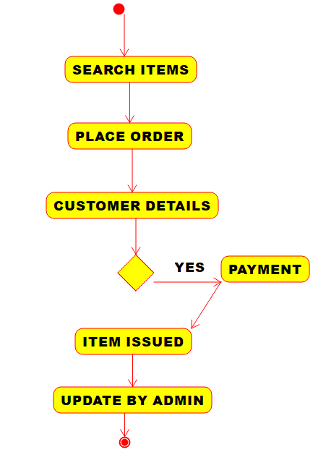

3.COMPONENT DIAGRAM:-

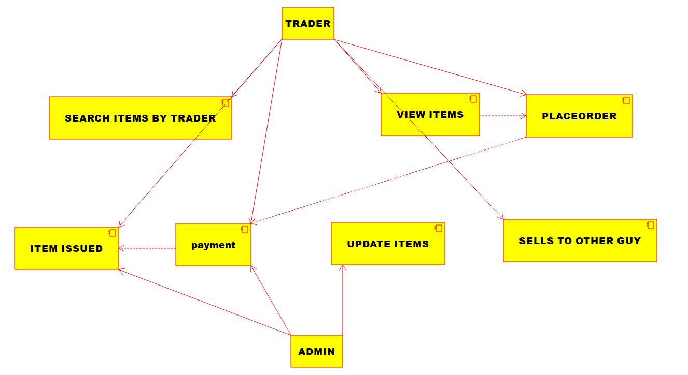

**13.AIM:-**To implement UML diagrams for BPO Management System..

**DESIGN:-**

1.ACTIVITY DIAGRAM:-

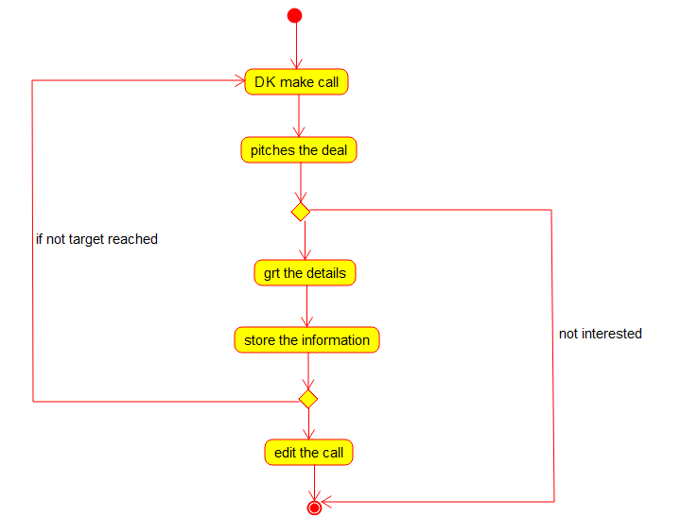

2.STATECHART DIAGRAM:-

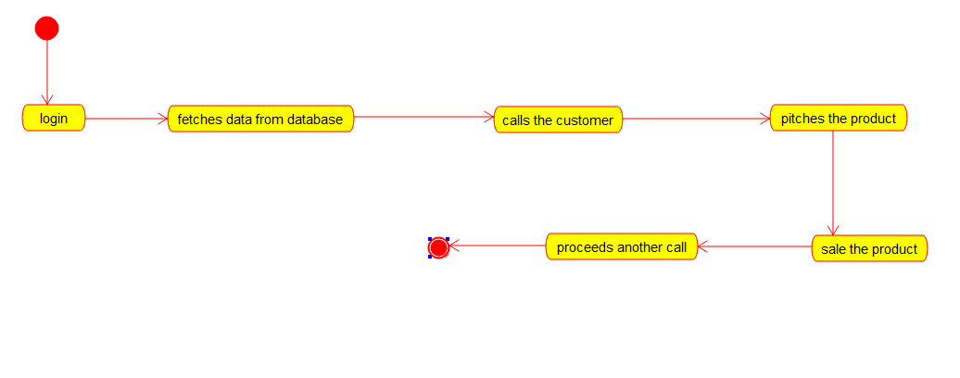

3.CLASS DIAGRAM:

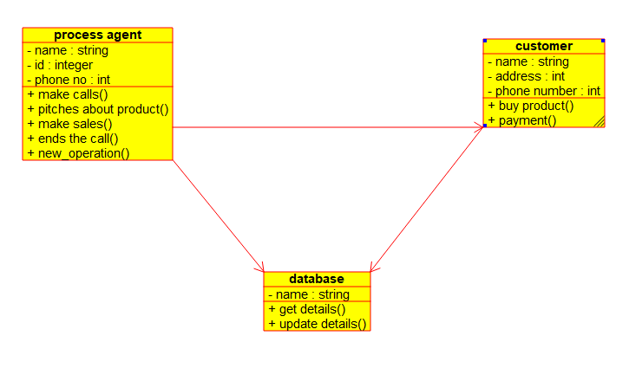

**14.AIM:-**To implement UML diagrams for E-Commerce Registration

**DESIGN:-**

1.ACTIVITY DIAGRAM:-

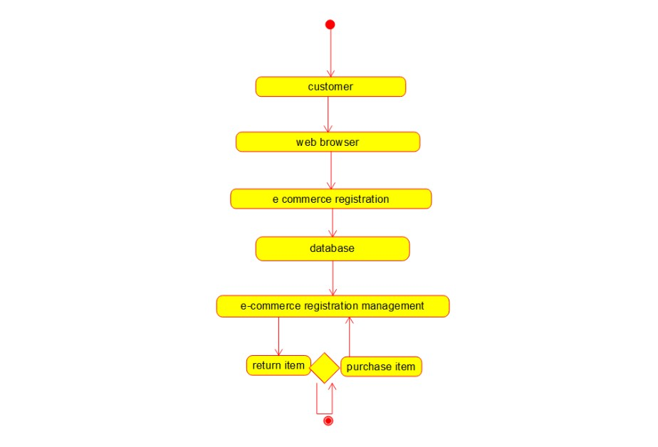

2.SEQUENCE DIAGRAM:-

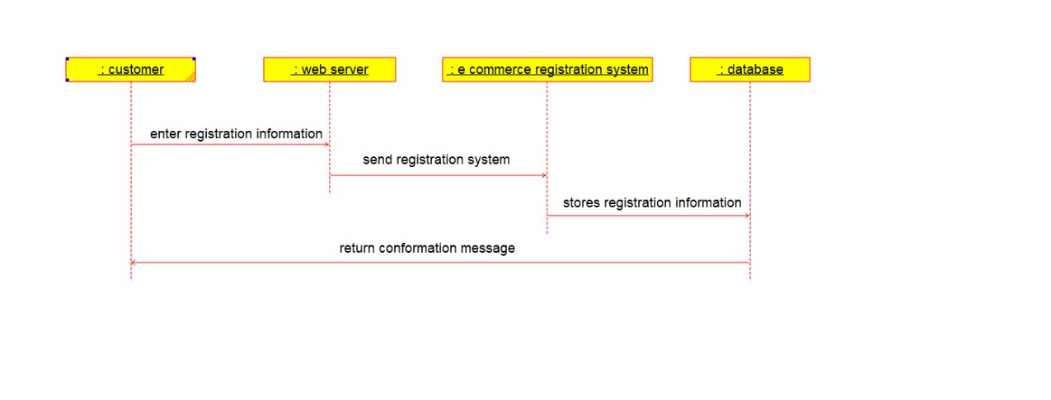

3.PACAKAGE DIAGRAM:-

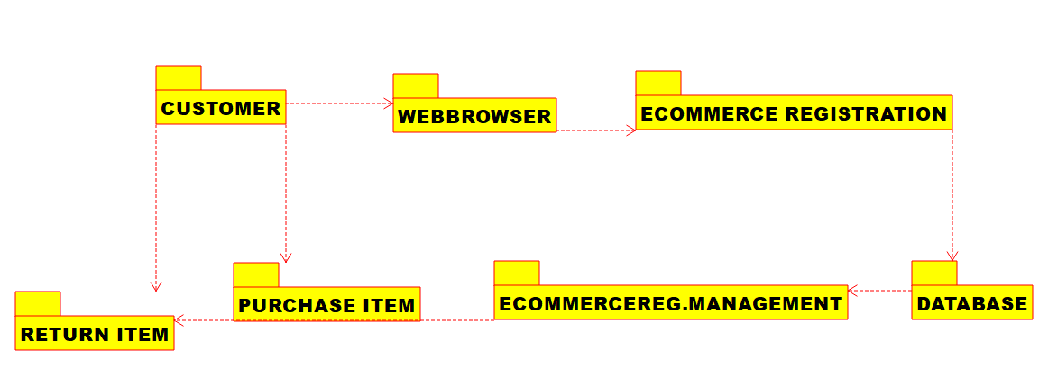

**15.AIM:-**To implement UML diagrams for Blood Bank Registration System..

**DESIGN:-**

1.USE CASE:

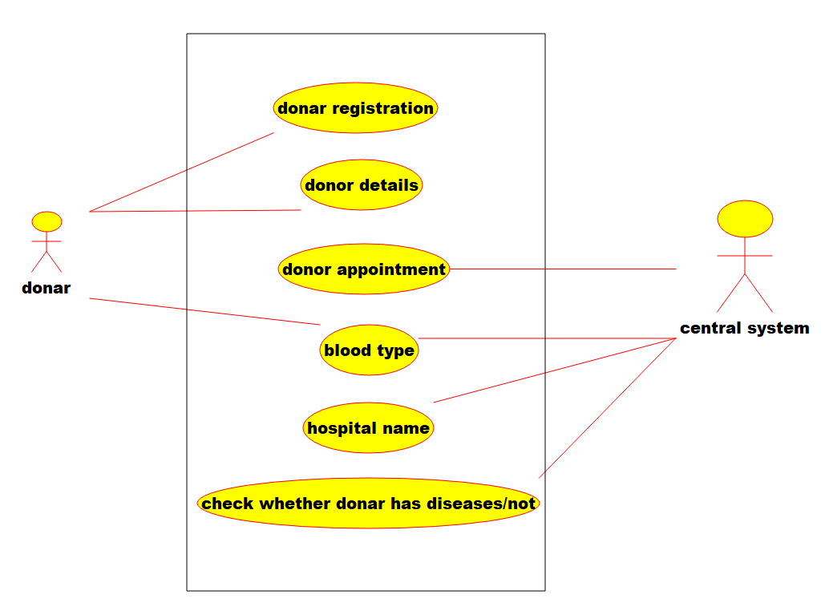

2.COLLABORATION DIAGRAM:-

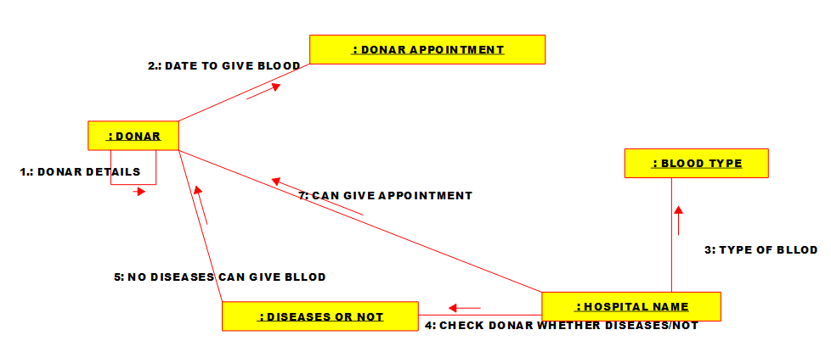

3.STATECHART DIAGRAM:-

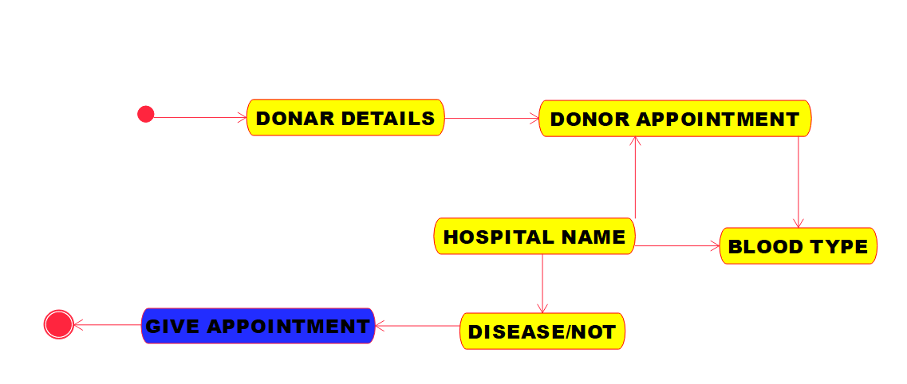

**16.AIM:-**To implement UML diagrams for Online Internship Registration System..

**DESIGN:-**

1.COMPONENT DIAGRAM:-

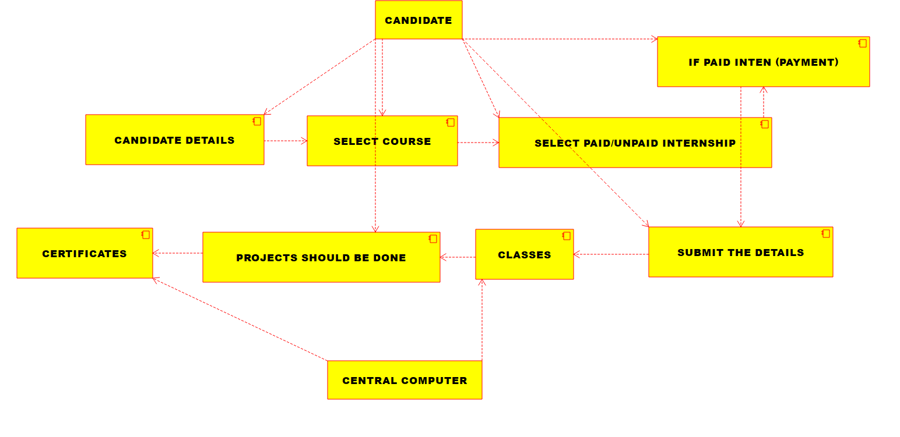

2.Deployment diagram:-

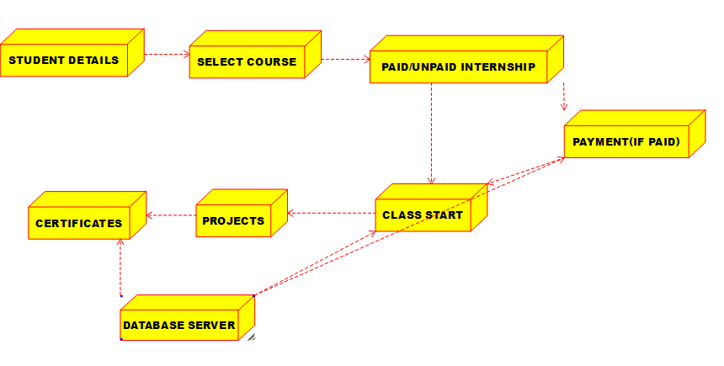

3.ACTIVITY DIAGRAM:-

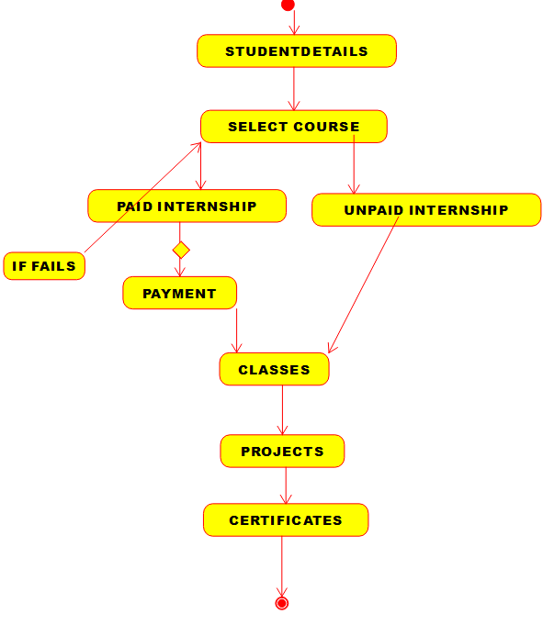

**17.AIM:-**To implement UML diagrams for Vehicle Registration Number Registering System…

**DESIGN:-**

1.SEQUENCE DIAGRAM:

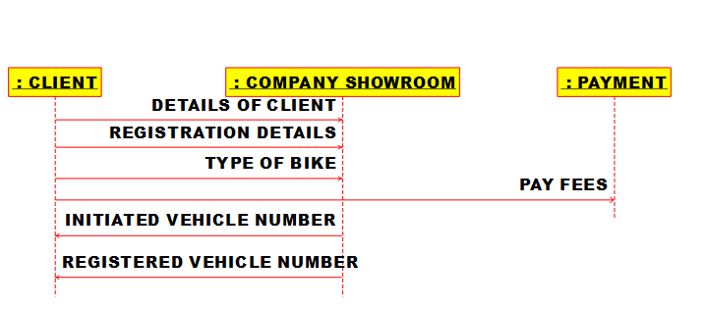

2.CLASS DIAGRAM:

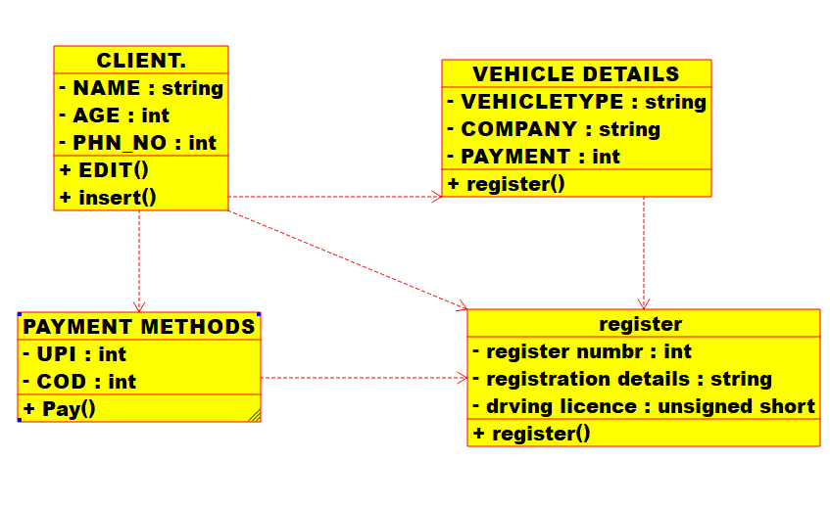

3.PACAKAGE DIAGRAM:

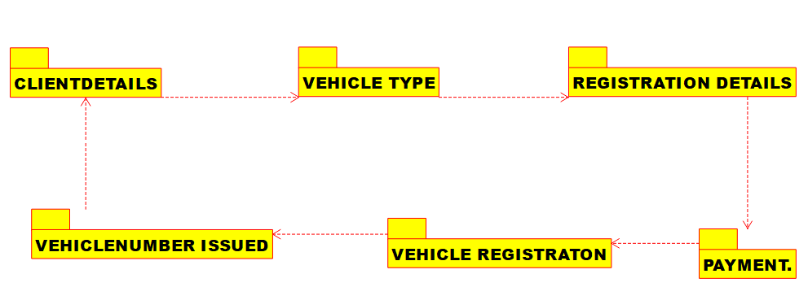

**18.AIM:-**To implement UML diagrams for FOOD ORDERING System…

**DESIGN:-**

1.USE CASE:

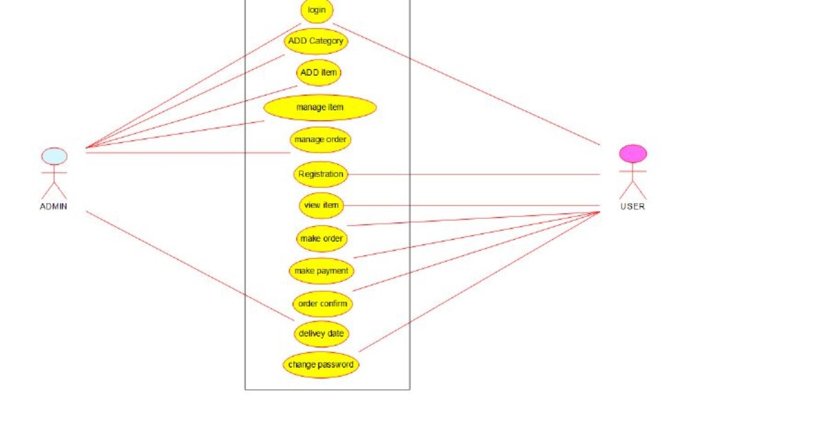

2.CLASS DIAGRAM:-

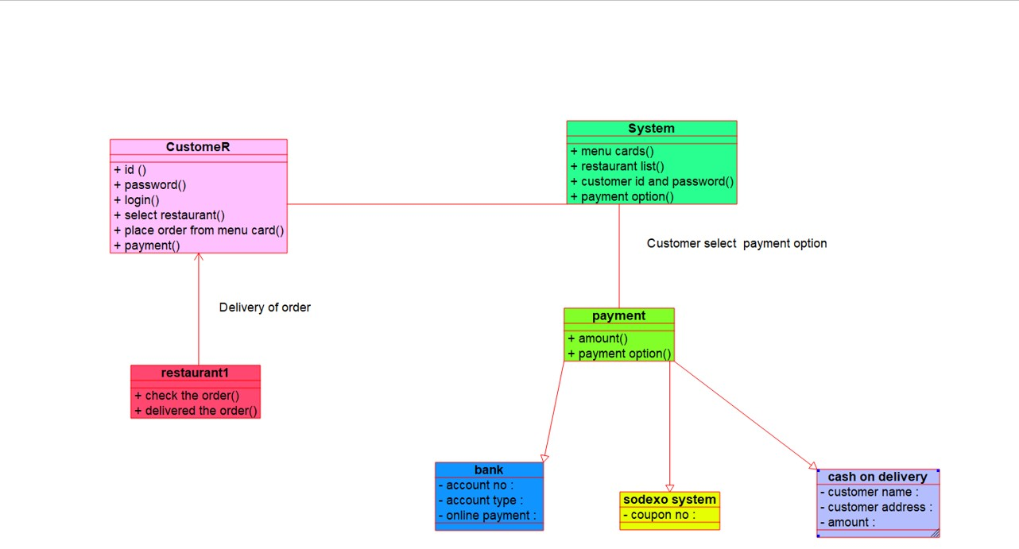

3.COLLABORATION DIAGRAM:-

