**Round 2**

**1. Story Outline**

**Configuring Operational amplifier as Summer and Subtractor**

Operational Amplifier(op-amp) is a highly functional device with interesting characteristics of High gain,Infinite bandwidth,High input impedance and low output impedance.It finds various applications.Configuring op-amp as summer and subtractor enables signals to be added and subtracted while processing them in a communication system.

**2. Story**

The story should cover some key points, they are:

* **Set the Visual Stage description**

**Experiment 2**

Signals from two or many sources could be added up or subtracted using opamp configured as summer and subtractor. The signal source will be a variable regulated power supply and measurement could be done suitably. Signal addition/deletion is a common scenario in any communication setup.

* **Set the User objectives and goals**

Model a system based on design equations and construct the same.

Measure the input and output to a system and work out a relation between the two.

Verify whether the system works as per the design.

* **Set the pathway activities**

**Experiment 2**

1. The experiment set up consists of a Variable Regulated power supply and Dual power supply as blocks.

2.Connecting wires is also included to enable connections between the equipment.

3. Dual Power supply also provided to power up the operational amplifier.

4.Circuit is constructed by picking up the values of the components from the palette and/after suitable design.

4.The front panel of the equipments are opened up. Selection keys are used to select various settings.

4 The connections are made and front panel adjustments are familiarised.

5. The power supply is adjusted suitably to provide necessary inputs.

6. The output in case of summer and subtractor are measured and displayed.

7. Observations are noted down and the output is studied.

**Set Challenges and Questions/Complexity/ Variations**

1. Differential amplifier amplifies the ___________ between two input signals

a) addition

b) **subtraction**

c) multiplication

d) division

2. The output voltage expression for inverting summing amplifier , having four internal resistors is _________ (Assume the value of all internal resistors are equal)

a) **Vo = -(Rf/R )×(Va +Vb+Vc+Vd)**

b) Vo = (RF/R)×(Va +Vb+Vc+Vd)

c) Vo = (R/ RF)×(Va +Vb+Vc+Vd)

d) None of the mentioned

3. What will happen if we have a mismatch between two input terminals in an op-amp?

a) Input offset voltage

b) **Output offset voltage**

c) Both the input and output offset voltage

d) None of the mentioned

4. Which of the following is not an Op-Amp characteristic?

a) High gain

b) **Low Gain**

c) High input impedance

d) Low output impedance

5. ________ makes the output voltage to reduce to zero.

a) **Input offset voltage**

b) Output offset voltage

c) Offset minimizing voltage

d) Error voltage

6. The output of the negative feedback Op - Amp is _________.

a) equal to the input

b) increased

c) **fed back to the inverting input**

d) fed back to the non - inverting input

7. Negative feedback ________ .

a) increases the input and output impedances

b) **increases the input impedance and bandwidth**

c) decreases the output impedance and bandwidth

d) does not affect impedance or bandwidth

8. In Op-amp , the input stage is a ______.

a) **differential amplifier**

b) class B push-pull amplifier

c) CE amplifier

d) swamped amplifier

9. __________ is not an ideal op-amp characteristics.

a) Infinite voltage gain

b) Infinite bandwidth

c) **Infinite output resistance**

d) Infinite slew rate

10. The output voltage of an op-amp is determined by _________.

a) Positive saturation

b) Negative saturation

c) **Both positive and negative saturation voltage**

d) Supply voltage

* **Allow Pitfalls : Yes**
* **Equations/ Formulas**

**Output voltage for inverting summing amplifier**

V o  = -(R f /R )×(V a  +V b +V c +V d )

where

Rf - Feedback resistance

R - Input resistance

Va,Vb,Vc,Vd –Four different inputs

**3. Flowchart**

**Experiment 2**

Observe the output so as to verify the application

Adjust suitable values of Inputs

Make connection and construct the circuit

Study Front panel details and adjustments

Select Equipments from the palette

Record the observations

**4. Mindmap**

**Experiment 2**

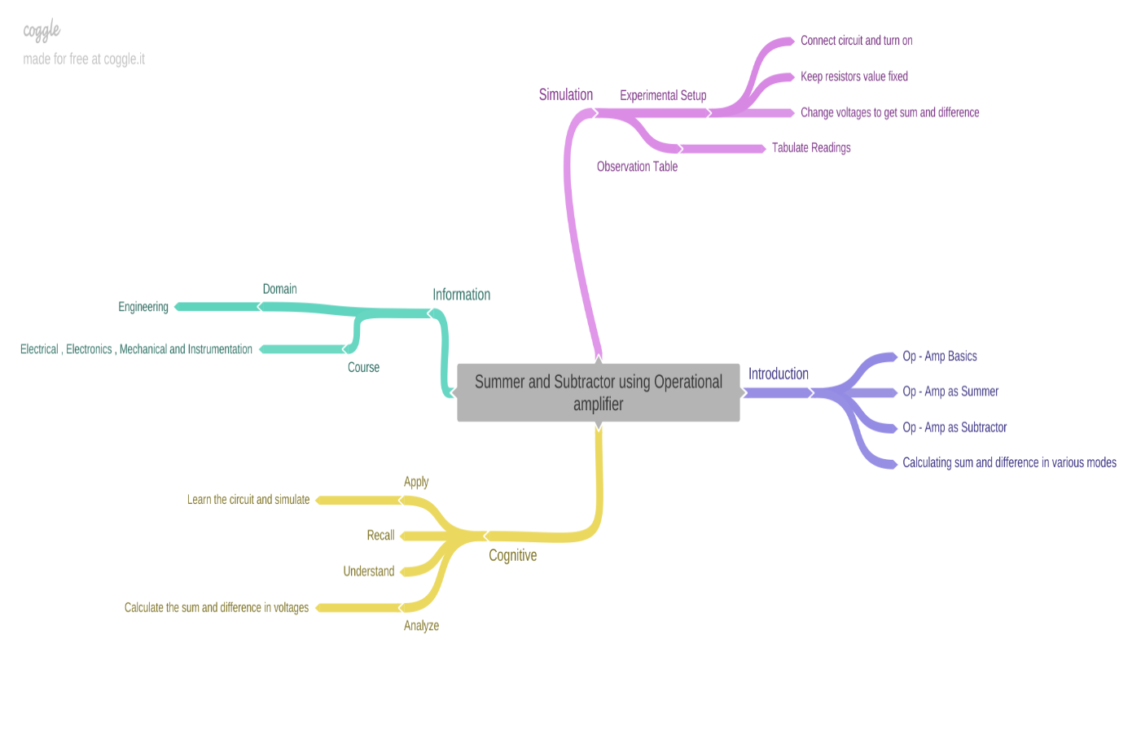

**5. StoryBoard-Experiment 2**

Construction of Summer circuit

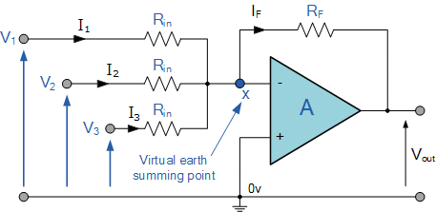

Inverting Summer

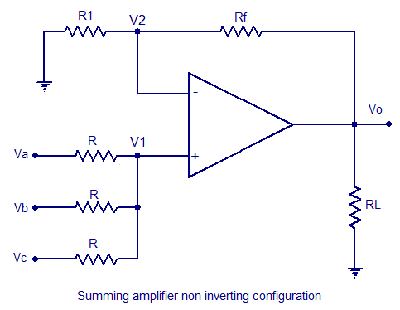

Non Inverting Summer

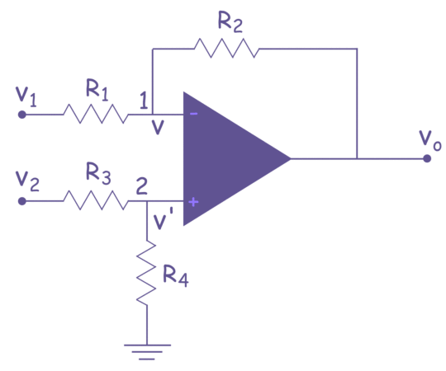

Subtractor





The resistance values could be chosen from the design suitably.

The input is set from Variable Regulated power supply.

The output is measured suitably and recorded in the tabulation.

The observations are tabulated.

* **Summer**

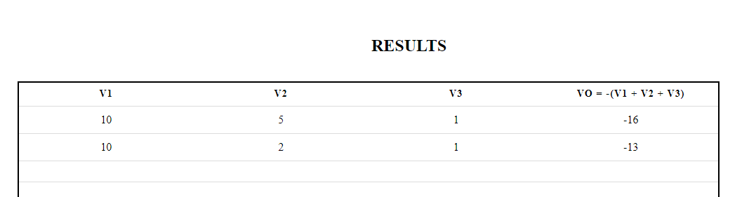

* **Subtractor**

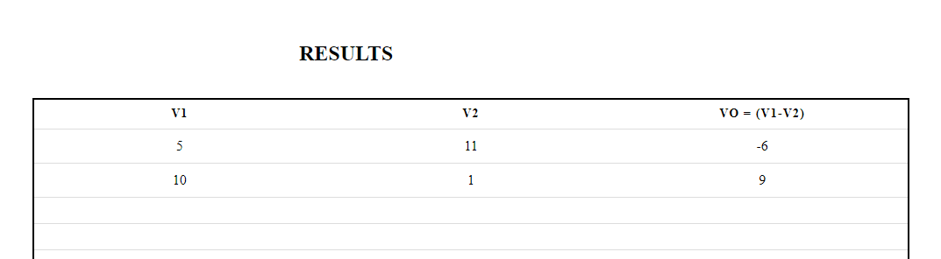

* **Conclusion**

Time required to perform the virtual experiment.

The approximate time required to understand the procedure to perform the experiment would take about 5 min.

To generate data will take another 5 min.

Calculating and entering the values of various entities in the Result table will take approximately 5 min.

Answering the assessment questions will take about 5 min. Thus, the total time required to perform the experiment will require around 20 min.