Observation Notes and Rating Summary
ENT208TC Validation Report Evidence Appendix

Project | Desktop Smart Companion Assistant (Hardware + Software)
Team | X Space | Session 2 - Group 1
Evidence reference | B2
Evidence type | Observation notes, rating summary, and cross-participant usability findings
Participants covered | P1-P5
Prototype scope | V1 usability testing with selected V2 follow-up checks
Recommended link description | Observation notes and rating summary based on P1-P5 usability testing sessions, including task completion, observed problems, severity ratings, and design implications.
How this file should be used in the evidence table
Paste the share link to this DOCX in the B2 row. Keep A1-A5 as separate detailed session records and C1 as the formal WJX survey report link. B2 is the cross-session observation/rating summary, not a raw survey export.

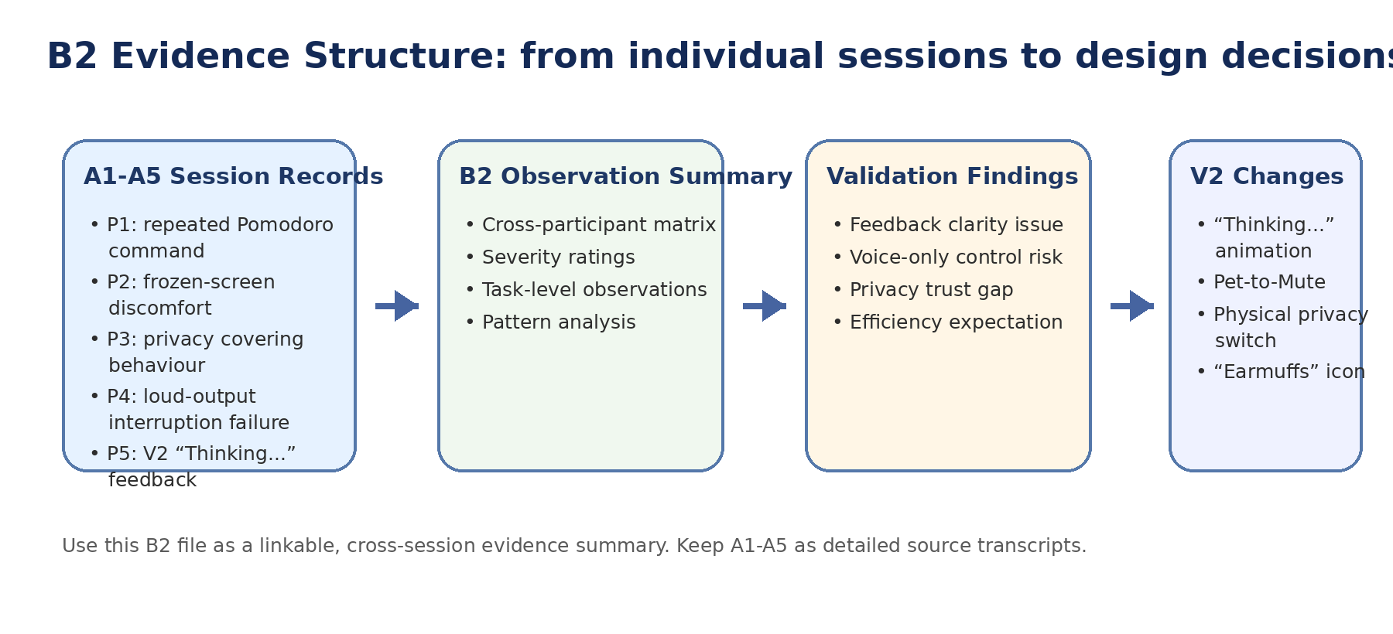
Figure 1. Evidence structure connecting individual session records, B2 summary, validation findings, and V2 design changes.

1. Evidence Purpose
This B2 evidence file summarises observation notes and rating evidence across five user-testing sessions. It is designed to support the validation report by showing patterns across participants rather than relying only on single quotes. The evidence focuses on task completion, visible feedback, repeated-command behaviour, interruption control, and privacy confidence.
Core evaluation areas:
- Productivity support: setting a 25-minute Pomodoro timer.
- Interruption control: stopping a long audio/news response.
- Privacy control: disabling or confirming microphone-off status.
- Perceived usability: whether users understood the system state without extra explanation.

2. Testing Method Summary
Item | Description
Session format | In-person usability testing
Session length | Approximately 20 minutes per participant
Participants | P1-P5, recruited from different user backgrounds
Prototype tested | V1 prototype; selected V2 follow-up checks for major design changes
Data collected | Observation notes, participant behaviour, direct quotes, task outcome, and researcher-coded severity rating
Main task areas | Pomodoro timer, interruption control, privacy control
Evaluation focus | Task completion, user confidence, feedback clarity, perceived control, and privacy trust

3. Rating Scale Used
Rating | Meaning | Evidence interpretation
Low | Minor issue; user noticed it but task was still completed smoothly. | Useful for polishing, not central to validation findings.
Medium | Noticeable issue; user hesitated, felt uncertain, or needed extra effort. | Indicates friction that may affect adoption.
High | Serious issue; user confidence was reduced or task flow was disrupted. | Requires clear V2 design response.
Critical | Task could not be completed reliably, or the user lost control of the interaction. | Must be addressed before final demonstration or deployment.

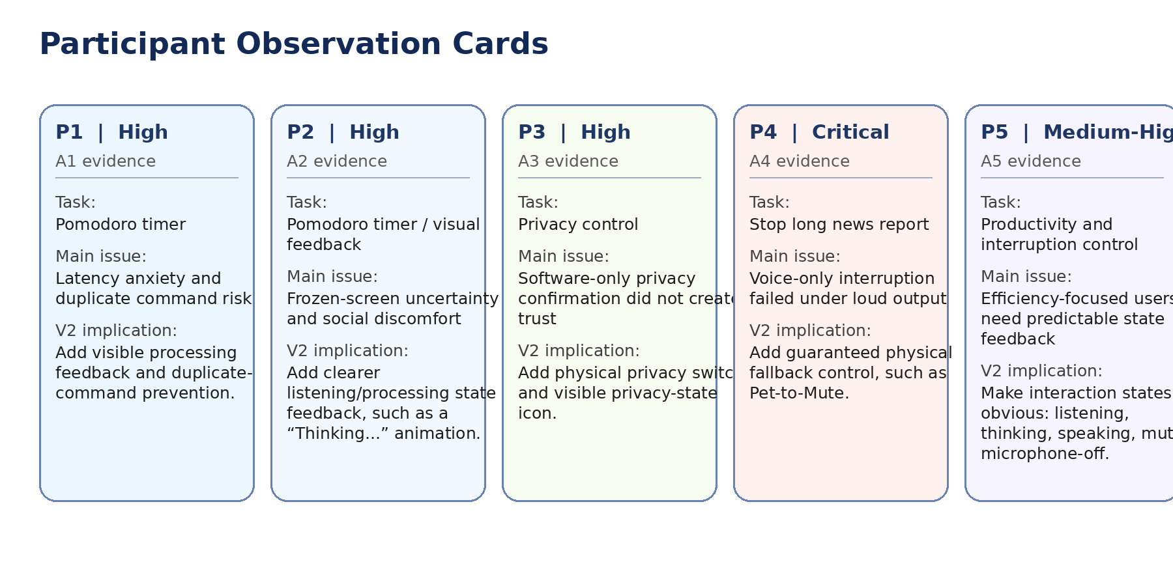
Figure 2. Participant observation cards summarising the main task, severity, issue, and V2 implication for each session.
4. Participant Observation Summary
Participant | Main task observed | Key observation | Severity | V2 design implication | Evidence ref.
P1 | Pomodoro timer | Repeated the same voice command because the screen gave no immediate processing feedback. The timer was not completed cleanly on the first attempt. | High | Add visible processing feedback and duplicate-command prevention. | A1
P2 | Pomodoro timer / visual feedback | Paused after giving the command and looked for visible confirmation. The frozen screen created uncertainty about whether the command had been received. | High | Add clearer listening/processing state feedback, such as a “Thinking...” animation. | A2
P3 | Privacy control | Received a voice confirmation that the microphone was off, but still physically covered the device with a book. | High | Add physical privacy switch and visible privacy-state icon. | A3
P4 | Stop long news report | Attempted to stop the device by voice while the news output was loud. The device did not reliably capture the stop command, so the participant used a manual workaround. | Critical | Add guaranteed physical fallback control, such as Pet-to-Mute. | A4
P5 | Productivity and interruption control | Expected quick feedback and considered visible processing feedback important for avoiding repeated commands. Also needed reliable interruption control in high-pressure work contexts. | Medium-High | Make interaction states obvious: listening, thinking, speaking, muted, microphone-off. | A5

5. Key Direct Quotes Used for Coding
Participant | Quote / follow-up comment | Coded issue | How it supports validation
P1 | “It didn’t react, so I thought it missed my command. I ended up shouting it three times, and it set three separate timers.” | Latency anxiety and duplicate command risk | Add visible processing feedback and duplicate-command prevention.
P2 | “When it doesn’t reply, I feel like a fool just staring at a frozen screen.” | Frozen-screen uncertainty and social discomfort | Add clearer listening/processing state feedback, such as a “Thinking...” animation.
P3 | “Just hearing it say ‘Closed’ isn’t enough. It’s connected to the internet; I still feel like it’s eavesdropping.” | Software-only privacy confirmation did not create trust | Add physical privacy switch and visible privacy-state icon.
P4 | “It speaks so loudly that it can’t hear me telling it to shut up. Being unable to force an interruption feels anti-human.” | Voice-only interruption failed under loud output | Add guaranteed physical fallback control, such as Pet-to-Mute.
P5 | “Now that I see it’s thinking, I don’t feel the need to repeat myself.” | Efficiency-focused users need predictable state feedback | Make interaction states obvious: listening, thinking, speaking, muted, microphone-off.

6. Visual Rating Summary
The figures below convert the observation notes into a compact evidence map. They help the marker see that the validation findings are not isolated comments, but repeated usability patterns across the sessions.
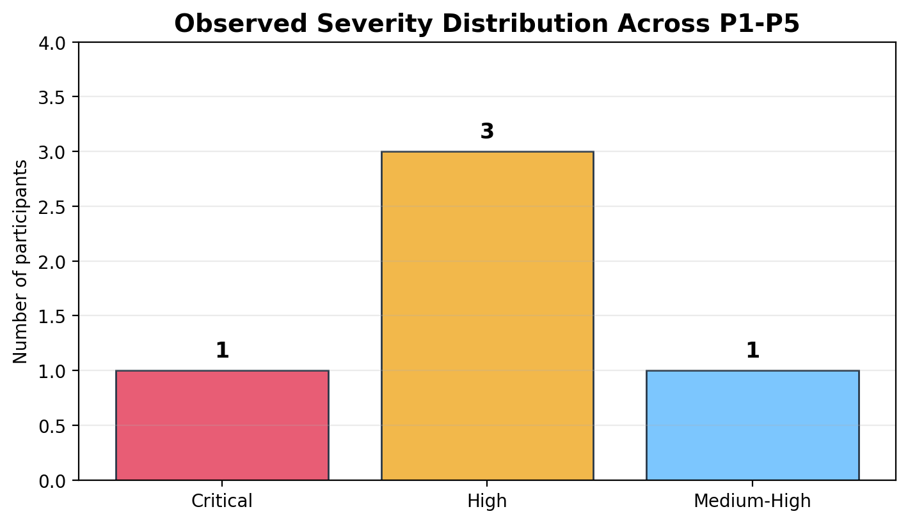
Figure 3. Distribution of coded severity levels across P1-P5.
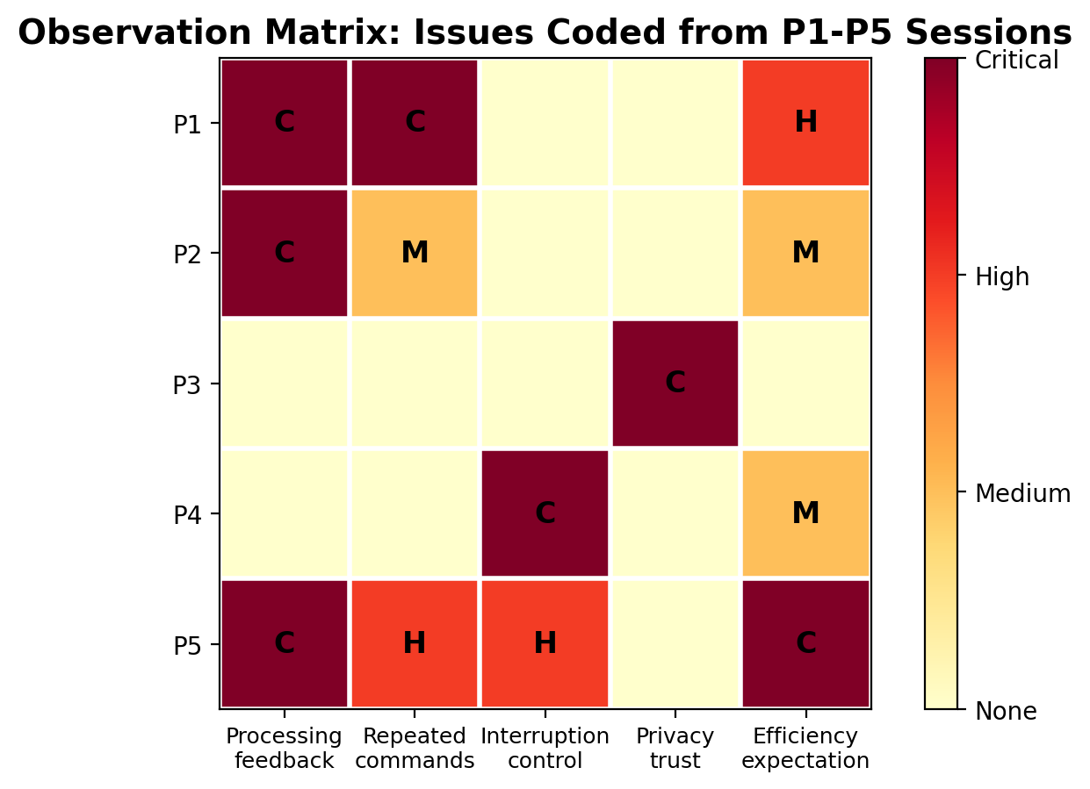
Figure 4. Observation matrix showing where usability issues appeared across participants. M = Medium, H = High, C = Critical.

7. Cross-Participant Findings
Finding 1: Users need visible processing feedback
Evidence pattern: P1, P2, and P5 all showed that a silent or frozen interface creates uncertainty. P1 repeated the Pomodoro command, P2 felt socially uncomfortable staring at a frozen screen, and P5 reported that seeing the system think reduced the need to repeat commands.
Design implication: V2 should display a clear “Thinking...” animation or equivalent state indicator while API or speech processing is happening.

Finding 2: Voice-only control is not reliable enough for interruption
Evidence pattern: P4’s session showed a critical failure case: when the assistant’s own speaker output was loud, the device could not reliably capture the stop command. P5 also valued immediate and dependable control in high-pressure work contexts.
Design implication: V2 should include a physical fallback, such as Pet-to-Mute, so users can immediately regain control without relying on speech recognition.

Finding 3: Privacy confidence requires visible and physical cues
Evidence pattern: P3 did not trust a software-only microphone-off confirmation and physically covered the device. The behaviour shows that privacy trust is psychological as well as technical.
Design implication: V2 should include a physical privacy switch and a visible “Earmuffs” icon to make the microphone state credible and easy to understand.

Finding 4: Efficiency-focused users need predictable interaction states
Evidence pattern: P1 and P5 valued fast, minimal, predictable interaction. When the system state was unclear, users either repeated commands or became less confident in the product.
Design implication: V2 should make all core states visible: listening, thinking, speaking, muted, and microphone-off.

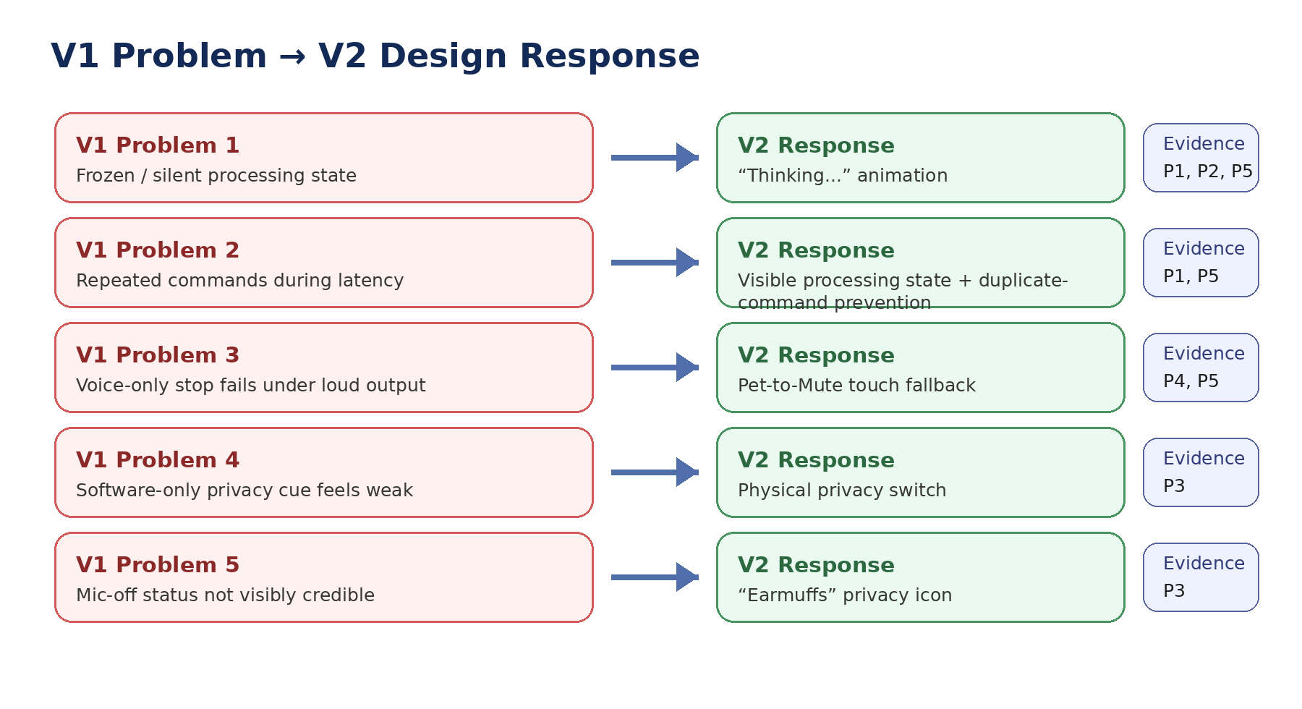
Figure 5. Visual mapping from V1 usability problems to V2 design responses.

8. V1 Problem to V2 Change Matrix
V1 problem | Evidence source | V2 design change | Expected improvement
Users thought the system was frozen or had missed the command. | P1, P2, P5 | “Thinking...” animation and clearer state feedback. | Reduce uncertainty and prevent unnecessary repeated commands.
Users repeated commands because there was no processing feedback. | P1, P5 | Visible processing state and duplicate-command prevention. | Improve perceived responsiveness and interaction confidence.
Voice-only stop command failed during loud audio output. | P4, P5 | Pet-to-Mute touch control. | Provide reliable interruption even when voice input fails.
Users did not trust software-only microphone-off confirmation. | P3 | Physical privacy switch. | Increase psychological safety and trust.
Users needed a clearer privacy state. | P3 | “Earmuffs” icon. | Make privacy state visible at a glance.

9. Task-Level Observation Summary
Task area | Participants involved | Observed problem | Overall severity | Recommended V2 response
Pomodoro / productivity task | P1, P2, P5 | Processing delay or frozen visual state led to uncertainty, repeated commands, or reduced confidence. | High | Add “Thinking...” animation and state indicators.
Interruption control task | P4, P5 | Voice-only stop command was unreliable during loud output or high-pressure contexts. | Critical / High | Add Pet-to-Mute physical fallback.
Privacy control task | P3 | Software-only microphone-off confirmation did not provide enough trust. | High | Add physical privacy switch and “Earmuffs” icon.
Overall interaction clarity | P1-P5 | Users wanted clear indication of whether the assistant was listening, processing, speaking, muted, or mic-off. | Medium-High | Make system state visible and consistent across all main interactions.

10. Conclusion for Validation Report
The B2 observation and rating summary shows that the main validation issues were feedback clarity, control reliability, and privacy trust. The most serious problem was not simply whether the prototype could technically complete tasks, but whether users could understand and control the interaction while it was happening.
The strongest evidence pattern was that invisible processing caused user uncertainty. P1 repeated the Pomodoro command, P2 interpreted the frozen screen as uncomfortable, and P5 explicitly valued the “Thinking...” feedback. This supports the V2 “Thinking...” animation and clearer visual state indicators.
A second major pattern was the need for reliable interruption control. P4’s loud-output failure showed that voice-only control cannot be the only method for stopping the device. This supports the Pet-to-Mute fallback control.
A third major pattern was privacy trust. P3’s physical covering behaviour showed that a voice confirmation alone was insufficient. This supports the physical privacy switch and “Earmuffs” privacy icon.

