C2 — Before / After Prototype Screenshots and Design Changes
ENT208TC Validation Report Evidence Appendix
Scope: V1 to V2 prototype changes for the “Thinking...” animation, Pet-to-Mute control, physical privacy switch, and “Earmuffs” icon.
Evidence ID | C2
Evidence type | Before / after prototype screenshots with annotated explanation
Purpose | To show how key user-testing findings were translated into concrete V2 interface and hardware changes.
Main source evidence | A1–A5 individual participant transcripts and observation notes
Main design themes | Latency visibility; interruption reliability; privacy trust; state clarity

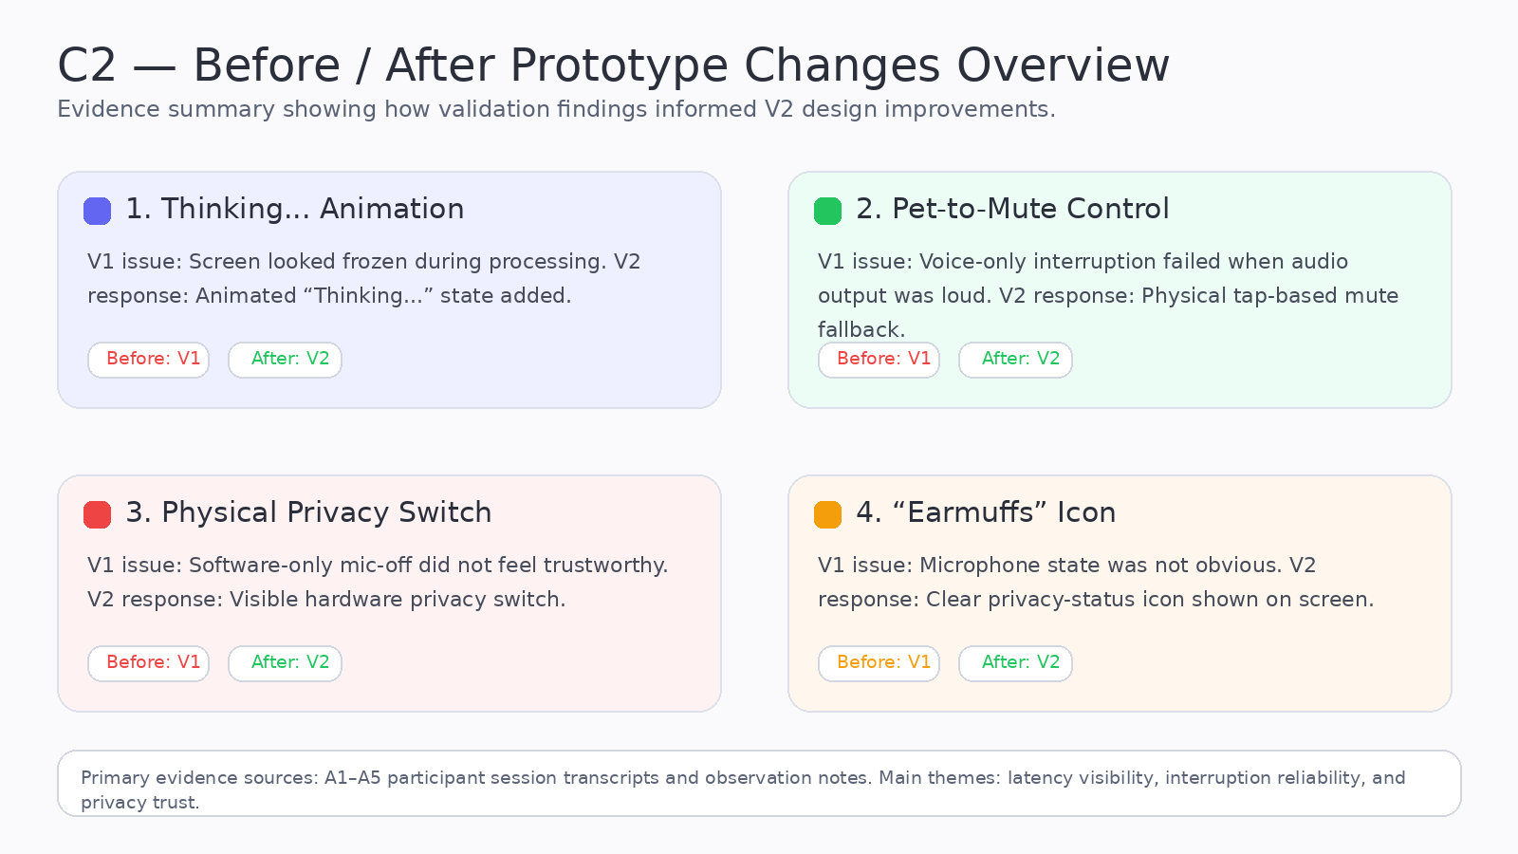
Figure C2-1. Overview of the four V1→V2 prototype changes documented in this evidence file.
1. Evidence Summary
This document presents annotated before/after screenshots and design notes showing how specific validation findings from user testing informed the transition from the V1 prototype to the V2 prototype. The focus is not only on what changed visually, but also on why each change was necessary and which usability or trust issue it addressed.
2. Change Mapping Table
V1 problem | Key participant evidence | V2 design response | Expected improvement
Screen looked frozen during processing | P1, P2, P5 | “Thinking...” animation | Higher confidence; fewer repeated commands
Voice stop unreliable during loud output | P4 | Pet-to-Mute control | Faster interruption and better control
Mic-off status not psychologically credible | P3 | Physical privacy switch | Improved privacy trust
Privacy mode not obvious at a glance | P3 | “Earmuffs” icon | Clearer visible privacy state
Change 1 — “Thinking...” Animation
The “Thinking...” animation was introduced to make API processing visible and to reduce the impression that the system had frozen. This change is most directly supported by P1, P2, and P5, who described uncertainty or repeated commands when no intermediate feedback was shown.
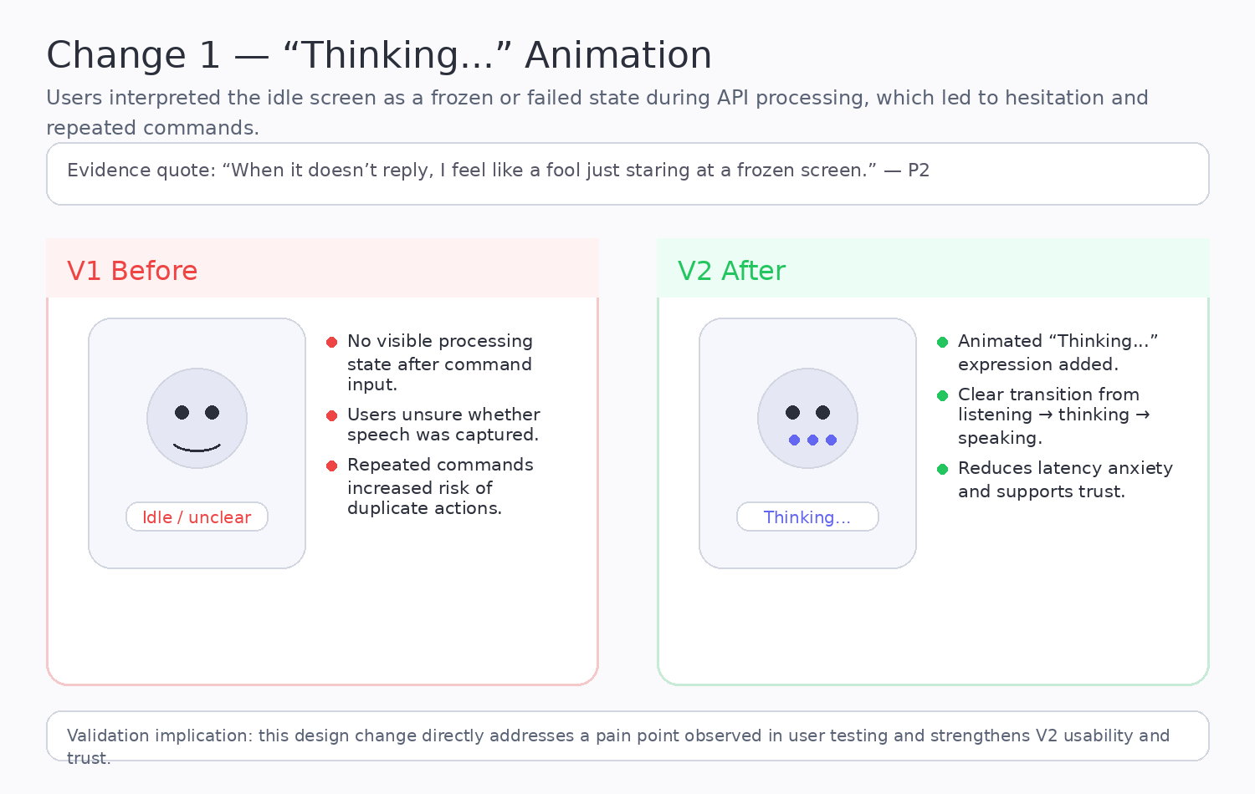
Figure C2-2. Before/after illustration for the “Thinking...” animation.
- What changed: V2 introduces a clearer or more reliable interaction cue than V1.
- Why it matters: the change directly addresses a validated user problem rather than being a purely cosmetic update.
- Validation connection: this figure should be read together with the relevant A-series participant transcript(s).
Change 2 — Pet-to-Mute Control
The Pet-to-Mute control provides a guaranteed physical interruption fallback when voice-only stop commands fail. This change responds most directly to P4’s high-volume interruption problem and also supports efficiency expectations mentioned by P5.
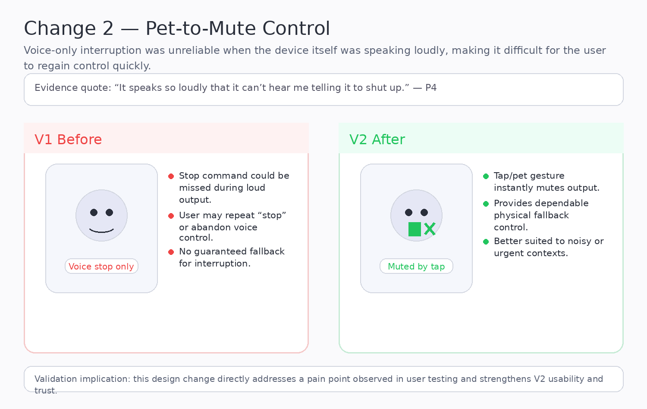
Figure C2-3. Before/after illustration for the Pet-to-Mute control.
- What changed: V2 introduces a clearer or more reliable interaction cue than V1.
- Why it matters: the change directly addresses a validated user problem rather than being a purely cosmetic update.
- Validation connection: this figure should be read together with the relevant A-series participant transcript(s).
Change 3 — Physical Privacy Switch
The physical privacy switch was added because a software-only confirmation of microphone-off status did not provide enough trust. P3’s behaviour showed that privacy assurance must be visible and physical, not only verbal or software-based.
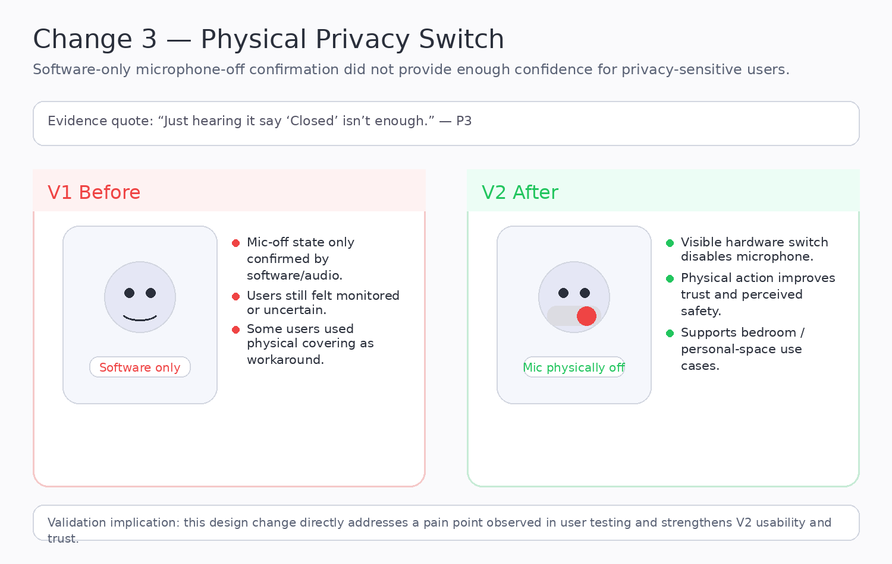
Figure C2-4. Before/after illustration for the physical privacy switch.
- What changed: V2 introduces a clearer or more reliable interaction cue than V1.
- Why it matters: the change directly addresses a validated user problem rather than being a purely cosmetic update.
- Validation connection: this figure should be read together with the relevant A-series participant transcript(s).
Change 4 — “Earmuffs” Icon
The “Earmuffs” icon complements the privacy switch by showing the privacy mode on screen. It makes the microphone state legible at a glance and reduces ambiguity after the microphone has been turned off.
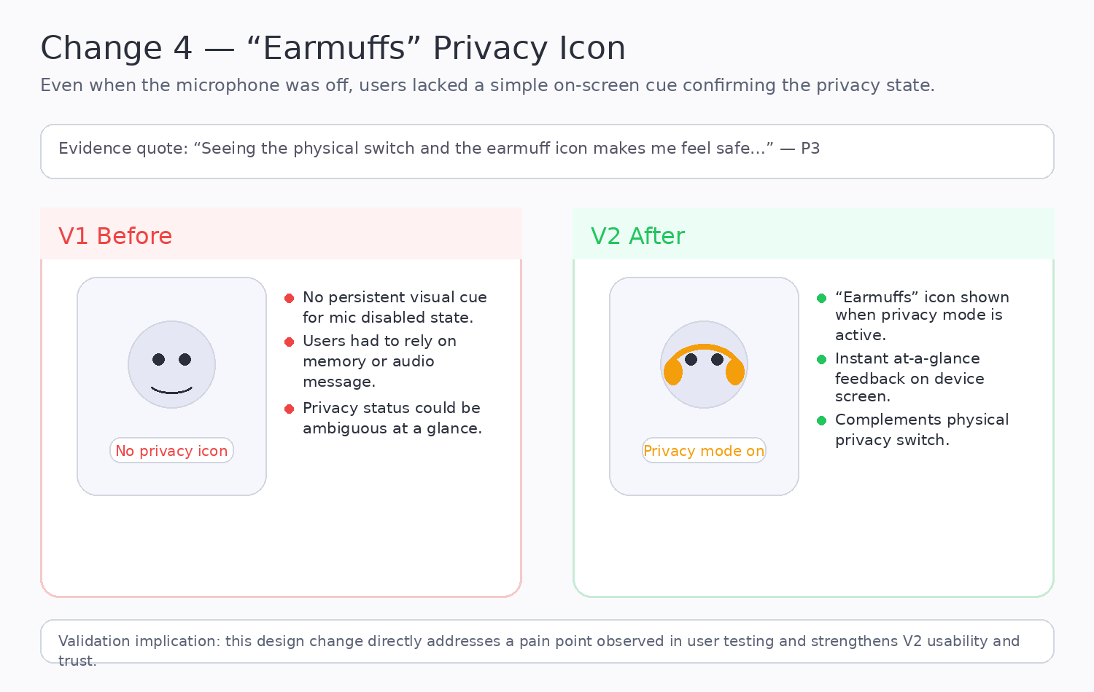
Figure C2-5. Before/after illustration for the “Earmuffs” icon.
- What changed: V2 introduces a clearer or more reliable interaction cue than V1.
- Why it matters: the change directly addresses a validated user problem rather than being a purely cosmetic update.
- Validation connection: this figure should be read together with the relevant A-series participant transcript(s).
3. Comparative Summary Across All Four Changes
Change | Primary problem solved | Main user evidence | Design type | Impact on V2
Thinking... | Hidden latency / uncertain processing | P1, P2, P5 | On-screen animation | Improves feedback clarity and trust
Pet-to-Mute | Failed interruption under loud output | P4 | Touch / physical control | Improves interruption reliability
Privacy switch | Low trust in software-only mic-off | P3 | Hardware control | Improves privacy confidence
Earmuffs icon | Mic-off state not visible enough | P3 | On-screen icon | Improves state awareness

