Kanazawa Institute of Technology

金沢工業大学

JICA Trainee

NINJA ROBOT

FOR FARM LAND MANAGEMENT

Author:

HENRIQUE RENO SAWADA

Supervisor:

PROF. DR. TAKASHI KAWANAMI

October 2016

**NINJA ROBOT**

**FOR FARM LAND MANAGEMENT**

Final Report for the conclusion of the JICA Trainee program for Nikkeys, presented in October 2016 in Kanazawa Institute of Technology (金沢工業大学).

Author:

Henrique Reno Sawada

Supervisor:

Prof. Dr. Takashi Kawanami

October 2016

**Abstract**

The main purpose of the project is to use different IoT (Internet of Things) technologies in farm land management, monitoring the conditions like temperature and humidity, being possible to follow and study the weather variations and the consequences into the plantation. Furthermore, it is possible to receive alerts when the conditions changes dangerously for the health of the plants and even to automate some measures to control and maintain the most perfect environment.

The main equipment studied and implemented was RasberryPi, Arduino and IMBLE BLE device, being programed in Python and C Language. Some sensors, actuators and cameras was studied during the project, and ThingSpeak webservice was used to work with the data acquired.

**Keywords**: IoT (Internet of Things), RaspberryPi, Arduino, BLE, ThingSpeak

**TABLE OF CONTENTS**

1 INTRODUCION 3

1.1 Motivation 3

1.2 Inspiration 3

1.3 Advantages 3

2 ARCHITECTURE 4

3 COMPONENTS OVERVIEW 5

3.1 Arduino 5

3.1.1 Sensors 6

3.1.2 Actuators 6

3.2 Raspberry Pi 6

3.3 BLE (Bluetooth Low Energy) 6

3.4 PiCamera 6

3.5 RICOH Theta S (360° Camera) 6

3.6 ThingSpeak 6

4 RESULTS AND DISCUSSION 7

4.1 BLE protocol 7

4.2 Arduino and BLE 7

4.3 RaspberryPi and BLE 7

4.4 Raspberry and ThingSpeak 7

4.5 RaspberryPi and RICOH ThetaS 7

5 PROPOSAL FOR FUTURE RESEARCH 8

6 CONCLUSION 9

7 REFERENCES 10

# INTRODUCION

## Motivation

## Inspiration

## Advantages

# ARCHITECTURE

Follow the example of the architecture expected with the project:

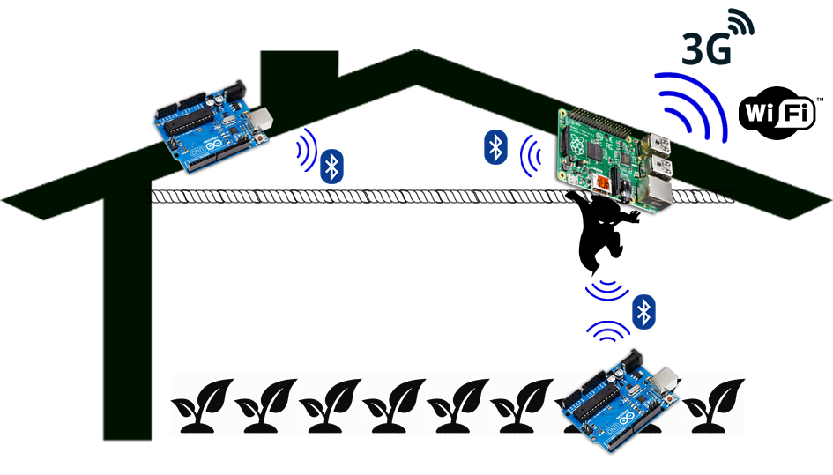

Figure 1 - Example of architecture in Greenhouse

# COMPONENTS OVERVIEW

Several components were used in this project, requiring a time for study and learn the properly use of those many different equipment. This chapter will briefly describe the main characteristics of hardware and software utilized in the project, and the methodology and references for study.

## Arduino

According to the Arduino website [1] “Arduino is an open-source prototyping platform based on easy-to-use hardware and software.”. There are several boards models available in the market nowadays, and in this project was used the Arduino UNO and Arduino Pro Mini.

With this powerful microcontroller board is very easy to start using sensor and actuators. The IDE Software is provided by free in the websites [1] [2], however due to legal questions in the trademark and fight between the creators, there are two main websites [3] [4]. The programing is in then Processing [5] language (very similar to C), and supports C and C++.

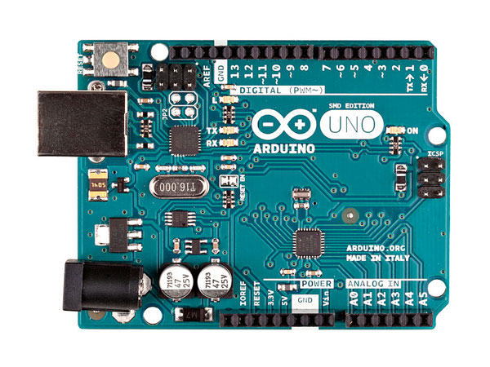

Figure 2 - Arduino Logo and Arduino UNO board

The main resource for studying the functionalities of the board was the Arduino Cookbook [6], that is very complete and contains many useful examples. Furthermore, in the Arduino IDE is possible to access many examples of the libraries and is very convenient to study and copy the usage of the functions.

### Sensors

### Actuators

## Raspberry Pi

## BLE (Bluetooth Low Energy)

## PiCamera

## RICOH Theta S (360° Camera)

## ThingSpeak

# RESULTS AND DISCUSSION

## BLE protocol

## Arduino and BLE

## RaspberryPi and BLE

## Raspberry and ThingSpeak

## RaspberryPi and RICOH ThetaS

# PROPOSAL FOR FUTURE RESEARCH

# CONCLUSION

# REFERENCES

[1] Arduino webpage .org <http://www.arduino.org/>

[2] Arduino webpage .cc <https://www.arduino.cc/>

[3] Fight between trademark and creators <http://hackaday.com/2015/02/25/arduino-v-arduino/>

[4] Hidden history of Arduino <http://arduinohistory.github.io/>

[5] Processing <https://processing.org/>

[6] Margolis, M. 2011. Arduino Cookbook, 2nd Edition. USA: O’Reilly Media, Inc.