Electrolyte-Screening

To understand the solvation structure-conductivity relationship of a concentrated-salt system, and analyze the electronic structure of the solvation complex in the sense of binding strengthen between cation and coordinated solvent/anion. We propose this workflow, which essentially is an artificial solvation structure that includes numerous possibilities of a solvent-salt system and all possible combinations. This binding strength will work as a descriptor for the solvation structure. This workflow combines four different WaNos to generate a set of molecular configurations. The simulation is performed within the DFT approach, and the structure generation is fully automatized and supports any molecule type.

Find more details

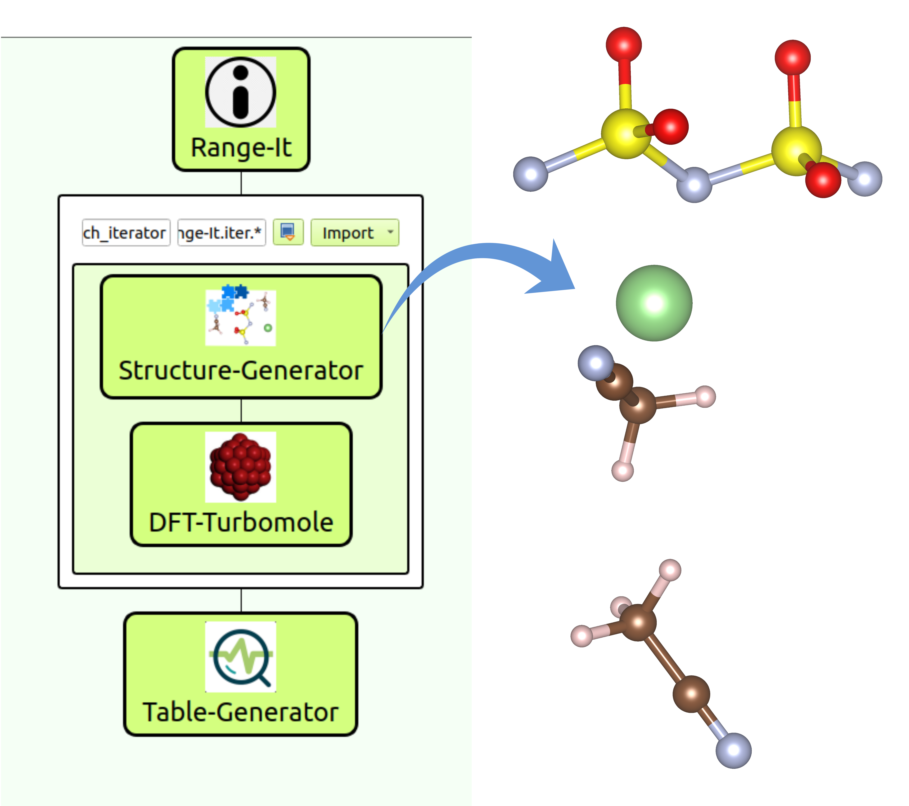
https://github.com/KIT-Workflows/Electrolyte-Screening

