Appendix S-4
Power Tool Package Envelopes

- Any power tool may be used. There are no restrictions on size or shape. Teams should bring the actual power tool with them to the discussion at the Competition along with sockets and extensions, if applicable, and be prepared to prove to the judges the tool has access to each fastener that used the power tool cost.

- Future years may use simplified versions of the following power tools shown below. These are included only for reference.

- Right Angle Electric Power Tool:

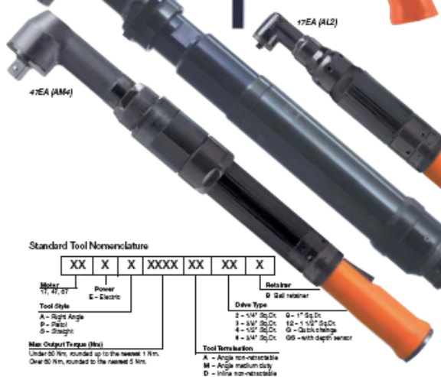
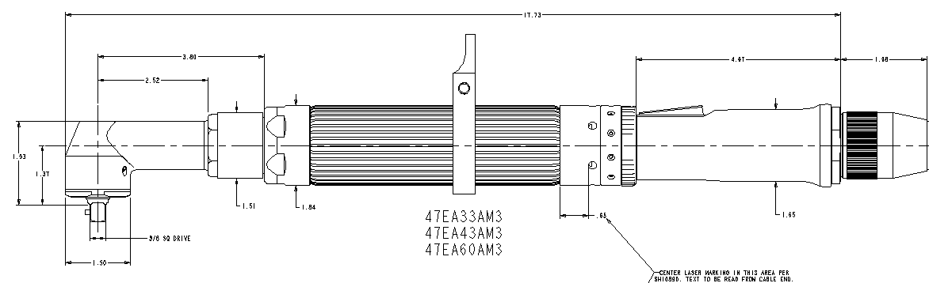

- Pistol Grip Electric Power Tool:

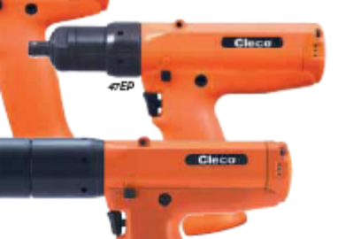

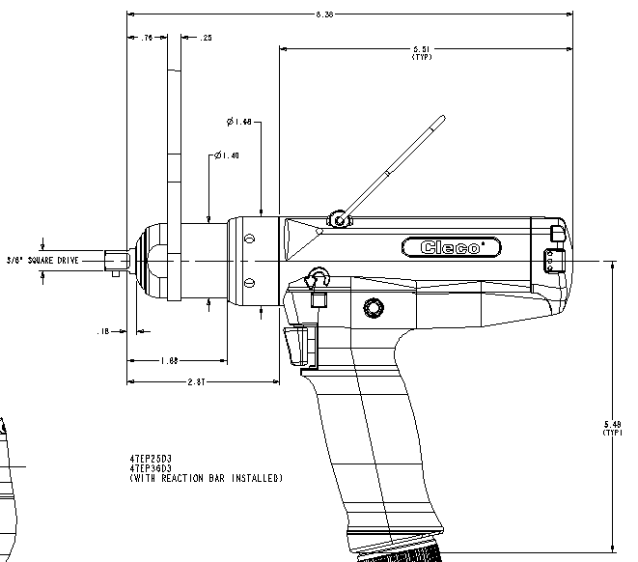

3 Nut Runner Electric Power Tool:

