Okapi Wildlife Reserve Mining Activity Assessment
Requested period: 1 January–31 October 2026

Assessment status: incomplete
Sentinel-2 catalog records and sample cloud-optimized pixels were accessible. The full-reserve, season-matched raster pass exceeded the available command execution window and was terminated before all tiles and quarters were processed. Consequently, this report contains no reserve-wide mining detection result.
No count, area, coordinates, activity status or confidence assessment is reported. The empty site layers and NoData rasters are explicit status placeholders, not zero detections and not evidence that mining is absent. No site is confirmed.

1. Executive summary
Boundary area: 1,393,822.39 ha. Mining result: not determined.

2. Background and objectives
The objective is to screen the RFO for mining-related disturbance from January through October 2026.

3. Study area description
Source RFO.json: valid Polygon; WGS84 GeoJSON; EPSG:32635 area calculation. WGS84 extent: 27.985046, 0.964802, 29.083703, 2.478476.

4. Data sources and methodology
Public Sentinel-2 L2A STAC scenes were catalogued for season-matched 2025 and 2026 periods. The attempted script masks SCL cloud/shadow classes and computes NDVI, EVI, NBR, NDMI, BSI and MNDWI at 20 m. It did not complete reserve-wide raster processing. Other source status and links are in the workbook.

5. Mining detection results
Not determined. No reserve-wide candidates were persisted or validated.

6. Spatial distribution of mining activities
Not determined; no coordinates or candidate polygons are reported.

7. Mining expansion and temporal analysis
Not determined. A reference inventory of previously known mines was not supplied.

8. Environmental implications
No site-specific impacts can be assessed without validated detections.

9. Limitations and confidence assessment
Processing was incomplete; cloud/phenology/confounder review and independent visual or field validation were not performed. Earth Engine authentication was absent. Sentinel-1, Landsat, GLAD/GFW, Hansen and FIRMS were not processed.

10. Recommendations for RFO management and patrol operations
Complete the script in a runtime that permits the full raster job; review all candidates with high-resolution imagery and local knowledge; provide patrol-post and historical mine layers; then validate in the field where safe and appropriate.

11. Maps, tables, imagery and references
The maps below show the reserve boundary only and are explicitly marked NOT ANALYZED. No site evidence imagery exists because site detection did not complete.
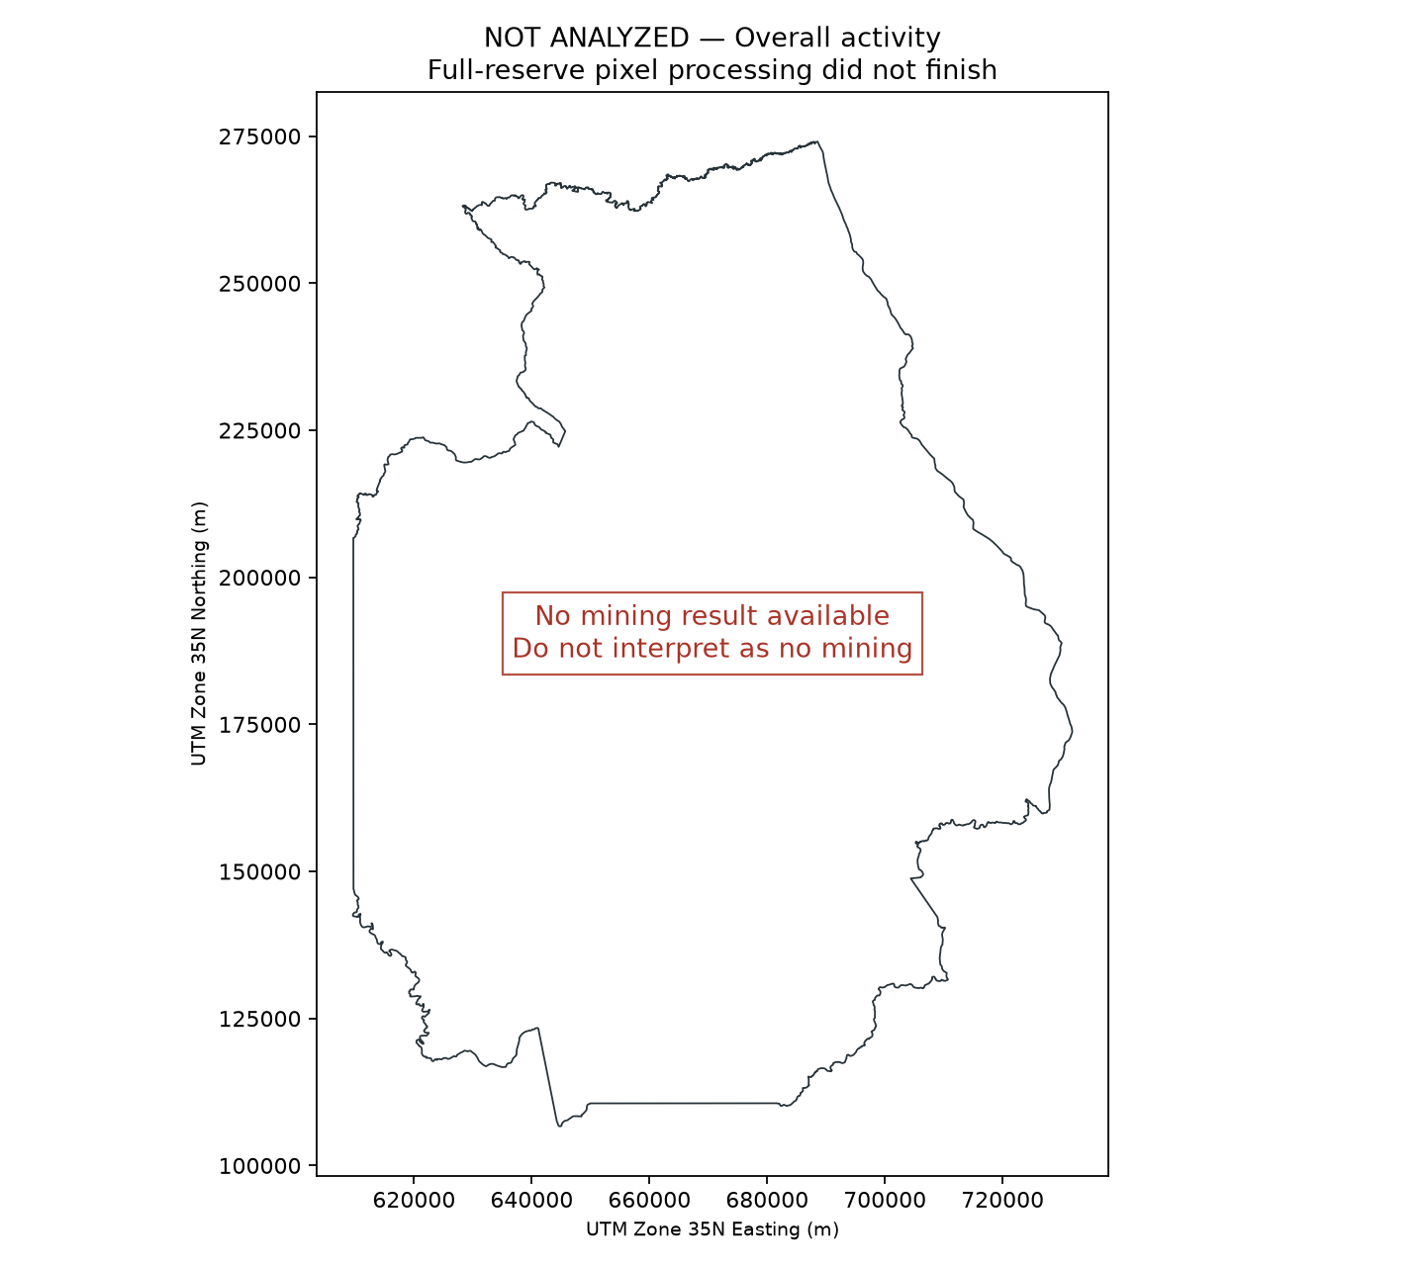
Overall_RFO_Mining_Activity_Map.png
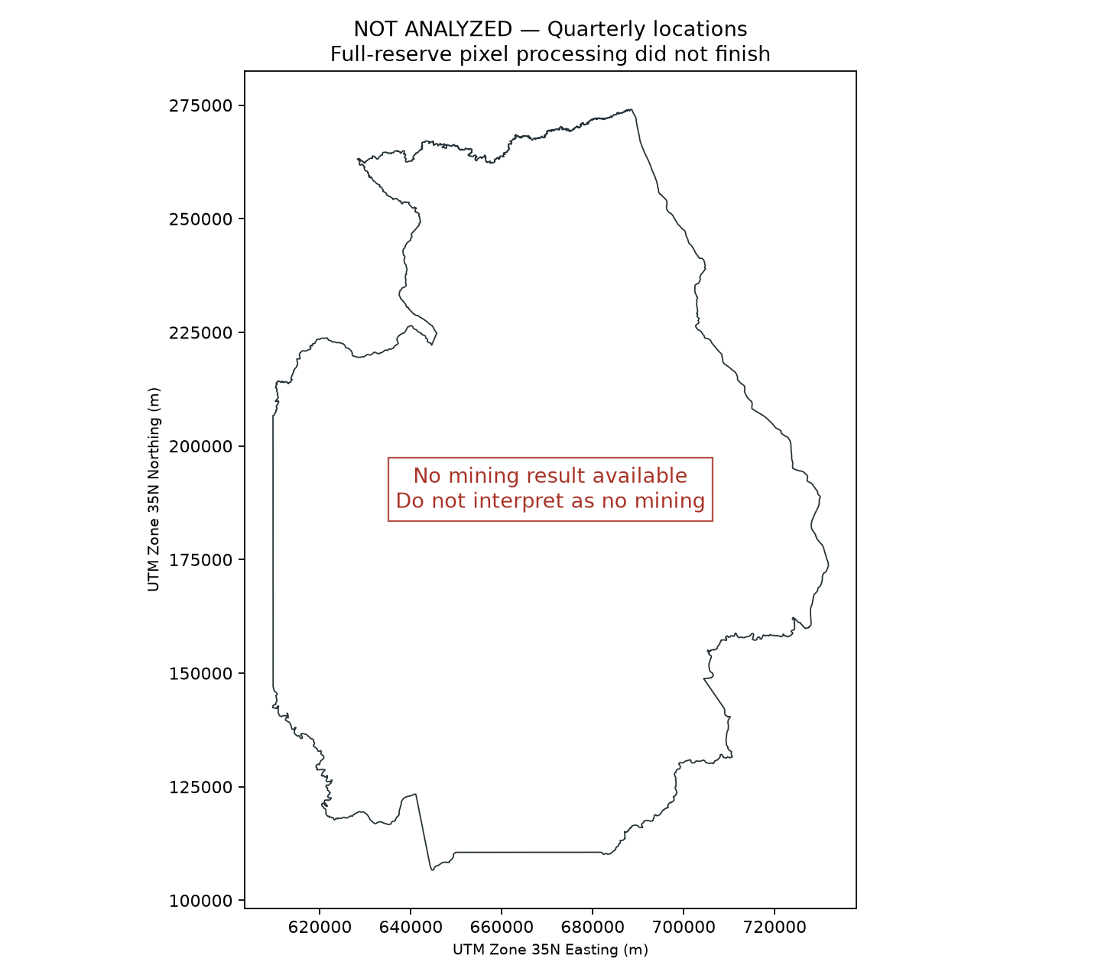
Mining_Locations_by_Quarter_Map.png
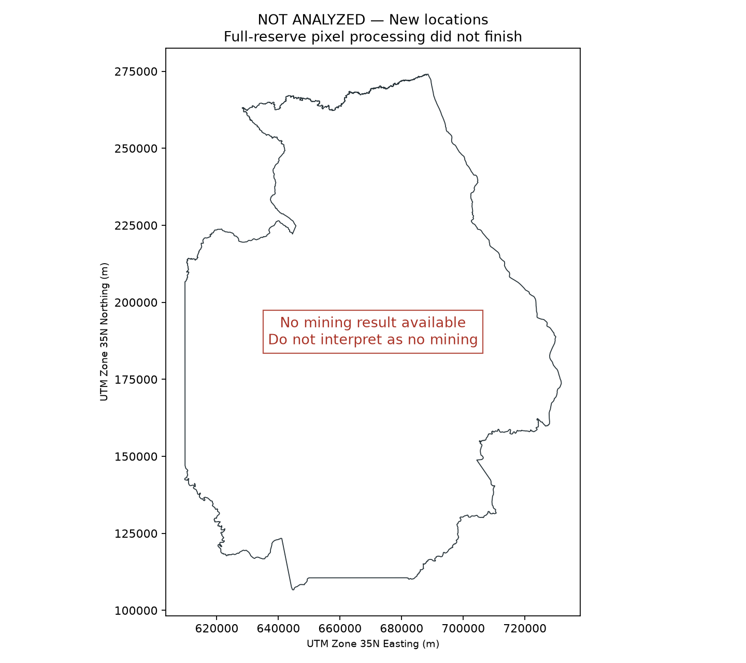
New_Mining_Locations_2026_Map.png
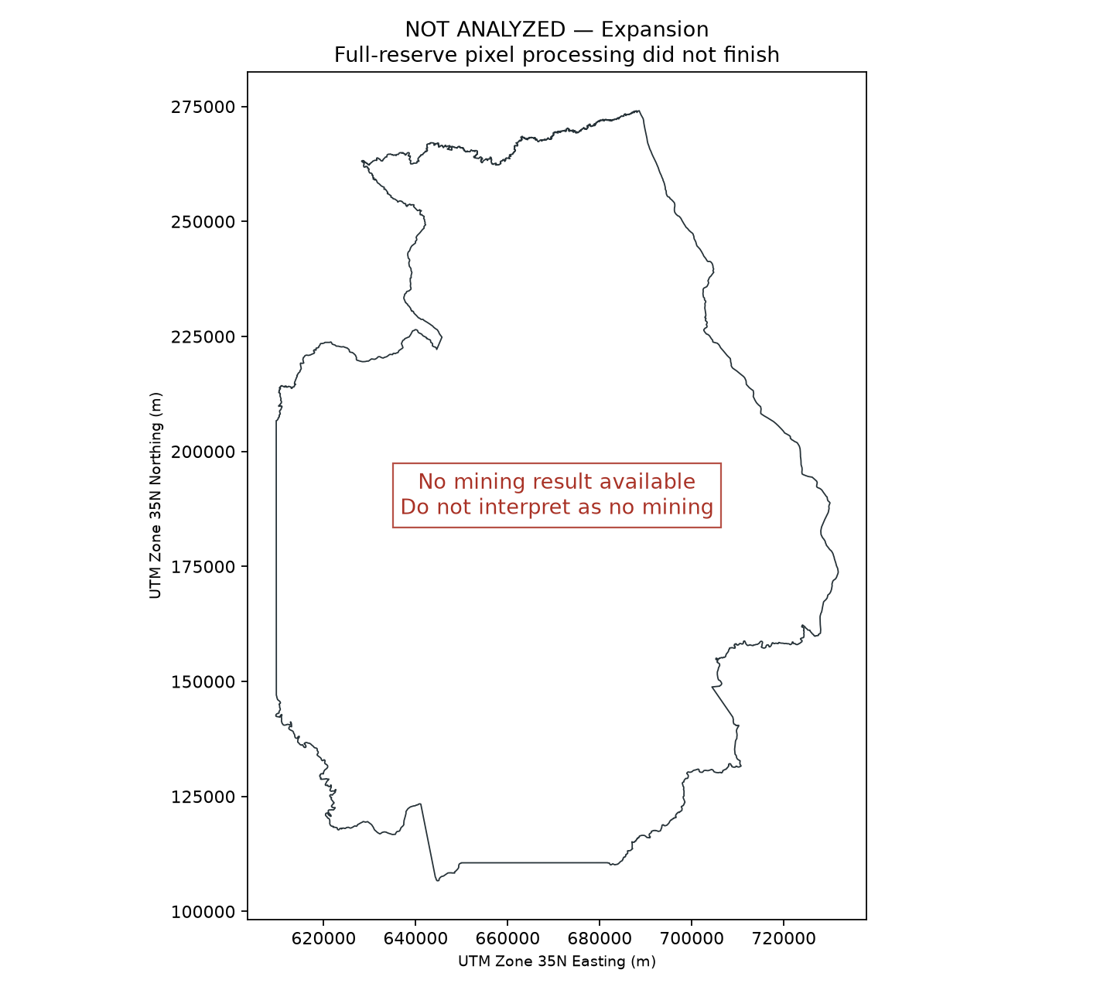
Mining_Expansion_Map.png
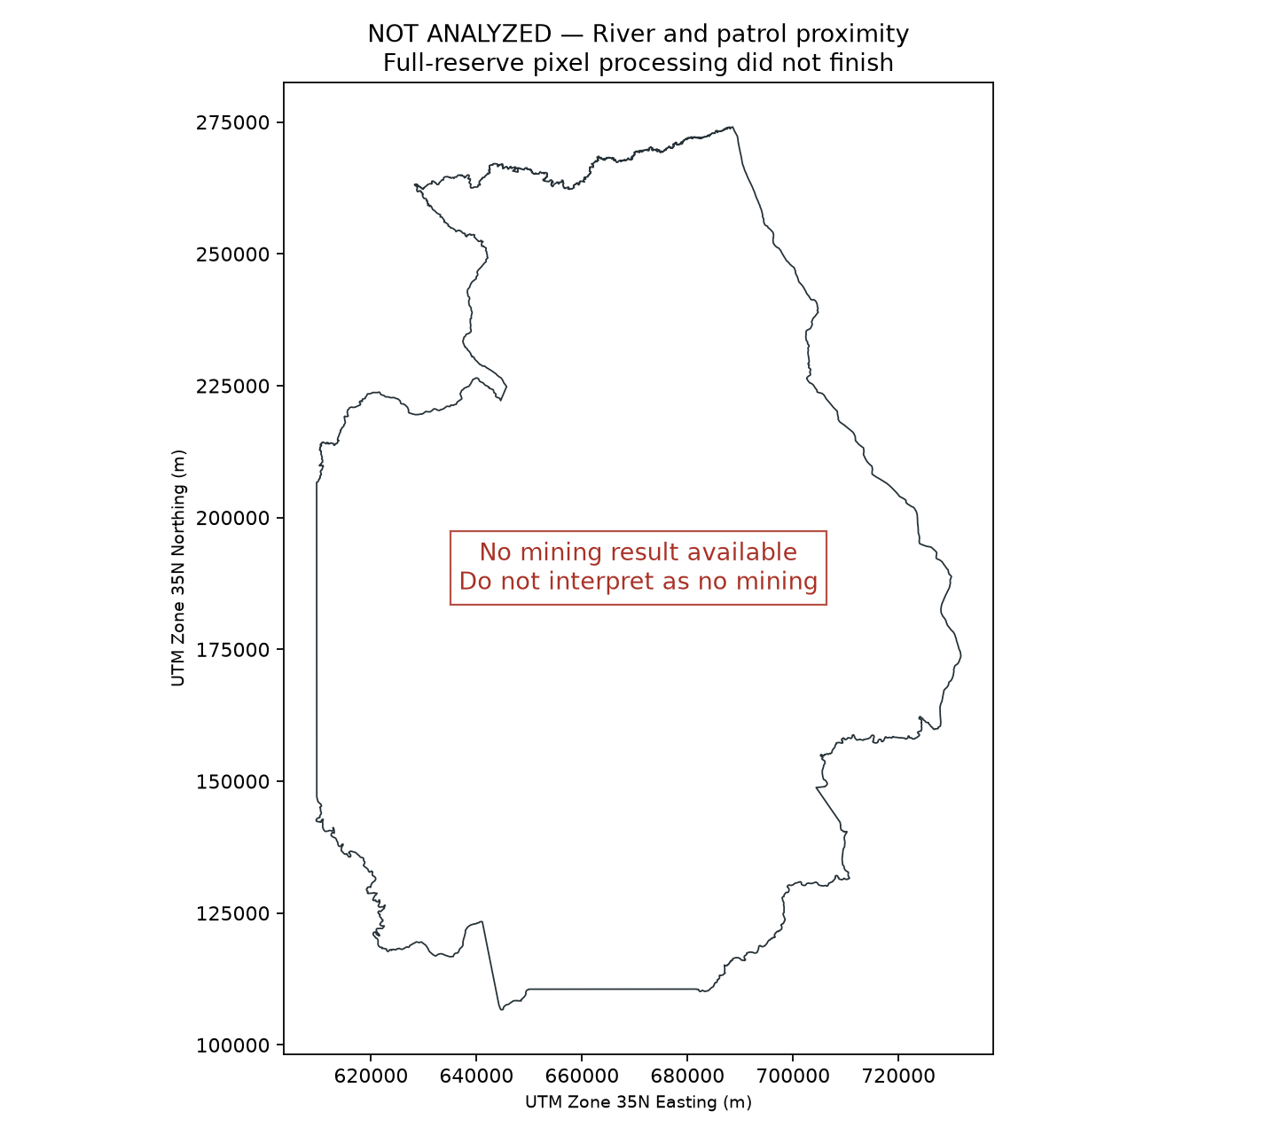
Mining_River_and_Patrol_Proximity_Map.png
References: Sentinel-2 L2A catalog https://planetarycomputer.microsoft.com/api/stac/v1/collections/sentinel-2-l2a ; Landsat C2 L2 https://planetarycomputer.microsoft.com/api/stac/v1/collections/landsat-c2-l2 ; Sentinel-1 GRD https://planetarycomputer.microsoft.com/api/stac/v1/collections/sentinel-1-grd ; Global Forest Watch https://www.globalforestwatch.org/ ; NASA FIRMS https://firms.modaps.eosdis.nasa.gov/ .

