1. Hypercube is a static network binary n-cube architecture with 2nnodes n is the dimension with 2 nodes per dimension. It has a poor scalability and the packaging is difficult for higher dimension.

It has a

Node degree = n

Network diameter = n

Bisection width = N/2 (N = 2n)

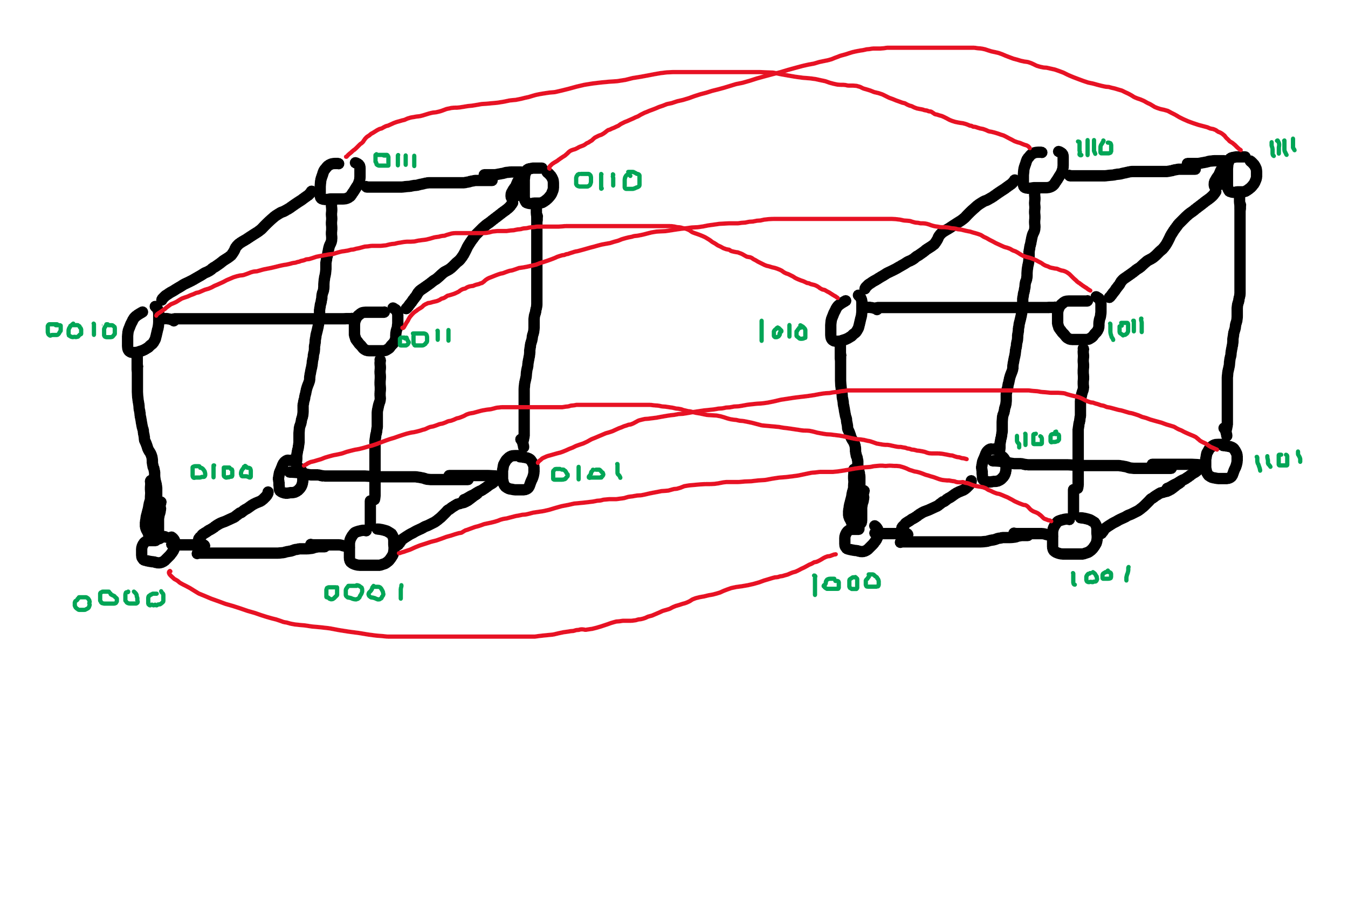



|  |  |
| --- | --- |
| 3 CCC | 4-ary 3-cube |
| NODE DEGREE: 3 | NODE DEGREE: 6 |
| NETWORK DIAMETER: 6 | NODE DIAMETER: 6 |
| BISECTION WIDTH: 4 | BISECTION WIDTH: 32 |
|  | C:\Users\Souvik_2\Documents\20200504_130521.jpg |

1. Network throughput is defined as the total number of messages that a network can handle per unit time. One method is to calculate the capacity of the network i.e. the total number of messages in the network at once. Maximum throughput is the fraction of that capacity.

A part of a network is said to be hotspot if that portion of network has a disproportionately large portion of the total network traffic. Hotspot can decrease the performance of the network by causing congestion.

Ex – in a binary tree network the top most node has a relatively higher proportion of network traffic than the leaf node.



|  |  |
| --- | --- |
| BUS NETWORK | SWITCH NETWORK |
| The paths of different component of the network is connected to a common line. | There are concurrent path to a resource and these paths are point to point |
| It is slow when there is a large number of users as they are all accessing a single path for the resource. | Multiple paths are available to a resource. |
| If the shared path get blocked by a user then the whole network is in stall state | If a user is not getting resource then other users are not effected due to the presence of concurrent paths. |
| SCALACBILITY IS POOR implementation cost is low | Scalablility is better with higher implementation cost |

