

SCHOOL OF EARTH SCIENCES, REAL ESTATE, BUSINESS STUDIES AND INFORMATICS

COURSE NAME; **COMMUNICATION SKILLS**

COURSE CODE; **CS 102**

INSTRUCTOR; **DR MDOE**

PROGRAMME; **BACHELOR OF INFORMATION SYSTEMS MANAGEMENT**

GROUP NUMBER; **03**

DATE OF SUBMISSION;

|  |  |  |
| --- | --- | --- |
| **S/N** | **NAME OF STUDENT** | **REGISTRATION NUMBER** |
| **1** | **DONALD HILLARY MSHOMI** | **31749/T.2023** |
| **2** | **ZUBERI ANDREA COSMAS** | **30860/T.2023** |
| **3** | **ILHAM ABDALLAH LUSINDE** | **30667/T.2023** |
| **4** | **KURUTHUM SAID JEREMIA** | **31334/T.2023** |
| **5** | **INNOCENT JOHN KIWOLY** | **31019/T.2023** |

QUESTION:

How do you interpret the following non-verbal cues sent by others? Do they always mean the same to you?(a) Yawning (b) Leaning on a chair (c) Cleaning a throat off and on (d)Late arrival (e) Sweating (f) Raised eyebrows (g) Keeping silent after a question or remark

Non verbal communication-it means conveying information without using spoken words, written words and sign language. This is through using certain facial expression or hand gestures to convey a certain message also body postures, eye contacts, and distance between speakers are some examples of non-verbal communication. Non-verbal cues are interpreted differently in different locations, and some have a common meaning despite the area or culture. P. Sooriya (2017) “according to experts, a substantial portion of our communication is non verbal “.

This is how I interpret the following non -verbal cues .

1. Yawning

Is a deep involuntary breath of air, which involves opening your mouth wide to let air in. The process shows that the person what’s to sleep (sleepiness) that’s how people interpret when people yawn.

The picture below shows the person is yawning.

1. Leaning on the chair

Leaning forward indicates concern, interest or focusing on the topic.

1

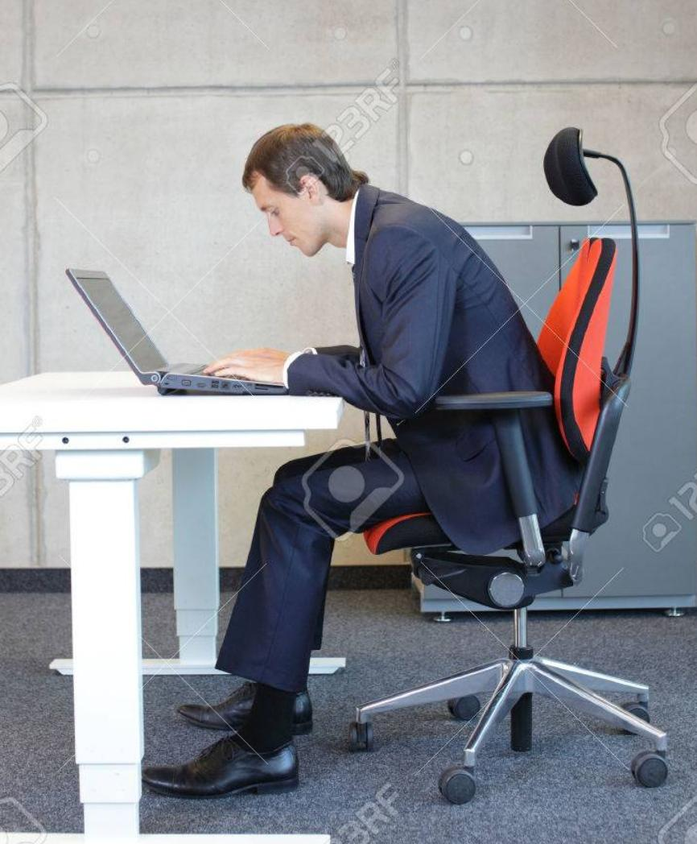The picture below shows someone is leaning forward .

While leaning backward shows the opposite, this shows lack of interest and mostly it shows that person is tired. That’s how I interpret leaning backward on the chair

The picture below shows someone is leaning backward on the chair



(c Cleaning the throat

This involves voluntary coughing. This indicates that someone is preparing to say something or say a speech

2

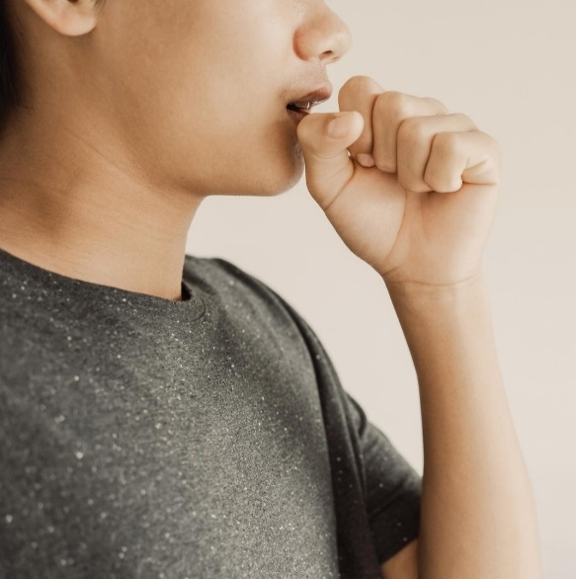The following picture shows someone clearing the throat before saying something serious .

1. Late arrival

This involves arriving after the proper or expected time, when someone arrives late that means the person is lazy, that’s my interpretation.

(e ) Sweating

This is the process where by someone release waste from skin , the waste is in water form

This implies that the person sweating was doing some exercise.

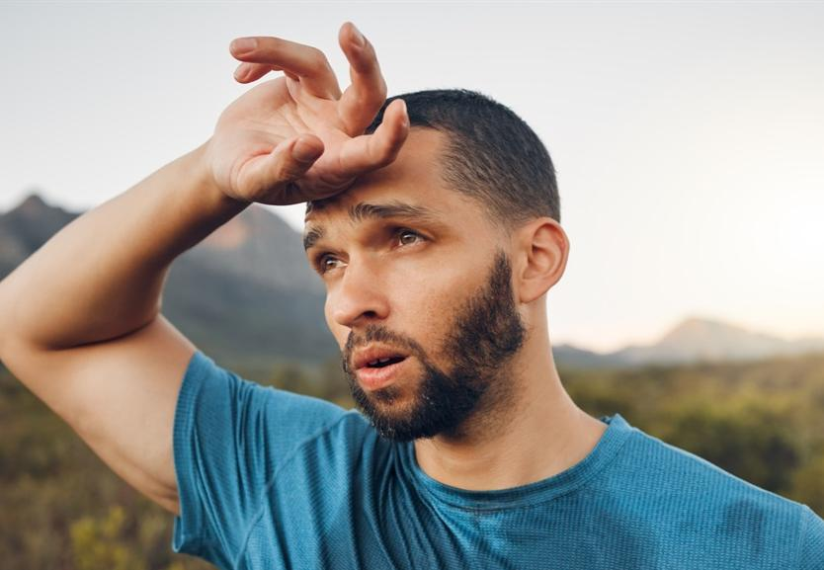The following picture shows someone is sweating

3

(F) Raised eyebrows

This shows that someone is amazed with the information given, this is experienced when someone’s eyebrows moves far from his/her eyes

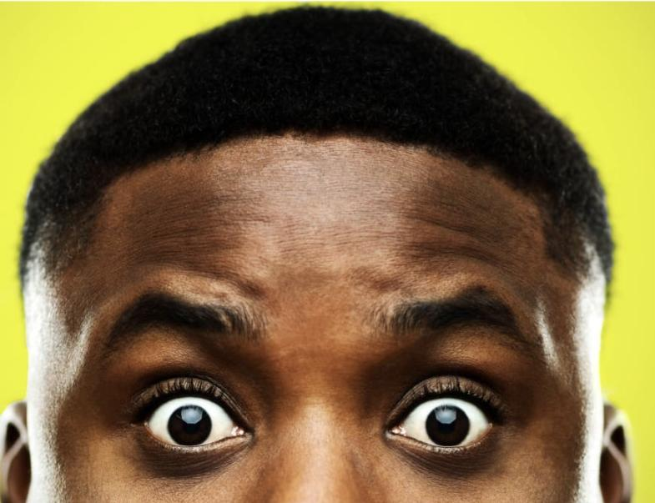The following picture shows some is amazed after hearing exciting news

(g) Keeping silent after a question or a remark

When someone keeps silent after a question this indicates neither of the listeners has understood or knows the answer, this most occurs in schools, universities and etc

Sometimes these cues don’t mean the same as explained some cues have a lot of messages they display example cleaning the throat some times it indicates to stop what your doing , late arrival indicates traffic , sweating also indicates anxiety and keeping silence indicates ignorance , they give different interpretation depending on how they are used, when they are used , also they depend on the culture or the area (surrounding environment) .

4

REFERENCE

-P.sooriya (2017) , NON VERBAL COMMUNICATION .

5