# ARDHI UNIVERSITY



**SCHOOL OF EARTH SCIENCE, REAL ESTATE, BUSINESS AND INFORMATICS**

**DEPARTMENT OF COMPUTER SYSTEMS AND MATHEMATICS**

**BSc. INFORMATION SYSTEMS MANAGEMENT YEAR 1**

**IS 291: PROJECT 1 INFORMATION SYSTEM ANALYSIS, DESIGN AND**

**IMPLEMENTATION**

**PROJECT TITLE: LECTURER-STUDENTS NOTES REPOSITORY**

# PREPARED BY: GROUP 3

|  |  |  |
| --- | --- | --- |
| **S/N** | **NAME OF STUDENT** | **REGISTRATION NUMBER** |
| **1** | **DONALD HILLARY MSHOMI** | **31749/T.2023** |
| **2** | **ZUBERI ANDREA COSMAS** | **30860/T.2023** |
| **3** | **ILHAM ABDALLAH LUSINDE** | **30667/T.2023** |
| **4** | **KURUTHUM SAID JEREMIA** | **31334/T.2023** |
| **5** | **INNOCENT JOHN KIWOLY** | **31019/T.2023** |

# 

# DECLARATION

We, **Group 3**, hereby declare that this report is our own work and effort. The work in this report was carried out in accordance with the Regulations of the Ardhi University. Where other sources of information have been used, they have been shown in the references list.

# S/N Student’s Name Signature Date

1. DONALD HILLARY MSHOMI .......................... ..................
2. ZUBERI ADREA COSMAS ........................... ...................
3. ILHAM ABDALLAH LUSINDE ........................... ...................
4. KURUTHUM SAID JEREMIA .......................... ...................
5. INNOCENT JOHN KIWOLY ......................... ....................

**Supervisor(s):**

1. Dr. EUNICE LIKOTIKO: **Signature….**…………………… **Date**……………….

2.Dr. WINFRIDA MWINGILA: **Signature** ……………………… **Date**…………………

# ABSTRACT

In today’s fast paced educational environment, students relay heavily on lecture notes for effective learning and revision. However, there is often a challenge in obtaining these notes on time from the lecturers. This delay can create a gape in understanding as student are unable to revise the lecture while it is still fresh in their minds.

Therefore, most of the students fail to get lecturer notes from their respective lecturers that is due to delaying of class representative to share the notes to the students on time due to different reasons like the class representative may forget to share the notes due to personal factors.

Therefore, this project has developed Lecturer-Students notes repository system. This system helps a student to access notes anywhere and at any time regarding that has internet access without depending on anyone else.

The suggested system will be identified as lecturer-students notes repository.

# ACKNOWLEDGEMENT

We humbly offer our profound appreciation to the All-Powerful God, the author and preserver of life, for his kindness and love towards us, our loved ones, and everyone in our immediate vicinity, as they have enabled us to become greater than we ever could have imagined.   
We would like to express our gratitude to Drs. Eunice and Winfrida for their excellent supervision and selflessness during the entire study; their endurance and persistent efforts to offer us constructive criticism and intellectual guidance were highly motivating and beneficial in helping us finish this project. With thanks, we would like to thank our families for their support as well as those who indirectly helped with this project. We also want to thank our fellow students for their comments and encouragement. We also thank every member of the Department of Computer System and Mathematics staff for their assistance in finishing our study.

**TABLE OF CONTENTS**

DECLARATION i

ABSTRACT ii

ACKNOWLEDGEMENT iii

LIST OF FIGURES vii

LIST OF TABLES viii

LIST ABBREVIATIONS ix

CHAPTER ONE 1

INTRODUCTION 1

1.1 General introduction 1

1.2 Problem statement 2

1.3 Objectives 2

1.3.1 General objective 2

1.3.2. Specific objectives 2

1.4 Significance of the study 3

CHAPTER TWO 4

LITERATURE REVIEW 4

2.1 Introduction 4

2.2. LITERATURES FOR DATA COLLECTION 4

2.2.1 Proposed an e-Learning management system 4

2.2.2 Implementation of an improved e-learning system 4

2.2.3 Project on online notes sharing 5

CHAPTER THREE 6

METHODOLOGY 6

3.1 Introduction 6

3.2 Data collection methods 6

3.2.1 Literature review 6

3.2.2 Questionnaire 6

3.3 TOOLS USED 9

3.3.2 Waterfall methodology 9

CHAPTER FOUR 11

SYSTEM ANALYSIS AND DESIGN 11

4.1 Introduction 11

4.2 Requirement analysis 11

4.2.1 User requirements 11

4.2.1.1 Functional requirements 11

4.2.1.2 Non-functional requirements 12

4.2.2 System requirements 12

4.2.2.1 Hardware requirements 12

4.2.2.2 Software requirements 13

4.3 System designs 14

4.3.1 System design architecture 14

4.3.2 Entity Relationship Diagram (ERD) 15

CHAPTER FIVE 17

IMPLEMENTATION AND TESTING 17

5.1 Introduction 17

5.2 Implementation 17

5.2.1 Home page 17

5.2.2 sign up page 18

5.2.3 Login page 18

5.2.4 lecturer Dashboard page 19

5.2.5 Students dashboard Page 20

5.2.6 Notes List Page 20

5.3 Testing 21

CHAPTER SIX 23

SUMMARY, CONCLUSION AND RECOMMENDATION 23

6.1 Introduction 23

6.2 Chapter summaries 23

6.2.1 Introduction 23

6.2.2 Literature review 23

6.2.3 Methodology 23

6.2.4 System analysis and design 23

6.2.5 Implementation and testing 23

6.3 Conclusion 23

6.4 Challenges and limitations 24

6.5 Recommendations 24

REFERENCES 25

# LIST OF FIGURES

Figure 3. 1: Waterfall Method 10

# Figure 4. 1: Use case diagram …..……………………………………………………………..14

Figure 4. 2: ERD diagram 15

# Figure 5. 1: Home page………..………………………………………………………………..17

Figure 5. 2: User registration form 18

Figure 5. 3: Login page 19

Figure 5. 4: lecturer Dashboard page 19

Figure 5. 5: Students dashboard 20

Figure 5. 6: Notes List 20

Figure 5. 7: Feedback page 21

# LIST OF TABLES

Table 3. 1: Methodology 9

Table 5. 1: Testing 22

# LIST ABBREVIATIONS

|  |  |
| --- | --- |
| HTML | Hypertext Markup Language. |
| SQLite3 | Structured Query Language. |
| CSS | Cascading Style Sheet. |
| CPU | Central Processing Unit |
| RAM  ERD | Random Access Memory  Entity Relational Diagram |

# CHAPTER ONE

# INTRODUCTION

## 1.1 General introduction

Lecture-Student notes repository refers to the sharing of notes between lecturer and the students for reference and more learning for the student’s betterment. It is an important concept in the learning field and studies since it helps students have fast hand notes available for their early studying mastering and understanding.

Every student requires notes for better revision, mastering, and understanding. In order to get those notes they need to collect them from their class representative who is given by the respective lecturer, whereby the notes tend to fluctuate in time of distribution in which the students sometimes fail to get the notes right on time therefore hinder their mastering, revision and understanding of a student. One of the key reasons is that the Class representative might forget or has no access to display the notes to their fellow students hence delay in time for the notes to reach every student for their revision. At the same time the challenge arises when the notes are deleted from the source whereby for it’s retrieval is hard to get on time. Students fails to revise the notes still fresh in the head as they lack references of the lecture guiding them, by doing so the students’ performance might pull backwards.

Many students in universities face this, in order to overcome this situation, the lecturers should find an alternative way that the students will receive the notes on time for their revision and mastering and also, they can get the notes anytime and anywhere regarding the place they are so that it would be easy for them to obtain the notes. By this stated problem was also solved by other researchers whereby they developed a system of online notes sharing in which in this system a student can also share notes (Aravind Venkatesan and Sakthivel Nageshwaran 2022).

In order to solve this, we develop the system that will have the ability to provide notes to the students on time, faster, and a long period of time, whereby only the lecture has the ability to upload notes and not the student.

Therefore Lecturer-Student notes repository offers crucial advantage to both the lecturers and students, since the Lecturers are able to provide the notes on time and the students can access the notes easily anytime and anywhere regarding the place, they are hence can improve their mastering and revision for their studies.

## 1.2 Problem statement

# Often struggle to get the required lecture notes on time from the lecture for further revision has been a problem. This creates a gap in understanding because students are supposed to review the lecture while it is still fresh in their minds. Without timely access to the lecture notes, students may find it challenging to reinforce their understanding of the lecture material. They might miss out on important details or concepts that were covered in class. This can have a negative impact on their learning out comes and overall academic performance. The lack of availability of lecture notes in a timely manner can also disrupt the students’ study routine. It becomes difficult for them to plan their revision schedule effectively if they don’t have access to the necessary materials when they need them the most.

Therefore, there is a need for a solution that ensures students can easily and promptly obtain the required lecture notes for revision purposes. This would help bridge the gap in understanding and enable students to reinforce their learning while the lecture content is still fresh in their minds. By creating a system that allows a lecturer to upload notes and a student to download notes in which this system will solve the problem of getting the notes on time.

## 1.3 Objectives

### 1.3.1 General objective

The general objective of this project was to develop a Lecturer-Student notes repository system, to support the availability of the notes. Where by lecturer’s upload and download notes in it and the students gets the notes by downloading the notes from it.

### 1.3.2. Specific objectives

The specific objectives of this project were as follows:

1. To gather user requirements for Lecturer-Students Notes Repository system
2. To design Lecturer-Students Notes Repository system
3. To develop Lecturer-Students Notes Repository system
4. To test and validate the Lecturer-Students Notes Repository system

## 1.4 Significance of the study

The expected outcome of this study will greatly benefit both the Lecturers and the Students. By developing a lecturer-student notes repository system lecturers can easily upload notes in it and students can quickly download the notes for their quick revision and mastering for their understanding. This can save time and effort for both lecturers and students.

# CHAPTER TWO

# LITERATURE REVIEW

## 2.1 Introduction

This chapter's goal is to examine various literary works that are connected to a specific project. These literary pieces have been gathered from a variety of sources, including books, journals, conference articles, and government reports.

## 2.2. LITERATURES FOR DATA COLLECTION

### 2.2.1 Proposed an e-Learning management system

Jabr & Al-Omari) in [4] proposed an e-Learning management system with Web services-oriented framework. This proposed framework increased the efficiency and effectiveness of collaborative learning in terms of Reusability, Interoperability, Accessibility and Modularization. The gap in the statement lies in the absence of empirical evidence or specific examples demonstrating the effectiveness of the proposed e-Learning management system with a Web services-oriented framework. While the authors claim that their framework increases the efficiency and effectiveness of collaborative earning in terms of reusability, interoperability, accessibility, and modularization, they do not provide concrete data, case studies, or examples to support these assertions. But our system we address it by User Feedback and Evaluation: Gather feedback from users (e.g., students, instructors) who have used the lecturer- student notes repository system. Conduct surveys, interviews, or focus groups to assess their experiences with the system and its impact on collaborative learning. Use this feedback to identify strengths and areas for improvement.

### 2.2.2 Implementation of an improved e-learning system

(Bello Alhaji Buhari) This research deals with the design and implementation of an improved e-learning system taking Computer Science Unit, Mathematics Department of Usmanu Danfodiyo University, Sokoto as the case study. It allows upload of learning materials online and give room for one-on-one interaction with the lecturer by creating an avenue for the students to ask questions and get their answers online. The system is aimed at being user-friendly, reliable and improved with better specifications. The e-learning system is designed using HTML, CSS, PHP, Ajax, and MySQL. To ensure proper interaction between students and lecturers, this proposed system incorporate audio calls to lecturers through Skype and also video conferencing through webinar (Web Based Seminar); a software that enables lecturers deliver lecture live. It gives the system the ability to give, receive, and discuss information in real time. The gap in this research lies in the lack of evaluation or validation of the effectiveness and usability of the proposed e-learning system. While the research describes the design and implementation of the system, it does not provide evidence or data to support its claims of being user-friendly, reliable, and improved with better specifications. But on system will determine if its user -friendly by gained from user feedback and testing can inform future iterations and improvements of the system.

### 2.2.3 Project on online notes sharing

According to Aravind Venkatesan & Sakthivel Nageshwaran (2022), created a project on online notes sharing, where by the student can download and even upload notes, the system was written using PHP, MYSQL. The user needs to sign up and then login and get their own dashboard. But our system is written using python, Django as framework, Html and CSS and the only user who is capable of uploading notes is the lecture and not the student.

# CHAPTER THREE

# METHODOLOGY

## 3.1 Introduction

Methodology can be defined as a proper study or analysis of all the methods used in the particular study or activity (Merriam-Webster, 2023). Also, it involves the use of various tools such as software and programming languages so as to achieve the general objective of the study (Dawson, 2019). Methodologies were used to ensure that each specific objective was achieved so as to facilitate the goal of attaining a general objective of developing a system which allows the lecture to share notes whereby the student can access the notes through downloading in the system.

## 3.2 Data collection methods

### 3.2.1 Literature review

In this study the literature review which were used includes journals which were a systematic literature review and analysis of online notes sharing systems (websites) and another on e-learning. From these literature reviews we got that most of the online notes sharing system aren’t free they charger fee so as to access the notes in which our system is free, also on other systems there is no limitation on who to upload notes (anyone can upload notes), but in our system only the lecturer can upload notes, this prevents uploading unwanted folders.

### 3.2.2 Questionnaire

This is the research instrument or tool that consists of a set of questions designed to gather information or data from respondents (Babbie, 2020). These questionnaires were prepared and supplied to some of the university’s student through google form. They were online which helped in minimizing cost and increasing efficiency in data collection. They were distributed via WhatsApp. The reason as to why we use questionnaires its because it easy and effective method to collect data.

Below are the result of our google form questionnaires based on the availability of notes

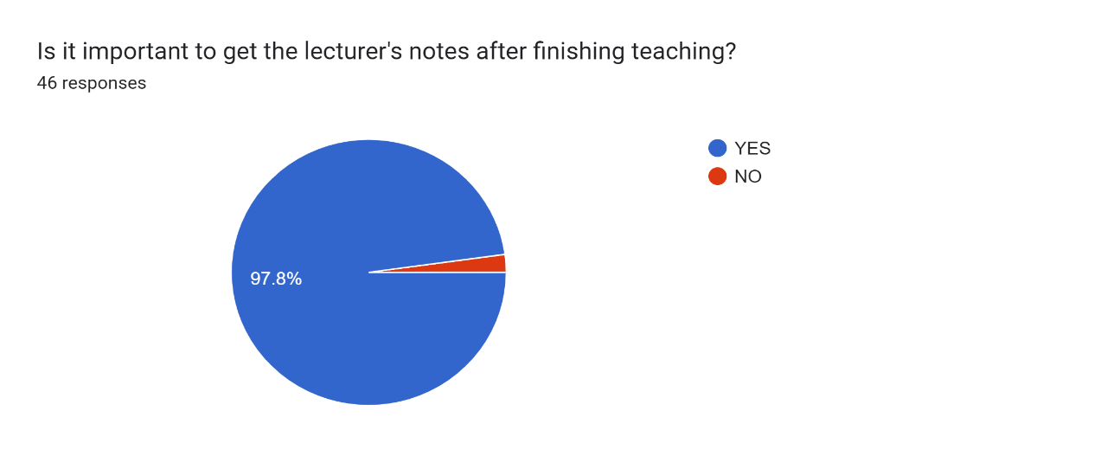

Forms response chart. Question title: 

Is there a need to get notes before being taught ? . Number of responses: 46 responses.

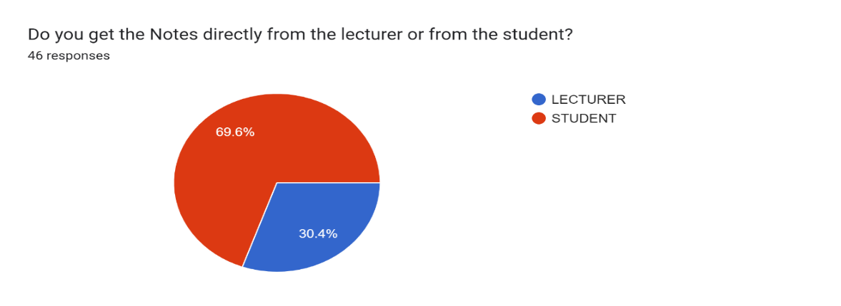

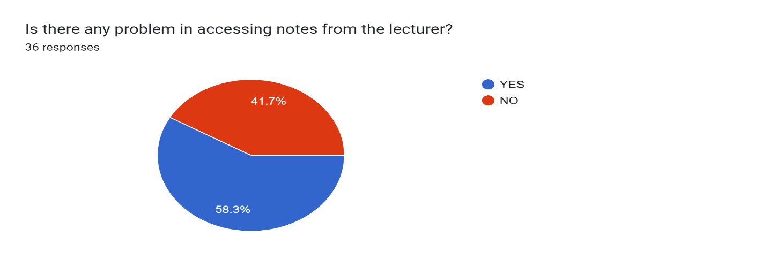

Forms response chart. Question title: Is there any problem of access to notes from the student?
. Number of responses: 44 responses.

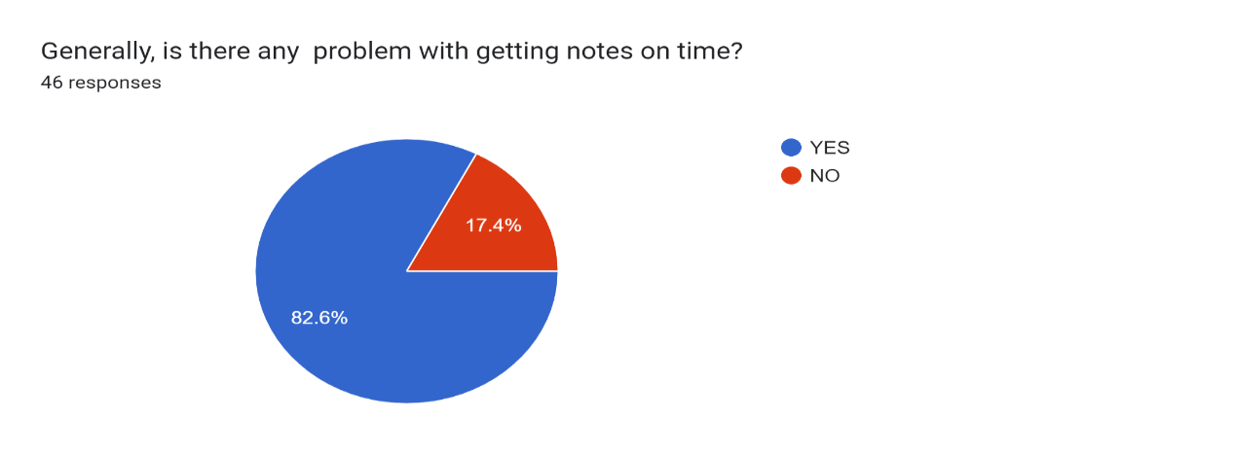

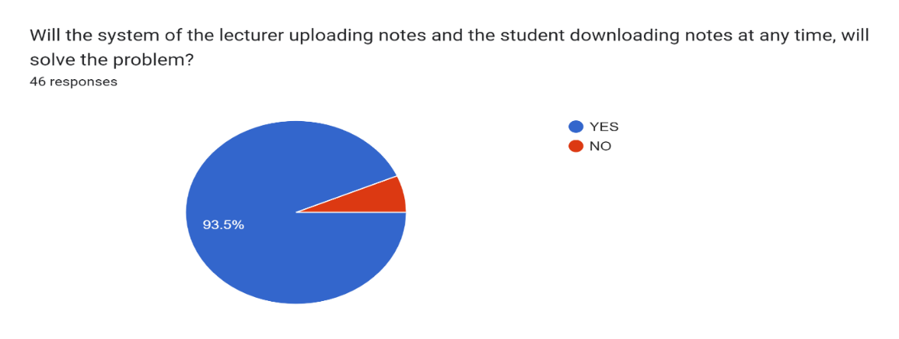

On summary from the 46 response questionaries from our fellow student we collect the data that there is exists a problem of getting notes on time due to the routing method of lecturers shared note with Class representative. Also, if there system of notes sharing will be available it will help to solve the problem

## 3.3 TOOLS USED

**Table 3. 1: Methodology**

|  |  |  |  |  |
| --- | --- | --- | --- | --- |
| S/N | Specific objectives | Methodology | Tools | Deliverable |
| 1 | To gather user requirements for lecture- student repository | -Questionnaire  -Literature review | -Google forms  -google scholar | System requirements |
| 2 | To design lecture – student repository system | -object oriented approach | -draw.io  -star UML | System design document |
| 3 | To develop lecture student repository notes | -waterfall methodology | Html,CSS, python ,Django ,SQlite3 | Prototype / develop system |
| 4 | -To Test and validate lecture – student notes repository | Unit testing | Computer, browser | Testing results |

### 3.3.2 Waterfall methodology

In designing our system, we have used the guidance of waterfall methodology by following the

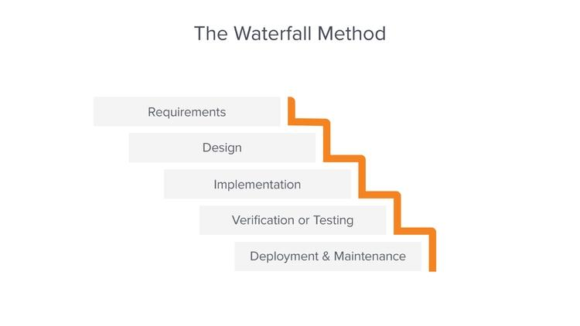Steps of its linear sequential phases as shown below

**Figure 3. 1:** Waterfall Method

# CHAPTER FOUR

# SYSTEM ANALYSIS AND DESIGN

## 4.1 Introduction

System analysis is a phase in the system development life cycle which involves collecting and interpreting facts, identifying problems and decomposing a system into its components (Roth et al., 2013). System design may be defined as the process of planning a system or replacing an existing system by defining its components so as to satisfy specific requirements (Esfandiari & Lu, 2014). This chapter explains the techniques used to implement our system.

## 4.2 Requirement analysis

Requirement analysis is the process of determining the needs and conditions for a new or altered product, considering possibly conflicting requirements of the various stakeholders (Pressman, 2014). In this section, we analysis the two types of requirements: user requirements and system requirements.

### 4.2.1 User requirements

User requirements are specifications that describe what users expect from a system, encompassing their needs and constraints (Sommerville, 2015). These requirements are divided into two categories: functional requirements and non-functional requirements.

### 4.2.1.1 Functional requirements

Functional requirements describe the specific behaviors and functions that the system must perform (Sommerville, 2015). For the Lecturer-Students Notes Repository system, the functional requirements are:

1. User Registration: The system allows users to register as either lecturers or students by providing necessary information such as name, email, and password.
2. User Login: The system allows users to log in using their registered email and password.
3. Lecturer Note Upload: The system allows lecturers to upload notes in various formats (e.g., PDF, DOCX).
4. Lecturer Note Management: The system allows lecturers to view and manage (e.g., update, delete) their uploaded notes.
5. Note Viewing: The system allows both lecturers and students to view available notes.
6. Note Downloading: The system allows both lecturers and students to download notes.

### 4.2.1.2 Non-functional requirements

Non-functional requirements define the system’s quality attributes and operational criteria (Paradkar, 2017). For the Lecturer-Students Notes Repository system, the non-functional requirements are:

1. Scalability: The system can handle an increasing number of users (both lecturers and students) without performance degradation.
2. Security: The system ensures user data is protected through proper authentication and authorization mechanisms. Lecturers have access to upload and manage notes, while students only have viewing and downloading rights
3. Usability: The system features a user-friendly interface that is easy to navigate, making it straightforward for users to perform their tasks.
4. Availability: The system is accessible at all times, ensuring reliable uptime so users can access notes whenever needed.

### 4.2.2 System requirements

System requirements specify the necessary hardware, software, and data components needed for the system to operate effectively (Pressman, 2014). This section discusses the hardware and software requirements for the system.

### 4.2.2.1 Hardware requirements

Hardware requirements refer to the physical components needed to run the software effectively (Smith, 2016). For the Lecturer-Students Notes Repository system, the hardware used includes:

i. Processor (CPU): Intel(R) Core(TM) i5-6300U CPU @2.40GHz 2.50GHz

The CPU is responsible for executing instructions and performing calculations. It ensures efficient system performance and supports multiple concurrent users.

ii. RAM: 8.00GB

RAM is used to store data and instructions that are actively being used by the CPU, allowing for smoother multitasking and faster data access.

iii. Storage: 128GB SSD

SSDs provide faster data retrieval and storage performance, essential for quick access to uploaded notes.

iv. Display:

A standard monitor with a resolution of 1920x1080 pixels is sufficient for development and user interaction, ensuring clear and detailed display of information.

### 4.2.2.2 Software requirements

Software requirements describe the applications and systems needed to develop and run the system (Smith, 2016). The software used includes:

i. HTML and CSS: HTML (Hypertext Markup Language) is used for structuring the web pages. CSS (Cascading Style Sheets) is used for styling the web pages to make them visually appealing and user-friendly.

ii. Python: Python is the programming language used for the backend logic of the application. It handles the server-side operations and integrates with the database.

iii. Django: Django is a high-level Python web framework that enables rapid development of secure and maintainable websites. It is used to manage the application’s functionality, including user authentication, note management, and database interaction.

iv. SQLite (db.sqlite3): SQLite is a lightweight, disk-based database that doesn’t require a separate server process. Django uses SQLite by default for its database, stored in `db.sqlite3`. It is used to store user information, uploaded notes, and other relevant data.

v. PyCharm: PyCharm is an integrated development environment (IDE) used for writing, editing, and debugging code. It supports various programming languages and provides tools for efficient development. PyCharm was used to develop and manage the codebase for the Lecturer-Students Notes Repository system.

vi. Web Browser: Applications like Google Chrome, Mozilla Firefox, and Microsoft Edge are used to access and test the web application, ensuring compatibility and performance across different browsers.

vii. Windows 10 Pro: The operating system used for developing and running the system. It supports various development tools and provides a stable environment for testing and deployment.

viii. Microsoft Word: Used to create and edit documentation, including the project report. It provides tools for formatting and organizing information clearly and professionally.

## 4.3 System designs

### 4.3.1 System design architecture

System architecture involves conceptualizing and defining the structure and behaviors of a system (Pressman, 2014). The purpose of the system architecture design is to bridge the gap between user requirements and system implementation, providing a blueprint for development. The architectural design of the Lecturer-Students Notes Repository system ensures that lecturers can upload, view, and download notes, while students can only view and download notes.

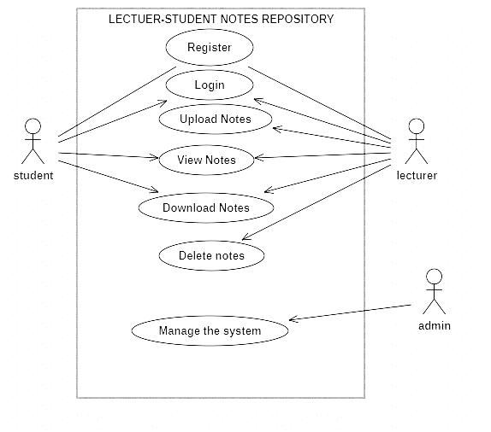

**Figure 4. 1:** Use case diagram

The system architecture consists of the following components:

i. Client Interface: Accessible via web browsers, where users (lecturers and students) interact with the system using HTML and CSS for the frontend.

ii. Web Server: Handles requests from the client interface and processes them using Django.

iii. Database Server: Stores user information, uploaded notes, and other relevant data, managed by Django’s ORM (Object-Relational Mapping) and stored in SQLite (`db.sqlite3`).

iv. Application Logic: Manages the core functionality, including user authentication, note management, and access control, implemented using Python and Django.

### 4.3.2 Entity Relationship Diagram (ERD)

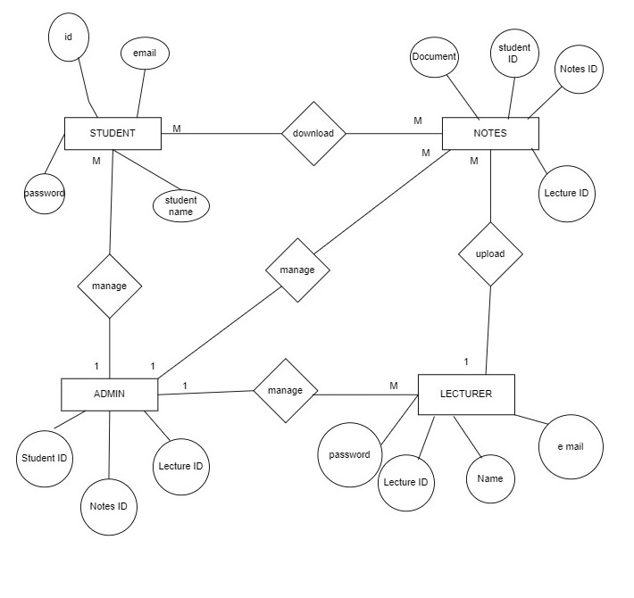An Entity Relationship Diagram (ERD) represents the data entities, relationships, and constraints within the system (Chen, 1976). The purpose of including the ERD is to illustrate the data model and relationships between different entities, aiding in the design of the database schema.

**Figure 4. 2:** ERD diagram

The ERD includes the following entities:

i. User: Contains information about users (lecturers and students) such as user ID, name, email, password, and role.

ii. Note: Contains information about notes such as note ID, title, description, file path, upload date, and lecturer ID.

Role: Defines the roles (lecturer or student) and their associated permissions.

# CHAPTER FIVE

# IMPLEMENTATION AND TESTING

## 5.1 Introduction

In this chapter the elements of the development phase, tools required for implementation of the system are described. Furthermore, it is in this chapter where testing results of the system are explained and how the system is implemented.

## 5.2 Implementation

Lecturer-Student notes repository system was developed by using different languages and technologies where for frontend development HTML, CSS, while in backend development which we use DJANGO. The following are the phases of system development.

### 5.2.1 Home page

The home page in this system carries the general view of the system, it represents different areas of the system through the navigation links. Those navigation bars will allow the system users to access different areas in the system according to their roles.

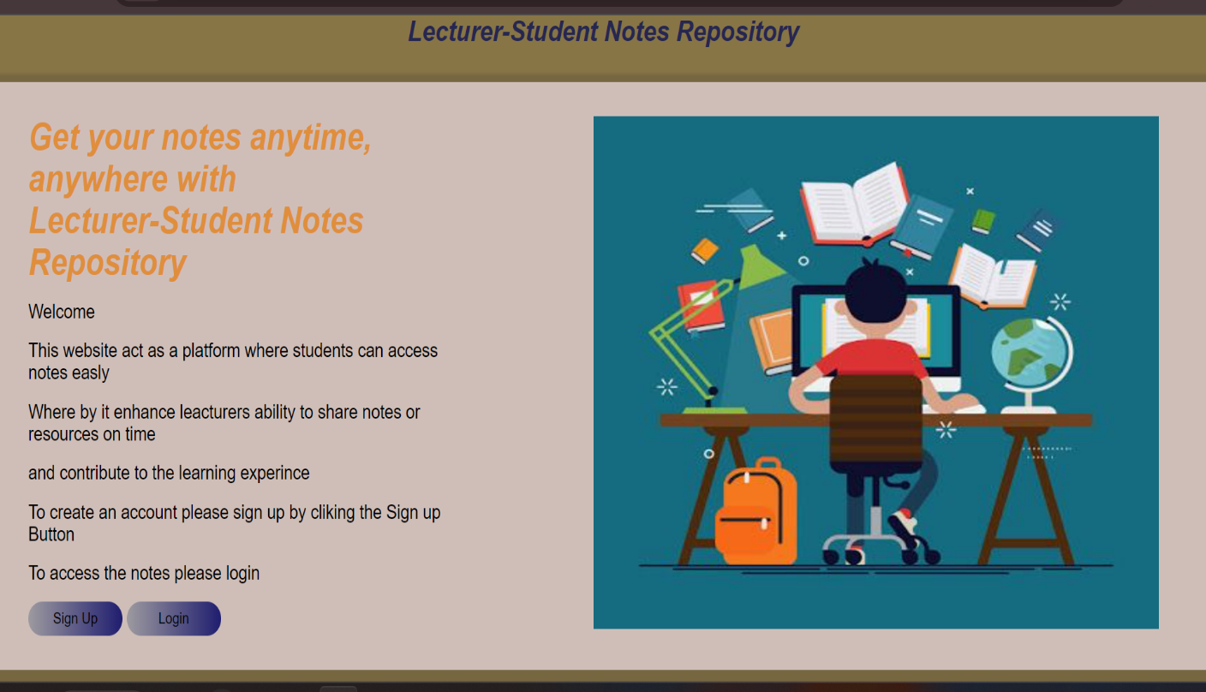

**Figure 5. 1:** Home page

### 5.2.2 sign up page

On this page unregistered student or lecturer will be required to register. Student or lecture, he or she must fill in the details. If the user was registered successfully, he or she will be directed to the login page. Figure 5.2.2 shows the login page

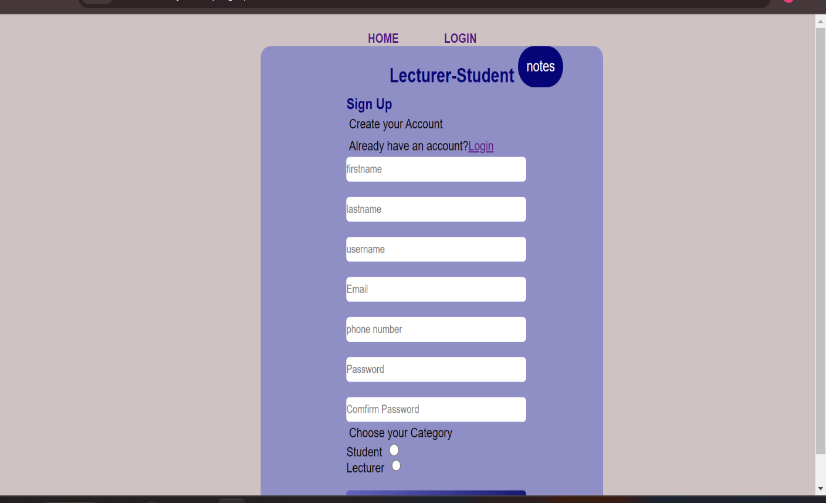

**Figure 5. 2:** User registration form

### 5.2.3 Login page

This page will allow a registered user to access other pages in the system by entering user name and password. According to different roles that were assigned to the system users, he or she will be directed to the respective page immediately when the system validates the identity of the user who has signed into the system. Figure 5.2.3 shows the login page.

# 

**Figure 5. 3:** Login page

### 5.2.4 lecturer Dashboard page

Is the dashboard in which user with the categories of lecturer can be able to have option of upload notes, view notes and download note. Figure 5.2.4 shows the lecturer Dashboard page

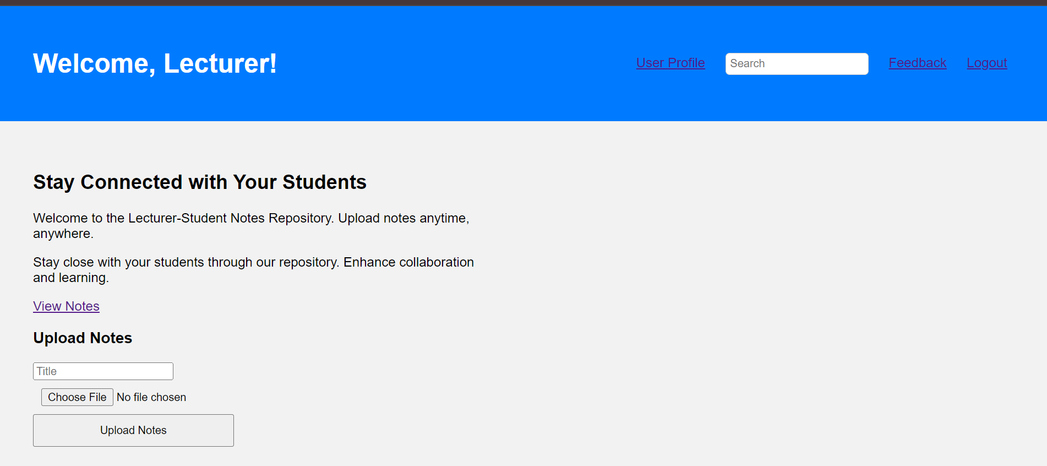

**Figure 5. 4:** lecturer Dashboard page

### 5.2.5 Students dashboard Page

Is the dashboard in which user with the categories of student can be able to have only two options of view notes and download notes. 5.2.5 shows the students dashboard

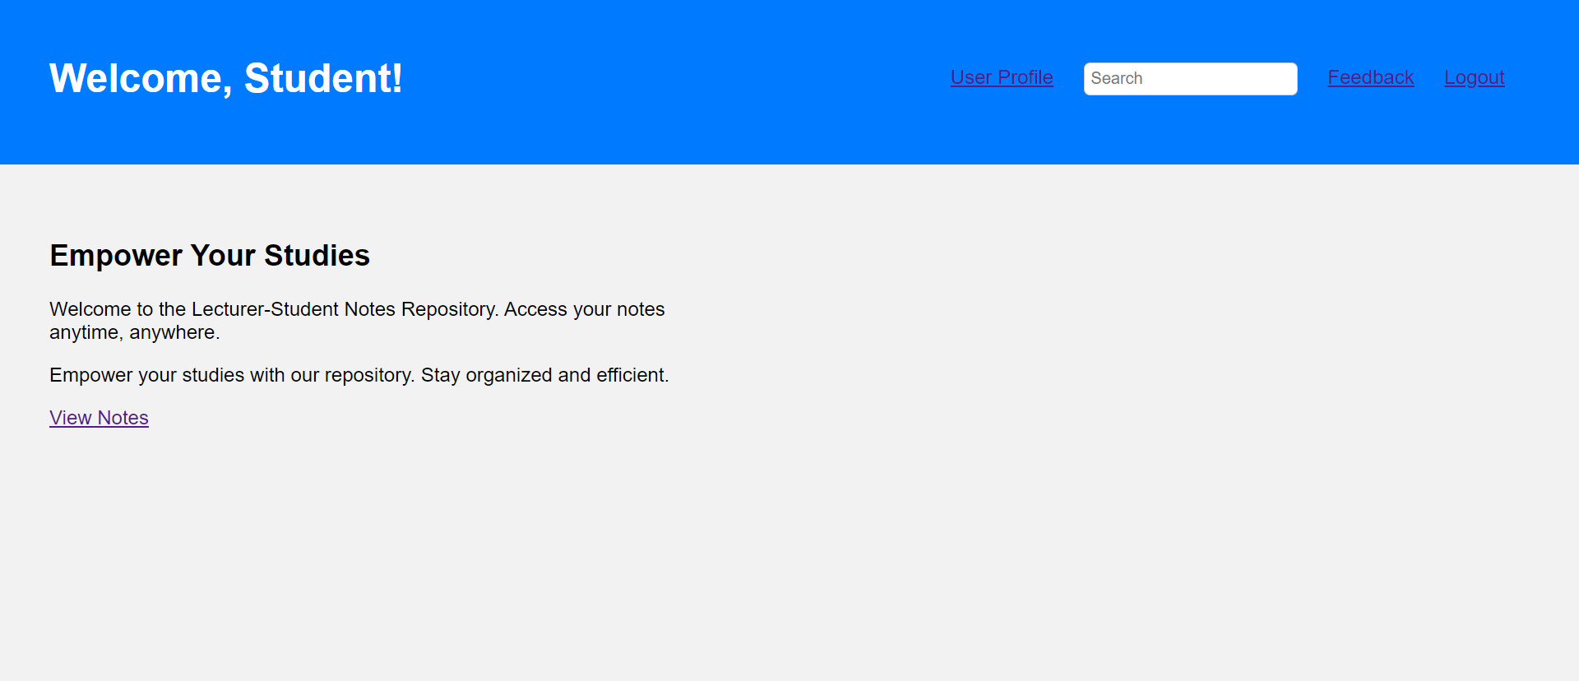

**Figure 5. 5:** Students dashboard

### 5.2.6 Notes List Page

## Is the page which provide the user with all available uploaded notes, with the name of lecturer who upload, name of the notes and time in which notes uploaded. 5.2.6 show Notes List

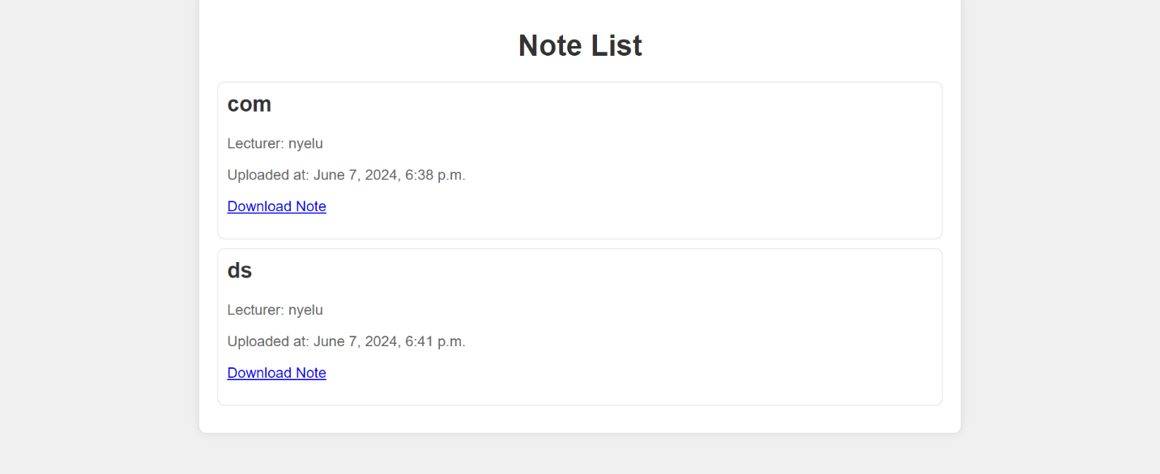

**Figure 5. 6:** Notes List

### 5.2.7 Feedback page

## Is the page which allow user to write their opinion and suggestion in order to improve the function of our system and that feedback will be only seen by admin. 5.2.7 shows Feedback page

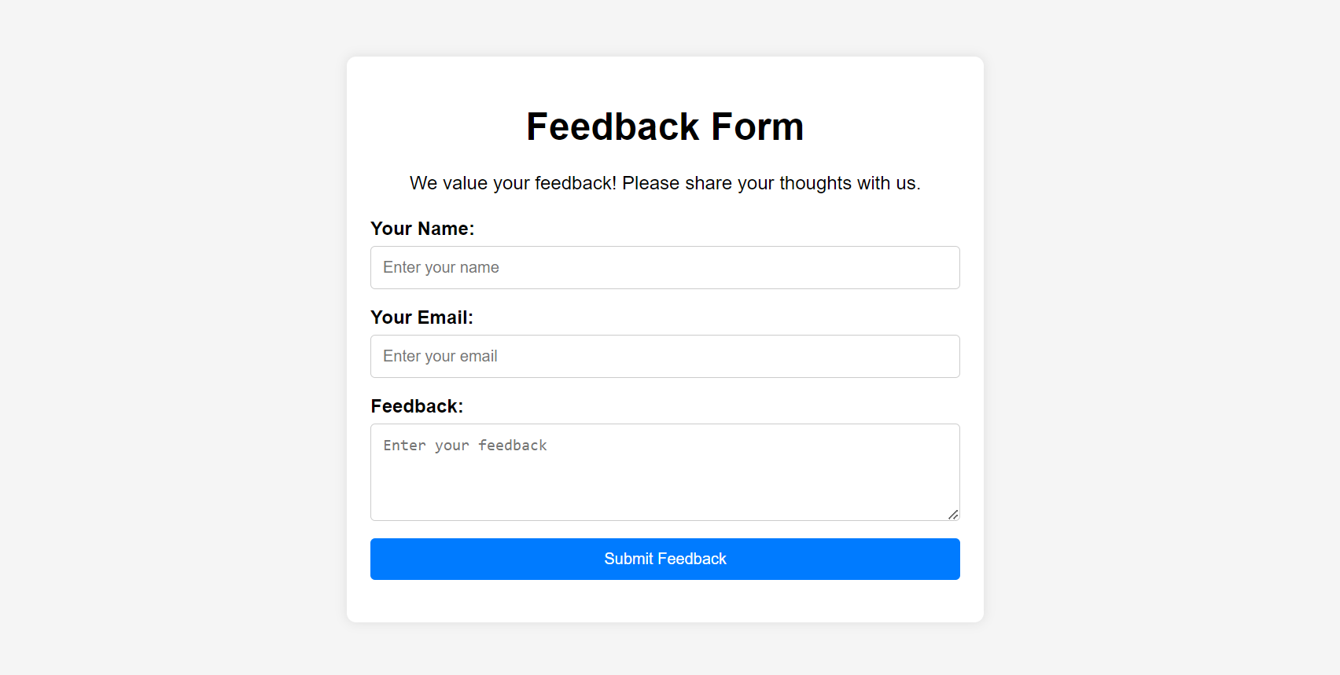

**Figure 5. 7:** Feedback page

## 5.3 Testing

System testing is testing conducted on a complete integrated system to evaluate the system's compliance with its specified requirement (Garaham, 2006). System testing is performed on the entire system in the context of either functional requirement specifications or system requirement specification, or both. System testing tests not only the design, but also the behavior and even the believed expectations of the customer. In our project we use unit testing as one of software system testing where unit testing is done by developers during the development phase. It involves testing individual units or components of the software to ensure they work correctly. Unit testing helps in identifying bugs early in the development process. Testing process is illustrated in Table 5.3.1

**Table 5. 1: Testing**

|  |  |  |  |
| --- | --- | --- | --- |
| S/N | Functional Requirement | Expected Outcome | Test Results |
| 1. | The system allows users to  register | The user should enter details into the system | The system allows users to perform this function |
| 2. | The system allows users to login | The user should login into the system | The system allows users to perform this function |
| 3. | The system allow user to upload the notes | The user should upload the notes into the system | The system allows users to perform this function |
| 4. | The system allow user to download the notes | The user should download the notes in the system | The system allows users to perform this function |

# CHAPTER SIX

# SUMMARY, CONCLUSION AND RECOMMENDATION

## 6.1 Introduction

This chapter provides a summary on the entire process of developing the learning system. Furthermore, this chapter provides the conclusion on the study as well as some recommendations.

## 6.2 Chapter summaries

### 6.2.1 Introduction

This chapter was about introduction of the project report which includes background information of the project title, problem statement, general objective, specific objectives and significance of the study.

### 6.2.2 Literature review

This chapter contains some reviewed literature which were related to our study and they helped in the collection of data used in implementing the system.

### 6.2.3 Methodology

This chapter was describing the methodologies like literature review, questionnaire used during data collection and approaches used in methodology.

### 6.2.4 System analysis and design

This chapter was explaining the requirement analysis which includes user requirements, system requirements and data requirements. It also shows how the system was designed by using ERD diagrams as well as use case diagrams.

### 6.2.5 Implementation and testing

In this chapter languages and technologies used in implementing the system were described and it shows each part of the system and how it works.

## 6.3 Conclusion

Conclusively, the aim of the study was successfully accomplished. With a system which aims to solve the problem of availability of notes to the student, by make student be able to download notes anytime anywhere. However, this study gives way to more research studies associated with this study in the future.

## 6.4 Challenges and limitations

We faced a variety of difficulties and constraints when developing our project, such as a lack of enough knowledge that makes it challenging to add some system functionalities, and a limited time for development of system.

## 6.5 Recommendations

In the lecture note management system, lecturers can upload their notes, and students can download them to support their learning needs. We would recommend a feature that would enable to minimize or remove the vulnerabilities of unauthorized access to the system and ensure that only registered lecturers can upload content.

Furthermore, more research should be done on ways to ensure the system is user-friendly and accessible on smartphones. This will enhance accessibility for students, especially in regions where access to computers is limited, thus significantly improving the educational experience.

# REFERENCES

Almalaise, S. A. (2019). A System Literature Review and Analysis of Unemployment Problem

Aravind Venkatesan & Sakthivel Nageshwaran (2022). Online notes sharing.

Dorothy Garaham, R. B. (May 2006). *foundations of software testing.* New York.

Garaham, R. B. (May 2006). *Foundation of Software Testing.* New York.

Jabr, M. A., & Al-Omari, H. K. (2010). e-Learning Management System Using Service Oriented Architecture

Paradkar, S. (2017). *Mastering Non-Functional Requirements.* Mumbai: Packt Publishing.

Pressman, R. S. (2014). *Software Engineering: A Practitioner's Approach.* McGraw-Hill

Sommerville, L. (2015). *Software Engineering 10th Edition.* Pearson.

Wiegers, K. E. (2013). *Software Requirements 3rd Edition.* Microsoft Pres