# ARDHI UNIVERSITY



**SCHOOL OF EARTH SCIENCE, REAL ESTATE, BUSINESS AND INFORMATICS**

**DEPARTMENT OF COMPUTER SYSTEMS AND MATHEMATICS**

**BSc. INFORMATION SYSTEMS MANAGEMENT YEAR 1**

**IS 191 : PROJECT 1 INFORMATION SYSTEM ANALYSIS, DESIGN AND**

**IMPLEMENTATION**

**PROJECT TITLE: ARU EVENT MANAGEMENT SYSTEM**

# PREPARED BY: GROUP 2

|  |  |  |  |
| --- | --- | --- | --- |
|  | MEMBER NAMES | REG.NUMBERS | SIGNATURE |
| 01. | CHRISTINA JUSTINE KIMARIO | 31703/T.2023 |  |
| 02. | ZAKIA NASWABU GEORGE | 30271/T.2023 |  |
| 03. | STEVEN GEORGE OKINYI | 31567/T.2023 |  |

# DECLARATION

We, **Group 2**, hereby declare that this report is our own work and effort. The work in this report was carried out in accordance with the Regulations of the Ardhi University. Where other sources of information have been used, they have been shown in the references list.

# S/N Student’s Name Signature Date

1. CHRISTINA JUSTINE KIMARIO ……………………………………………………….
2. ZAKIA NASWABU GEORGE ……………………………………………………….
3. STEVEN GEORGE OKINYI ………………………………………………………..

**Supervisor(s):**

1. Dr. Eunice Likotiko: **Signature**……………………**Date**……………….

2.Dr. Winfrida Mwigilwa: **Signature** ……………………**Date**…………………

# ABSTRACT

Participation and attendance of students in different events occur in Ardhi University is vital in promoting education and enhance accountability and depends on how the information is passed down to these people and how the events are managed by the sponsors and organizer, but there is a problem because of difficulty of passing down the information to the student due to lack of proper media that will be adverting the events and management, this lead to delay of information and poor attendance of students

ARU event management system offers several advantage to both students and sponsors to advertise their events and that everyone will be able to access the system for exploring and creating events, also every student will be able to access the system and register to a certain event. The system aims to ease passing down of information to students at the intended time

# ACKNOWLEDGEMENT

We sincerely extend our innermost gratitude to the Almighty God, the creator and sustainer of life for his grace and love to us, our family, friends and all that are around us since they have been the reason for us to be more than we thought we could be.

We extend our appreciation to Dr. Eunice and Dr.Winfrida for their abundant support outstanding supervision and sacrifice throughout this study from the beginning to its completion, and their patience and tireless efforts to provide us with intellectual direction and criticisms were very inspirational and helpful for us to complete this project. We would like to acknowledge with gratitude, support from our families and thank people who indirectly participated in this project without forgetting our fellow students for their support and suggestions. Also, we extend our thanks to all staff of the Department of computer system and mathematics for their contribution in completion of our study.

# TABLE OF CONTENT

DECLARATION i

ABSTRACT ii

ACKNOWLEDGEMENT iii

TABLE OF CONTENT vi

LIST OF FIGURES vi

LIST OF TABLES vii

LIST ABBREVIATIONS viii

CHAPTER ONE ………………………………………………………………………………….1

1.1 General introduction 1

1.2 Problem statement 1

1.3 Objectives 2

1.3.1 General objective 2

1.3.2. Specific objectives 2

1.4 Significance of the study 2

CHAPTER TWO 3

2.3 Event management system 3

2.4 Online event participation registration 4

CHAPTER THREE……………………………………………………………………………

3.1 Introduction 5

3.2 Data collection methods 5

3.2.1 Literature review 5

3.2.2 Questionnaire 5

3.2.3 Brainstorming 6

3.2.4 Waterfall methodology 6

3.3 Tools used 7

4.1 Introduction 9

4.2 Requirement analysis 9

4.2.1 User requirements 9

4.2.1.1 Functional requirements 9

4.2.1.2 Non-functional requirements 10

4.2.2 System requirements 10

4.2.2.1 Hardware requirements 11

4.2.2.1 Software requirements 11

4.3.1 System design architecture 12

Figure 4.1 Class diagram 13

4.3.3 Use case diagram 13

5.1 Introduction 15

5.2 Implementation 15

5.2.1 Home page 15

Figure 5.1 Home page 16

5.2.2 Login and registration form 16

Figure 1.2 login and registration form 17

5.2.3 Profile page 17

Figure 5.3 Profile page 18

5.3 Testing 19

6.1 Introduction 19

6.2 Chapter summaries 20

6.2.1 Introduction 20

6.2.2 Literature review 20

6.2.3 Methodology 20

6.2.4 System analysis and design 20

6.2.5 Implementation and testing 20

6.3 Conclusion 20

6.4 Challenges and limitations 20

6.5 Recommendations 21

REFERENCES 22

7

# LIST OF FIGURES

|  |  |
| --- | --- |
| Figure 3.1 Waterfall model | 7 |
| Figure 4.1 Class diagram | 12 |
| Figure 4.2 Use case diagram | 13 |
| Figure 5.1 Home page | 14 |
| Figure 5.2 Login page | 15 |
| Figure 5.3 Profile page | 16 |
| Figure 5.3 Profile page before creating event | 17 |
| Figure 5.4 Profile page after creating event | 18 |

# LIST OF TABLES

|  |  |
| --- | --- |
| Table 3.1 Methodology | 7 |
| Table 5.1 Testing | 20 |

# LIST ABBREVIATIONS

|  |  |
| --- | --- |
| HTML | Hypertext Markup Language |
| CSS | Cascading Style Sheet |
| ARUSO | Ardhi University Student Organization |
| EMS | Event Management System |

**CHAPTER ONE**

**INTRODUCTION**

# 1.1 General introduction

In Ardhi university where information provision and transparency to the student is the best way to promote their participation in daily activities including their attendances in lectures and different events that are to take place at Ardhi University including both academical political and social events. But due to lack of proper media that will be managing this events there has been a problem of information delivering to the student hence lead to poor attendance and participation

ARU events management system is a comprehensive solution designed to

Streamline the planning organization and execution of events of all scales and types that may be taking place in Ardhi University . Due to the increasing of the number of students the need of efficient event management tools has never been more crucial. This project aims to address this need by providing User friendly platform that empowers event planners with the tools they nned to orchestrate successful events seamlessly

Research conducted by Allied Market Research forecast significant growth in the global event management software market driven by factors such as rising demands for automation in event planning processes (Allied Market Research 2022. In addition to market trends, academic research also highlights the benefits of using technology in event management. A study published in the international Journal of event and festival management emphasizes the role of technology in enhancing the efficiency and effectiveness of event planning and execution( Xie et al..,2019

Overall, the research landscape underscores the importance of technological solutions like events management system in meeting the demands of modern event planning industry.By aligning with market trends and academic findings,this project is positioned to address critical challenges faced by event organizers and contribute to the advancement of the field

# 1.2 Problem statement

At Ardhi university there is tendence of delay of information about different events occurring within the campus which this is due to the low use of website by the students. Moreover the what sup groups created by students governments are still not efficient as still the method is not so efficient

So, the project we are conducting aid at modifying the system of delivering the message to the student, as we are creating a system that will be managing the events promoting and advertising them to ensure fast delivering of message to the students

# 1.3 Objectives

## 1.3.1 General objective

The general objective of this project was to develop ARU events management system that will be managing different events in Ardhi University to enable students to be provided with events information on time and trigger their participation

## 1.3.2. Specific objectives

The specific objectives of this project were as follows:

1. To gather user requirements for ARU events management system
2. To design ARU events management system
3. To implement ARU events management system

iv. To test ARU events management system

# 1.4 Significance of the study

The expected outcome of this study will greatly benefit students and events organizers/sponsors. By developing a ARU event management system students can be able to explore different events and register to the event ,also the sponsors and events organizers can be able to create the events for students participation

# CHAPTER TWO

**LITERATURE REVIEW**

**2.1 Introduction**

The purpose of this chapter is to analyze different works of literature related to a particular project. These literary works have been collected from various sources such as official reports, books, journals and conference articles. The following were literature reviews.

**2.2 A Systematic Literature Review and Analysis of problem facing events management system with possible solution**

In recent years, the event management industry has witnessed a paradigm shift towards the adoption of advanced technological solutions to enhance efficiency and effectiveness.

The rapid evolution of event management software has revolutionized the way events are planned organized and executed. From simple task management tools to comprehensive event management platform , technology has enabled event organizers to streamline processes improve communications and enhance attendee experience(Getz&Andersson,2018. Cloud computing, mobile application and analytic are among the key technology advancements dividing innovation in the field(Xie et al..,2019

Challenges and opportunities, despite the benefits offered by event management systems challenges persist in their implementation and utilization security concerns integration complexities and the need for user training are among the common challenges faced by organizations seeking to adopt these systems(Lee&Jung,2019. However these challenges also present opportunities for further research and development to address existing gaps and improve the usability and effectiveness of event management system

# 2.3 Event management system

Event management system integrate various aspects of events planning including registration marketing and analytic .They minimize administrative efforts by automating tasks such as booking scheduling and communication with vendors. This allows event organizers to focus on finer field details of event planning rather than getting bogged down in logistics(Wrike Team2023

On university campuses, for example EMS can handle the complexities of managing student and faculty events ensuring compliance with safety guidelines and improving communication between all parties involved. This not only enhances the safety and organizations pf events but also helps in efficient space management and real time tracking to avoid scheduling conflicts(EMS software,2023

# 2.4 Online event participation registration

Event registration software typically offers comprehensive tools for managing both in person and virtual events. Key forms ticketing, attendee management, features include customization registration forms ticketing attendee management payment processing and integration with other tools like CRM and email marketing software(Williams,2016&2017

These highlight the essential feature and benefits of modern event registration platforms, as well as the importance of choosing a solution that aligns with specific event needs and organizational goals. For more detailed information you can refer to sources like ,HubSpot.Eventible and ClickDimensions

**CHAPTER THREE**

**METHODOLOGY**

# 3.1 Introduction

Methodology can be defined as a proper study or analysis of all the methods used in the particular study or activity (Merriam-Webster, 2023). Also, it involves the use of various tools such as software and programming languages so as to achieve the general objective of the study (Dawson, 2019). Methodologies were used to ensure that each specific objective was achieved so as to facilitate the goal of attaining a general objective of developing a system which links ARU event management system

# 3.2 Data collection methods

## 3.2.1 Literature review

In this study the literature review which were used includes two journals which were a systematic literature review and analysis of unemployment problem and potential solutions and another journal which was the research to recruit online. Also, there was a report which was used as a review which was an online event participation registration. From these literature reviews we get the knowledge that among the causes of poor event management and participation in many organizations is due to poor application of modern technology to create efficient systems which will be managing the events

## 3.2.2 Questionnaire

This is the research instrument or tool that consists of a set of questions designed to gather information or data from respondents (Babbie, 2020). These questionnaires were prepared and supplied to some of the graduates and other job seekers through Google form. They were online which helped in minimizing cost and increasing efficiency in data collection. They were distributed via Whats up. Also, we use face to face visits as a way of obtaining information from the students. The reason as to why questionnaires were used is to understand the overall perception of students on the current methods of getting information. We succeeded in reaching severalt respondents and the general response was they need changes in the current existing systems for example ARUSO media and whats up groups.

## 3.2.3 Brainstorming

Brainstorming is a data collection method which involves generating ideas and sharing knowledge to solve a particular commercial or technical problem, in which participants are encouraged to think without interruption. Brainstorming is a group activity where each participant shares their ideas as soon as they come to mind (Rawlinson, 1986).

## 3.2.4 Waterfall methodology

Waterfall methodology is the methodology that has a sequential, linear process of project management (Sherman, 2015). As shown in Figure 3.1, it consists of several discrete phases. The specific phases of the system vary somewhat from source to source, but they generally include;

1. Requirement gathering and documentation: In this stage, you should gather comprehensive information about what this project requires. You can gather this information in a variety of ways, from interviews to questionnaires to interactive brainstorming. By the end of this phase, the project requirements should be clear, and you should have a requirements document that has been distributed to your team.
2. System design: Using the established requirements, your team designs the system. No coding takes place during this phase, but the team establishes specs such as programming language or hardware requirements.
3. Implementation: Coding takes place in this phase. Programmers take information from the previous stage and create a functional product. They typically implement code in small pieces, which are integrated at the end of this phase or the beginning of the next.
4. Testing: Once all coding is done, testing of the product can begin. Testers methodically find and report any problems. If serious issues arise, your project may need to return to phase one for revaluation.
5. Delivery or deployment: In this phase, the product is complete, and your team submits the deliverable to be deployed or released.
6. Maintenance: The product has been delivered to the client and is being used. As issues arise, your team may need to create patches and updates to address them. Again, big issues may necessitate a return to phase one.

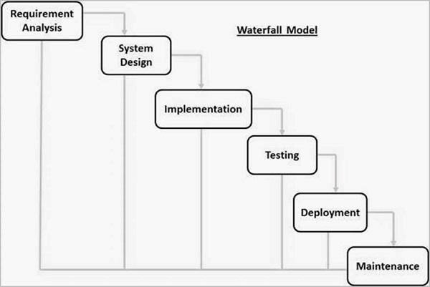

Figure 3.1 Waterfall model

# 3.3 Tools used

**Table 3.1 Methodology**

|  |  |  |  |  |
| --- | --- | --- | --- | --- |
| S/N | Specific objective | Methodology | Tools | Deliverable |
| 1. | To gather user requirements for ARU event management system | -Questionnaire  -Literature review | -Google forms and face to face visits **-**Journal and report | System requirements |
| 2. | To design ARU event management system | **-**Object Oriented Analysis and  Design (OOAD) | **-**Star UML | System design |
| 3. | To implement ARU event management system | -Waterfall methodology | -HTML  -CSS  -Clerk  -Tailwind CSS  -JavaScript  -Nextjs  -MongoDB | ARU event management system |
| 4. | To test and validate ARU event management system | **- Unit** testing | Computer | Testing results |

**CHAPTER FOUR**

**SYSTEM ANALYSIS AND DESIGN**

# 4.1 Introduction

System analysis is a phase in the system development life cycle which involves collecting and interpreting facts, identifying problems and decomposing a system into its components (Roth et al., 2013). System design may be defined as the process of planning a system or replacing an existing system by defining its components so as to satisfy specific requirements (Esfandiari & Lu, 2014). This chapter explains the techniques used to implement our system.

# 4.2 Requirement analysis

Requirement analysis is the process of studying user needs to arrive at a definition of system, hardware or software requirement. It is a critical phase in software engineering, as it forms the foundation for the development and design of a software system (Pressman, 2014). Also, there are the two types of requirement analysis which are user requirements and system requirements.

## 4.2.1 User requirements

User requirements are statements that describe the needs, expectations and constraints of the users for a particular system, product or service. They represent the desired functionality, performance and characteristics that the users expect from the system to fulfill their specific tasks or achieve their goals (Sommerville, 2015). User requirements are classified into two types which are functional requirements and non-functional requirements

### 4.2.1.1 Functional requirements

Functional requirements specify the specific behaviors, operations and capabilities that a system, product or service must possess to satisfy the user’s needs and achieve its intended purpose. These requirements describe the desired functionality, inputs, outputs and interactions with other system components (Sommerville, 2015). The functional requirements of this system were;

1. The system allows users to login
2. The system allows users to explore events

III.The system allows users to create events

Iv.The system allows users to delete event

V.The system allows users to logout.

### 4.2.1.2 Non-functional requirements

Non- functional requirements are an essential factor in developing a solution that will ensure customer satisfaction and delivery of business goals. Non-functional requirements may also be viewed as the constraints under which the functional requirements operate (Paradkar, 2017). The non-functional requirements for this system were;

1. Scalability: The system can easily scale out and in easily just by being registered and deleting accounts without deteriorating the performance of the system.
2. Security: The system is created in a way that the administrator will be the one who will have full authority on accessing and updating. It can be said that security is ensured with the use of passwords as well as access control.
3. Usability: The system is developed in a sense that it enables the use of it easily due to the use of simple language in the click options and directions.
4. Availability: The system can be accessed anytime in a day.

## 4.2.2 System requirements

System requirements specify the hardware, software, network and other technical specifications that a system must meet to support the desired functionality and performance (Wiegers, 2013). There are two types of system requirements which are hardware requirements and software requirements.

### 4.2.2.1 Hardware requirements

Hardware requirements refers to the minimum or recommended specifications for computer hardware components and systems needed to run specific software or perform certain tasks effectively

i. Processor (CPU) Intel(R) Core (TM) i5-6300U CPU @2.40GHz 2.50GHz

The CPU is responsible for executing instructions and performing calculations. It is measured in terms of clock speed (GHz) and the number of cores. Higher clock speeds and more cores generally result in better performance. ii. RAM 8.00GB

Is used to store data and instructions that are actively being used by the CPU. Having sufficient RAM allows for smoother multitasking and faster data access. RAM is measured in gigabytes (GB).

1. Storage 128SSD

There are two primary types of storage which are Hard Disk Drives (HDD) and Solid-State Drives (SSD). HDDs provide large storage capacities but are generally slow, while SSDs offer faster performance but with small capacities. The storage capacity required depends on the amount of data you need to store.

1. Display

The display requirements depend on the intended use. For general tasks, a standard monitor with a resolution of 1920x1080 pixels (Full HD). However, for specialized tasks like graphic design or gaming, higher resolution or multiple displays might be desired.

### 4.2.2.1 Software requirements

Software requirements are descriptions of the functionalists, features and constraints that a software system or application should process to meet the needs of its users and stakeholders i. Visual Studio Code

Is a free and open-source source code editor developed by Microsoft. It is designed to provide developers with a lightweight yet powerful tool of writing, editing and debugging code across various programming languages and platforms.

1. Web browser

Is an application software used to locate, retrieve and display the content of the World Wide Web. It includes Google Chrome, Mozilla Firefox and Microsoft Edge.

1. Windows 10Pro

Is a Microsoft operating system for personal computers, tablets, embedded devices and internet of things devices. It supports software used in developing and implementing a system. v. Microsoft Word

It is used to create and edit documents containing text and images. It was used to create a project report document for our system.

**4.3 System designs**

## 4.3.1 System design architecture

System design architecture refers to the process of conceptualizing and defining the architecture, components, interfaces and overall structure of a system, product or application. It involves translating requirements into a blueprint that outlines how the system will be built and the function (Pressman, 2014). The purpose of introducing system design is to bridge the gap between user requirements and system implementation, providing a roadmap for developing a system that fulfills the user’s needs effectively and efficiently.

**4.3.2 Class diagram**

Class diagram is the diagram which represents the static behaviors of the system similar to Entity Relational Diagram. In structured system analysis and design methodology (Booch et al...,2005) Class diagram includes both state and behavior of the system

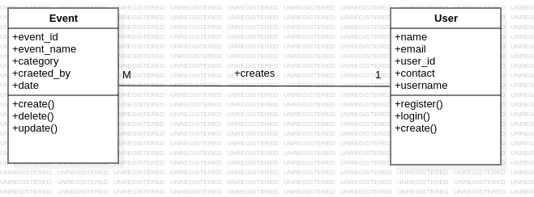

# Figure 4.1 Class diagram

## 4.3.3 Use case diagram

Use case diagram is a diagram which specifies the behavior of a system or part of a system and its description of a set of sequences of actions, including variants, that a system performs to yield an observable result of value to an actor (Booch et al., 2005). An actor is an idealization of an external person, process or thing interacting with a system, subsystem or class (Rumbaugh et al.

1999). The use class diagram is illustrated in Figure 4.2.

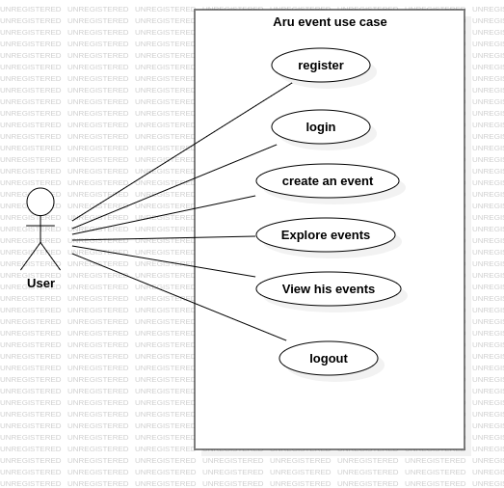

Figure 4.2 Use case diagram

**CHAPTER FIVE**

**IMPLEMENTATION AND TESTING**

# 5.1 Introduction

In this chapter the elements of the development phase, tools required for implementation of the system are described. Furthermore, it is in this chapter where testing results of the system are explained and how the system is implemented.

# 5.2 Implementation

ARU event management system was developed by using different languages and technologies where for frontend development HTML, CSS and JAVASCRIPT were used also, TAILWIND as the framework of CSS was used, while in backend development which involve user inputs during registration and login, JAVASCRIPT and NEXTJS as its framework was also used .Also for connection with database management and to export data into database management for the storage of data and user validations MONGODB was used and also for login and accounts creation together profiles management CLERK was used . The following are the phases of system development.

## 5.2.1 Home page

The home page in this system carries the general view of the system, it represents different areas of the system through the navigation links on the top right corner of the system. Those navigation bars will allow the system users to access different areas in the system according to their roles. Navigation bar contains the system logo (top left corner of the system) and the navigation links. Figure 5.1 shows the home page of ARU events management system.

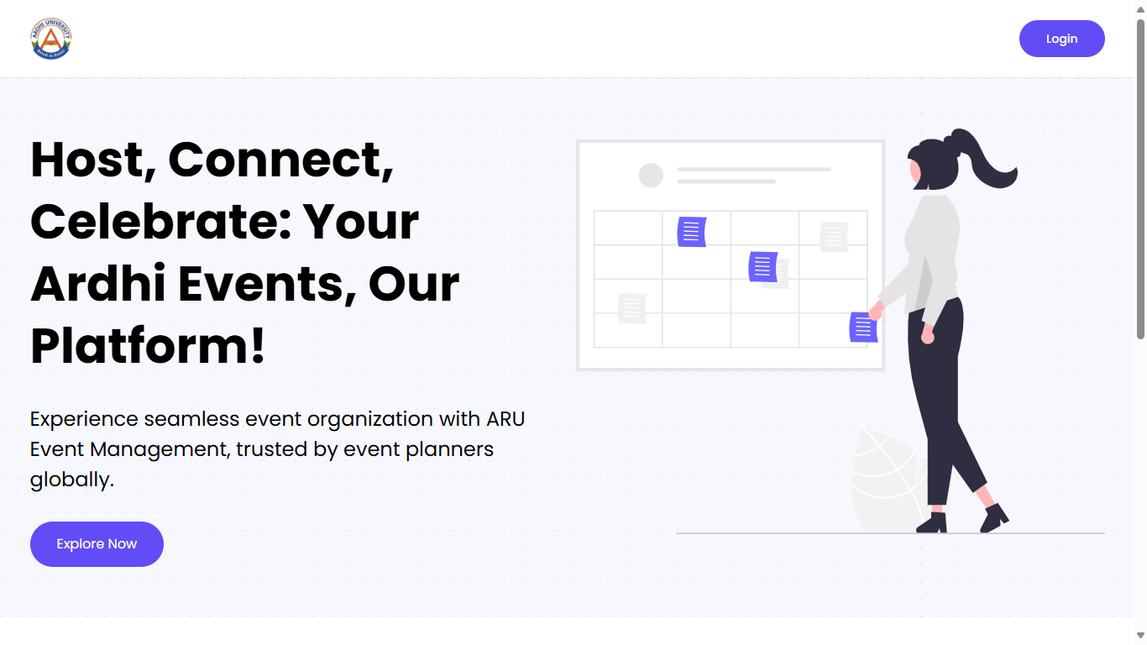

# Figure 5.1 Home page

## 5.2.2 Login and registration form

On this page the system allows users toto register to and if one is signed in google will proceeed or the user will be required to fill in the email

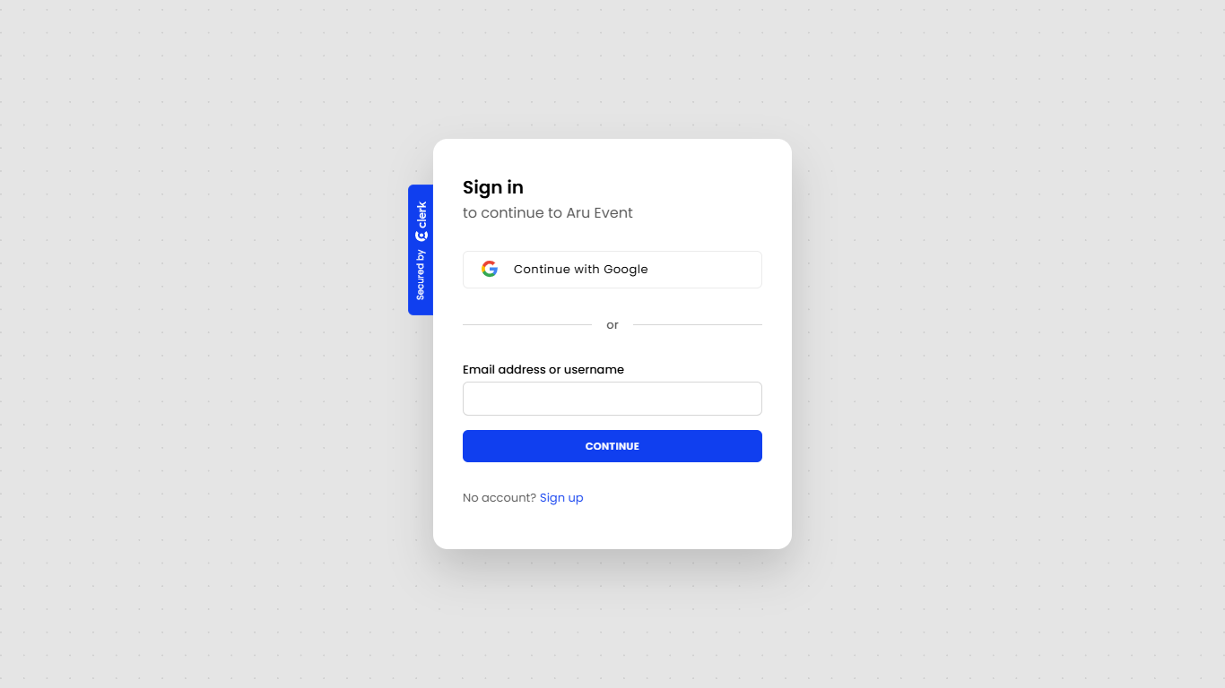

# Figure 1.2 login and registration form

## 5.2.3 Profile page

This page appears only when the user login to the system. In this page the user is allowed to create events

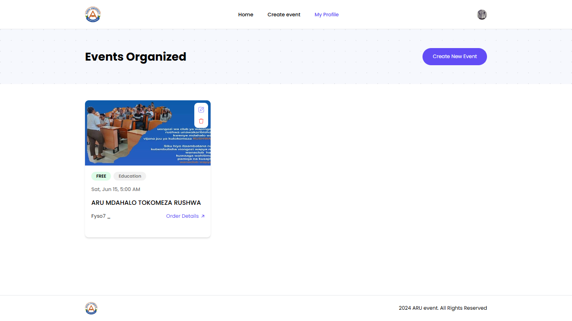

# Figure 5.3 Profile page

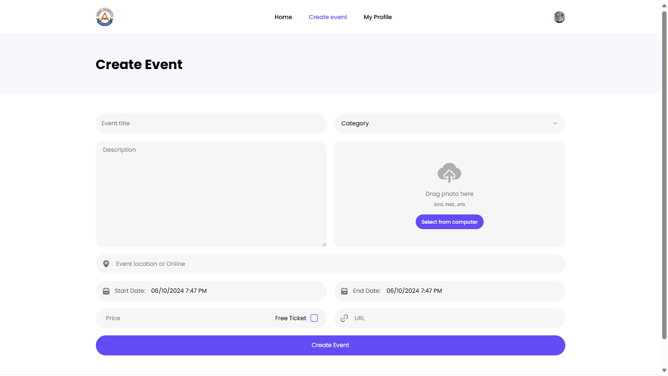

Figure 5.5 Profile page before creating event

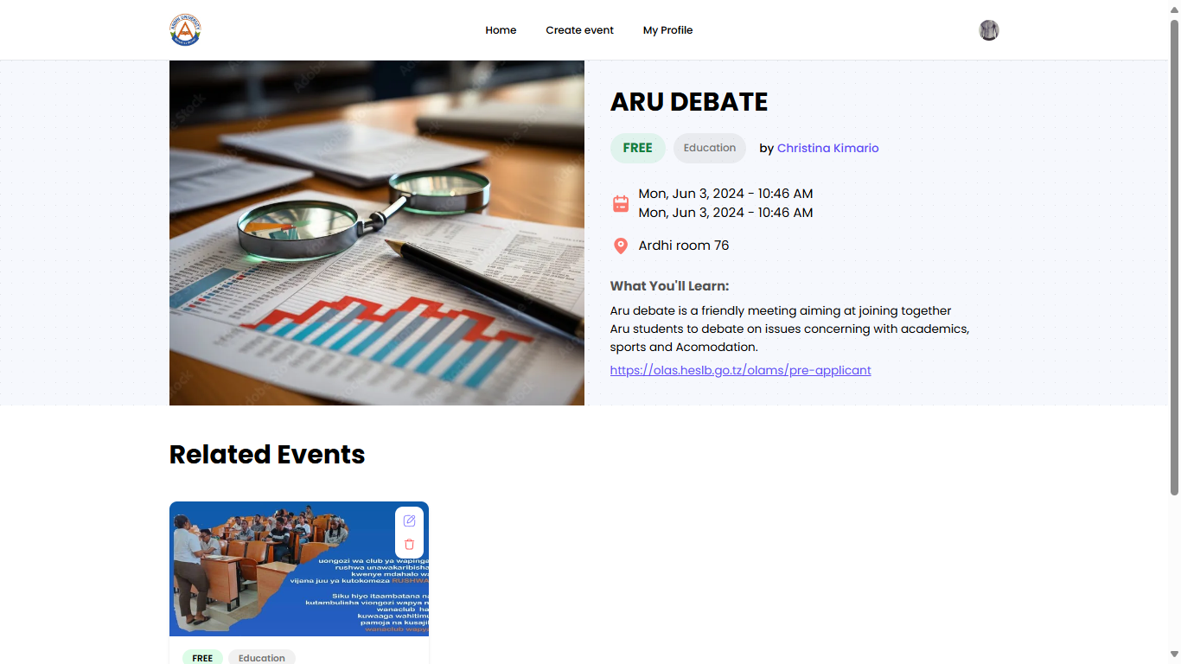

Figure 5.5 Profile page after creating event

# 5.3 Testing

System testing is testing conducted on a complete integrated system to evaluate the system's compliance with its specified requirement (Garaham, 2006). System testing is performed on the entire system in the context of either functional requirement specifications or system requirement specification, or both. System testing tests not only the design, but also the behavior and even the believed expectations of the customer. In our project we use alpha testing as one of software system testing where alpha testing is a type of software testing performed to identify bugs before releasing the product to real users or to the public. Alpha testing is user acceptance testing (Garaham, 2006). Testing process is illustrated in Table 5.1.

**Table 5.1 Testing**

|  |  |  |  |
| --- | --- | --- | --- |
| S/N | Functional Requirement | Expected Outcome | Test Results |
| 1. | The system allows users to  log in | The user should enter details into the system | The system allows users to perform this function |
| 2. | The system allows users to explore events | The user should explore events into the system | The system allows users to perform this function |
| 3. | The system allow user to create events | The user should create events into the system | The system allows users to perform this function |
| 4 | The system should allow user to logout and delete their accounts | The users should be able to logout and delete their accounts from the system | The system should allow users to perform this function |

**CHAPTER SIX**

**SUMMARY, CONCLUSION AND RECOMMENDATION**

# 6.1 Introduction

This chapter provides a summary on the entire process of developing the ARU events management system. Furthermore, this chapter provides the conclusion on the study as well as some recommendations.

# 6.2 Chapter summaries

## 6.2.1 Introduction

This chapter was about introduction of the project report which includes background information of the project title, problem statement, general objective, specific objectives and significance of the study.

## 6.2.2 Literature review

This chapter contains some reviewed literature which were related to our study and they helped in the collection of data used in implementing the system.

## 6.2.3 Methodology

This chapter was describing the methodologies like literature review, brainstorming, questionnaire as well as waterfall methodology used during data collection and approaches used in methodology.

## 6.2.4 System analysis and design

This chapter was explaining the requirement analysis which includes user requirements, system requirements and data requirements. It also shows how the system was designed by using class diagrams as well as use case diagrams.

## 6.2.5 Implementation and testing

In this chapter languages and technologies used in implementing the system were described and it shows each part of the system and how it works.

# 6.3 Conclusion

Conclusively, the aim of the study was successfully accomplished. A system which aims to promote students with potential information about different events which are to take place at Ardhi university and enhance the delivering of these information on time that each student is accessed with this system

# 6.4 Challenges and limitations

During the development of our project, we faced different challenges and limitations among those challenges and limitations includes limited knowledge which makes it difficult to add some of the functionality to the system, differences in ideas among group members as well as limited time of developing our system.Also we fail to implement a condition where only the admin will be able to create and manage events creation and advertisement the events as everyone who will login will be able to create the event. Also we failed to implement the payment system that means only free events will be able to be created and not otherwise for the process is very complicating.

# 6.5 Recommendations

From the above report about the system we recommend the student to use the system efficiently and the student government to use the system effectively to pass information to the students, also we call upon the attention and loyalty of the students to use the system for learning purpose and not otherwise meaning that events created should have realistic and proper information about the students should be provided

# REFERENCES

Dorothy Garaham, R. B. (May 2006). *foundations of software testing.* New York

EMS Software(,2023.*What is event management system*

Garaham, R. B. (May 2006). *Foundation of Software Testing.* New York.

Kumar, R. (April 2021). Online Job Search Application. *International Sound of Engineering*

*Research and Technology*

Paradkar, S. (2017). *Mastering Non-Functional Requirements.* Mumbai: Packt Publishing.

Pressman, R. S. (2014). *Software Engineering: A Practitioner's Approach.* McGraw-Hill Education.

Rawlinson, G. J. (1986). *Creative Thinking and Brainstorming.* Johannesburg: Gower Publishing Ltd.

Rob Samuda. (2023). *Major Job-hunting Hurdles of Today*.

Sommerville, L. (2015). *Software Engineering 10th Edition.* Pearson.

Wiegers, K. E. (2013). *Software Requirements 3rd Edition.* Microsoft Press

Williams, C,(2016&2017 *Everything you need to know about Event registration.*HubSpotBlog

Wrike Team(2023 *Measuring Event Success with Event management system.*Wrike Team

25