CHAPTER THREE

METHODOLOGY

3.1 Introduction

Methodology can be defined as a proper study or analysis of all the methods used in the particular study or activity (Merriam-Webster, 2023). Also, it involves the use of various tools such as softwares and programming languages so as to achieve the general objective of the study (Dawson, 2019). Methodologies were used to ensure that each specific objective was achieved so as to facilitate the goal of attaining a general objective of developing a system which allows the lecture to share notes whereby the student can access the notes through downloading in the system.

3.2 Data collection methods

3.2.1 Literature review

In this study the literature review which were used includes two journals which were a systematic literature review and analysis of online notes sharing systems (websites) and another on e-learning. From these literature reviews we got that most of the online notes sharing system aren’t free they charger fee so as to access the notes , also we got knowledge on how to create the system by using html , on the frontend and Django as the framework on the backend .

3.2.2 Questionnaire

This is the research instrument or tool that consists of a set of questions designed to gather information or data from respondents (Babbie, 2020). These questionnaires were prepared and supplied to some of the universities student through google form. They were online which helped in minimizing cost and increasing efficiency in data collection. They weredistributed via WhatsApp. Also, we use face to face visits as a way of obtaining information from students .

The reason as to why questionnaires were used is to understand the overall difficulties of students on receiving notes . We succeeded in reaching respondents and the general response was they need changes in the current existing systems of notes sharing .

3.2.3 Brainstorming

Brainstorming is a data collection method which involves generating ideas and sharing knowledge to solve a particular commercial or technical problem, in which participants are encouraged to think without interruption. Brainstorming is a group activity where each

participant shares their ideas as soon as they come to mind (Rawlinson, 1986).

3.2.4 Waterfall methodology

Waterfall methodology is the methodology that has a sequential, linear process of project management (Sherman, 2015). As shown in Figure 3.1, it consists of several discrete phases. The specific phases of the system vary somewhat from source to source, but they generally include;

i. Requirement gathering and documentation: In this stage, you should gather comprehensive information about what this project requires. You can gather this information in a variety of ways, from interviews to questionnaires to interactive brainstorming. By the end of this phase, the project requirements should be clear, and you should have a requirements document that has been distributed to your team.

ii. System design: Using the established requirements, your team designs the system. No coding takes place during this phase, but the team establishes specs such as programming language or hardware requirements.

iii. Implementation: Coding takes place in this phase. Programmers take information from the previous stage and create a functional product. They typically implement code in small pieces, which are integrated at the end of this phase or the beginning of the next.

iv. Testing: Once all coding is done, testing of the product can begin. Testers methodically find and report any problems. If serious issues arise, your project may need to return to phase one for revaluation.

v. Delivery or deployment: In this phase, the product is complete, and your team submits the deliverables to be deployed or released.

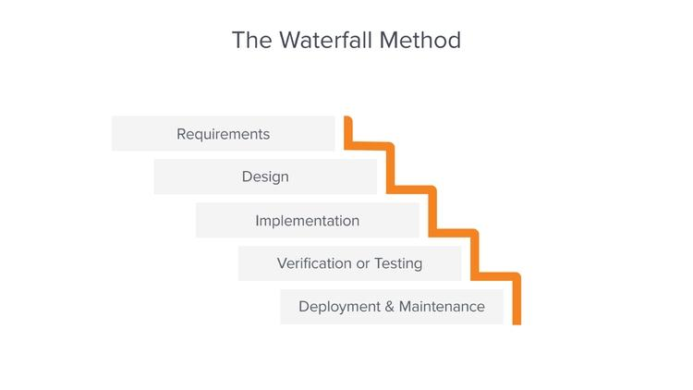vi. Maintenance: The product has been delivered to the client and is being used. As issues arise, your team may need to create patches and updates to address them. Again, big issues may necessitate a return to phase one.

3.3 Tools used

Table 3.1 Methodology

|  |  |  |  |  |
| --- | --- | --- | --- | --- |
| S/N | Specific objectives | Methodology | Tools | Deliverable |
| 1 | To gather user requirements for lecture- student repository | -Questionnaire  -Literature review | -Google forms  - face to face visits  -google scholar | System requirements |
| 2 | To design lecture – student repository system | -object oriented approach | -draw.io  -star UML | System design document |
| 3 | To develop lecture student repository notes | -water fall methodology | Html, CSS, python ,Django ,SQlite | Prototype / develop system |
| 4 | -To Test and validate lecture – student notes repository | Unit testing | Computer, browser | Testing results |