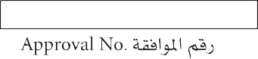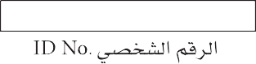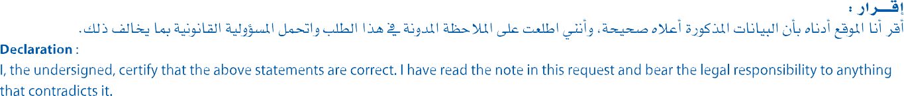

✔

✔

10*/*07*/*2018

متزوجة

ايلاريه موريس فرنسيس شلبي

عادي

1988/01/05

زوجة

مصرية

A03989712

الجيزة

|  |  |  |  |
| --- | --- | --- | --- |
|  |  |  |  |
|  |  |  |  |
|  |  |  |  |
|  |  |  |  |

33629054

✔

مصري

جامعي

ام غويلينا

296792

28581809269

كريم اسحق فهمي جرجس

10221108

12500

عائلي

1053762

مهندس

جديد

خوار

Required Attachments

1. Photocopy of the sponsor's l.D card.
2. Photocopy of valld passport of the person to be brought in.
3. An attested copy of marriage contract & birth certificates for children.

4. An attested copy of the employment contract emphasizing Job & Salary.

5. A certificate of good conduct (Police Clearance) which is attested by

the relevant authorities for ad ults.

6. A health insurance with a company that is accepted in the state, for the

whole duration of the visitor's stay in the country.

7, Pass the medical examination abroad in accordance with the adopted

mechanlsm by the relevant authorities.

8. Any other conditions deemed necessary by the relevant authority In

this regard.



.J,;oS:ll Iul.l..;JI (.>"- o.iy.o .I

•.....l.i.£l...I y,u..ll I_,4.. jl_p,. (.>"- o.iy.o .Y

. \li':ll )l.;..::;bJ '[IJj.11 i.>"- a;........, o.iy.o .Y

.y:;l.;Jl_1 "4tl .JS}.! J..11 '-"'" as.i-. •.iy.o .!

,:,.. .:i:;;Jl;ll a...,,;;..\l .:,LbL.JI.:,.. a;...._,. c!_l ,l.._1 _,,,... ;, .•

..i..l._,JI

.a[!,ll •l.:\i '""' ;.J,;l. l.!_1.i.l\.i;.i..,:W.l .:..IS_,..!JI .s_,..1.s.i.J ..,--u;;..b .1

. }\.;JI

.s.>.! .i..:w,I <;f>tl Jl!J ?;J: L;JI \ I.)l;l-,. _,,,;:; ;, .v

.Id.,_!!

...,.. I a...,,;;..\I ILoi,,:; .;_,;.1J. ,_,1.A

Important Notes



1.This form should be typed InArable.

1. Name & data should be typed as written in the passport.
2. A valid residency permit fur the foreign spouse of the gulf citizen issued

ln his country or a marriage approval attested by the relevant authorities.

4, All the documents must be in serial as mentioned above.

5. Original documents are required when submitting the appllcatlon fur approval.

.a,,_,..i1 :Ul.l;l 4c.l;Jo ylJ..ll .:,.,, .\

._,.;..JI ..)IJ'\'l u_,.i.._,,- t.. ..,._

•-"/ .;,.< !<)bl \/l :i..,.J..).IJ

I.::.L\t,,ll_1 ,t....\/i <;b!: .Y

l *'\!)L..*<..ll!fl\ a.....;.J .Y

;i._ F_,..*_,,-* Lo ....-

. I.::.I,;_,,. a;.;_,.. [IJ) :U:.I,_. Jl

,,:;*t"* .....,1_1 .:,L;J,,,.ti .iy.o .:;p:; .:i1

..)kl >J-l;ll

.t

.l.;;;U....U yJJ..!1 f./.,.;:; .i.ic. I a,i....\11 Jll.\_,JI Ji..;,,.l .•