**DEVELOPMENT OF A SUPPORT DRONE**

**FOR**

**EMERGENCY SERVICES**

**Submitted**

**By**

**Jagannath Sagar Karri**

**Regd. No: BU21EECE0100162**

**Under the Guidance of Mrs. Sanhita Manna**

**Assistant Professor**

**Duration: 01/09/2024 to Date/Month/Year**



**Department of Electrical, Electronics and Communication Engineering [14 Bold]**

**GITAM School of Technology**

**GITAM**

**(DEEMED TO BE UNIVERSITY)**

**(Estd. u/s 3 of the UGC act 1956)**

**NH 207, Nagadenehalli, Doddaballapur taluk, Bengaluru-561203 Karnataka, INDIA.**

**DECLARATION**

**I/We declare that the project work contained in this report is original and it has been done by me under the guidance of my project guide.**

**Name:**

**Jagannath Sagar Karri**

**Date: Signature of the Student**

**Department of Electrical,Electronics and Communication Engineering [14 Bold]**

**GITAM School of Technology, Bengaluru-561203**



**CERTIFICATE**

**This is to certify that (Student Name) bearing (Regd. No.:) has satisfactorily completed Mini Project Entitled in partial fulfillment of the requirements as prescribed by University for VIIIth semester, Bachelor of Technology in “Electrical, Electronics and Communication Engineering” and submitted this report during the academic year 2024-2025.**

**[Signature of the Guide] [Signature of HOD**

**Table of contents**

**Chapter 1: Introduction 1**

1.1 Overview of the problem statement 1

1.2 Objectives and goals 1

**Chapter 2 : Literature Review 2**

**Chapter 3 : Strategic Analysis and Problem Definition 3**

3.1 SWOT Analysis 3

3.2 Project Plan - GANTT Chart 3

3.3 Refinement of problem statement 3

**Chapter 4 : Methodology 4**

4.1 Description of the approach 4

4.2 Tools and techniques utilized 4

4.3 Design considerations 4

**Chapter 5 : Implementation 5**

5.1 Description of how the project was executed 5

5.2 Challenges faced and solutions implemented 5

**Chapter 6:Results 6**

6.1 outcomes 6

6.2 Interpretation of results 6

6.3 Comparison with existing literature or technologies 6

**Chapter 7: Conclusion 7**

**Chapter 8 : Future Work 8**

Here write Suggestions for further research or development Potential improvements or extensions 8

**References 9**

# Chapter 1: Introduction

## 1.1 Overview of the problem statement

The project addresses the need for advanced tools to enhance the efficiency of emergency response services, focusing on a drone designed for reconnaissance and support in disaster-affected areas. The drone will provide real-time situational awareness to emergency responders, reducing response times and improving decision-making​

## 1.2 Objectives and goals

• **Objective:**

Develop an assistance drone to enhance emergency service capabilities by providing real-time situational awareness and supporting rescue operations​

• **Goals:**

* Implement high-resolution imaging for detailed assessment.
* Integrate real-time communication for continuous data transmission.
* Ensure operation under harsh environmental conditions with a 1 km range and 40-minute flight time

# Chapter 2: Literature Review

Key Publications

* APPLICATIONS OF UNMANNED AERIAL VEHICLES: A REVIEW

<http://dx.doi.org/10.17993/3ctecno.2019.specialissue3.85-105>

* A review of UAV autonomous navigation in GPS-denied environments

<https://doi.org/10.1016/j.robot.2023.104533>

* Reliable Flying IoT Networks for UAV Disaster Rescue Operations

<https://doi.org/10.1155/2018/2572460>

* UAV- based Photogrammetry and Geo-computing for Hazards and Disaster Risk Monitoring – A Review

<https://doi.org/10.1186/s40677-016-0060-y>

Key Resources – Whitepaper| Application Notes | Datasheet| Others

* Component: Ublox NEO-M8N GPS Module [Datasheet](https://content.u-blox.com/sites/default/files/NEO-M8-FW3_DataSheet_UBX-15031086.pdf)
* Component: Sharp GP2Y0A21YK0F Analog Distance Sensor [Datasheet](https://www.google.com/aclk?sa=l&ai=DChcSEwiIl4DWg5yIAxW8pmYCHY0NMekYABABGgJzbQ&co=1&ase=2&gclid=CjwKCAjwuMC2BhA7EiwAmJKRrBtztMSsuNlPfdn68FPPq6cgkdmq8mlJXbafm-oNZmNHA4eAnA3pJRoCKiAQAvD_BwE&sig=AOD64_2xf9INuFubsuBNRGzjhXYOXYXggA&q&nis=4&adurl&ved=2ahUKEwir4PjVg5yIAxVO6jgGHYxzLjIQ0Qx6BAgKEAE)
* Component: HC-SR04 Ultrasonic Distance Sensor [datasheet](https://www.google.com/aclk?sa=l&ai=DChcSEwiLuYO_g5yIAxXCHoMDHfzvBPEYABAAGgJzZg&co=1&ase=2&gclid=CjwKCAjwuMC2BhA7EiwAmJKRrN7Ucb8RXaSMjmCIruuOh4aHAB2CfBFEctjkus-iMg2nt-L1z18mbRoCynMQAvD_BwE&sig=AOD64_1QxHEQmWzM1n8Q45tofGCA3s69uw&q&nis=4&adurl&ved=2ahUKEwiYvPu-g5yIAxVm4zgGHcZLF4kQ0Qx6BAgOEAE)

Existing Implementations – Products| Opensource| GitHub etc

* Aerial Drones for Fire Disaster Response

10.5772/intechopen.1002525

* DJI ENTERPRISE – Fire fighting

https://enterprise.dji.com/public-safety/firefightingFirefighting

# 

# Chapter 3 : Strategic Analysis and Problem Definition

## 3.1 SWOT Analysis

**Strengths**

S1. High-resolution imaging provides detailed situational awareness.

S2. Real-time communication enhances coordination and decision-making.

S3. Autonomous navigation allows for operation in challenging environments without constant human intervention.

**Weaknesses**

W1. Battery limitations restrict flight time and range.

W2. Dependence on communication infrastructure may affect performance in areas with poor connectivity.

**Opportunities**

O1. Increasing need for efficient disaster response solutions worldwide.

O2. Potential partnerships with government agencies, NGOs, and private sectors involved in disaster management.

O3. Expansion into other applications, such as surveillance, wildlife monitoring, and infrastructure inspection.

**Threats**

T1. Potential for signal interference or hacking, compromising communication and control

T2. Environmental challenges (e.g., severe weather conditions) that could affect drone operation.

### 

### 

### 3.2 Project Plan - GANTT Chart

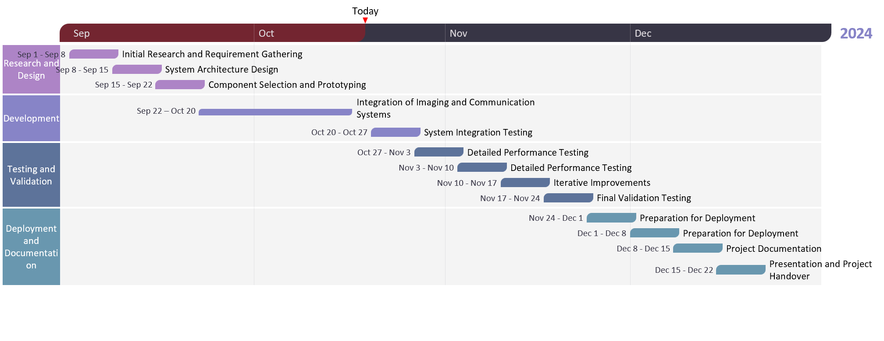

##### 3.3 Refinement of problem statement

Focus on developing a drone that is not only cost-effective but also scalable and adaptable for various disaster response scenarios. Address specific challenges related to power management, data transmission reliability, and durability in adverse conditions

# 

# Chapter 4: Methodology

## 4.1 Description of the approach

• Develop a prototype using off-the-shelf components to minimize costs.

• Implement a modular design for easy maintenance and future upgrades.

• Conduct controlled environment testing to ensure the drone’s reliability before deployment in actual disaster scenarios.

### 4.2 Tools and techniques utilized

• Program the microcontroller (e.g., Arduino Nano) using Mission planner for flight control and sensor integration.

• Utilize simulation software for initial flight and obstacle avoidance testing.

#### 4.3 Design considerations

• Balance between cost and functionality, ensuring essential features are met without exceeding budget constraints.

• Focus on lightweight materials to optimize flight time and maneuverability.

• Design the drone to be compact and portable for rapid deployment

# Chapter 5: Implementation

## 5.1 Description of how the project was executed

• Components such as GPS, ultrasonic sensors, camera modules, and Wi-Fi communication modules were procured and integrated into the drone’s design.

• Initial prototyping involved testing sensor integration and flight stability in a controlled indoor environment.

• Software development focused on enabling autonomous navigation and real-time data streaming.

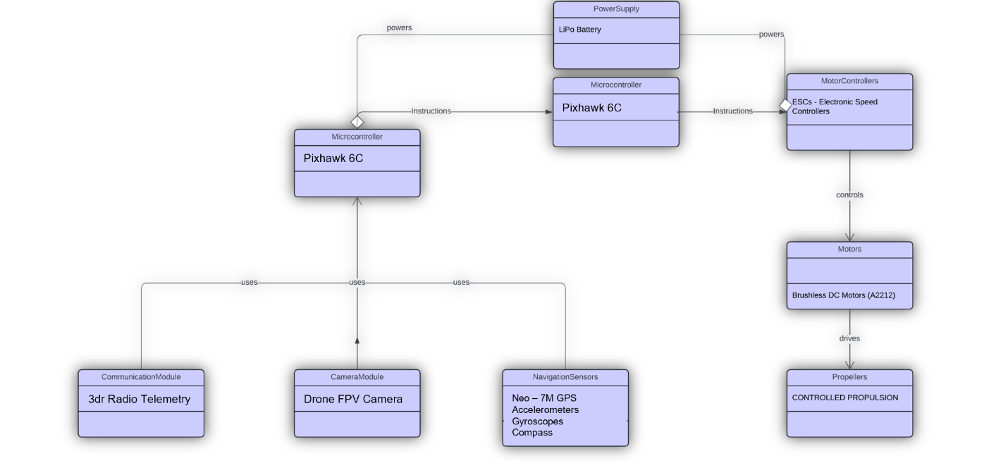

### 5.2 Challenges faced and solutions implemented

• Challenge**:** Limited battery life restricting operational time.

* **Solution:** Optimized power consumption by conserving weight of the drone

• Challenge**:** Ensuring reliable communication in areas with poor network coverage.

* **Solution:** Implemented robust Radio protocols and researched alternative communication technologies.

# Chapter 6: Results

## 6.1 outcomes

### 6.2 Interpretation of results

### 

#### 6.3 Comparison with existing literature or technologies

# Chapter 7: Conclusion

Here write Suggestions for further research or development and Potential improvements or extensions

# 

# Chapter 8 : Future Work

#### Here write Suggestions for further research or development Potential improvements or extensions

#### 

# References