**Project Title: LED Blinker Lights with Transformer and Capacitor**

*Project Description:*

The project aims to design and create a set of LED blinker lights that can be used for both safety and decoration purposes. The LED blinker lights will be designed to provide high visibility to vehicles and pedestrians during low light conditions, such as foggy weather, night time, or dark places. The blinker lights can also be used for decorative purposes, such as for home or party decorations. The LED blinker lights will be powered by a transformer and a capacitor instead of a microcontroller, making it a simpler and more cost-effective design.

*Purpose:*

The purpose of experimenting with a double LED blinker light circuit is to understand the basic principles of electronic circuits and to learn how to create a simple electronic device. The LED blinker circuit is a popular circuit for beginners in electronics because it is easy to build and requires only a few components.

By building a double LED blinker circuit, you can learn about the properties of different electronic components, such as resistors, capacitors, and transistors. You can also learn about the concept of voltage and current, and how they are used to power electronic devices. And this circuit or experiment can enhance on-hand experiments to prepare for the basics of becoming a professional engineer.

*Materials:*

* Battery (e.g., 9V)
* -Capacitor (e.g., 2200uF)
* -LED lights (e.g, depending on the available LED)
* -Resistors (e.g., 220 ohms)
* -Breadboard
* -Jumper wires

*Schematic Drawing:*

Here is the schematic drawing for the LED blinker lights with a transformer and capacitor:

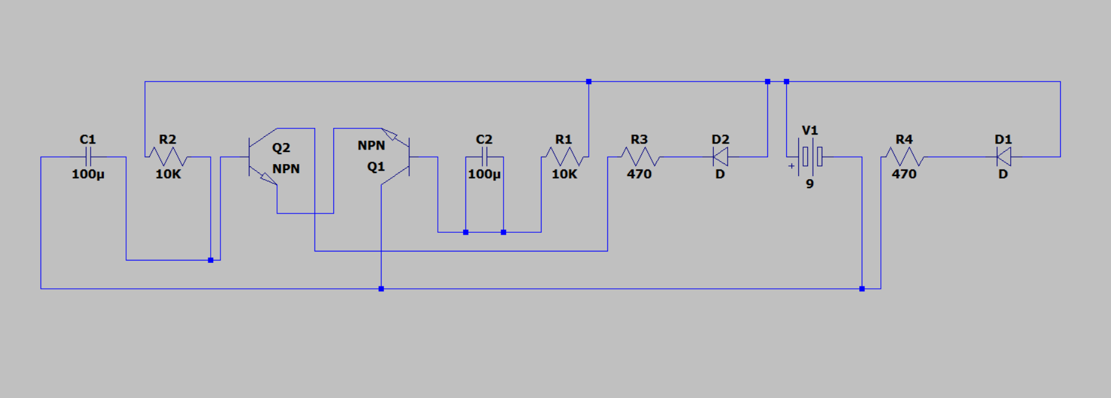

*Block Diagram:*



In this block diagram, the 9V battery is used as the power source. A voltage regulation component ensures a stable voltage supply to the circuit. The current limiting resistor is used to protect the LEDs. The transistor acts as a switching element, controlling the flow of current through the LEDs. The capacitor is introduced as a timing component, controlling the blink rate of the LED blinker lights. Finally, the LED blinker lights emit light according to the timing of the capacitor, creating the blinking effect.