BAI31123 Knowledge Representation
Group Project: Build an Expert System

Subject of the system:
Selecting a Vehicle Type

Group members:
1 | Chow Kai Jie
2 | Woon Ren Yi
3

1. The subject, and why rules suit it
This system evaluates a driver’s lifestyle, seating needs, primary terrain, and fuel preferences to recommend the most suitable vehicle type such as Compact Hatchback, Sedan, SUV, MPV, Pickup Truck, Sport Car, Wagon or Pure Electric. A rule-based expert system is ideal for this task because vehicle selection follows deterministic, logical criteria rather than probabilistic guessing. By structuring decisions trees into logical middle layers, the system can systematically eliminate incompatible vehicle categories via straightforward user inputs. A user comes to this system seeking personalized advice on which type of vehicle best fits their daily driving conditions, household requirements and personal preferences. Instead of browsing hundreds of individual car models, the user wants a clear, objective recommendation on the vehicle segment they should target, along with a logical explanation of why that specific type satisfies their daily requirements.

Vehicle classification relies on explicit, conditional constraints. For example, vehicle must be a Minivan or MPV if the passenger capacity is more than 5 and compact hatchbacks are disqualified if there is high off-road capability is required. These conditions use Boolean logic (“and”, “or”, “not”) that easily map to Prolog rules and middle-layer abstractions such as city_commuter, offroad_capable or performance_oriented. The difference between rule-based and data or statistics driven is rule based is logical deductions but data or statistics driven is probabilistic predictions. In term of vehicle type, recommending a vehicle type is based on clear design rules and boundaries such as extra cargo needs, towing needs and seating requirements. It does not require analysing large datasets or training probabilistic machine learning models because the rules are clear and cannot be changed. For data or statistics driven, statistical machine learning is required for non-deterministic tasks with continuous variables and noise such as predicting a vehicle’s future resale value, estimating component failure rates over time or calculating insurance risk based on historical driver demographics.

The rules were established through a combination of personal experience with vehicle specs, watching videos by automotive journalists on YouTube and standard manufacturer classification criteria. These sources define how vehicle types are categorized based on body style, drivetrain layout and intended usage especially from automotive journalist.

2. How we structured the knowledge
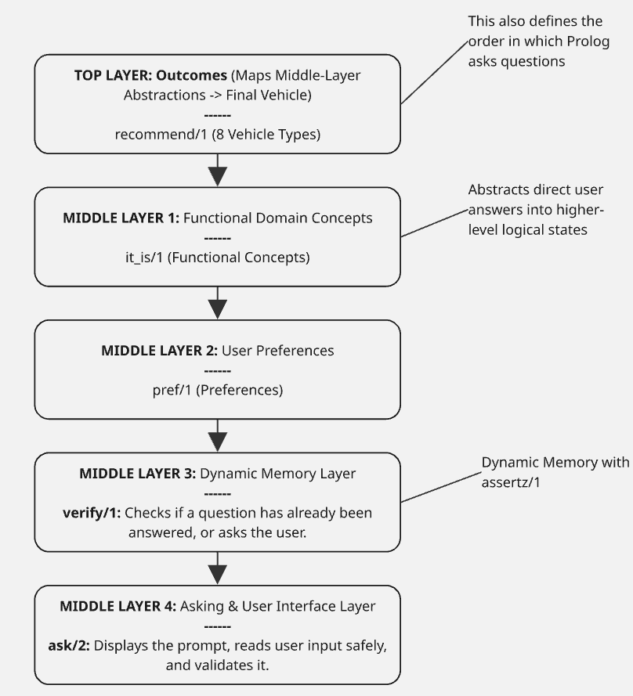
Figure 1 Layer Flowchart
1. TOP LAYER: Outcomes (recommend/1)
- This layer is used to evaluate the combination of middle-layer state to reach a final vehicle classification.
- The rules have:
  - recommend('Pure Electric Commuter (EV)')
  - recommend('Compact Hatchback')
  - recommend('SUV')
  - recommend('Wagon / Estate')
  - recommend('MPV / Minivan')
  - recommend('Pickup Truck')
  - recommend('Coupe / Sports Car')
  - recommend('Sedan')
2. MIDDLE LAYER 1: Functional Domain Concepts
- This layer is used to group raw binary user inputs into logical concepts, allowing different vehicle types to share and reuse common characteristics such as SUVs and Pickup Trucks require off-road capability.
- The rules have:
  - it_is(city_commuter)
  - it_is(large_family)
  - it_is(offroad_capable)
  - it_is(heavy_hauler)
  - it_is(extra_cargo_need)
  - it_is(performance_oriented)
  - it_is(daily_passenger)
3. MIDDLE LAYER 2: User Preferences
- This layer isolates user preferences from the lower-level question-and-answer mechanism, making the rules easier to read, maintain, and reuse.
- It uses pref/1 to represent user preferences as logical conditions, while verify/1 checks whether the user has answered the corresponding question and stores the answer.
- The rules have:
  - pref(pure_ev)
4. MIDDLE LAYER 3: Dynamic Memory Layer
- This layer is used to manage local state by checking if a question has already been answered (yes/1 or no/1). If not answered, it triggers the asking layer and stores the result using assertz/1 to ensure questions are never repeated during a session.
5. MIDDLE LAYER 4: Asking & User Interface Layer
- This layer is used to handle terminal I/O, displays formatted prompts, safely reads raw string inputs via read_line_to_string, and validate y/n responses.

Why These Layers and Not Others?
We initially considered a straight forward, single-tier structure where outcome rules queried the user prompt predicates directly. Let we take an example:
This means the expert system would recommend an SUV if the user needs off-road capability and their passenger requirements fit a standard family vehicle. However, this created code duplication, tightly coupled user questions to final conclusions, and made handling exclusive conditions like disqualifying hatchbacks when performance or off-road needs are present, which is messy. So, when we introduce it_is/1 middle layers allowed us to abstract vehicle features cleanly and reuse them across multiple distinct vehicle categories.
The Seventh-Outcome Test (Modularity Evaluation)
For our current expert system, we already have eight outcomes. So, if we added a ninth outcome tomorrow, how many rules would we have to touch?
In our architecture design, the modularity of the middle layers (it_is/1 and pref/1) means that we would not have to rewrite the question or memory tiers. However, because of Prolog’s top-down evaluation order and rule shadowing, adding a new outcome requires careful placement. We must insert the new recommend/1 rule at the correct priority level, update negative exclusions (\+) in overlapping rules to prevent shadowing, and synchronize the explanation metadata, such as description, tradeoff, and rationale, to maintain consistency.
If we add Hybrid as a new outcome, we would have to touch approximately 3 to 5 existing rules or blocks, depending on where the new outcome fits in the hierarchy:
a. Top-Tier Rule Addition: We must insert a new recommend('Hybrid') rule at the correct priority level in the top layer.
b. Negative Constraint Updates: we might need to add negative constraints, such as \+ it_is(new_features), to closely related preceding rules because Prolog evaluates rules from top to bottom, and rule shadowing can cause them to accidentally intercept matches intended for the new outcome
c. Explanation Metadata Synchronization: New description/2, tradeoff/2, rationale/2, and matching reason_text/3 entries (along with consistent store/2 clauses) for any new outcome would be necessary to maintain full synchronization across the explanation pipeline.
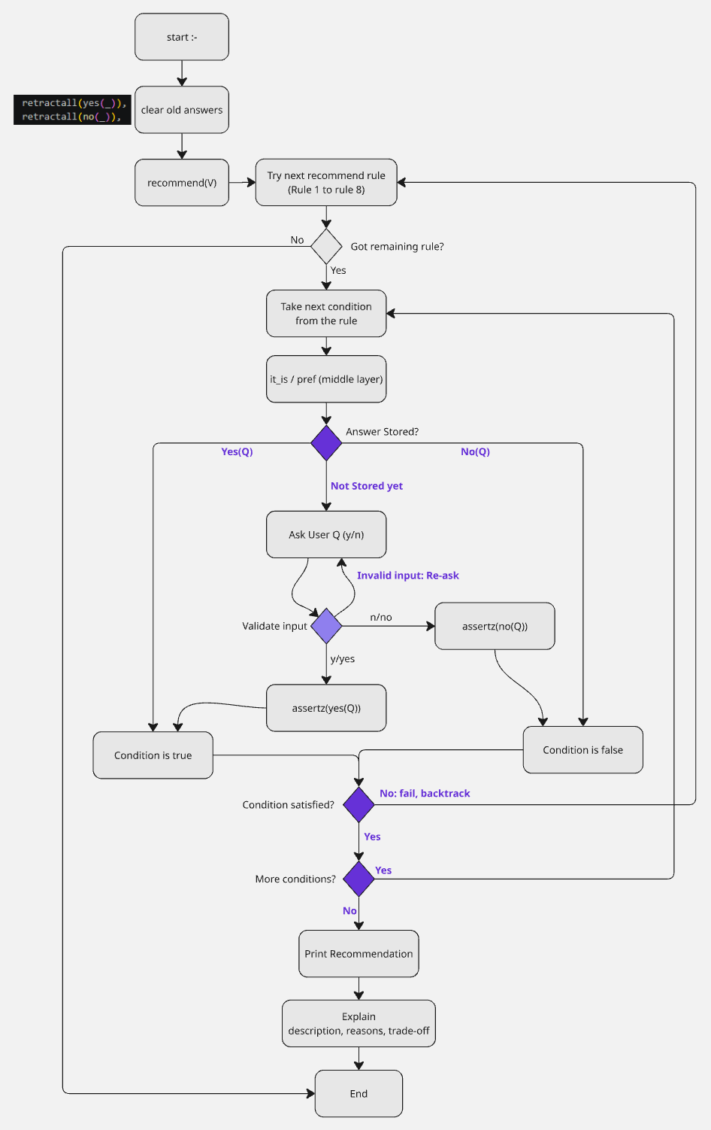
Figure 2 System Flowchart
3. Two decisions we argued

Decision 1: What to do when two rules both fit — rely on rule order, or make every rule exclusive?
Side A wanted one broad question (“Do you need high cargo capacity or heavy towing capability?”), because it keeps the consultation short and both needs point toward larger, stronger vehicles.
Side B wanted two narrow questions, one for cargo space and one for towing, because they lead to different vehicles: a wagon gives cargo space but is not built for towing, while a pickup truck is built for both.
We chose the single broad question to keep the number of questions at six, and reused its answer through a middle-layer concept (extra_cargo_need is derived from heavy_hauler). The trade-off is a known weakness: a user who needs heavy towing but not off-road driving is recommended a Wagon / Estate, which suits extra cargo but not towing. With more time we would split the question into two, so that Wagon and Pickup Truck could be told apart properly.

Decision 2: Keep questions broad or add specific utility traits?
Side A wanted to keep the questions broad to maintain six questions and keep the consultation short. Broad questions are easier for users to answer and reduce the complexity of the recommendation system.
Side B wanted to add specific utility traits, such as higher_seating and versatile_cargo, to better differentiate SUVs from Sedans and Wagons. For example, an SUV is suitable for users who prefer higher seating, while a Wagon is more suitable for users who need versatile cargo space.
We chose to keep the questions broad to maintain the six-question limit and keep the system simple. However, this creates a known weakness because the system may recommend a Sedan or Wagon when an SUV would better match the user's preferences. With more time, we would add specific utility questions to distinguish these vehicle types more accurately.

4. How we tested it

We tested in two stages. While building, we tested each outcome as soon as its rule was written: we answered the questions the way a typical user for that vehicle would, and checked that the system recommended it and gave a sensible explanation. Once all eight outcomes were written, we tested systematically. The system asks six yes/no questions, so there are only 64 possible combinations of answers. We ran every combination and recorded which vehicle each one produced, looking for two problems: an outcome that no combination can reach, and a combination that gets an answer contradicting our own rules.
This found two real bugs. First, Pickup Truck could never be recommended: any user who needed off-road driving and heavy towing matched the SUV rule first, because it sits above the Pickup Truck rule. Second, a user carrying more than five passengers who also wanted easy city parking was recommended a Compact Hatchback, which contradicts our rule that more than five passengers means an MPV. We fixed both by adding exclusions (+ it_is(heavy_hauler) to SUV, + it_is(large_family) to Compact Hatchback), then re-ran all 64 combinations to confirm that all eight outcomes are now reachable.

what we described to it | what we expected | what it said | right?
City commuter who prefers a pure electric vehicle | Pure Electric Commuter (EV) | Pure Electric Commuter (EV) | Yes
Wants easy city parking; no EV, no off-road, no towing, no performance, 5 or fewer passengers | Compact Hatchback | Compact Hatchback | Yes
Regularly carries more than 5 passengers | MPV / Minivan | MPV / Minivan | Yes
Enjoys high performance and sporty driving, 2–4 passengers. | Coupe / Sports Car | Coupe / Sports Car | Yes
Drives off-road and needs heavy towing, 5 or fewer passengers | Pickup Truck | Pickup Truck (SUV before our fix) | Yes, after fix
Needs heavy towing but never drives off-road | Wagon / Estate | Wagon / Estate | Yes
Prefers higher seating and needs 5 or fewer passengers. | SUV | Wagon / Estate | No

A case it gets wrong
A user who explicitly wants an SUV (preferring a higher driving position and versatile cargo space for family trips) is incorrectly recommended a Wagon / Estate or falls through to no recommendation at all.
Why it happens: This is caused by a combination of overlapping rule conditions and strict sequential prioritization. In our initial design, the SUV rule required both it_is(daily_passenger) and it_is(offroad_capable). However, many urban SUV buyers do not drive on rugged, unpaved off-road terrain. Because they answered no to offroad_capable, the system failed the SUV rule entirely and instead routed them down to the Wagon or Sedan rules.
Furthermore, because the Pickup Truck rule also required offroad_capable and heavy_hauler, and sat above or interacted tightly with cargo rules, users wanting versatile utility without extreme off-roading were completely starved of an SUV recommendation. This revealed a flaw in our initial domain modeling: treating off-road capability as a mandatory gatekeeper for an SUV prevented everyday family crossover/SUV buyers from ever reaching the outcome. (Note: To truly fix this in a future iteration, the SUV rule should decouple off-road capability from general SUV classification, introducing dedicated questions for seating position and everyday cargo versatility).

5. What we would do with another three weeks
According to the test case table, we can see current system is unable to recommend SUV to user when they prefers higher seating and needs 5 or fewer passengers. So, with another three weeks, we would implement two major architectural refinements to improve classification accuracy and eliminate rule ambiguities:
1. Decouple Cargo Space from Heavy Towing via Fine-Grained Questions
- What we would change: Replace our single broad heavy_hauler question with two distinct middle-layer queries: versatile_cargo (for luggage, groceries, and large everyday items) and heavy_hauler (specifically for towing trailers, boats, or heavy loads). Furthermore, we would introduce a higher_seating preference predicate.
- What it would fix: This directly resolves the weakness where users needing cargo space without off-road capabilities get misrouted to a Wagon. It allows the system to clearly differentiate between an urban family lifestyle (SUV), a utility lifestyle (Pickup Truck), and an everyday commuter lifestyle (Sedan/Wagon) without relying on restrictive off-road prerequisites.
2. Refine Top-Tier Rule Precedence and Mutual Exclusivity
- What we would change: Restructure the top-level outcome conditions (recommend/1) using explicit negative constraints (\+) across overlapping categories, ensuring that crossover vehicles like SUVs can be recommended to drivers who prefer higher seating and cargo space even if they answer no to off-road terrain.
- What it would fix: This prevents urban SUVs from being entirely starved of recommendations when users do not drive off-road, making the expert system far more robust and commercially realistic for everyday drivers.

Use of AI assistants
- Did you use one? Yes.
- What you used it for: Checked Prolog code logic; assisted in learning and understanding Prolog concepts, including format control sequences (~n, ~w), built-in predicates (flush_output/0, assertz/1, retractall/1), and rule definition syntax (start :-); and assisted with debugging errors.
- What you changed: Reviewed, verified, and adapted the suggested logic and syntax to fit the specific requirements of the assignment, and adjusted the formatting outputs to match the expected program behavior.

Before you submit
- Every grey prompt deleted.
- Three to four pages.
- Section 4 contains a case your system gets wrong.
- Section 5 names something specific.
- The repository link works, and has commits from everyone.
- The contribution statement is attached as a separate page.

