Juliana Linares R

INTRODUCTION TO OBJECT PROGRAMMING

Final Project Documentation

Presented to Mihai Maftei

LaSalle College

July 26th, 2016

# Program Description:

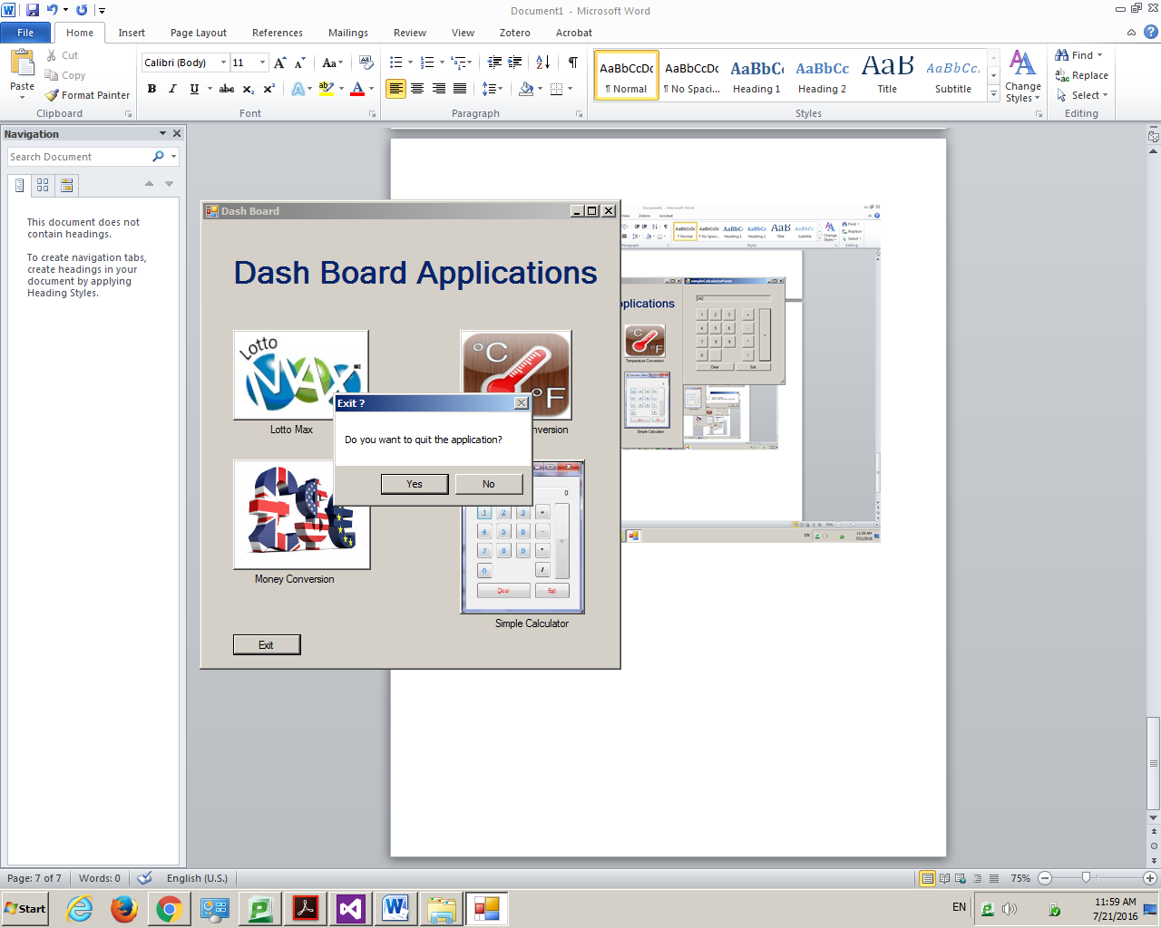

This program gives the user to open four different applications and that gives the option to close it from the exit button.

## Lotto Max Application

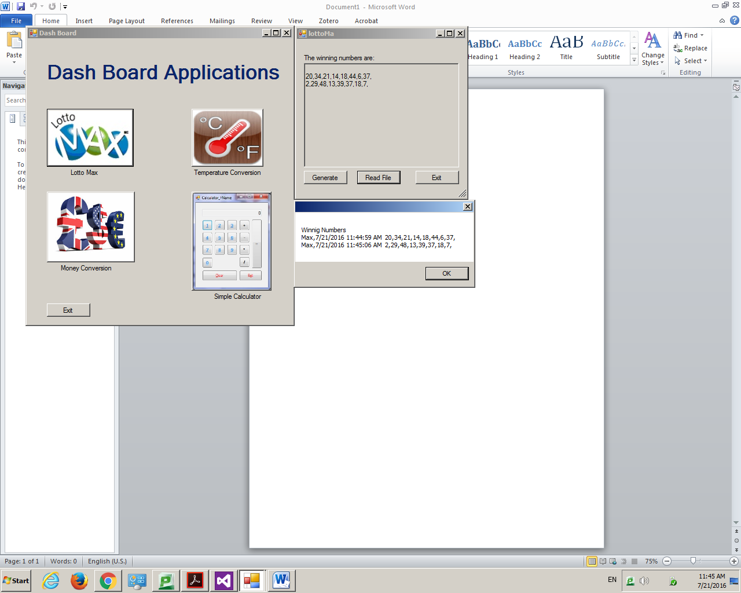 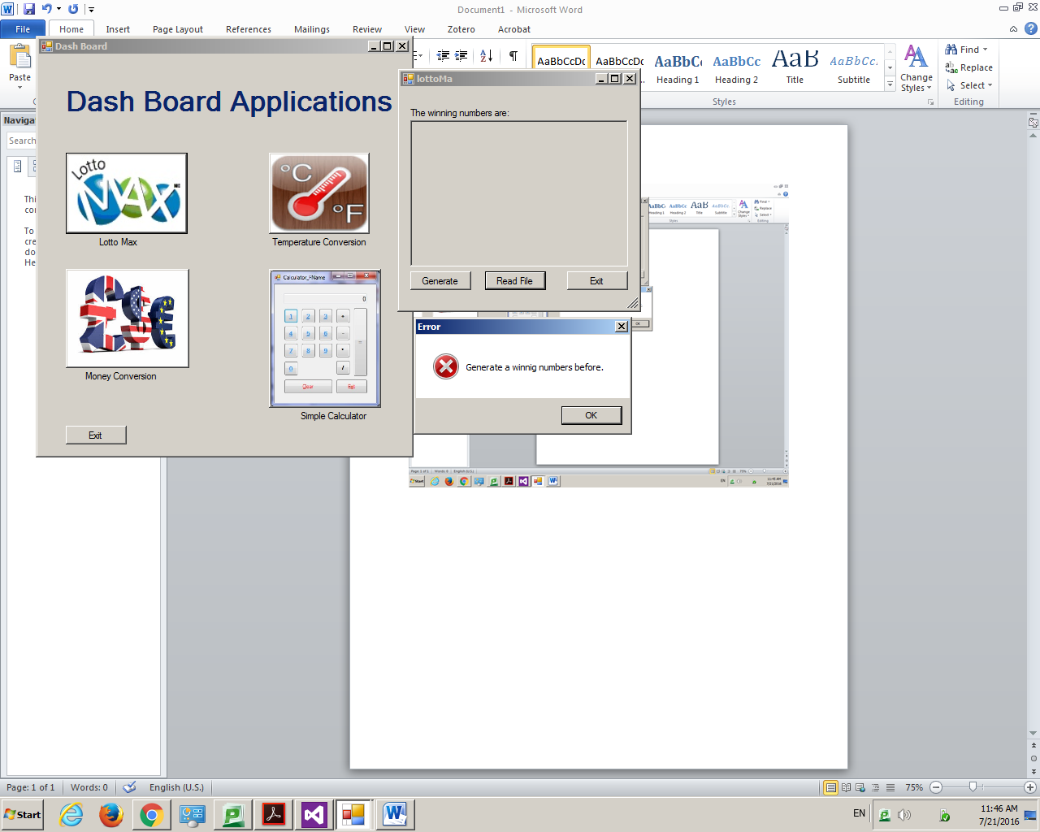

This application creates 8 random numbers when clicking in Generate and saves them in a document called LottoMaxJulianaLinares.txt. It also displays the calculated numbers and the time when they were calculated in a message box, when clicking in Read File. Finally, the exit button gives the option to close the program and goes back to the main menu. In addition, it displays an error box when Read File is clicked but there are not .txt file created yet.

## Temperature Conversion application

## 

This application converts Fahrenheit degrees to centigrade or centigrade to Fahrenheit, when clicking in convert button and the same time it saves the values in a file called TemperatureConversionJulianaLinares.txt. The button read file displays a message box whit the values converted previously. It also displays an error if the value inserted is not correct or does not existed.

## Money Conversion application

## 

In this program is possible to calculate the value of one currency compared with other. It is necessary to insert a value and check the from currency and the to currency. The value converted and entered are saved in a MoneyConversionJulianaLinares.txt, in case the file does not exists a message error is showed to the user. When clicking in read file a message box shows the previous money exchanges.

## Simple Calculator application

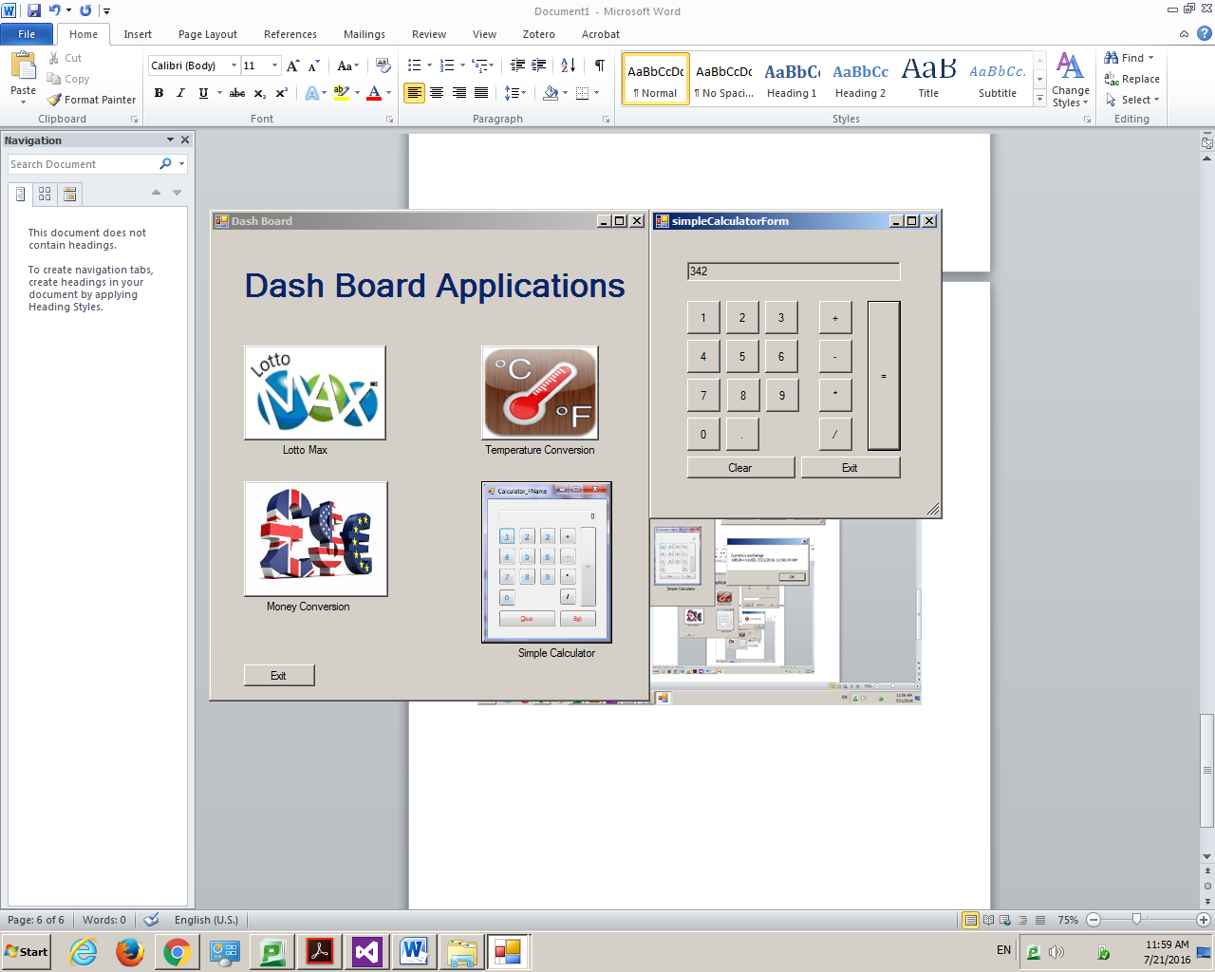

This program effectuates simple calculations like addition, subtraction, multiplication and division. It also clears al previous calculations when clicking on the clear button.

# Used Classes and Methods:

|  |  |
| --- | --- |
| Class | Method |
| Calculator | * Add(value) * Subs(value) * Mult(value) * Div(value) * Equals(value) |
| FileStream |  |
| StreamWriter | * Write(text) |
| StreamReader | * ReadLine * Peek |
| DateTime | * Now |
| Random | * Next( from , to ) |
| MessageBox | * Show |
| File | * Delete * Exist |
| Directory | * Exists * CreateDirectory |