1. Find the A-Frame Documentation for primitive objects on <https://aframe.io>
   1. Go to <https://aframe.io>
   2. Click on **DOCS**, found in the top right corner
   3. Scroll down the left side column until you find **PRIMTIVES** towards the bottom
   4. Now, use the documentation on primitive objects to complete this activity
2. Setup A-Frame
   1. Add the example code called **aframeobjects.html** to you’re A-Frame projects folder
   2. Drag and drop the **aframeobjects.html** file onto your web browser
   3. Open up **Visual Studio Code**
   4. Go to **Explore** and use **Open Folder** to open up you’re A-Frame projects folder in Visual Studio Code
   5. Now, with your folder open, open the **aframeobjects.html** file so that it can be seen in Visual Studio Code
3. Replace the sphere with an octahedron (Directly below is the line of code to change)

<a-sphere position="0 1.25 -5" radius="1.25" color="#EF2D5E"></a-sphere>

* 1. To change the sphere into an octahedron, change both a-sphere keywords with the a-octahedron keyword
  2. Using <https://htmlcolorcodes.com/> as a guide, change the octahedron’s color to purple (No exact answer here of course! Can be any shade of purple you like)
  3. HINT: Make sure the hashtag, #, is placed before the 6 letters and numbers that represent your color!

1. Rotate the cylinder (Line of code to edit is shown below)

<a-cylinder position="1 0.75 -3" radius="0.5" height="1.5" color="#FFC65D"></a-cylinder>

* 1. Add rotation="" to the cylinder A-Frame object (remember, it has to be between the <a-cylinder keyword and the first > character in order to change that feature of the cylinder)
  2. Rotate the cylinder along the x-axis by 90 degrees and the z-axis by 90 degrees by entering the correct values between the quotation marks of rotation=""

1. Reposition and scale the box (Line of code to edit is shown below)

<a-box position="-1 0.5 -3" rotation="0 45 0" color="#4CC3D9"></a-box>

* 1. Change the position="-1 0.5 -3” code such that the box is above the cylinder
     1. To do this, change the x-axis value to 1, and the y-axis value to 3
  2. Scale the box so that it intersects with the cylinder
     1. To do this, add height="” code to the box to modify the height from its default height and change the value to 4

1. Extra: Using the A-Frame documents page for primitive objects, add an a-torus to the position where the a-box used to be, change its color to a shade of red, and make the radius 0.5
   1. 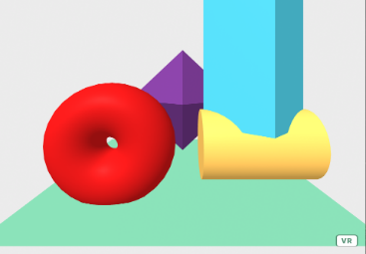The original position of the a-box was -1 on the x-axis, 0.75 on the y-axis, and -3 on the z-axis
2. Final Result (Use to check your solutions!):