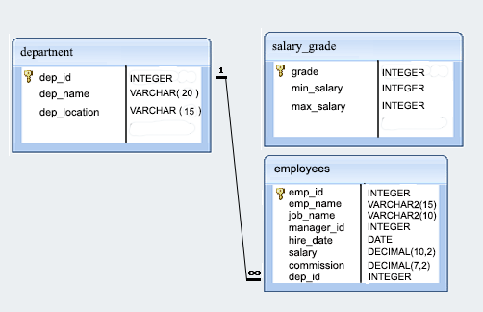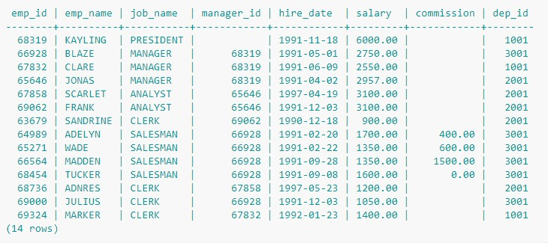

1. From the following table return complete information about the employees.

* Select * from employees;

1. Write a SQL query to find the salaries of all employees. Return salary.

* Select salary from employees;

1. Write a SQL query to find the unique designations of the employees. Return job name.

* select distinct job_name from employees;

1. Write a SQL query to list the employees’ name, increased their salary by 15%, and expressed as number of Dollars.

* SELECT emp_name,concat(‘$’,(salary+salary*0.15)) as increased_salary from employees;

1. Write a SQL query to list the employee's name and job name as a format of "Employee & Job".

* Select concat(emp_name,’ ‘,job_name) as ‘Employee & Job’

FROM employees;

1. Write a query in SQL to produce the output of employees as follows.

OUTPUT:- Employee  
 JONAS(manager).

* SELECT concat(emp_name,’(‘,job_name,’)’) AS Employee FROM employees;

1. Write a SQL query to find those employees with hire date in the format like February 22, 1991. Return employee ID, employee name, salary, hire date.

* SELECT emp_name,emp_id,salary,DATE_FORMAT(hire_date,’%m %d %y’) AS hire_date FROM employees;

1. Write a SQL query to count the number of characters except the spaces for each employee name. Return employee name length.

* SELECT length(trim(emp_name)) FROM employees;

1. Write a SQL query to find the employee ID, salary, and commission of all the employees.

* SELECT emp_name,emp_id,salary,commission FROM employees;

1. Write a SQL query to find the unique department with jobs. Return department ID, Job name.

* SELECT DISTINCT dep_id, job_name FROM employees;

1. Write a SQL query to find those employees who do not belong to the department 2001. Return complete information about the employees.

* SELECT * FROM employees where dep_id != 2001;

1. Write a SQL query to find those employees who joined before 1991. Return complete information about the employees.

* SELECT * FROM employees where hire_date < (‘1991-1-1’);

1. Write a SQL query to compute the average salary of those employees who work as ‘ANALYST’. Return average salary.

* SELECT avg(salary) FROM employees where job_name = ‘ANALYST’;

1. Write a SQL query to find the details of the employee ‘BLAZE’.

* SELECT * FROM employees where emp_name = ‘BLAZE’;

1. Write a SQL query to find those employees whose commission is more than their salary. Return complete information about the employees.

* SELECT * FROM employees where commission > salary;

1. Write a SQL query to find those employees whose salary exceeds 3000 after giving 25% increment. Return complete information about the employees.

* SELECT * FROM employees where salary+salary*0.25 > 3000 ;

1. Write a SQL query to find the names of the employees whose length is six. Return employee name.

* SELECT emp_name FROM employees where emp_name = length(emp_name);

1. Write a SQL query to find those employees who joined in the month January. Return complete information about the employees.

* SELECT * FROM employees where to_char(hire_date,’mon’) = ‘jan’;

1. Write a SQL query to find the name of employees and their manager separated by the string 'works for'.

* SELECT CONCAT(emp_name,’works for ‘,job_name) FROM employees ;

1. Write a SQL query to find those employees whose designation is ‘CLERK’. Return complete information about the employees.

* SELECT * FROM employees WHERE job_name = ‘CLERK’ ;

1. Write a SQL query to find those employees whose experience is more than 27 years. Return complete information about the employees.

* SELECT * FROM employees WHERE ROUND(DATEDIFF(NOW(),hire_date)/365) > 27; //***

1. Write a SQL query to find those employees whose salaries are less than 3500. Return complete information about the employees.

* SELECT * FROM employees WHERE salary < 3500 ;

1. Write a SQL query to find the employee whose designation is ‘ANALYST’. Return employee name, job name and salary.

* SELECT emp_name,job_name,salary FROM employees WHERE job_name = ‘ANALYST’ ;

1. Write a SQL query to find those employees who have joined in the year 1991.Return complete information about the employees.

* SELECT * FROM employees WHERE to_char(hire_date,’yyyy’) = ‘1991’ ;

1. Write a SQL query to find those employees who joined before 1st April 1991. Return employee ID, employee name, hire date and salary.

* SELECT emp_id,emp_name,hire_date,salary FROM employees WHERE hire_date < ‘1991-04-01’ ;

1. Write a SQL query to find those employees who are not working under a manager. Return employee name, job name.

* SELECT emp_name, job_name FROM employees WHERE job_name != ‘manager’;

1. Write a SQL query to find those employees who joined on 1st May 91. Return complete information about the employees.

* SELECT * FROM employees WHERE hire_date = ‘1991-05-01’ ;

1. Write a SQL query to find those employees working under the manger whose ID is 68319. Return employee ID, employee name, salary, and age.

* SELECT emp_name,salary,age(CURRENT_DATE,hire_date) “EXPERIENCE” FROM employees WHERE manager_id = 68319 ;

1. Write a SQL query to find those employees who earn more than 100 as daily salary. Return employee ID, employee name, salary, and age.

* SELECT emp_id,emp_name,age(CURRENT_DATE,hire_date) “EXPERIENCE” FROM employees WHERE (salary/30) > 100;

1. Write a SQL query to find those employees who retired after 31-Dec-99, completion of 8 years of service period. Return employee name.

* SELECT emp_name FROM employees WHERE hire_date + interval ‘8 years’ > ‘1999-12-31’;

1. Write a SQL query to find those employees whose salary is an odd value. Return complete information about the employees.

* SELECT * FROM employees WHERE salary%2 = 1 ;
* SELECT * FROM employees WHERE mod(salary,2) = 1 ;

1. Write a SQL query to find those employees whose salary contains only three digits. Return complete information about the employees.
2. Write a SQL query to find those employees who joined in the month of APRIL. Return complete information about the employees.

* SELECT * FROM employees WHERE to_char(hire_date,’mm’) = ‘04’ ;

1. Write a SQL query to find those employees who joined in the company before 19th of a month. Return complete information about the employees.

* SELECT * FROM employees WHERE to_char(hire_date,’DD’) < ‘19’ ;

1. Write a SQL query to find those employees who are SALESMAN and experience more than 10 months. Return complete information about the employees.
2. Write a SQL query to find those employees of department id 3001 or 1001 and joined in the year 1991. Return complete information about the employees.

* SELECT * FROM employees WHERE (dep_id = 3001 OR dep_id=1001) AND (to_char(hire_date,’yyyy’) = ‘1991’ ) ;

1. Write a SQL query to find those employees who are working for the department ID 1001 or 2001.Return complete information about the employees.

* SELECT * FROM employees WHERE dep_id = 1001 OR dep_id = 2001 ;

1. Write a SQL query to find those employees whose designation is ‘CLERK’ and work in the department ID 2001. Return complete information about the employees.

* SELECT * FROM employees WHERE job_name = ‘CLERK’ AND dep_id = 2001 ;

1. Write a query in SQL to find those employees where -      
   1. The employees receive some commission which should not be more than the salary and annual salary including commission is below 34000.  
   2. Designation is ‘SALESMAN’ and working in the department ‘3001’. Return employee ID, employee name, salary and job name.

* SELECT emp_id, emp_name, salary, job_name FROM employees WHERE (salary+commission)*12 < 34000 AND job_name = ‘SALESMAN’ AND dep_id = 3001 ;

1. Write a SQL query to find those employees who are either CLERK or MANAGER. Return complete information about the employees.

* SELECT * FROM employees WHERE job_name = ‘CLERK’ OR job_name = ‘MANAGER’ ;

1. Write a SQL query to find those employees who joined in any year except the month of February. Return complete information about the employees.

* SELECT * FROM employees WHERE to_char(hire_date, ‘MM’) != ‘02’ ;

1. Write a SQL query to find those employees who joined in the year 91. Return complete information about the employees.

* SELECT * FROM employees WHERE to_char(hire_date,’yyyy’) = ‘1991’ ;

1. Write a SQL query to find those employees who joined in the month of June 1991. Return complete information about the employees.

* SELECT * FROM employees WHERE to_char(hire_date, ’mon-1991’) = ‘jun-1991’;

1. Write a SQL query to find all the employees whose annual salary is within the range 24000 and 50000 (Begin and end values are included.). Return complete information about the employees.

* SELECT * FROM employees WHERE salary*12 >= 24000 AND salary*12 <= 50000 ;
* SELECT * FROM employees WHERE salary*12 BETWEEN 24000 AND 50000 ;

1. Write a SQL query to find all those employees who have joined on 1st May, 20th Feb, and 3rd Dec in the year 1991. Return complete information about the employees.

* SELECT * FROM employees WHERE to_char(hire_date, ‘dd-mon-yyyy’) IN (’01-may-1991’,’20-feb-1991’,’03-dec-1991’);

1. Write a SQL query to find those employees working under the managers 63679 or 68319 or 66564 or 69000. Return complete information about the employees.

* SELECT * FROM employees WHERE manager_id IN (63679,68319,66564,69000) ;

1. Write a SQL query to find those employees who joined after the month JUNE in the year 1991 and within this year. Return complete information about the employees.

* SELECT * FROM employees WHERE hire_date BETWEEN ’01-JUL-1991’ AND ‘31-DEC-1991’ ;

1. Write a SQL query to find those employees who joined in 90's. Return complete information about the employees.

* SELECT * FROM employees WHERE to_char(hire_date,’yy’) BETWEEN ‘90’ AND ‘99’ ;

1. Write a SQL query to find those managers who are in the department 1001 or 2001. Return complete information about the employees.

* SELECT * FROM employees WHERE job_name = 'MANAGER' AND (dep_id=1001 OR dep_id=2001) ;

1. Write a SQL query to find those employees who joined in the month FEBRUARY with a salary range between 1001 to 2000 (Begin and end values are included.). Return complete information about the employees.

* SELECT * FROM employees WHERE to_char(hire_date,’MON’) = ‘FEB’ AND (salary >= 1001 OR salary <= 2000) ;

1. Write a SQL query to find those employees who joined before or after the year 1991. Return complete information about the employees.

* SELECT * FROM employees WHERE to_char(hire_date,’yyyy’) NOT LIKE ‘1991’ ;

1. Write a SQL query to find employees along with department name. Return employee ID, employee name, job name, manager ID, hire date, salary, commission, department ID, and department name.

* SELECT e.emp_id, e.emp_name, e.job_name, e.manager_id, e.hire_date, e.salary, e.commission, e.dep_id, d.dep_name FROM employees e, department d WHERE e.dep_id = d.dep_id ;