SOMAIYA VIDYAVIHAR
Padmabhushan (Late) Shri. K. J. Somaiya, an entrepreneur and philanthropist, established Somaiya Vidyavihar for imparting value-based education to today’s youth. It is one of the largest private educational campuses in Mumbai. He had the vision and grit to achieve his dreams single-mindedly. (Late) Dr. Shri. S. K. Somaiya was a great visionary who further developed campus with more than 34 institutions. The Somaiya Vidyavihar offers school education, diplomas and under graduate/post graduate degree programs in various disciplines.
ABOUT KJSCE
K.J Somaiya College of Engineering (KJSCE) established in 1983 is an Autonomous College Affiliated to University of Mumbai and has permanent affiliation to the University of Mumbai. Presently institute offers five undergraduate courses Computer, Electronics, E&TC, Information Technology and Mechanical Engineering which are provisionally accredited up to November 2016. The institute also offers post graduate courses in Mechanical, Electronics, E&TC, IT, and Computer Engineering.
THEME
K. J. Somaiya College of Engineering and the ISTE Student Chapter – KJSCE is organizing PRAKALPA 17 on 31st. March & 1st. April, 2017. The competition is being organized since 2006 and has since been gaining increasing popularity among the students from various colleges across the state.
I) Paper Presentation on Artificial Intelligence on 31st. March 2017
The theme of this year’s Prakalpa is Artificial Intelligence-Innovation towards Future. Papers are invited from students based on any one of the following categories. Send the paper via e-mail only for scrutiny in standard two column IEEE format. In covering letter of e-mail quote your affiliation and the category. A maximum of 4 students can be present in a group

- Machine Learning
- Computer Vision
- Natural Language processing
- Artificial Neural Networks
- Data Mining
- Evolutionary Algorithm

II) Technical Quiz competition on 31st. March 2017.
This year a technical quiz is being introduced for students from all branches. The quiz will be conducted in 2 rounds, with both being held on the same day. The first round will be the elimination round where students from each branch will be asked questions with respect to their branch itself. The top 2 teams from each branch qualify for the final round. The final round will have teams facing questions which will be based on the latest as well as on the technical developments which revolutionized the lives of humans. A maximum of 3 students can be present in a team. The team with the maximum points in the final round will be declared the winner. The decision of the organizer will be final in this regard. All rights are reserved with organizers to disqualify entry at any level.

III) Theme Based Project Competition on 1st. April 2017
The PRAKALPA 17 will have separate section of theme based working project competition. The theme is Artificial intelligence-Innovation towards Future. The participants are requested to send separate entries via e-mail for this theme based project competition. A maximum of 4 students can be present in a group
IV) Working Model/Project Exhibition/Competition on 1st. April 2017
This competition is open to all students from FE to BE students for all engineering colleges. Send the synopsis of project in any diverse field via e-mail for scrutiny. For the evaluation of this competition there will be separate category for FE/SE/TE and BE, each with software and hardware based projects. Please mention year and type of project (software/hardware) in e-mail clearly while sending synopsis. Same group with multiple entries on same topic/project/theme in all competitions is not permitted. A maximum of 4 students can be present in a group
PRIZES
Cash prizes for winners and participation certificate for all participants will be given. All rights are reserved with the organizers.
I) Conference on Artificial Intelligence
Cash prizes: 1st .prize Rs.3500, 2nd prize Rs.2000.
II) Technical Quiz
Cash prizes: 1st prize Rs.1500, 2nd prize Rs.1000.
III) Theme Based Project Competition
Cash prizes: 1st prize Rs.4000, 2nd prize Rs.3000 and 3rd prize Rs.2000.
IV) Project exhibition/competition
Cash prizes: 1st prize Rs. 4000, 2nd prize Rs.3000 and 3rd prize Rs.2000 and consolation prize Rs. 500 in each category. The projects will be classified into different categories (all rights reserved with organizers)
SCHEDULE
I) Conference on Artificial Intelligence
- Date of conference: March 31, 2017 (Friday)
- Last date for sending paper via e-mail in standard two column format (A4 size paper, 12 font size, Times New Roman) on or before March 20,2017
II) Technical Quiz
- Date of competition: March 31, 2017 (Friday)
- Last date of entry: on or before March 20,2017
III) Theme Based Project Competition
- Date of theme based project competition: April 1 , 2017 (Saturday)
- Submission of synopsis via e-mail in standard one column format (A4 size paper, 12 font size, Times New Roman) on or before March 20,2017
IV) Project Exhibition/Competition
- Date of project exhibition / competition: April 1, 2017 (Saturday)
- Submission of synopsis via e-mail in standard one column for project exhibition on or before March 20,2017

Competitions will start at 9.30 a.m. sharp. Participants may plan for return journey after 7.00 p.m.
Prize distribution ceremony on both days will be at 5.30 p.m.

Patrons  Dr. Shubha Pandit, Principal  Prof. A. S. Thosar, Vice Principal  Dr. N. R. Gilke, Vice Principal  Advisors  Dr. R. G. Karandikar  Prof. M. S. Marathe  Prof. A. S. Phadke  Prof. A. S. Desai  Convener  Prof. Bhushan Pradhan,  Prof. Sujata Pathak  Faculty Advisors,  ISTE Students’ Chapter, KJSCE  Organizing Committee  Prof. S. S. Kulkarni  Head, EXTC Dept.  Prof. Lekha Das  Head, ETRX Dept.  Prof. H. N. Bharathi  Head, Computer Dept.  Prof. Sangeeta Nagpure  Head, IT Dept. | Dr. Siddappa Bhosnoor  Head, Mechanical Dept.  Prof. S. R. Chawde,  Head, S&H Dept.  Prof. S.S. Hanumante,  Dean (SA)  Steering Committee  Dr. Kashinath Patil  Dr. Ramesh Lekurwale  Prof Irfan Siddavatam  Prof. Rajnarsimha  Prof. Kavita Kelkar  Prof. J. M. Kundargi  Prof. Makarand Kulkarni  Sis. Nisha Mishra  Chairperson, ISTE Students’ Chapter  Sis Trishala Pawar  Treasurer , ISTE Students’ Chapter  Sis.Rutuja Malani,  Bro.Ruchit Makwana  Bro.Abhishek Gadhave  Sis.Jawahirani Kiran  Bro.Anurag Pandya  Bro.Jigar Panchal

Entry fees:
- For KJSCE students: ₹ 500/- per team.
- For Non-KJSCE students: ₹ 700/- per team.
- For Technical quiz: ₹ 150/- per team.
- Payment of registration fee should be done on the day of competition.

Registration procedure:
- The link for the registration is available on www.iste-kjsce.org
- Fill the Google form by clicking on the link and submit it with details of the entire team (only one form to be submitted per team).
- A confirmation email will be sent within few days.

Note:
- Food coupons will be provided on Prakalpa day to each member of the team.
- The competitions will be judged by professionals from esteemed institutions and various industries.
- For any queries WhatsApp on +918976704985,+918879207275 or send an e-mail to prakalpa2017@gmail.com

- For brochure/entry form : e-mail to prakalpa2017@gmail.com or visit www.iste-kjsce.org or contact on +918976704985, +918879207275

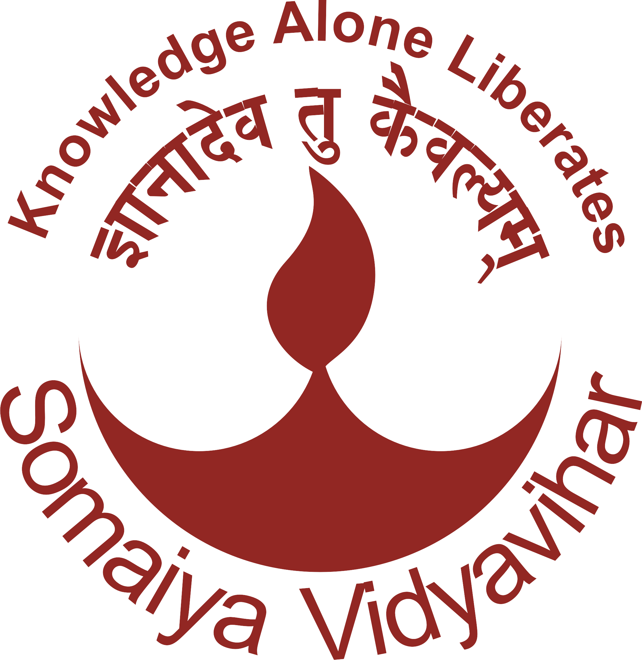

K. J. Somaiya College of Engineering, Mumbai-77
(Autonomous College Affiliated to University of Mumbai)

Presents

PRAKALPA 2017
State Level Conference and Working Model Exhibition
March 31 & April 01, 2017

Organized by

ISTE Students’ Chapter KJSCE (MH-60)



Contact
Convener, Prakalpa 2017
K. J. Somaiya College of Engineering
Vidyavihar, Mumbai - 400 077
www.somaiya.edu/vidyavihar/kjsce
prakalpa2017@gmail.com
www.iste-kjsce.org

