SupplyAI-RL
Explainable Supply Chain Optimization

A reinforcement learning agent decides what to reorder and from which supplier. A large language model explains those decisions in plain business English, stress-tests them with generated disruptions, and finally feeds those disruptions back as training data.

Phases complete | 0 to 5 of 10
Tests passing | 92
Calibration data | 1,067,371 real transactions (UCI Online Retail II)
Best RL agent | 71,227 GBP per 180-day episode
Best classical baseline | 83,624 GBP per 180-day episode
Document date | 19 August 2026

Contents
1. What this project is
2. The real-world scenario
3. System architecture, verified
4. The pipeline, step by step
5. Where we are, and the results
6. What is left to build
7. Reproducing everything

1. What this project is
IN ONE SENTENCE
Every day a retailer must decide, for each product, how many units to order and from which supplier. We train an AI to make that decision, prove whether it beats the rules the industry actually uses, and then make it explain itself.
Order too little and shelves go empty and sales are lost. Order too much and cash sits frozen in a warehouse that also has a hard ceiling on space. Pick a cheap supplier and the goods take eight days to arrive; pick a fast one and you pay 35% more per unit. Get it wrong and nobody notices until the money is already gone.
Conventional inventory software solves this with fixed rules, such as “when stock drops below 20 units, order 100”. Those rules work until demand or supplier behaviour changes, and then they fail quietly. A reinforcement learning agent adapts instead of following a fixed rule, but it becomes a black box: it hands a buyer a number with no reason attached, and no manager signs off on an order they cannot justify.
This project closes both gaps at once. The RL agent makes the decision. A large language model turns that decision into a sentence a human can act on, and separately invents realistic disruptions — a courier strike, a viral product, a factory outage — that we throw at the agent to see whether it holds up. In the final phase those invented disruptions are fed back as extra training data, so the claim is not merely “the LLM explains the RL” but “the LLM makes the RL better”.

The three moving parts
Component | What it is, and why it exists
A simulator | A day-by-day model of the business built from a million real sales records. It is the world the agent practises in, because you cannot learn a purchasing policy by experimenting on a real shop.
A decision-maker | MaskablePPO, a reinforcement learning algorithm, learning by trial and error across millions of simulated days — measured head-to-head against four properly tuned textbook policies.
An explainer | A language model that phrases already-computed facts as business English, generates stress-test scenarios as strict machine-readable JSON, and never invents a number.

THE HONEST HEADLINE RIGHT NOW
The tuned classical policy still beats our RL agent by 12,397 GBP per 180-day episode. That is reported openly rather than buried — it is a real finding from a deliberately fair comparison, and closing the gap is the current engineering task. Full detail in section 5.

2. The real-world scenario
Meet Northgate Gifts, a UK homeware and gift wholesaler. The shop is a fiction wrapped around entirely real numbers: the products, prices, demand levels and seasonal swings below are all measured from the actual dataset we calibrated on.

The shop
- Ten products, real ones from the real data: White Hanging Heart T-Light Holder, Jumbo Bag Red Retrospot, Pack of 72 Retrospot Cake Cases, World War 2 Gliders, and six more.
- One warehouse holding 20,000 units in total. Not one bin per product, but a single shared space. This is the crux of the whole problem: every pallet of cake cases is a pallet of gliders that will not fit.
- Three suppliers, each offering a different bargain:
  - EconoSource — cheapest, but takes 5 to 8 days and ships only about 90% of what you asked for.
  - RapidTrade — arrives in 1 to 3 days and ships 98% of the order, but charges 35% more per unit.
  - MidWay Supply — middling price and speed, but unreliable: it ships only 80% of an order and goes offline entirely for 5 to 10 days roughly once a quarter.
- Demand is not smooth. The busiest product averages 169 units a day with a standard deviation of 191 — some days sell almost nothing, some days sell hundreds. November runs at 1.75x the yearly average, January at 0.69x. Thursdays are busy, Sundays run at half speed, and the shop does not trade on Saturdays at all.

One day in the life, once the system is finished
It is Day 47 of the planning horizon — early November, the ramp into Christmas. Priya, the buyer, opens the dashboard at 8am. The system has already read the overnight numbers and made its ten decisions. For the White Hanging Heart T-Light Holder, it shows her this:
# PRODUCT 85123A - WHITE HANGING HEART T-LIGHT HOLDER

On hand 412 units
Already in transit 0 units
Days of cover 2.4 days <- below the 6-day lead time
Last 7 days sold 171 / day up 14% on the fortnight before
Warehouse now 17,340 / 20,000 -> 2,660 units of headroom

# DECISION
ORDER 340 UNITS FROM RAPIDTRADE (1-3 day delivery, 1.35x cost)

# EXPLANATION
"Cover has fallen to 2.4 days while November demand runs 14%
above the fortnight before. EconoSource would not deliver for
5-8 days, leaving roughly three days uncovered at 171 units a
day. Paying RapidTrade's 35% premium on 340 units costs about
214 GBP; the stockout it avoids is worth about 770 GBP in lost
margin and penalty. The order is capped at 340 rather than 500
because only 2,660 units of warehouse space remain and two
other products are also running short."
That is the product. Not a number, but a number with its reasoning attached, in language a buyer can defend to a finance director.
Critically, the language model did not invent that reasoning. The simulator computed every figure in it — the 2.4 days of cover, the 214 GBP premium, the 770 GBP avoided loss, the 2,660 units of headroom. The LLM was handed those facts and asked only to phrase them. Every number in its output is then checked back against the fact list before it reaches the screen. If that check fails, or the network is down, a plain deterministic template writes the sentence instead and the demo carries on regardless.

The second thing Priya gets: a stress test
She clicks “What could go wrong?”. The language model writes three disruption scenarios — not prose, but strict machine-readable configurations the simulator can actually execute:
Scenario A A viral video triples demand for the t-light holder, 9 days
Scenario B RapidTrade's courier strikes; lead times +6 days for 2 weeks
Scenario C MidWay Supply goes offline entirely for 12 days in peak season

Re-running the plan under each:
Scenario A -> profit -8%, fill rate holds at 91% survivable
Scenario B -> profit -3%, switches to EconoSource early handled
Scenario C -> profit -22%, three products stock out weak point
Those percentages illustrate the format rather than report measured results — Phase 7 is where they become real. But the mechanism underneath is already built and tested: the simulator has accepted injected disruptions since Phase 2, precisely so this would not have to be bolted on later.

And the third thing: the agent learns from them
Scenario C exposed a weakness. In the final phase, scenarios like it are not merely displayed — they are fed back as training data. The agent is retrained on a curriculum of LLM-invented crises, and we then measure whether that version survives new, unseen crises better than the version trained without them. That is the novel claim of the project, and it is the difference between a language model that decorates a reinforcement learning system and one that improves it.
THE WHOLE SYSTEM IN ONE SENTENCE
A buyer opens a dashboard and sees, for each product: what to order, from which supplier, why in plain English, what could go wrong, and how the decision compares against what their current rule-based system would have done.

3. System architecture, verified
An infographic of the system architecture was drafted, and every claim on it was checked against the actual source code in the repository. It was accurate on almost every point, including several details that are easy to get wrong.

What it got right
- “~1M transactions, Dec 2009 to Dec 2011” — exactly 1,067,371 rows of UCI Online Retail II.
- The six pipeline stages — clean, daily reshape, remove Saturdays, select 10 products, compute statistics, split before 1 June 2011. All six match configs/data.yaml line for line, including Saturday being weekday index 5.
- “20,000-unit warehouse” — matches warehouse_capacity_total: 20000. Worth flagging because an older comment in the config still mentions 12,000; the live value is 20,000.
- “STATE: 88 features” — verified by arithmetic: 10 products x 7 per-product signals = 70, plus 7 weekday one-hot and 2 month sine/cosine = 9, plus 3 suppliers x 3 signals = 9. Total 88.
- “21 options (7 quantities x 3 suppliers)” and “2 hidden layers, 128 units, ~20,000 parameters” — both match the environment and configs/train.yaml.
- Gamma-Poisson demand, 180-day episodes, reward = daily profit, four classical policies — all correct.

Four things that were changed
Fix | What was wrong, and what it now says
1 | The evaluation box said “30 held-out scenarios (post 1 Jun 2011)”, merging two different ideas. The 1 June 2011 split is a data split and already appears in the pipeline box. Evaluation runs on 30 held-out random seeds (500–529), never used for training the agent or tuning the baselines. It now reads “30 held-out seeds (500–529), unseen in training and tuning”.
2 | Action masking was missing from the RL agent box. It is the single most important implementation detail found so far — worth roughly 3x on its own. It now appears twice: in the agent card, and inside the loop with its two concrete rules.
3 | The “planned next” row omitted Phase 9, LLM-generated scenarios fed back as RL training curriculum — which is the project's actual novelty claim. It is now a fourth box, drawn solid rather than dashed to mark it out.
4 | Minor: there are five baseline policies, not four — the four tuned ones plus a deliberately dumb constant-order policy acting as a sanity floor. The simulator box now also names lead times, partial deliveries and supplier outages, which it models and which drive most of the interesting behaviour.

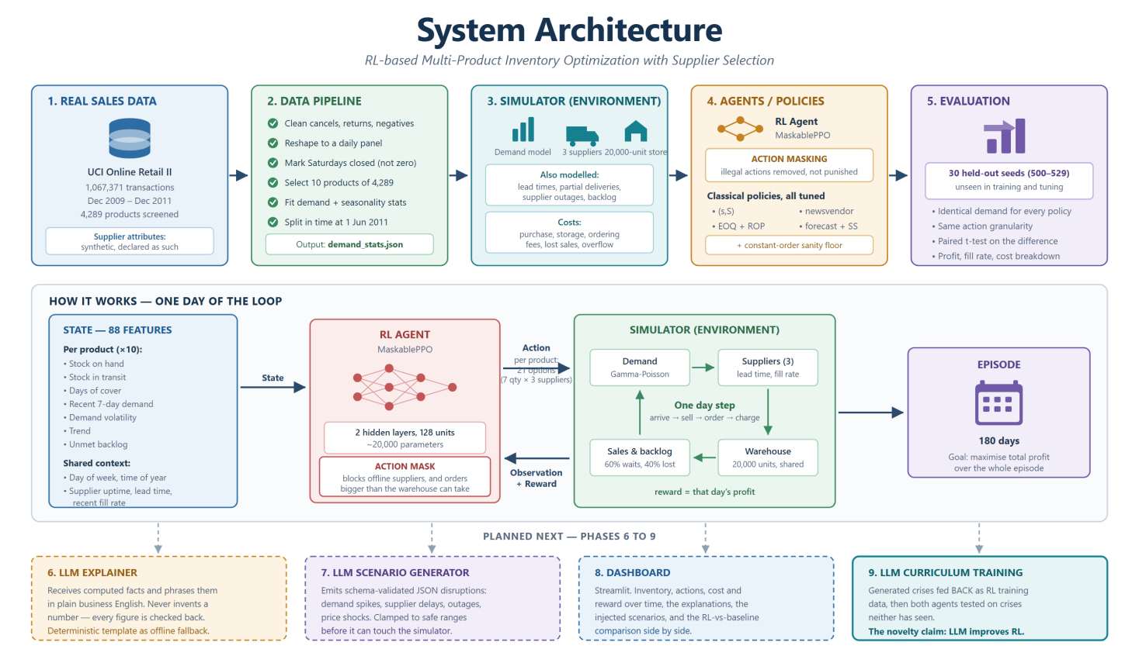
Figure 1 — System architecture. All four corrections applied, drawn from the source code. Five built stages across the top, the one-day decision loop in the middle, four planned phases along the bottom.

4. The pipeline, step by step
Each stage below explains what it does, which model or method sits inside it, a worked example with real numbers, why the project needs it, and how it hands over to the next stage.
STEP 1 Real sales data done · Phase 1
We start from UCI Online Retail II: 1,067,371 real invoice lines from a UK online gift retailer between December 2009 and December 2011. Real transactions, real prices, real customers.
THE MODEL HERE
None — this stage is pure evidence. That matters: everything downstream is only as honest as the data it was calibrated on, so we take the numbers from a real business rather than inventing a demand curve that flatters the agent.
A CANDIDATE WE REJECTED
We first screened a Kaggle retail inventory dataset. It looked ideal, with tidy columns for weather, promotions and competitor pricing. But every one of those supposed demand drivers correlated with demand at about 0.00, and its Demand Forecast column leaked the answer it was meant to predict. A model trained on it would have scored beautifully and learned nothing. We documented the rejection rather than quietly dropping it.
WHERE IT IS HONEST ABOUT ITSELF
Supplier lead times, fill rates and contract prices are synthetic and declared as such. No public dataset contains them — that information is commercially confidential. They are hand-authored to span the classic cost-versus-speed-versus-reliability trade-off from the inventory literature, and the report says so plainly.
HANDS OVER a million raw invoice lines — unusable as-is, because RL needs a day-by-day world to act in, not a transaction log.
STEP 2 The data pipeline done · Phase 1
This stage turns a transaction log into a small set of statistics that describe how ten products actually behave.
WHAT IT DOES, IN ORDER
- Clean. Drop cancelled invoices, returns, negative quantities and non-product service codes such as postage, bank charges and adjustments.
- Reshape to daily. Every invoice line collapses into “product X sold N units on day D”.
- Mark Saturdays closed. The retailer sold 5,119 units on Saturdays over two years, against roughly two million on other days. That is a shop that does not trade, not a shop with zero demand — treating it as zero demand would have taught the agent a fake weekly dip.
- Select ten products. From 4,289 candidates: 3,135 rejected for low volume, 949 because a single wholesale mega-order dominated their entire history, 24 for being too intermittent. That leaves 181 eligible, shortlisted to 60, and finally 10.
- Fit statistics. Mean, variability, seasonality and price per product.
- Split in time. Everything before 1 June 2011 calibrates the simulator; everything after is held back.
WORKED EXAMPLE — WHY THE TEN ARE NOT THE TOP TEN
We deliberately chose a spread of behaviours, not just the ten bestsellers, so the agent faces genuinely different problems: 4 steady products, 3 moderate, 3 bursty. Product 21212 (cake cases) sells 169 a day fairly reliably. Product 15036 (silk fans) averages 68 a day but with a standard deviation of 160 — it does nothing for a fortnight, then sells 500 in an afternoon. A policy that handles one badly mishandles the other.
WHAT COMES OUT
One file, demand_stats.json: per-product means, variability, zero-day fractions and prices; day-of-week factors (Thursday 1.23, Sunday 0.51); and month factors running from January at 0.69 up to November at 1.75.
HANDS OVER the recipe the simulator uses to generate demand. Without this step the simulator would be guesswork; with it, every unit of demand the agent sees has a real-world ancestor.
STEP 3 The simulator done · Phase 2
A Gymnasium environment: a virtual shop the agent can practise in millions of times. You cannot train a purchasing policy by experimenting on a real business, so the simulator is the training set.
THE DEMAND MODEL — GAMMA-POISSON (NEGATIVE BINOMIAL)
Real retail demand is overdispersed: it varies far more than a simple random process would. Product 21212 averages 169 units a day with a standard deviation of 191 — its variance is roughly 216 times its mean. The obvious choice, a Poisson process, has variance equal to its mean by definition, so it would produce a tidy series hovering near 169. The agent would learn that demand is far more predictable than it really is, and be destroyed by the first genuine spike.
So each day we draw a Gamma-distributed “appetite” first, then a Poisson count around it. Some days the appetite is low, some days high, which reproduces the bursts in the real series. Two multiplicative calendar effects measured from the data sit on top: day-of-week and month.
THE SUPPLIER MODEL
Each supplier has a triangular lead-time distribution, a fill rate drawn per order (so you often receive less than you asked for), a minimum order quantity, a fixed fee per order placed, and a per-day chance of going offline entirely. MidWay Supply's 1.2% daily outage chance is what generates the interesting crises.
THE SINGLE MOST IMPORTANT DESIGN CHOICE
One shared warehouse, not a private bin per product. With per-product capacity, products never compete, “order the maximum for everything” becomes optimal, and any fixed rule matches a learned policy — the problem is trivial. With shared space, stocking cake cases denies room to gliders. That is a genuine allocation problem, and one that per-product rules structurally cannot express, because each rule only ever sees its own product. It is the gap the RL agent exists to exploit.
ONE DAY, IN THE RIGHT ORDER
Goods ordered previously arrive, then today's demand is drawn, then demand is met from stock with any shortfall becoming backlog (60% waits, 40% is lost forever), then the agent places today's order, then costs are charged. Ordering after demand is deliberate: a real buyer orders knowing what today sold. Getting this order of operations wrong is a common way inventory simulators accidentally hand the agent a look-ahead advantage.
THE MONEY
reward = revenue − purchase cost − holding cost − ordering fees − stockout penalty. Gross margin 45%. Holding costs 0.15% of unit cost per day, about 55% a year — high on purpose, because seasonal gift lines are dominated by markdown and obsolescence risk, not storage. Stock left at the end is credited back at 60% of cost, so the agent is not punished for an arbitrary stopping date. Goods arriving at a full warehouse are refused at the door and written off: already paid for, and lost.
HANDS OVER a world where decisions have consequences that take days to appear — exactly the delayed-feedback structure that makes this a reinforcement learning problem rather than a forecasting one.
STEP 4 The agents, and the rivals they must beat done · Phases 3 and 4
Two things live in this stage: the learned agent, and the classical policies it is measured against. The rivals were built first, and built properly.
THE RL MODEL — MASKABLEPPO
PPO (Proximal Policy Optimization) is a policy-gradient method: a small neural network reads the 88-number state and outputs a probability over actions, and after every batch of simulated days it nudges those probabilities toward whatever earned more profit — but only by a small clipped amount per update, which is what stops it lurching into a bad policy and never recovering. The network is tiny: two hidden layers of 128 units, about 20,000 parameters. It trains on CPU across 8 parallel copies of the simulator at roughly 345 steps a second, so a one-million-step run takes about 48 minutes.
The Maskable part is the important word. Before the agent chooses, the environment hands it a list of which actions are currently legal, and the illegal ones are made unavailable rather than merely punished. Two rules: you cannot order from a supplier that is offline, and you cannot order more than the warehouse can physically accept.
WHY MASKING MATTERED SO MUCH
The first unmasked run lost 25,308 to warehouse overflow — goods ordered into a full warehouse, paid for, then refused at the door — and a further 13,671 to ordering fees by splitting orders across all three suppliers nearly every day. Both are impossible or pointless actions the environment already knew about at decision time. Making them unavailable beat making the agent discover they were bad from a reward signal arriving six days later, buried among nine other products' outcomes. Profit went from 22,566 to 71,227, and overflow losses went to exactly zero.
THE ACTION, CONCRETELY
For each of the 10 products the agent makes one joint choice from 21 options: 7 order-quantity buckets times 3 suppliers. The buckets are multiples of that product's own mean daily demand — 0, 0.5x, 1x, 2x, 3x, 5x, 8x — which is what lets a single policy serve a product selling 169 a day and another selling 65 without learning a separate scale for each. Keeping quantity and supplier as one choice rather than two both matches the real decision and trains 2.8x faster.
THE FOUR CLASSICAL RIVALS
- (s,S) — when stock falls below s, top up to S. The rule most real systems use.
- EOQ + reorder point — classic economic order quantity, balancing ordering fees against holding cost.
- Newsvendor — sets a stock level from the statistical trade-off between the cost of one unit too many and one too few.
- Forecast + safety stock — predict next week's demand, then add a buffer sized by recent volatility.
Plus a deliberately dumb constant-order policy as a sanity floor. Every one of them sees the same state the agent sees, emits the same discrete action the agent must emit, and is parameterised in days of cover rather than units — so no RL win can be an artefact of a nicer action space.
THE RIVALS WERE TUNED, ON PURPOSE
Each classical policy got a grid search over its parameters, on tuning seeds 100 to 111 that are separate from the final evaluation seeds. That lifted the best of them from 66,395 to 84,920. Tuning them is not a favour — it is what makes any eventual RL result mean something. Beating a textbook-default baseline would prove nothing.
HANDS OVER one trained agent and five rule-based policies, all speaking exactly the same action language — ready to be measured against each other on equal terms.
STEP 5 Evaluation done · Phase 5
The fairness machinery. Every policy is run through the identical harness on 30 held-out seeds (500 to 529) — seeds never used to train the agent or tune the baselines.
WHY IDENTICAL SEEDS MATTER
Seed 501 produces the same customers walking in, the same delivery delays and the same supplier outages whether it is the (s,S) rule or the trained agent facing them. The comparison is therefore paired: both policies meet the same 180 days of the same business. That is a far stronger test than comparing two averages over different random worlds, and it lets us run a paired t-test on the difference.
ONE TRAP AVOIDED
The RL agent is scored through the same harness as the baselines, not through the training library's own internal episode-reward average. Those are two different quantities, and using each side's own preferred measure would have quietly favoured whichever was measured more generously.
WHAT IT REPORTS
Total profit, revenue, purchase cost, ordering cost, holding cost, stockout penalty, salvage, overflow loss, fill rate, units short and stockout product-days — per policy, with standard deviations across the 30 seeds. That breakdown is what lets us say exactly where the agent loses its money, rather than just that it does.
HANDS OVER the verdict in section 5 — and, for phases 6 to 9, a trusted measuring stick. Every later claim about explanations or curriculum training is checked with this same harness.
STEP 6 The LLM explainer next up · Phase 6
Turns a decision into a sentence. The agent says “340 units, RapidTrade”; the explainer says why, in language a buyer can act on.
THE MODEL
A hosted large language model through OpenRouter — Claude Sonnet 4.5 as primary, Gemini 2.0 Flash as fallback, swappable in configs/llm.yaml without touching code. Temperature 0.2, because we want faithful phrasing, not creativity.
THE RULE THAT MAKES IT TRUSTWORTHY
The LLM is never asked why a decision was made. It receives a dictionary of facts the simulator already computed — days of cover, lead times, the cost of the premium, the value of the stockout avoided, remaining warehouse headroom — and is asked only to express them. Every number in its output is then checked back against that dictionary. If a number appears that was not supplied, the output is rejected.
This is the difference between explanation and confabulation. An LLM asked to reason about a neural network's decision will produce a fluent, confident, unverifiable story. An LLM asked to phrase computed facts produces something checkable.
THE SAFETY NET
If there is no API key, the network is down, or the grounding check fails, a deterministic template writes the sentence instead. A live demo in front of an examiner must never depend on someone else's uptime.
HANDS OVER the human-facing half of the project — and the plumbing (fact extraction, prompt construction, response validation) that Phase 7 reuses in the opposite direction.
STEP 7 The LLM scenario generator pending · Phase 7
Where Phase 6 has the LLM describe the world, Phase 7 has it invent one. Given the business context, it writes disruptions worth testing against.
WHAT IT EMITS, AND WHAT IT DOES NOT
Not prose. Strict JSON matching a fixed schema: a type (demand_spike, supplier_delay, supplier_outage, price_shock), a start day, a duration, and the affected products or supplier. Higher temperature here (0.8), because we want varied stress tests.
Every generated value is validated against the schema and then clamped to safe ranges — demand multipliers to 0.2 to 5.0x, durations to 1 to 30 days, outages to 1 to 21 days — before it can touch the simulator. Nothing the LLM produces is executed directly, and a scenario is plain validated data, never executable content.
ALREADY HALF-BUILT
The injection mechanism was deliberately built back in Phase 2 rather than bolted on now, because Phase 9 needs it to be a first-class part of the environment. The simulator can already run scenarios; Phase 7 only adds the model that writes them.
HANDS OVER an endless supply of realistic crises — used two ways: as the stress test in the dashboard, and as training material in Phase 9.
STEP 8 The dashboard pending · Phase 8
A Streamlit app that makes all of the above visible: inventory over time, the actions taken, cost and reward breakdowns, the plain-English explanations, injected scenarios, and the RL-versus-baseline comparison side by side.
WHY IT COUNTS AS REAL WORK
This is where the project stops being a set of numbers in JSON files and becomes something a person can be shown in five minutes. It is also the demo surface for the viva — including the honest one, where the classical policy is shown winning if it is still winning.
HANDS OVER the presentation layer. Everything it renders already exists by this point; nothing new is computed here.
STEP 9 LLM-curriculum training pending · Phase 9 · the novelty
The closing loop, and the reason this project is more than “RL with a chatbot attached”.
THE EXPERIMENT
Train two agents. Agent A sees only ordinary simulated days. Agent B is trained on a curriculum that mixes in LLM-generated disruptions. Then test both on crises neither has seen, generated after training finished. If Agent B holds up better, the claim is earned: the language model improved the reinforcement learning agent, not just narrated it.
WHY IT IS A REAL RESEARCH QUESTION
An LLM has read a great deal about how supply chains fail — strikes, port closures, viral demand, single-supplier dependencies. Hand-writing a disruption curriculum means an engineer guessing at failure modes; an LLM proposes a broader and less self-serving set. Whether that breadth actually produces a more robust policy is exactly the thing worth measuring, and the answer is allowed to be no.
HANDS OVER the headline result of the dissertation, measured on the same evaluation harness built in Phase 5.

5. Where we are, and the results
Phases 0 to 5 are complete and tested. 92 tests pass, continuous integration runs on every push, and every figure below regenerates from a single command.

Phase status
Phase | What it covers | State
0 | Scaffold, dependencies, configs | done
1 | Data pipeline and calibration | done
2 | Supply chain simulator | done
3 | Baseline policies, tuned | done
4 | RL agent (trained; sweep outstanding) | in progress
5 | Evaluation harness | done
6 | LLM explainer | next
7 | LLM scenario generator | pending
8 | Streamlit dashboard | pending
9 | LLM-curriculum training | pending
10 | Report pack | pending

The headline result
Scored on 30 held-out seeds that neither the agent nor the baselines were tuned on. Profit is per 180-day episode, in GBP.
GBP = British pounds sterling. The source dataset (UCI Online Retail II) is a UK retailer, so every calibrated price, and everything computed from it, inherits that currency. Figures are not converted anywhere in the pipeline.
Policy | Profit | Fill rate | Ordering cost | Overflow loss
forecast + safety stock | 83,624 | 97.9% | 2,729 | 1,204
newsvendor | 82,049 | 98.0% | 3,275 | 242
EOQ + reorder point | 72,302 | 96.8% | 2,626 | 3,273
MaskablePPO agent, 1M steps | 71,227 | 94.3% | 7,068 | 0
(s,S) | 70,365 | 94.9% | 2,905 | 406
constant order (sanity floor) | 50,751 | 92.3% | 3,334 | 1,606
PPO without action masking | 22,566 | 94.8% | 13,988 | 16,796

READ THIS HONESTLY
The tuned classical policy currently beats the RL agent by 12,397 GBP per episode (paired t = −9.22, n = 30 — statistically significant, not noise). We report it rather than bury it. The comparison is fair by construction: same environment, same seeds, same action granularity, and the baselines were grid-search tuned rather than left at textbook defaults.

Where the missing 12,397 actually sits
- About 4,700 in stockouts. The agent runs a 94.3% fill rate against the baseline's 97.9% — it is systematically a little too lean.
- About 4,300 in fragmented sourcing. It pays 7,068 in ordering fees against the baseline's 2,729 — 2.6 times as much — because it splits orders across suppliers instead of consolidating.
- About 2,900 in lost revenue that follows from the stockouts.
Notably, the agent has already solved one problem the baselines have not: zero overflow loss, against 1,204 for the best baseline and 3,273 for EOQ. Action masking made overspending on space literally impossible. The remaining gap is about restraint and consolidation, not about physical constraints.

Closing the gap: what we plan to try
None of the following is implemented or measured yet — this is the plan, ranked by expected payoff for the effort involved, not a report of results. It is organised into three tiers.
TIER 1 — HIGHEST LEVERAGE, LOWEST EFFORT
1 Extend action masking to the ordering-fee leak. There is direct precedent: masking took overflow losses from 25,308 to exactly zero. The same logic applies to fragmented sourcing — an order so small that its fee exceeds the margin it earns is pointless by arithmetic, so the environment can make it illegal at decision time rather than letting the agent discover it from a reward that arrives six days later. Same idea for splitting one product across multiple suppliers in a single day.
2 Warm-start from the winning baseline. Clone forecast+SS behaviour first, through supervised learning on its trajectories, then let PPO fine-tune from there instead of from random initialisation. The agent starts near 83,624 and only has to find improvements, rather than rediscover decades of inventory theory from scratch. This is the most reliable single route to closing the gap.
3 Finish the hyperparameter sweep. Already written, not yet run (see section 6). Both training curves oscillate rather than settle, which points at learning rate and entropy — exactly what the grid targets.
TIER 2 — STRUCTURAL
4 Train longer. 1M steps on curves that have not plateaued may simply be undertrained. The sweep's 6M-step budget tests this directly.
5 Potential-based reward shaping for the leanness problem: a dense hint when days-of-cover drops below the lead time, instead of one sparse penalty six days later. Specifically the potential-based form, which is mathematically guaranteed not to change which policy is optimal — ad-hoc shaping would quietly change the objective and invalidate the fairness the whole evaluation harness is built on.
6 Check evaluation is not handicapping the agent. Scoring uses deterministic=True; the argmax action is sometimes worse than sampling. A five-minute check against stochastic evaluation rules this out cheaply.
7 Finer order buckets. Seven multiples of mean demand is coarse next to a baseline computing exact quantities. If the buckets are refined, the baselines must be re-tuned on the same buckets, or the fairness claim the whole comparison rests on breaks.
TIER 3 — REFRAME THE QUESTION
8 Test under disruption, not just calm. The current evaluation runs 30 ordinary seeds. The classical baselines are tuned for average conditions and structurally cannot coordinate across products or react to a supplier going offline — each rule only ever sees its own product. The agent can. It is plausible the agent already wins under stress and loses only on calm-weather averages, which would be a more interesting result than a marginal profit win: classical rules hold in steady state, RL wins when things break. It also flows directly into Phase 9, where the curriculum-trained agent should widen that margin further.

WHERE TO START
Items 1 and 6 first — both are small, both have the strongest prior of the list, and #1 in particular repeats a fix that has already worked once on this exact agent.

Is the project close to finished?
Depends which of two different things “finished” refers to.
As a deliverable | As the “RL beats rules” claim
Roughly halfway, and the completed half is solid: 5 of 10 phases done, 92 tests passing, a defensible evaluation methodology built before a single result was claimed. | Not close, as of today. 71,227 vs 83,624 is a real 15% gap, not rounding noise — and none of the fixes above have run yet.

The reason this is not a crisis: that single claim was never the whole project. Phases 6 and 7 (the explainer and the scenario generator) do not care which policy is running. Phase 9, the actual novelty claim, compares an RL agent trained on an LLM-generated curriculum against plain RL — an RL-versus-RL comparison, not RL-versus-baseline — so today's gap does not block it. The project was structured to survive this exact outcome.

The evidence, in figures
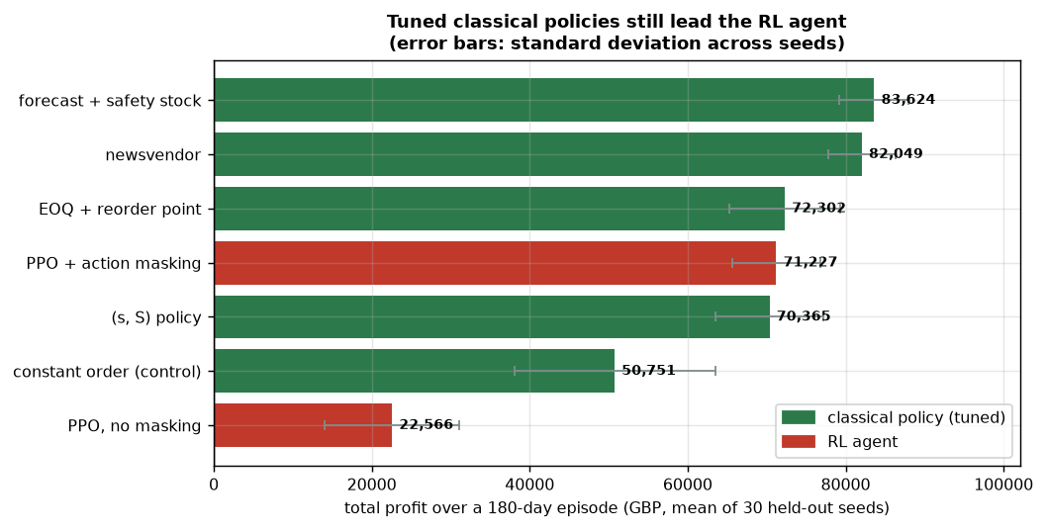
Figure 2 — Policy comparison. Every policy on the same 30 held-out seeds. The tuned classical policies cluster at the top; the masked agent sits mid-pack; the unmasked agent is a distant last.
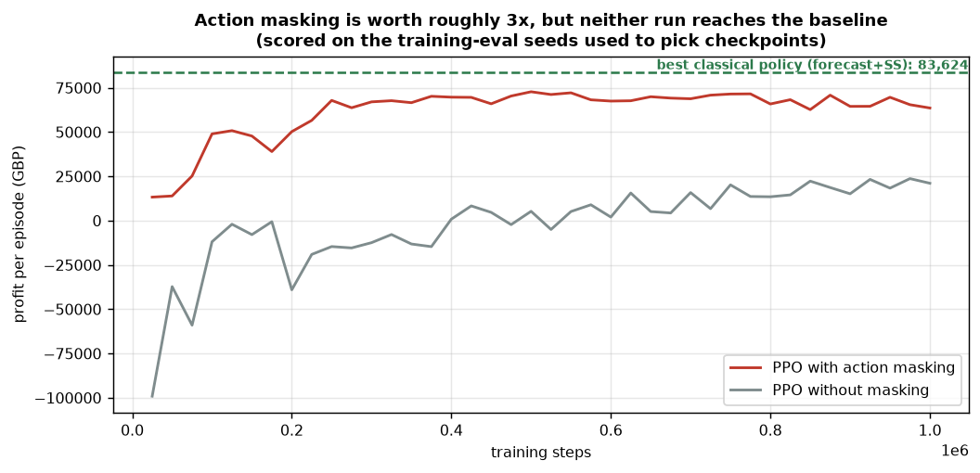
Figure 3 — Training curves. One million steps, masked versus unmasked. Note the gap action masking opens, and that both curves oscillate rather than settle — which points at learning rate and exploration.
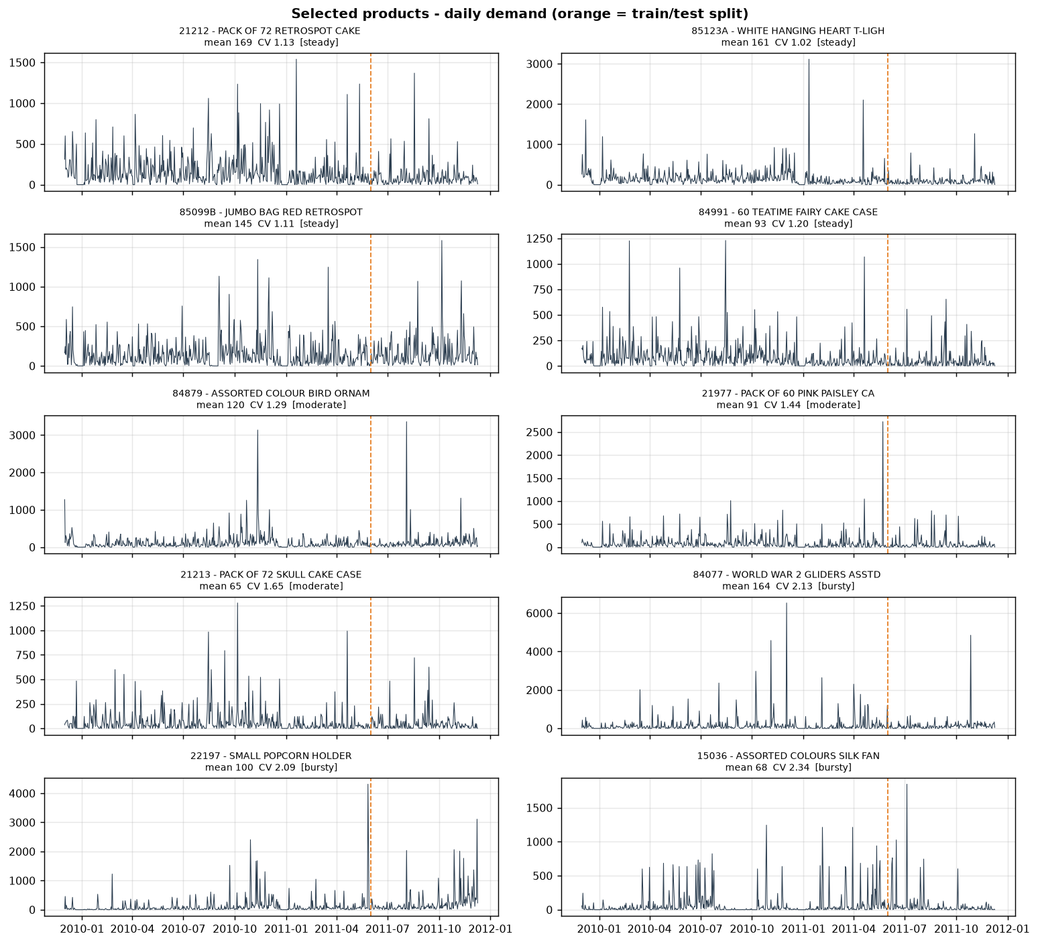
Figure 4 — The ten selected products. Two years of real daily demand. The spread is deliberate: four steady lines, three moderate, three bursty.
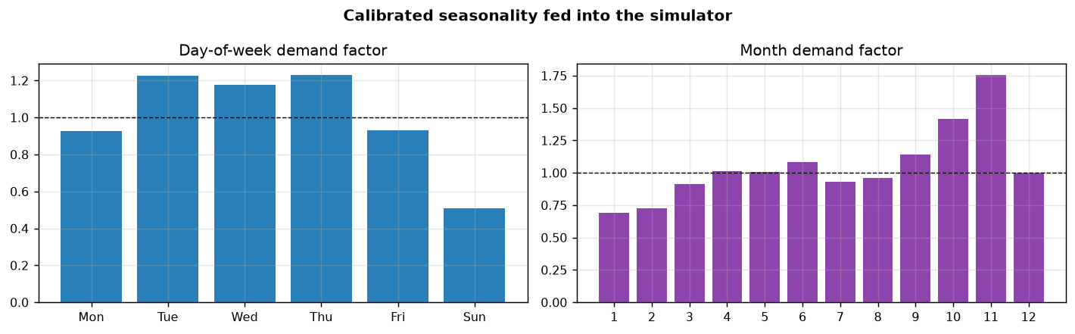
Figure 5 — Seasonality. Measured, not assumed. Thursday 1.23x, Sunday 0.51x; January 0.69x climbing to November 1.75x. Applied on top of every demand draw.
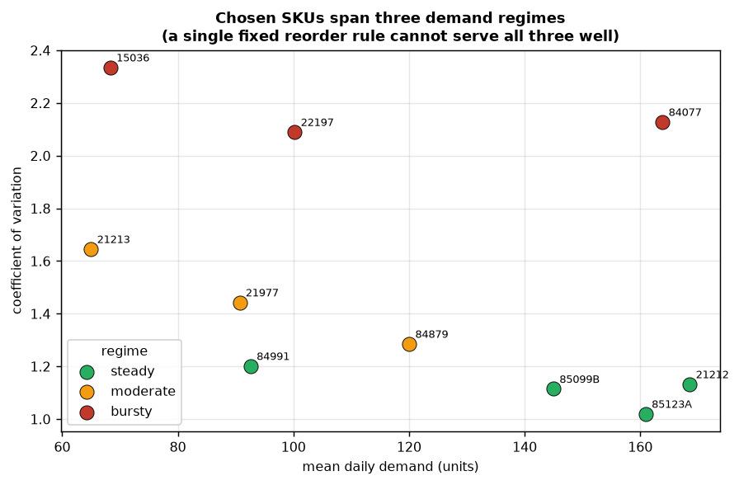
Figure 6 — Demand regimes. How the ten products split across steady, moderate and bursty bands, defined by coefficient of variation.
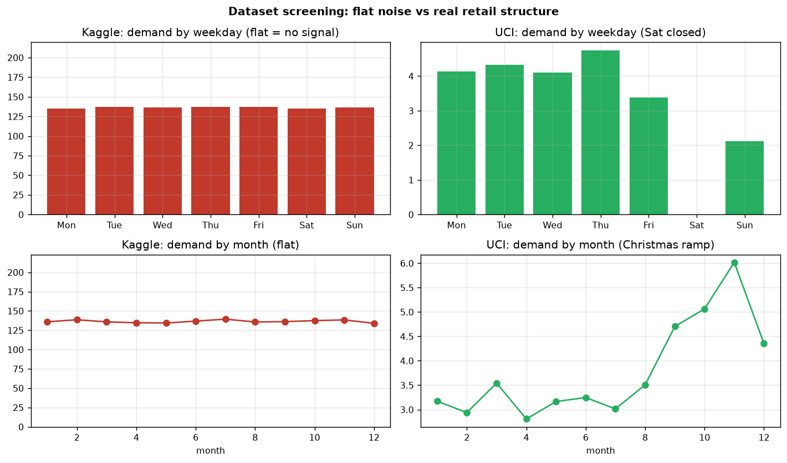
Figure 7 — Dataset selection. The negative result we kept. The rejected candidate's supposed demand drivers all correlate with demand at roughly zero.

6. What is left to build
Five phases remain, in this order. The first is unfinished business from Phase 4; the rest are new construction.

Immediately: finish the hyperparameter sweep
A sweep of 8 configurations over 6M steps was designed and launched to test whether the 12,397 gap can be closed by tuning. It has not produced results yet — results/sweep_results.json does not exist in the repository, so no sweep run has completed. The search deliberately assumes masking rather than searching over it, and targets what the first two runs suggested: lower learning rates to damp the oscillation, a wider entropy range (too little exploration is the likely cause of the supplier-consolidation blind spot), and larger networks to see whether capacity is binding at all. It runs with successive halving, so hopeless configurations are killed early, and it appends results as it goes so an interrupted Kaggle session still leaves usable output.
THE DECISION THIS FORCES
If the sweep closes the gap, the project reports an RL win. If it does not, the project reports a well-evidenced negative result on the optimisation half — which is still a genuine contribution — and the explainability and curriculum halves carry the novelty. Either way the work continues; only the framing of the conclusion changes. Worth deciding now which story the dissertation is structured around, so the sweep result slots in rather than forcing a rewrite.

The remaining phases
Phase | What it involves
6 — LLM explainer | Fact extraction from the environment, prompt construction, response validation, and the deterministic fallback. Needs an OpenRouter API key in .env; nothing before this phase does. The module directory src/llm/ exists but is empty.
7 — Scenario generator | Schema, JSON-mode prompting, validation and clamping. The simulator side is already built and tested, so this is the model wrapper plus its guard rails.
8 — Dashboard | Streamlit app over the existing evaluation traces. app/pages/ is scaffolded and empty. Nothing new is computed here; it renders what phases 1 to 7 already produce.
9 — Curriculum training | Two agents, one curriculum, tested on unseen crises through the Phase 5 harness. The headline experiment.
10 — Report pack | Final write-up, figures, and the dataset and synthetic-data declarations pulled together for submission.

What has to stay true throughout
- Never let the LLM invent decision reasons. Pass it computed facts; have it only phrase them; check the numbers back.
- Scenario generation emits validated JSON, never free prose, and is clamped before it reaches the simulator.
- Keep the real-versus-synthetic split explicit in configs and in the report. Demand is calibrated from real data; supplier attributes are hand-authored and declared.
- Every claim goes through the Phase 5 harness. Same seeds, same metrics, no exceptions.

7. Reproducing everything
The virtual environment lives at D:\venvs\supplyai, deliberately outside the project folder — long paths are disabled on this machine and PyTorch ships a license file nested deep enough to overflow the 260-character limit from inside the project directory.
# run the full test suite (92 tests)
D:/venvs/supplyai/Scripts/python -m pytest tests/ -q

# rebuild the calibrated demand statistics from raw data
D:/venvs/supplyai/Scripts/python -m src.data.run_pipeline

# regenerate every figure in section 5
D:/venvs/supplyai/Scripts/python -m src.eval.result_figures

# on CI or Kaggle, skip checks needing local-only packages
D:/venvs/supplyai/Scripts/python -m pytest -q -m "not local_env"
Everything is config-driven: configs/data.yaml, env.yaml, suppliers.yaml, train.yaml and llm.yaml hold every tunable value, and each one carries comments explaining why the number is what it is — including the ones arrived at by sweeping and the ones that are frank assumptions.
ONE THING WORTH CORRECTING IN THE OLDER NOTES
An early design decision recorded the Kaggle retail dataset as the primary calibration source, with UCI Online Retail II as a secondary check. That inverted during Phase 1: the Kaggle set was screened and rejected for having no learnable structure, and UCI Online Retail II is now the sole primary source. The code and configs are consistent on this; only the older planning notes still say otherwise.

