1. **What exactly is []?**

it is an empty list.

1. **In a list of values stored in a variable called spam, how would you assign the value 'hello' as the third value? (Assume [2, 4, 6, 8, 10] are in spam.)**

Spam[2] = ‘Hello’

Let's pretend the spam includes the list ['a', 'b', 'c', 'd'] for the next three queries.

1. **What is the value of spam[int(int('3' * 2) / 11)]?**

Expression int(int('3' * 2) / 11 will return 3 i.e ‘3’*2 = ‘33’ then it will pass in int() so it string will be converted into integer and then divide by 11 will give integer 3.

The pass 3 as an index value spam[3] should return ‘d’, however it throws an error.

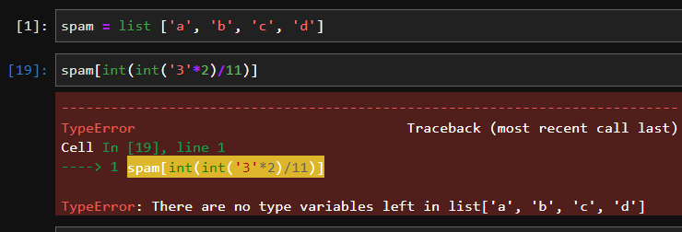

1. **What is the value of spam[-1]?**

‘d’

1. **What is the value of spam[:2]?**

[‘a’,’b’]

Let's pretend bacon has the list [3.14, 'cat,' 11, 'cat,' True] for the next three questions.

1. **What is the value of bacon.index('cat')?**

**1**

1. **How does bacon.append(99) change the look of the list value in bacon?**

[3.14, 'cat,' 11, 'cat,' True,99]

**8. How does bacon.remove('cat') change the look of the list in bacon?**

[3.14, 11, 'cat' True,99]

1. **What are the list concatenation and list replication operators?**

A = [1,2,3,4] B=[5,6,7,8]

List concatenation operator **is ‘+’**

A+B = [1,2,3,4,5,6,7,8]

List replication operator is **‘*’**

A*3 = [1,2,3,4,1,2,3,4,1,2,3,4]

1. **What is difference between the list methods append() and insert()?**

When append() method is used elements are added are the end of the list.

When insert() method is used elements are be added at any place in the list based on index value.

1. **What are the two methods for removing items from a list?**

remove(): it search for the element and remove the 1st occurrence of that element.

pop(): it takes index value of element and removes it from list.

1. **Describe how list values and string values are identical.**

* A string is a sequence of characters and list is a sequence of items.
* Both strings and lists have lengths: a string's length is the number of characters in the string; a list's length is the number of items in the list.
* Each character in a string as well as each item in a list has a position, also called an *INDEX*

1. **What's the difference between tuples and lists?**

List is mutable i.e.; elements of the list can be manipulated/changed.

Tuple is immutable i.e.; elements of tuple can’t be changed once tuple is created.

1. **How do you type a tuple value that only contains the integer 42?**

A = (42,)

1. **How do you get a list value's tuple form? How do you get a tuple value's list form?**

By using tuple() function and pass a list.

A = [1,2,3,4]

B =tuple(A)

B = (1,2,3,4)

By using list() function and pass a tuple.

C = list(B)

C = [1,2,3,4]

1. **Variables that "contain" list values are not necessarily lists themselves. Instead, what do they contain?**

Variable contains reference/address of the list values rather than list values themselves.

1. **How do you distinguish between copy.copy() and copy.deepcopy()?**

**copy():**

* Shallow Copy stores the references of objects to the original memory address.
* Shallow Copy reflects changes made to the new/copied object in the original object.
* Shallow Copy stores the copy of the original object and points the references to the objects.
* Shallow copy is faster.

**Deepcopy()**

* Deep copy stores copies of the object’s value.
* Deep copy doesn’t reflect changes made to the new/copied object in the original object.
* Deep copy stores the copy of the original object and recursively copies the objects as well.
* Deep copy is comparatively slower.