1. **Write a Python program to print "Hello Python"?**

print('Hello Python')

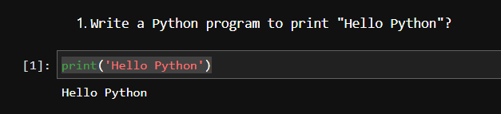

1. **Write a Python program to do arithmetical operations addition and division.?**

a = int(input('enter 1st number:'))

b = int(input('enter 2nd number:'))

print('sum:',a+b)

print('division:',a/b)

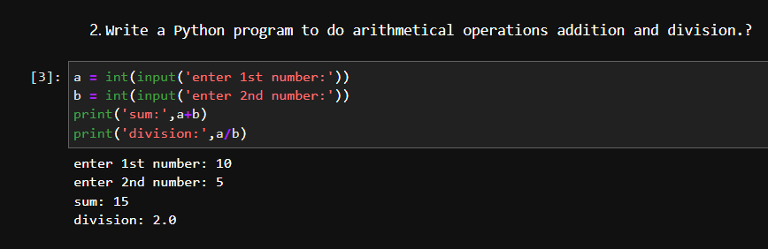

1. **Write a Python program to find the area of a triangle?**

b = int(input('enter the base:'))

h = int(input('enter the height:'))

print('area of triangle is:',(b*h)/2)

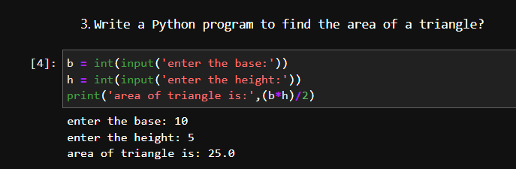

1. **Write a Python program to swap two variables?**

a,b = input('enter 2 numbers: ').split()

print(f'before swapping number a {int(a)} and b is {int(b)}')

a,b = b,a

print(f'after swapping number a {int(a)} and b is {int(b)}')

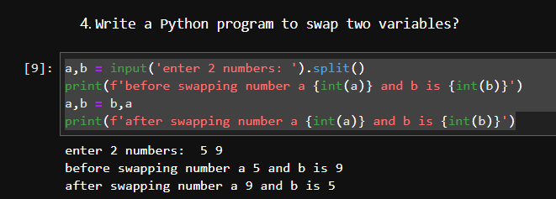

1. **Write a Python program to generate a random number?**

import random

num = random.randint(0,1000)

print(num)

