1. **Write a Python program to convert kilometres to miles?**

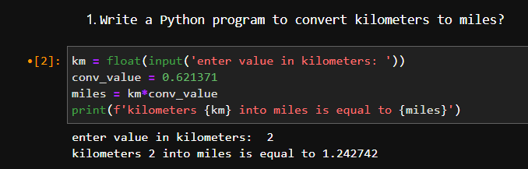

1. **Write a Python program to convert Celsius to Fahrenheit?**

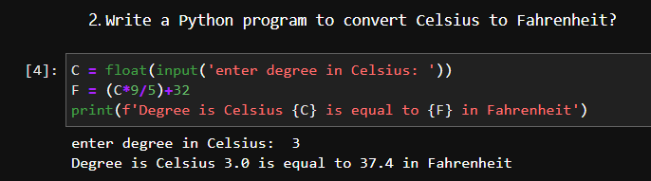

1. **Write a Python program to display calendar?**

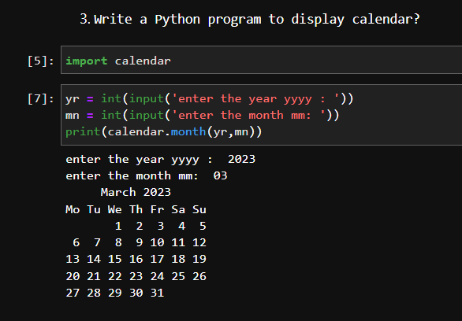

1. **Write a Python program to solve quadratic equation?**

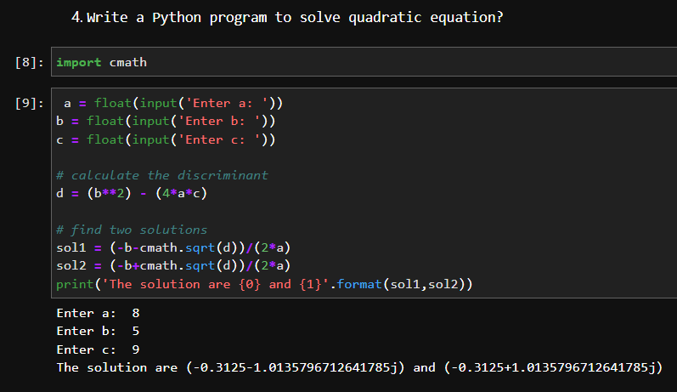

1. **Write a Python program to swap two variables without temp variable?**

