1. **Initialized the repository and added the remote location.**

1. **Added the data given for the Lab#2 and then committed it.**

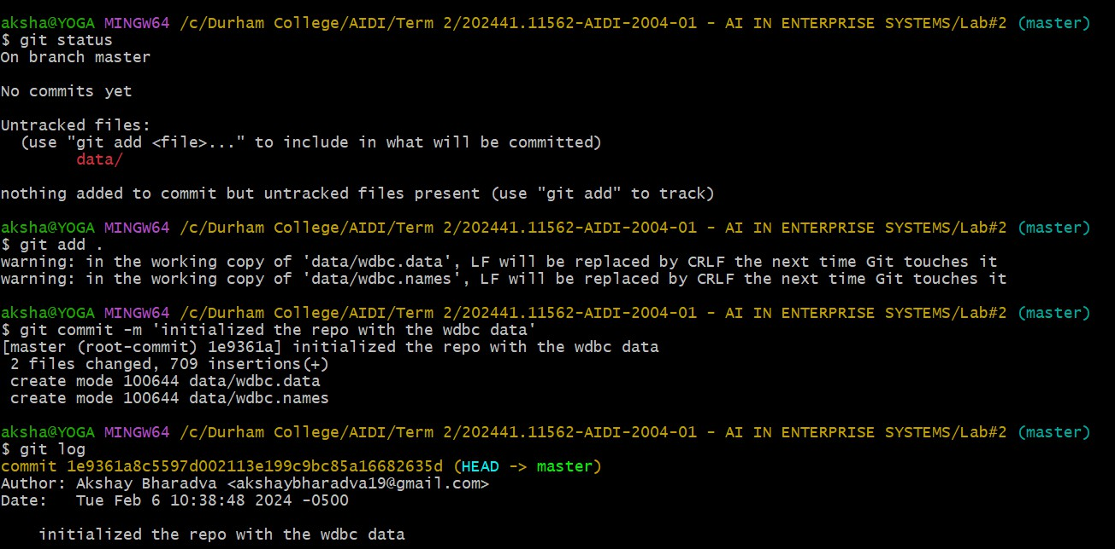

1. **Now, I’m creating the v1 model, steps included are**
   1. **Installing libraries**
   2. **Importing packages**
   3. **Importing data into pandas**
   4. **Splitting the data**
   5. **Selecting the model**
   6. **Training the model**
   7. **Evaluating it and checking the accuracy**

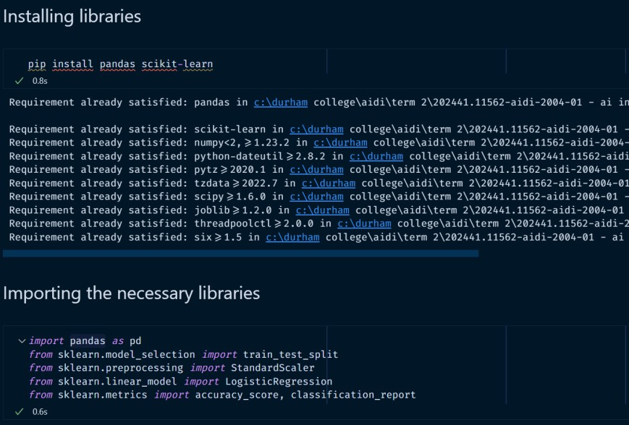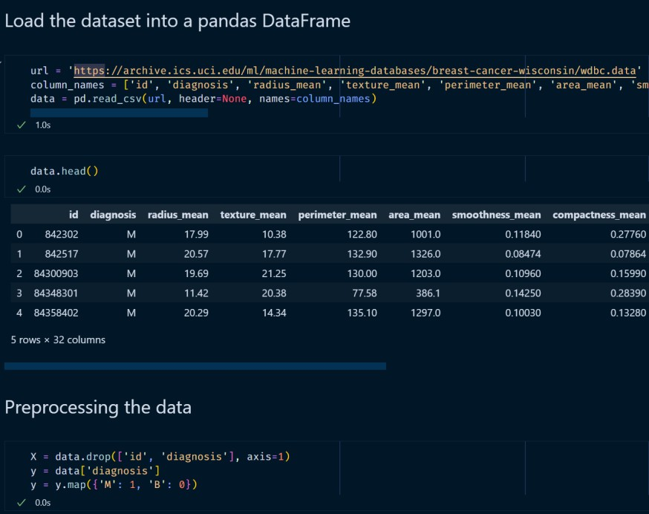

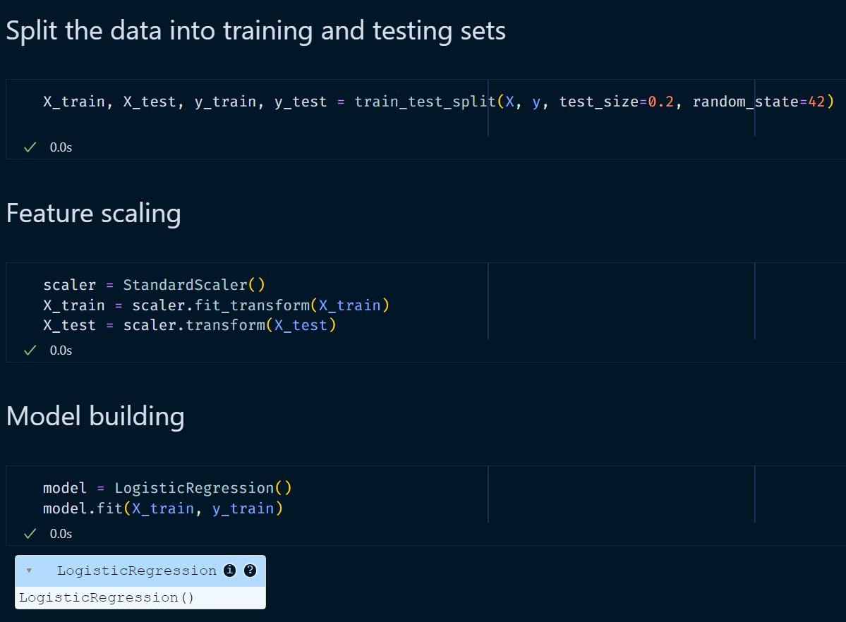

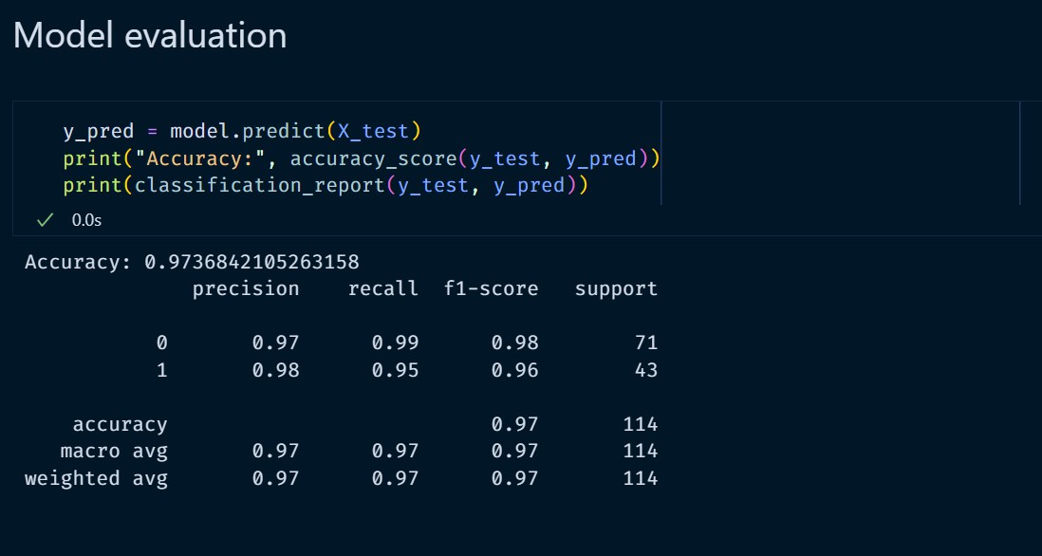

1. **Committing the akshay_bharadva_model_v1.ipynb to the master branch and pushing to the remote location.**

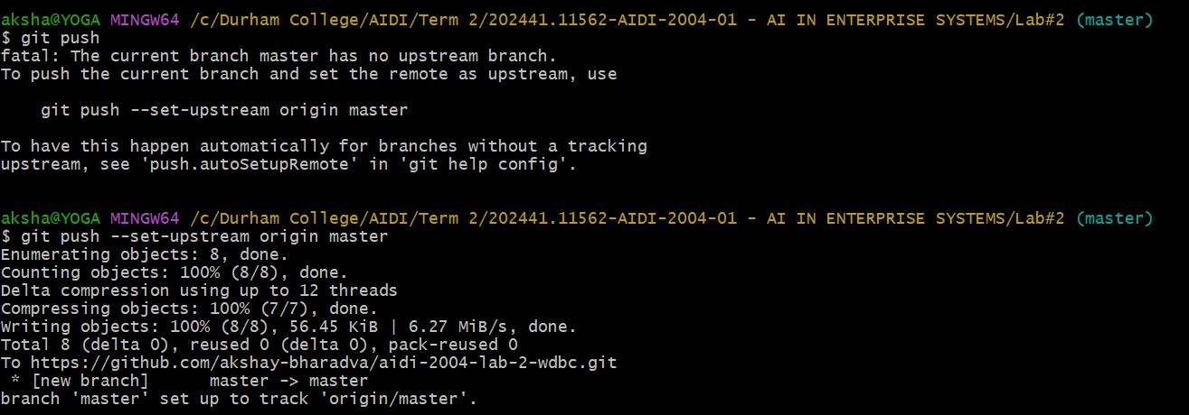

Checking to the remote.

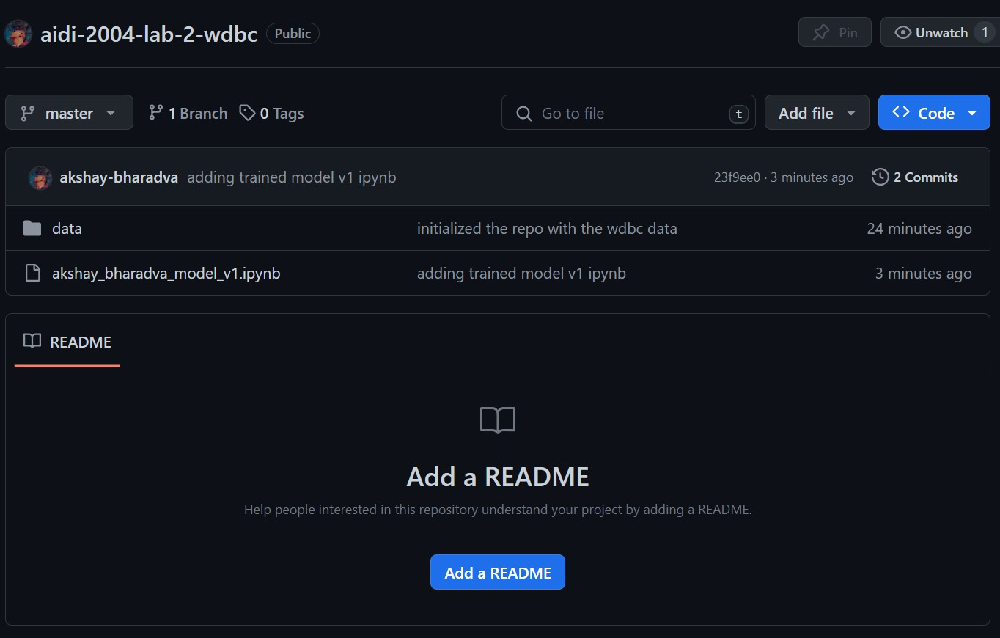

1. **Created random-forest branch from the master branch by using the command,\**
   1. **Git checkout -b random-forest**

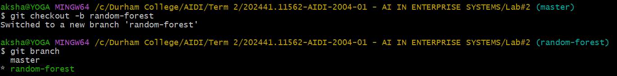

1. **Adding the v2 model ipynb with the Random Forest Classifier Algoritham.**

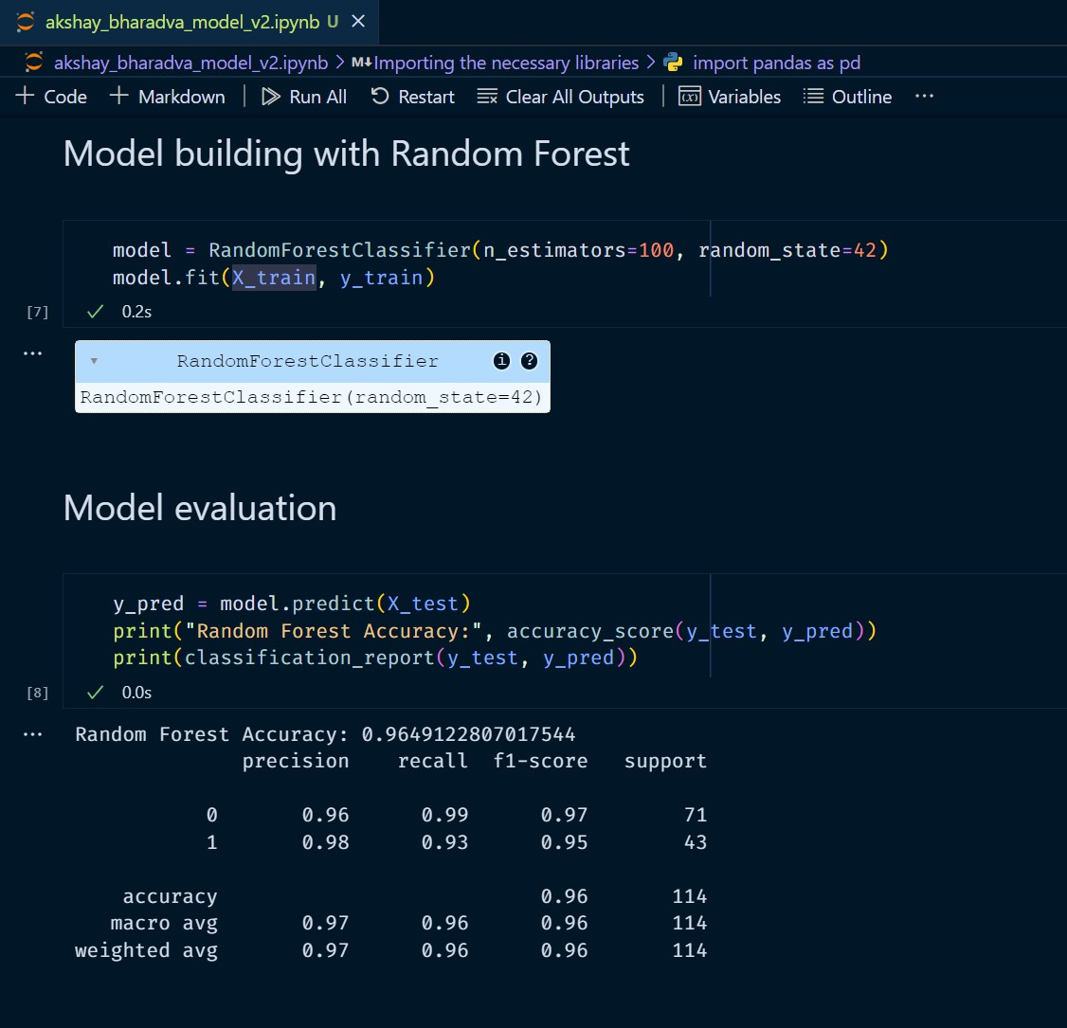

1. **Committing akshay_bharadva_model_v2.ipynb and pushing it to the remote.**

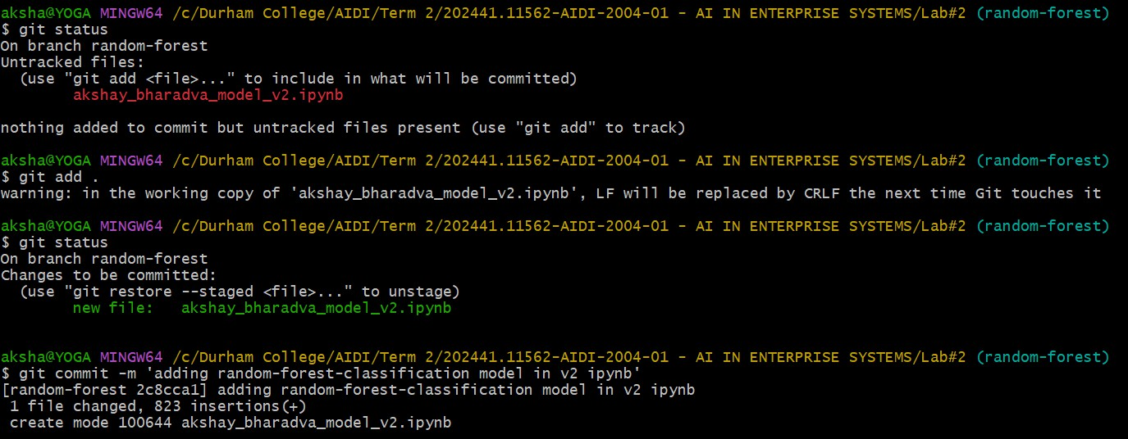

Checking git log,

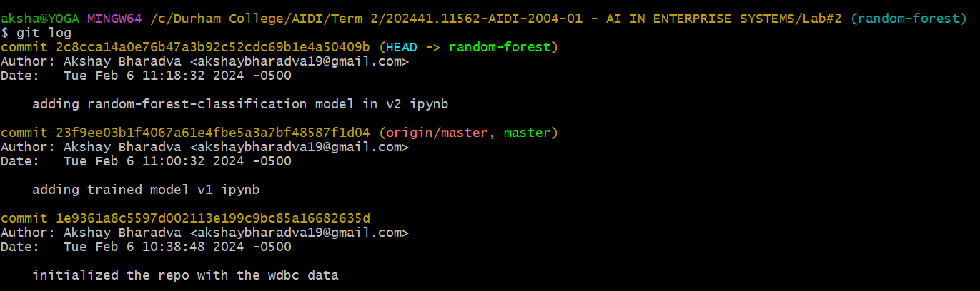

Pushing to the remote,

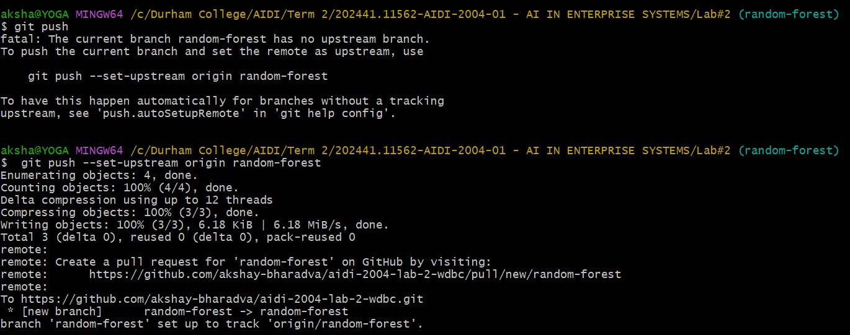

1. **Checking the remote location**

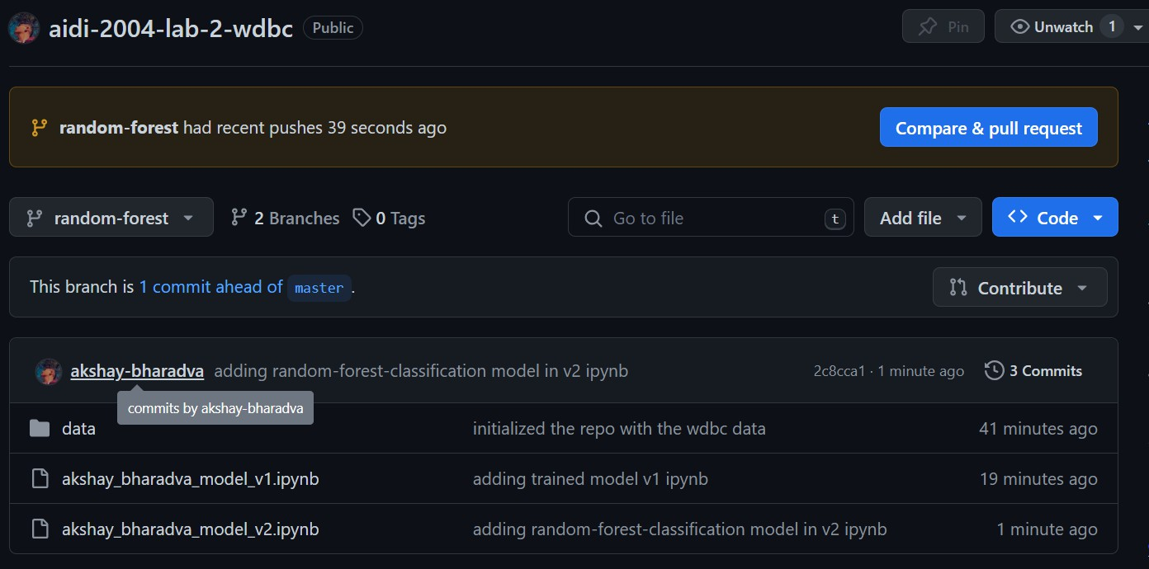

1. **Merging the random-forest branch into master branch so that master have all the code from random-forest branch.**

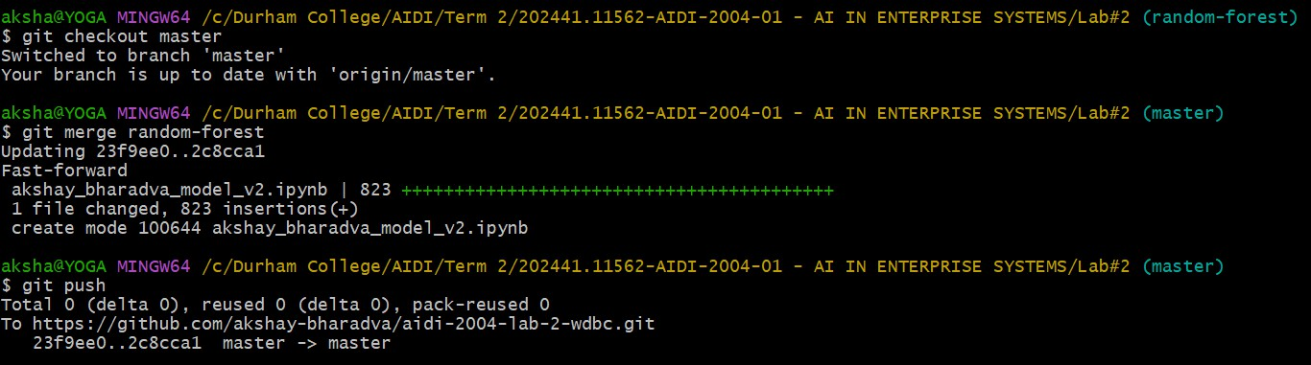

Checking the remote repository after merging and pushing,

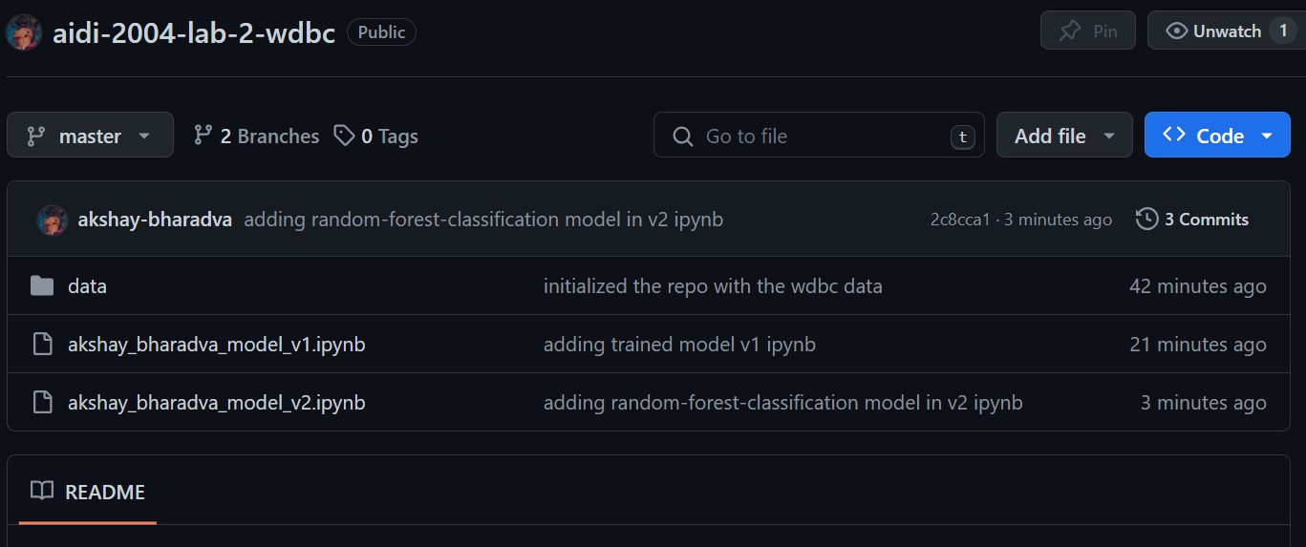

1. **Creating the README.md file for the description of the Lab#2 and tasks performed.**

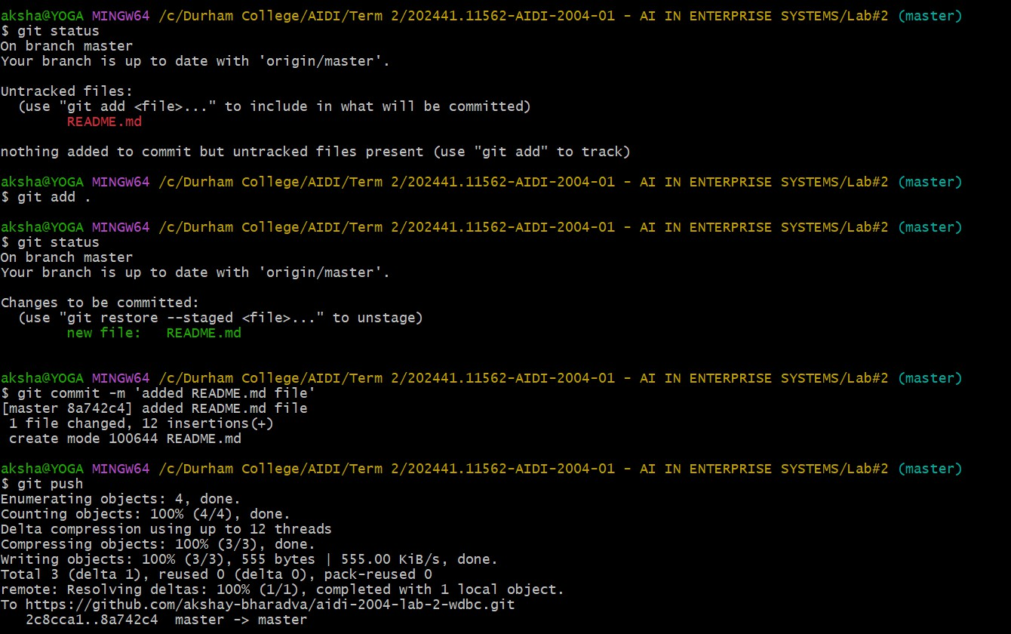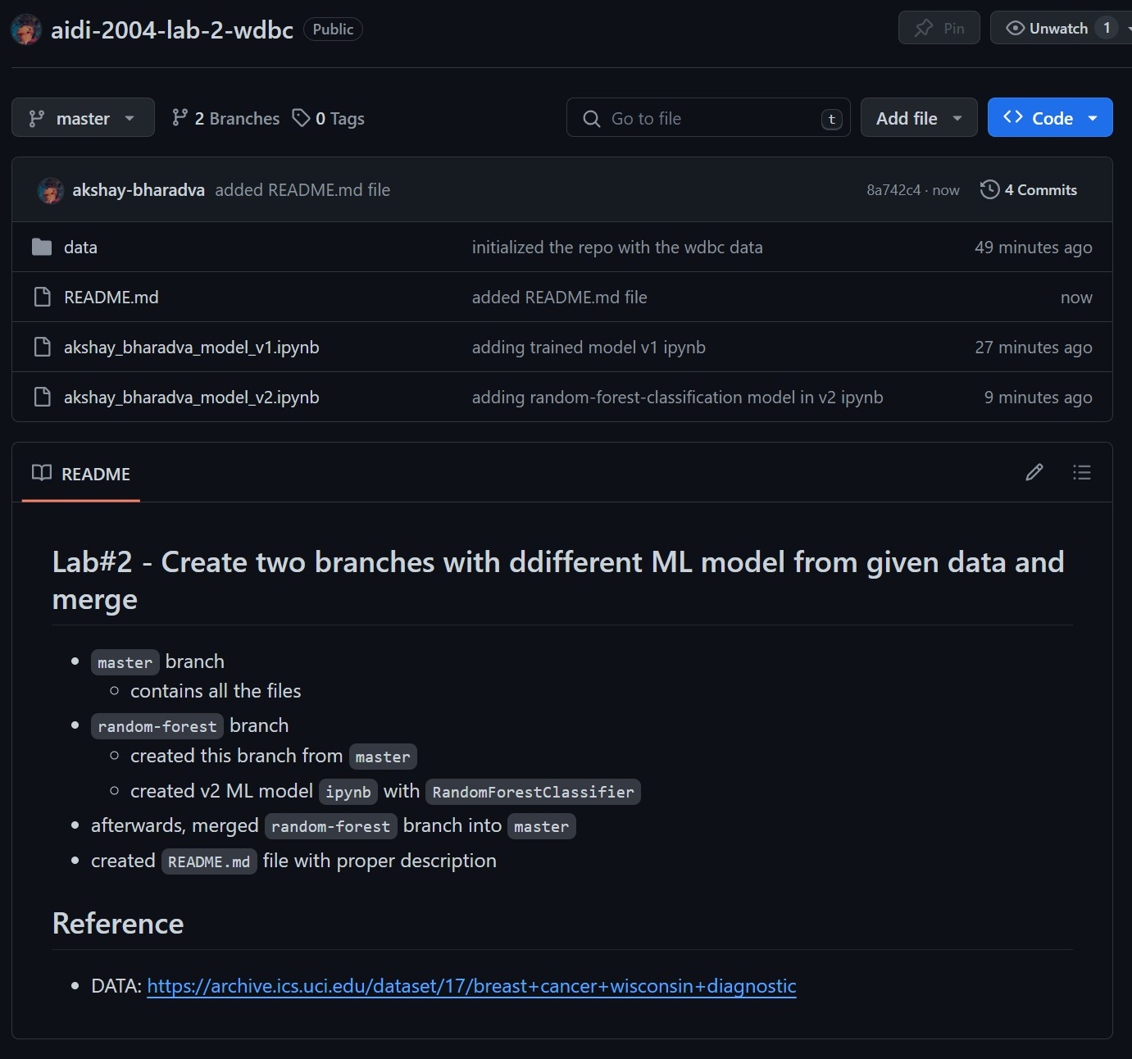

GitHub URL: <https://github.com/akshay-bharadva/aidi-2004-lab-2-wdbc>