The memory technology device (MTD) subsystem of the kernel is responsible for interfacing your system witho various flavours of flash memory.
Flash memory is rewritable storage that does not need power supply to hold information. Flash memory banks are usually organized into sectors. Unlike conventional storage, writes to flash addresses have to be preceded by an erase of the corresponding locations. Moreover, erases of portions of flash can be performed only at the granularity of individual sectors. Because of these constraints, flash memory is best used with device drivers and filesystems that are tailored to suit them. On Linux, such specially designed drivers and filesystems are provided by the MTD subsystem.

Flash memory chips generally come in two flavors: NOR and NAND. NOR is the variety used to store firmware images on embedded devices, whereas NAND is used for large, dense, cheap, but imperfect[1] storage as required by solid-state mass storage media such as USB pen drives and Disk-On-Modules (DOMs). NOR flash chips are connected to the processor via address and data lines like normal RAM, but NAND flash chips are interfaced using I/O and control lines. So, code resident on NOR flash can be executed in place, but that stored on NAND flash has to be copied to RAM before execution.

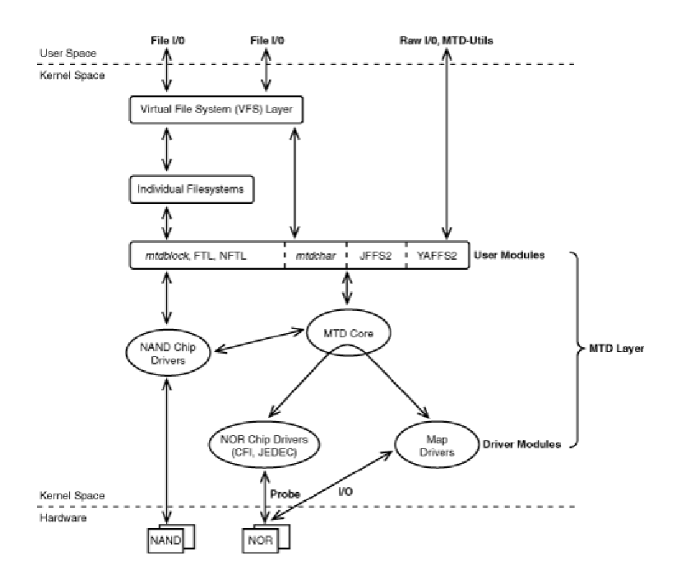

Linux-MTD Subsystem
The kernel's MTD subsystem shown in Figure 17.1 provides support for flash and similar nonvolatile solid-state storage. It consists of the following:
The MTD core, which is an infrastructure consisting of library routines and data structures used by the rest of the MTD subsystem
Map drivers that decide what the processor ought to do when it receives requests for accessing the flash NOR Chip drivers that know about commands required to talk to NOR flash chips NAND Chip drivers that implement low-level support for NAND flash controllers
User Modules, the layer that interacts with user-space programs Individual device drivers for some special flash chips

Map Drivers
To MTD enable your device, your first task is to tell MTD how to access the flash device. For this, you have to map your flash memory range for CPU access and provide methods to operate on flash. Also, the flashes can't be partitioned using the fdisk. Partition info has to be implemented as part of kernel code. MTP map driver assist in accomplishing this.

Example:
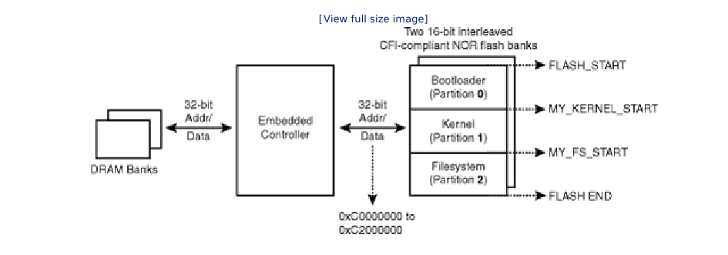
You have a 32 bit NOR flash connected to address bus. The flash is mapped at address 0XC0000000. It has three partitions – Bootloader, Kernel, Filesystem.
#define MY_FLASH_START 0X00000000
#define MY_KERNEL_START 0X00080000
#define MY_FS_START 0X00580000
#define MY_FLASH_END 0X02000000

static struct mtd_partition pda_partition[] = {
{
.name = “bootl”,
.size = (MY_KERNEL_START – MY_FLASH_START),
.offset = FLASH_START,
.mask_flags = MTD_WRITEABLE
},
{
.name = “krnl”,
.size = (MY_FS_START – MY_KERNEL_START),
.offset = MTDPART_OFS_APPEND,
.mask_flags = MTD_WRITEABLE
},
{
.name = “rootfs”,
.size = MTDPART_SIZ_FULL,
.offset = MTDPART_OFS_NEXTBLK
},
}

Next step is to implement the complete map driver. This is register a platform device.

Struct resource pda_flash = {
.start = 0XC0000000,
.end = 0XC2000000 – 1,
.flag = IORESOURCE_MEM
}

struct platform_device pda_platform_device = {
.name = “pda”,
.id = 0,
.resource = &pda_flash
}
platform_device_register(&pda_platform_device);

Next step is to register the map driver:

struct platform_driver pda_driver = {
.driver = {
.name = “pda_flash”,
}
.probe = pda_mtd_probe,
.remove = NULL,
};
static int __init pda_mtd_init()
{
return plaform_driver_register(&pda_map_driver)
}

Let's see how the probe is implemented. Probe does the following things:
- Reserves the flash memory address range using request_mem_region and obtains cpu acess to that memory using ioremap_nocache()
- populates a map_info structure with info such as start address and size of flash memory. This information is used during the probing in the next step.
- Probes the flash via a suitable MTD chip driver. Only chip driver knows how to query the chip and elicit the command set required to access it. The chip layer tries different permutations of bus widths and interleaves while querying. Here, we have 2 16-bit flash banks connected in parallel to fill the 32 bit processor bus width.
- Registers the mtd_patition structure.
Code View:
#include <linux/mtd/mtd.h>
#include <linux/mtd/map.h>
#include <linux/ioport.h>
static int
pda_mtd_probe(struct platform_device *pdev)
{
struct map_info *pda_map;
struct mtd_info *pda_mtd;
struct resource *res = pdev->resource;
/* Populate pda_map with information obtained
from the associated platform device */
pda_map->virt = ioremap_nocache(res->start,
(res->end – res->start + 1));
pda_map->name = pdev->dev.bus_id;
pda_map->phys = res->start;
pda_map->size = res->end – res->start + 1;
pda_map->bankwidth = 2;
/* Two 16-bit banks sitting
on a 32-bit bus */
simple_map_init(&pda_map); /* Fill in default access methods */
/* Probe via the CFI chip driver */
pda_mtd = do_map_probe("cfi_probe", &pda_map);
/* Register the mtd_partition structure */
add_mtd_partitions(pda_mtd, pda_partitions, 3); /* Three Partitions */
/* ... */
}

Now, mtd knows how the flash is organized and how to access it. When the kernel is built with map driver, user applications can see your bootloader, kernel, rfs partitions such as /dev/mtd0, /dev/mtd1 and /dev/mtd2.

NOR chip drivers:- NOR chips are CFI compliant. Common flash interface, a interface, designed to do away with the need for developing seperate drivers to support chips from different vendors. Software can query CFG-compliant flash chips and automatically detect block sizes, timing parameters and command set to be used for communication. Drivers that implement specification such as CFI and JEDED are chip drivers. The code for chip drivers can be found at drivers/mtd/chips/cfi_probe.c

The CFI specification defines various command sets that compliant chip can implement. Some of the common ones are as follows:
command set 0001, supported by intel and sharp
command set 0002, supported by AMP and Fujitsu
command set 0020, used on ST flash chips

Nand Chip driver: NAND technology users such as USB pen drives, DOMs, Compact Flash memory, and SD/MMC cards emulate standard storage interfaces such as SCSI or IDE over NAND flash, so you don't need to develop NAND drivers to communicate with them.[5] On-board NAND flash chips need special drivers, however, and are the topic of this section.

As you learned previously in this chapter, NAND flash chips, unlike their NOR counterparts, are not connected to
the CPU via data and address lines. They interface to the CPU through special electronics called a NAND flash
controller that is part of many embedded processors. To read data from NAND flash, the CPU issues an
appropriate read command to the NAND controller. The controller transfers data from the requested flash
location to an internal RAM memory, also part of the controller. The data transfer is done in units of the flash
chip's page size (for example, 2KB). In general, the denser the flash chip, the larger is its page size. Note that
the page size is different from the flash chip's block size, which is the minimum erasable flash memory unit (for
example, 16KB). After the transfer operation completes, the CPU reads the requested NAND contents from the
internal RAM. Writes to NAND flash are done similarly, except that the controller transfers data from the internal
RAM to flash. The connection diagram of NAND flash memory on an embedded device is shown in Figure 17.3.

