The purpose of this document is to summarize my learnings on USB Ethernet available on BB-XM board. My intention was to learn the Ethernet driver on Linux using BB as a h/w. As a part of this, found some interesting stuff on USB while going through the SRM of BB-XM. Here are my observations:
- DM3730 has one High speed Multi-port USB Host controller and High speed USB OTG controller. The high speed is 480 Mbps and full speed and low speed have 12 and 1.5 Mbps respectively.
- The USB OTG uses the TPS65950 USB PHY. In high speed mode, the interface between USB controller and external usb phy is through the ULPI (UTMI low pin interface) standard which uses either 8 pin or 12 pin. In full speed/low speed mode, the ports interface to the USB PHY using 6/4/3 pin serial interface. Additionally, each port can be directly connected to the usb device by using the On chip transceiver-less link logic (TLL) adapter. (From TRM).
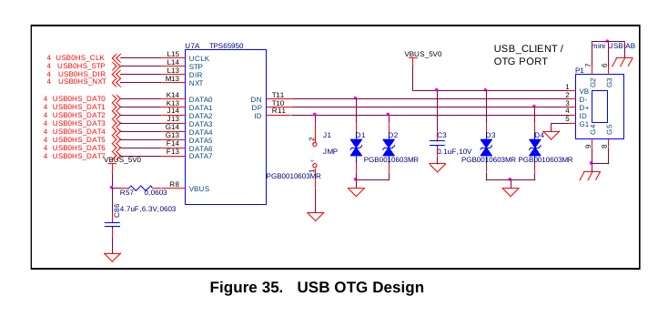
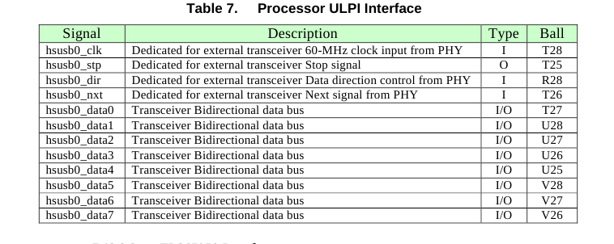
The OTG USB interface is accessed through the miniAB USB connector.

USB Ethernet:
This ethernet is provided through the on-board USB 4 port hub with an integrated 10/100 Ethernet. This allows for the support of the LS and FS USB devices without the need for an external USB HUB. Below is the block diagram of the same:

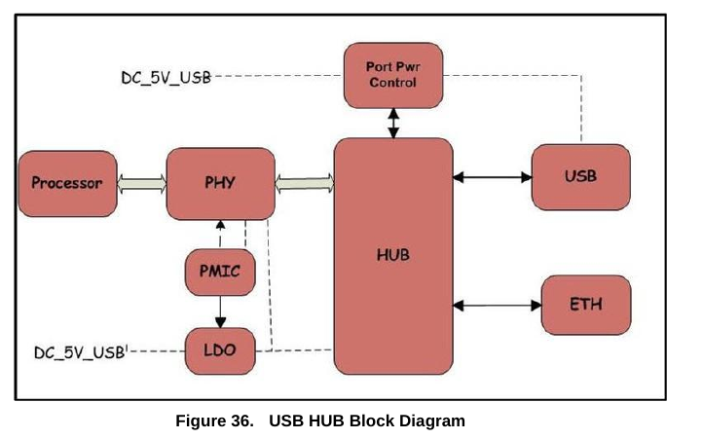
The figure below shows the processor and PHY interface.
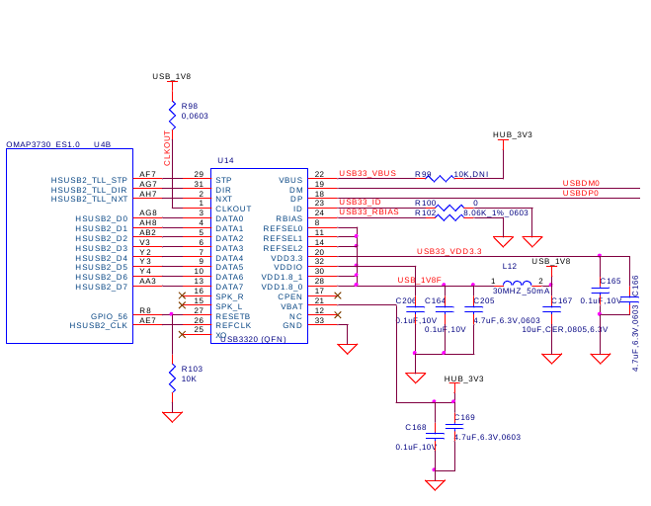
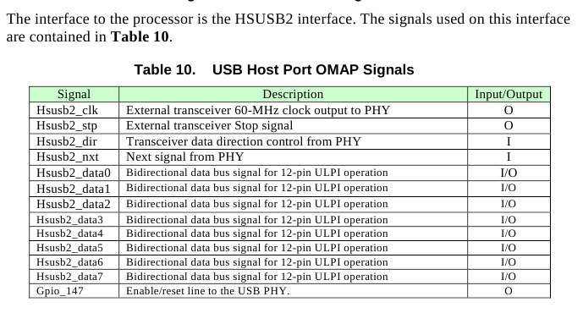
The PHY used in the design is a USB3320 series device from SMSC. The USB3320 is a
highly integrated Hi-Speed USB2.0 Transceiver (PHY) that meets all of the electrical
requirements to be used as a Hi-Speed USB Host. In this design, only the host mode of
operation is being supported as it is used to connect to the HUB on the board.

USB HUB
The key component in the HUB design is a SMSC LAN9514 USB HUB plus Ethernet
device. Figure 40 is the HUB design. The LAN9514/LAN9514i is a high performance Hi-Speed USB 2.0 hub with a 10/100Ethernet controller. The LAN9514/LAN9514i contains an integrated USB 2.0 hub, four integrated downstream USB 2.0 PHYs, an integrated upstream USB 2.0 PHY, a 10/100 Ethernet PHY, a 10/100 Ethernet Controller.

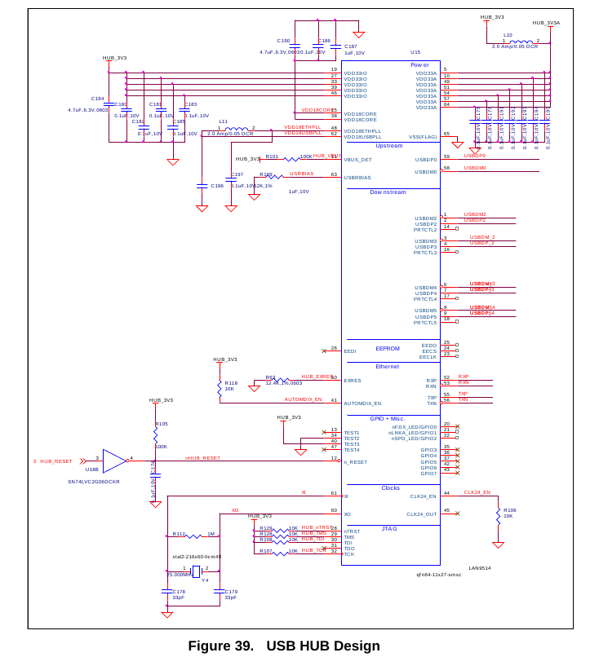
7.14.5 Ethernet
Figure 41 is the circuitry that applies to the Ethernet interface on the board. The
LAN9514 device while performing the function of the HUB also contains the Ethernet
controller.

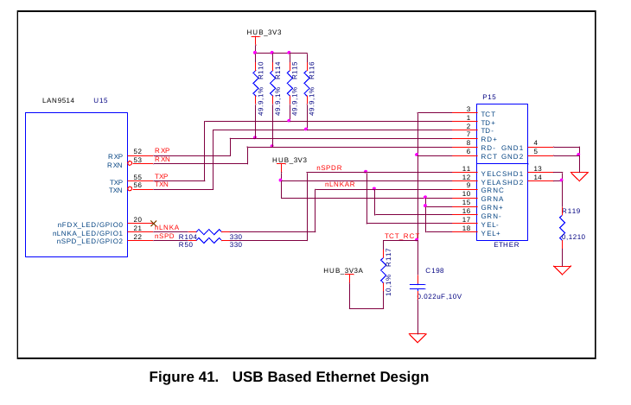
The 10/100 Ethernet controller provides an integrated Ethernet MAC and PHY which are
fully IEEE 802.3 10BASE-T and 802.3u 100BASE-TX compliant. A connector, P15,
with integrated magnetics is used to provide the physical interface off the board. The
Ethernet features auto polarity correction and Auto-MIDX.

Next lets come to the software part of this. The framework used for usb-eth is what we call as usbnet interface. File for the usbnet can be found at drivers/net/usb/usbnet.c. The driver for the Ethernet MAC and phy is located at drivers/net/usb/smsc95xx.c

