Good references for understanding the NAPI compliant drivers:
http://www.eantcal.eu/home/articles-and-publications/articles-eng/linux-napi-compliant-network-device-driver
https://bharathisubramanian.wordpress.com/2010/04/13/napi-the-new-api-for-linux-network-drivers/
https://wiki.linuxfoundation.org/networking/napi
http://lwn.net/Articles/30107/
https://courses.engr.illinois.edu/cs423/sp2014/Lectures/LinuxDriver.pdf

This doc explains the CPSW driver for am33x EVM. For this the docs are placed in Network/Docs/AM33XX.
Following things are available on the board with respect to ethernet:
- The PHY used is the Atheros AR8031_AL1A.
- The MII interface is RGMII interface.
Following the signals used for the RGMII interface between MAC and PHY:

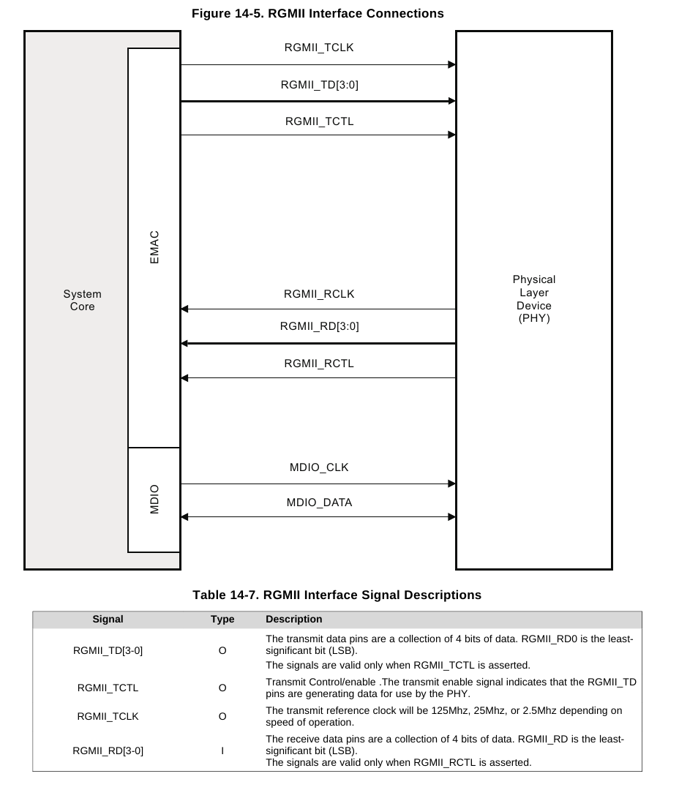
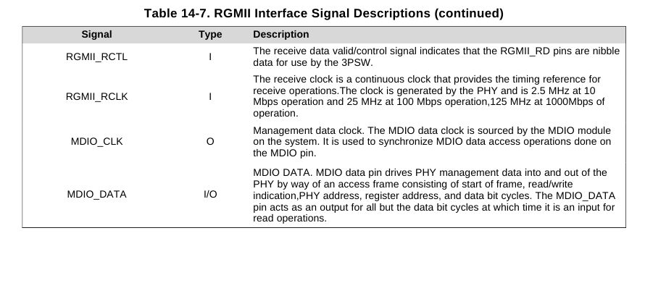
Let's now understand from the driver perspective. There is a function called rgmii1_init in board-am335xevm.c. This just sets the pin multiplexing for the RGMII mode. After that we invoke the am33xx_cpsw_init in arch/arm/mach-omap2/devices.c. The first thing which it does is to read the mac address from the control registers and initialize the am33xx_cpsw_slaves, then we set the phy mode to RGMII and the corresponding interface in MAC. Then we look up for the module mdio and build the device with name davinci_mdio with platform data of 16Mhz speed. The corresponding driver is located at drvers/net/ethernet/ti/davinci_mdio.c. Next step is to look for CPGMAC0 hw module and the device registered is cpsw. The corresponding driver is at net/ethernet/ti/cpsw.c.
Looking at the datasheet, it shows that it consists of following:
CPSW_SS - Ethernet switch sub system
CPSW_PORT – Ethernet Switch port control
CSPW_CPDMA – CPPI DMA controller module
CPSW_STATS – Ethernet statistics
CPSW_STATE_RAM – DMA state RAM
CPSW_CPTS – Time sync module
ALE – Address Lookup Engine
SL1 – Sliver for port 1
SL2 – Silver for port 2
MDIO – Ethernet MDIO controller
CPSW_WR – Wrapper for RMII/RGMII

As per my understanding, the TRM says that the Ethernet subsystem consists of 2 GMII interface modules and 2 RGMII modules.

In arch/arm/mach-omap2/omap_hwmod_33xx_data.c, there is a hw module called cpgmac0 whose structure is defined as below:
static struct omap_hwmod am33xx_cpgmac0_hwmod = {
.name = "cpgmac0",
.class = &am33xx_cpgmac0_hwmod_class,
.clkdm_name = "cpsw_125mhz_clkdm",
.mpu_irqs = am33xx_cpgmac0_irqs,
.main_clk = "cpgmac0_ick",
.prcm = {
.omap4 = {
.clkctrl_offs = AM33XX_CM_PER_CPGMAC0_CLKCTRL_OFFSET,
.modulemode = MODULEMODE_SWCTRL,
},
},
.slaves = am33xx_cpgmac0_slaves,
.slaves_cnt = ARRAY_SIZE(am33xx_cpgmac0_slaves),
.flags = (HWMOD_SWSUP_SIDLE | HWMOD_SWSUP_MSTANDBY |
HWMOD_SWSUP_RESET_BEFORE_IDLE),
};
The cpsw platform device is created as a part of cpsw_init. The platform data for this device as follows:

static struct cpsw_platform_data am33xx_cpsw_pdata = {
.ss_reg_ofs = 0x1200,
.channels = 8,
.cpdma_reg_ofs = 0x800,
.slaves = 2,
.slave_data = am33xx_cpsw_slaves,
.ale_reg_ofs = 0xd00,
.ale_entries = 1024,
.host_port_reg_ofs = 0x108,
.hw_stats_reg_ofs = 0x900,
.cpts_reg_ofs = 0xc00,
.cpts_clock_mult = 0x80000000,
.cpts_clock_shift = 29,
.bd_ram_ofs = 0x2000,
.bd_ram_size = SZ_8K,
.rx_descs = 64,
.mac_control = BIT(5), /* MIIEN */
.gigabit_en = 1,
.host_port_num = 0,
.no_bd_ram = false,
.version = CPSW_VERSION_2,
};

It consists of offsets for various things such as ss_regs_off, ale_regs_ofs, host_port_regs_off, hw_stats_regs_off, cptfs_regs_ofs. Apart from this the number of channels, num of slaves, rx_descs and so on. This is passed to cpsw driver.
The probe function cpsw_probe (/net/ethernet/ti/cpsw.c) does the following things:
- Alloc the etherdev device with cpsw_private as the private data for the same.
- Then we go about initializing the various fields such as pointer to platform data, allocate the time sync structure
- Allocate the slaves
- Then, we go about getting the base addresses of SS (switch subsystem)and WR (wrapper subsystem).
- Get the virtual address for the SS (2K) and WR (256) registers
- Then, we go about initializing the address for the slave ports
- We request the timer 5 and 6 for rx and tx.
- Next step is to initialize the dma register params which contains the offsets for various DMA registers. Then, we initialize the number of channels, ram size (8K) here. After initializing all these parameters, we go about calling the cpdam_ctl_create.
- Then, we initialize the tx and rx ch for dma
- Then, initialize the Address Look up enable
- Next we go about initializing the irqs which are following:
static struct omap_hwmod_irq_info am33xx_cpgmac0_irqs[] = {
{ .name = "c0_rx_thresh_pend", .irq = 40 },
{ .name = "c0_rx_pend", .irq = 93 },
{ .name = "c0_tx_pend", .irq = 94 },
{ .name = "c0_misc_pend", .irq = 43 },
{ .irq = -1 }
};
We request the irqs for these and register a handler.
After this, register the netdev_ops and register the netdevice. So, this finishes the probe function: So, to summarize, following are the steps performed in the probe:
- Alloc the ether_dev and initialize the various fields of the private structure
- Get the virtual address for the Ethernet Subsystem and Ethernet Wrapper system.
- Allocate the timers (Need to understand, why are timers required)
- Initialize the dma parameters and the dma descriptors.
- Create and initialize the address look-up enable (ALE)
- Register the handlers for various IRQs.
- Register the netdev_ops and finally the netdevice.
Now, let's come to the open. Here are the things done in the open:
- Disable the tx and rx and disable the dma channels
- call the netif_carrier_off
- Initialize the host port
- Next invoke the slave_open function, which in turn does the following:
  - Soft reset the slaves
  - set up max packet size
  - try to connect the phy. Configure and start the phy.
  - Set the TX to fixed prio and set the offset of RX to 0
  - Allocate and submit the SKB for all the rx descriptors and submit to on the dma channel queu.
  - Register the time sync module
  - Enable the rx and tx timers for capturing the interrupts
  - Start the DMA's and enable the rx and tx and enable the dma's
  - Finally mark the port as open.
One doubt over here is that netif_start_queue has never happened. Need to understand, where it happens.
Now, let's come to the TX function:cpsw_tx_packet_submit
- Pad the skb to minimum of 60 bytes
- Put the timestamps on SKB and then invoke the cpsw_tx_packet_submit which in turn invokes the cpdma_chan_submit for TX data
- I see that there is cpsw_poll

