Mayank Kundalwal

Department of CSE Indian Institute of Technology Jodhpur
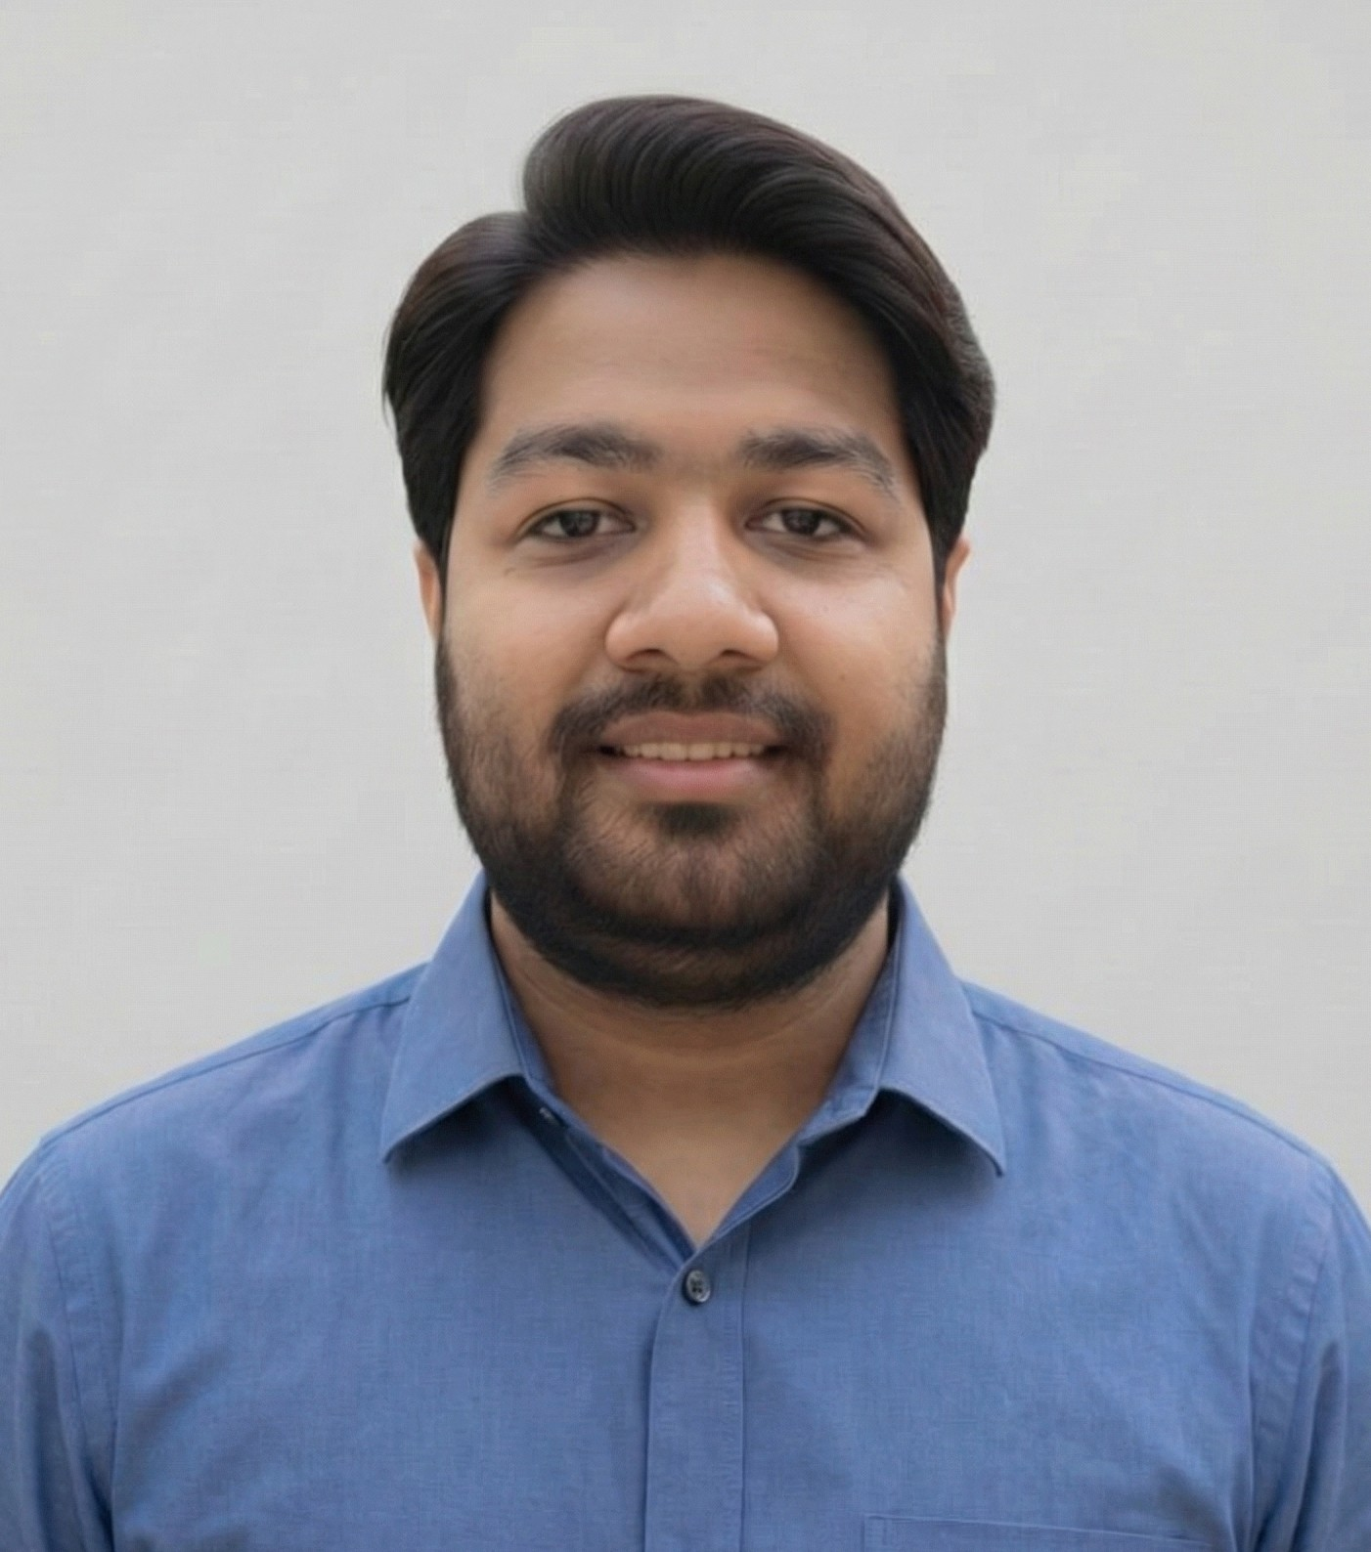
� (+91) 9261444448
C8 kundalwal.1@iitj.ac.in

Curriculum Vitae

Research Summary

ï Linkedin
� My Webpage
1lr Google Scholar

My research focuses on federated learning and representation learning for privacy-sensitive and heterogeneous environments. I develop robust and interpretable models for medical imaging and distributed systems. My work includes publications in IEEE Transactions and WACV, along with contributions to defense-funded radar signal processing projects.

Education
2019–2025 PhD, Computer Science & Engineering, Indian Institute of Technology, Jodhpur, Towards Robust Privacy-preserving Federated Learning under Heterogeneous Environments for Medical Imaging Applications.

2016–2018 M.Tech, Computer Science & Engineering, NIT Patna,
Privacy-Preservation Framework for Cloud-Based Healthcare Systems CGPA: 8.24. 2012–2016 B.Tech, Computer Science & Engineering, Poornima University, CGPA: 7.38.

Research Interests
Federated Learning, Computer Vision, Representation Learning, Medical Image Analysis

Teaching Experience

Jan 2026–Present

Assistant Professor, Manipal University Jaipur.
Teaching undergraduate courses, conducting lectures and tutorials, mentoring students, and designing assessments. Focus on building strong conceptual understanding through interactive and board-oriented teaching approaches.

Technical Skills
Programming Languages: Python (advanced), C/C++, Java
Deep Learning Frameworks: PyTorch, TensorFlow, Keras
Domain Expertise: Federated Learning, Computer Vision, Representation Learning

Research Projects

2023–Present Confidential Defense Project (Indian Army), Researcher.
Developing long-range moving target detection algorithms using pulse-doppler radar. The project aims to enhance object identification accuracy at distances of approximately 20 km under challenging environmental conditions. Responsibilities include radar signal processing, Doppler-based motion analysis, and algorithm prototyping for detection and tracking.
(Certain details are classified and cannot be disclosed publicly.)

Industry Experience
2018–2019 Cloud Engineer, Cloudminister Technologies Pvt. Ltd., Jaipur, India.
Worked on cloud infrastructure and distributed systems, including server management, virtualization, and deployment. Gained experience in maintaining scalable and reliable cloud-based services and supporting system operations.

Publications

Journal Articles
2025 Mayank Kumar Kundalwal and Deepak Mishra. Flame: Federated learning with masked autoencoders and mean-prototypes embedding for sparsely labeled medical images. IEEE Transactions on Emerging Topics in Computational Intelligence. IEEE, 2025.
2025 Mayank Kumar Kundalwal and Deepak Mishra. Ar2fl: Anomaly-resistant robust framework for federated learning. IEEE Transactions on Artificial Intelligence. IEEE, 2025.
2019 Mayank Kumar Kundalwal, Kakali Chatterjee, and Ashish Singh. An improved privacy preservation technique in health-cloud. ICT Express, volume 5, pages 167–172. Elsevier, 2019.

In Conference Proceedings
2026 Mayank Kumar Kundalwal, and Deepak Mishra, Federated Model Synchronization for Diagnos-tic Redefinition through a Novel Selective Parameter Unlearning, In 2026 IEEE/CVF Winter Conference on Applications of Computer Vision (WACV), IEEE, 2026.
2024 Mayank Kumar Kundalwal, Anurag Saraswat, Ishan Mishra, and Deepak Mishra. Client contribution normalization for enhanced federated learning. In 2024 IEEE 21st India Council International Conference (INDICON), pages 1–6. IEEE, 2024.
2022 Mayank Kumar Kundalwal, Anurag Saraswat, Ishan Mishra, and Deepak Mishra. Bafl: Federated learning with base ablation for cost effective communication. In 2022 26th International Conference on Pattern Recognition (ICPR), pages 1922–1928. IEEE, 2022.
2018 Mayank Kumar Kundalwal, Ashish Singh, and Kakali Chatterjee. A privacy framework in cloud computing for healthcare data. In 2018 International conference on advances in computing, communication control and networking (ICACCCN), pages 58–63. IEEE, 2018.

Submitted / Under Review Publications
2025 Mayank Kumar Kundalwal, and Deepak Mishra, Context-Aware Hierarchical Swarm Learning for Medical Image Applications, In ACM Transactions on Multimedia Computing, Communications, and Applications (TOMM) (Under Review).
2026 Mayank Kumar Kundalwal, and Deepak Mishra, Selective Federated Unlearning through Anchor Editing in Embedding Space, In IEEE Internet of Things Journal (Under Review).

Achievements
2026 DEI Travel Grant Recipient – IEEE/CVF (WACV 2026).
2025 Poster Presentation: “Graduate Forum” at IndoML 2025, BITS Pilani – Hyderabad Campus
2023–Present Cyber Volunteer Squad Member – Ministry of Home Affairs, Government of India. Recognized at the G20 Conference on Crime and Security in the Age of NFTs, AI, and the Metaverse (2023).
2023–2025 Indian Army (Defense R&D) Research Funding – Radar-based Moving Target Detection Project.
2019–2023 Ministry of Education (MoE) Doctoral Fellowship for PhD Research. 2016–2018 MHRD Fellowship for M.Tech Studies.
Reviewer for leading journals (IEEE TAI, TETCI, IoT Journal, TDSC ) and top conferences (WACV, ICPR, IJCAI, ECAI).

Referees

Dr. Deepak Mishra Dr. Suman Kundu
Assistant Professor, Dept. of CSE Assistant Professor, Dept. of CSE Indian Institute of Technology, Jodhpur Indian Institute of Technology, Jodhpur C8 dmishra@iitj.ac.in C8 suman@iitj.ac.in

