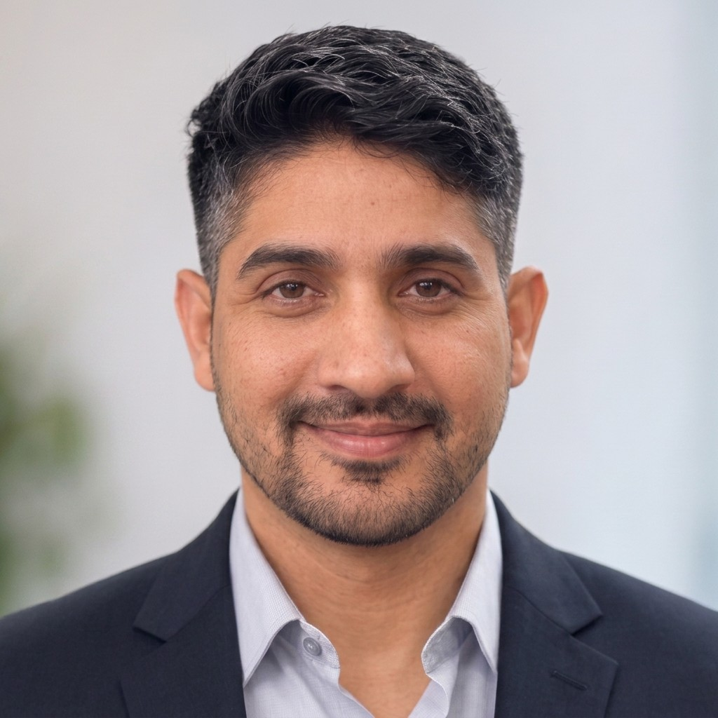
Dr. Satveer Singh
a satveersingh.1339@gmail.com × +91 94628 44562
 Flat no 403, Tower no 5, Omaxe Executive Homez, Omaxe city, Jaipur, 302026
Ƹ ResearchGate ŵ Google Scholar ] LinkedIn ç My Webpage

Employment History
Oct 2025 – till now  Assistant Professor
Institute of Engineering and Technology

JK Lakshmipat University, Jaipur
Feb 2024 – Sept 2025  Assistant Professor
Dept. of IoT and Intelligent Systems

Manipal University Jaipur
Feb 2019 – July 2019  Junior Research Fellow
Scientific Analysis Group

Defence Research and Development Organization (DRDO), Delhi
Sept 2016 – Jan 2019  Assistant Professor
Dept. of Computer Science and Engineering
Maharani Girls Engineering College, Jaipur

Education
Aug 2019 – July 2024  Ph.D. (Computer Science and Technology)

Jawaharlal Nehru University, New Delhi, India
School of Computer and Systems Sciences
Thesis title: Fog Device Deployment and IoT Workload Distribution in Fog-integrated Cloud: A Metaheuristic Approach
Course Work CGPA: 8.0
July 2014 – Aug 2016  M.Tech. (Computer Science and Engineering)

Sant Longowal Institute of Engineering and Technology, Punjab, India
Dept. of Computer Science and Engineering
Thesis title: Strategies for Optimum Resource Allocation in Cloud
CGPA: 8.69
July 2009 – July 2013  B.Tech. (Computer Science and Engineering)
Rajasthan Technical University, Rajasthan, India Aravali Institute of Technical Studies, Udaipur, Rajasthan Major Project: The Secured Ignition System
Percentage: 64.70

Courses Taught
C Programming  Procedural programming, memory management.
Python Programming  Object-oriented programming, data scripting.
Data Structures  Abstract types, standard implementations. DAA (Design & Analysis of Algorithms)  Algorithm paradigms, complexity analysis.
Computer Networks  Network protocols, socket programming. Edge, Fog & Cloud Computing  Virtualization and resource scheduling.
Machine Learning  Supervised, unsupervised, neural networks.

Research Publications

Journal Articles

R. Keshri, S. Singh, and D. P. Vidyarthi, “Fog Device Deployment for Enhanced Edge Communication and Network Cohesion using JAYA,” Journal of Grid Computing, vol. 24, no. 2, p. 12, 2026. î DOI: 10.1007/s10723-026-09832-x.
1

S. Singh, H. Dureja, and R. Singh, “A multilingual smart farming system for real time agricultural decisions using machine learning,” Discover Applied Sciences, vol. 8, no. 6, p. 613, 2026. î DOI: 10.1007/s42452-026-08597-y.
2

S. Singh, E. E. Sham, and D. P. Vidyarthi, “Optimizing Fog Device Deployment for Maximal Network Connectivity and Edge Coverage using Metaheuristic Algorithm,” Future Generation Computer Systems (FGCS), vol. 157, pp. 529–542, 2024. î DOI: 10.1016/j.future.2024.04.010.
3

S. Singh, E. E. Sham, and D. P. Vidyarthi, “Optimizing Workload Distribution in Fog-Cloud Ecosystem: A JAYA based Meta-heuristic for Energy-Efficient Applications,” Applied Soft Computing Journal, vol. 154,
4
pp. 1–18, 2024. î DOI: 10.1016/j.asoc.2024.111391.

S. Singh and D. P. Vidyarthi, “A Hybrid Model using JAYA-GA Metaheuristics for Placement of Fog Nodes in Fog-integrated Cloud,” Journal of Ambient Intelligence and Humanized Computing (JAIHC),
5
pp. 3035–3052, 2024. î DOI: 10.1007/s12652-024-04796-w.

S. Singh and D. P. Vidyarthi, “FNSS: A Heuristics for Fog Node Site Selection,” SN Computer Science, vol. 5, no. 146, pp. 1–18, 2024. î DOI: 10.1007/s42979-023-02468-8.
6

S. Singh and D. P. Vidyarthi, “PMRNA: Parameter Matching of Realtime and Non-Realtime Applications for Resource Provisioning in Fog-integrated Cloud,” Concurrency and Computation: Practice and Experience, pp. 1–19, 2024. î DOI: 10.1002/cpe.8145.
7

S. Singh and D. P. Vidyarthi, “Fog Node Placement using Multi-Objective Genetic Algorithm,” International Journal of Information Technology (IJIT), vol. 16, no. 2, pp. 713–719, 2023. î DOI: 10.1007/s41870-023-01530-1.
8

Conference Proceedings

R. Keshri, S. Singh, and D. P. Vidyarthi, “Communication-Aware Fog Device Deployment in Edge-Fog-Cloud Systems Using Jaya Algorithm,” in International Conference on Data Science and Artificial Intelligence, Springer, 2025, pp. 73–82. î DOI: 10.1007/978-981-96-9083-1_6.
1

T. Vats and S. Singh, “Ev charging slot scheduling: Integrating advanced scheduling algorithms with sdn–a case study,” in International Conference on Next-Generation Networks and Deployable Artificial Intelligence, Springer, 2025, pp. 116–126. î DOI: 10.1007/978-3-032-15398-2_9.
2

S. Singh and D. P. Vidyarthi, “Designing Fog Device Network for Digitization of University Campus,” in International Conference on Soft Computing and its Engineering Applications, Springer, SCOPUS, 2022, pp. 123–134. î DOI: 10.1007/978-3-031-27609-5_10.
3

S. Singh and B. Singh, “Optimum Resource Allocation Approach in Cloud,” in International Conference on Advanced Communication Control and Computing Technologies (ICACCCT), IEEE, SCOPUS, 2016,
4
pp. 600–605. î DOI: 10.1109/ICACCCT.2016.7831711.

Skills
Area of Specialization  Cloud Computing, Fog Computing, Internet of Things, and Machine Learning.
Coding  C · Python · OPL (Optimization Programming Language) Simulators  CloudSim · iFogSim · CPLEX STUDIO IDE 20.1.0 (IBM)

Achievements
Aug 2021 – Feb 2024  UGC-SRF (Senior Research Fellowship) Aug 2019 – Aug 2021  UGC-JRF ( Junior Research Fellowship) Feb 2019 – July 2019  DRDO-JRF ( Junior Research Fellowship)
July 2014 to July 2016  GATE Scholarship (Graduate Aptitude Test in Engineering) 2014 to 2020  GATE Qualified Seven Times
Nov 2017, June2020  UGC-NET/JRF Qualified Two Times July 2016, Jan 2017, Dec 2018  UGC-NET Qualified Three Times

Workshop/Conference/Summer School/FDP
2026  Two Days Faculty Development Program (FDP) on Rethinking Learning Outcomes and Assessments for Programming Courses in the GenAI Era, April 03-04, Organized by Insti-tute of Engineering & Technology at JK Lakshmipat University, Jaipur.
 Session Chair at the IEEE International Conference on AI Engineering and Innovation (AIEI 2026), March 26-28, Organized by National Institute of Technology, Jamshedpur, India and University of South Dakota, USA.
2025  Five Days Faculty Development Program on Mastering Cloud Computing Essentials with AWS, March 03-07, Hosted by NITTTR, Chandigarh.
2024  Five Days Faculty Development Program on Developing the Future Workforce: Design-ing an AI and Analytics curricula, April 15-19, Hosted by SAS.
 Three Days Faculty Development Program by Dale Carnegie on Train The Trainer (TTT), Feb 19-21, Hosted by Manipal University, Jaipur, India.
2023  Training Workshop on IoT Organized by 5G Indigenous Test Bed O and M Team, 31st Oct, Hosted by Indian Institute of Technology, Delhi, India.
 One Week Short Term Course on Machine Learning and its Applications in IoT, Com-puter Vision and Cloud Computing (MICC-2023), July 10-14, Hosted by National Institute of Technology, Jamshedpur, India.
2022  One-Week Workshop on Blockchain Technology: Architecture and Applications, Nov
28- Dec 04, Hosted by Indian Institute of Information Technology, Kota, India.
2021  Online Workshop on Cyber Security and Digital Forensics, Aug 26- 30, Hosted by Aligarh Muslim University, Aligarh, India.

References

Prof. Deo Prakash Vidyarthi
Professor
School of Computer and Systems Sciences Jawaharlal Nehru University
New Delhi, India
a dpv@mail.jnu.ac.in

Prof. Birmohan Singh
Professor
Dept. of Computer Science and Engineering Sant Longowal Institute of Engineering and Tech.
Sangrur, Punjab, India
a birmohansingh@sliet.ac.in

