# Report Addendum

Group-51

Kartik Kapoor (20170010066) • Nikhil Sampangi (20170010136)

Aparna M Nair (20170020191) • Anusha Vullanki (20170020250)

DIGITAL HEARING AIDS

1)Ground Truth

* The main objective of a hearing aid is to fit the dynamic range of speech into the restricted dynamic range of the impaired ear and-
* To make the signal as clean and refined as possible so that the user’s ears are out of harm’s way
* For this project we have designed a configurable hearing aid system implemented in MATLAB programming language.
* This implementation of Hearing Aid includes noise reduction function, frequency shaping filter and amplitude compression filter.
* In order to reduce the noise, we added a noise reduction filter using wavelets
* In the frequency shaping filter, rather than amplifying all of the signals, we apply high gain for higher frequencies and vice versa
* Amplitude Compression filter will ensure that the amplified signal will not exceed saturation power. Saturation power is where the sound signal begins to become uncomfortable.
* What needs to be achieved in this project is a clarified and amplified output which is in accordance to the preferences applied by the user
* Here’s an example of what we’re trying to achieve:
  + Frequency Shaping filter:
  + 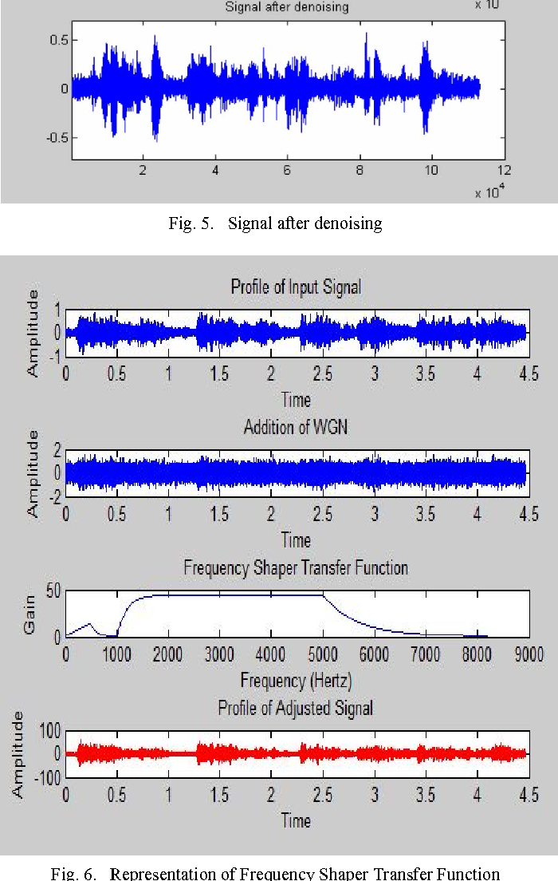
  + Spectrogram of original and adjusted signals:
  + 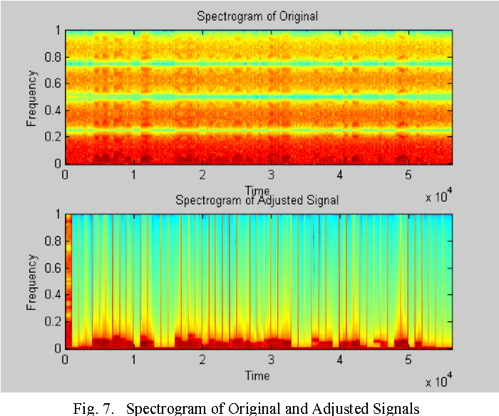

2) Validation

* In order to properly validate the working of this project we would either need an actual hearing aid to compare the output with when given the same input signal to both and measure the accuracy of the implemented (or)
* we would need a hearing-impaired person who can add his preferences and validate the output of implementation
* both of these mentioned validation techniques are not that feasible and practical. It also not an automated validation technique.
* Instead, we’ll just analyze the signal at every step and tabulate the information which will keep track of change in signal from input to output according preferences (gain, frequency transition values) given
* We may not be able to completely validate the working of our project but we’ll thoroughly analyze the code and plot the changes in the signal at the end every filter and derive the output
* We can later manually validate it’s working by listening to the input and output and observe the amplification of the output
* We’ll even depict the variation in the output signal for different preferences [ gain, frequency transition, saturation power] applied.

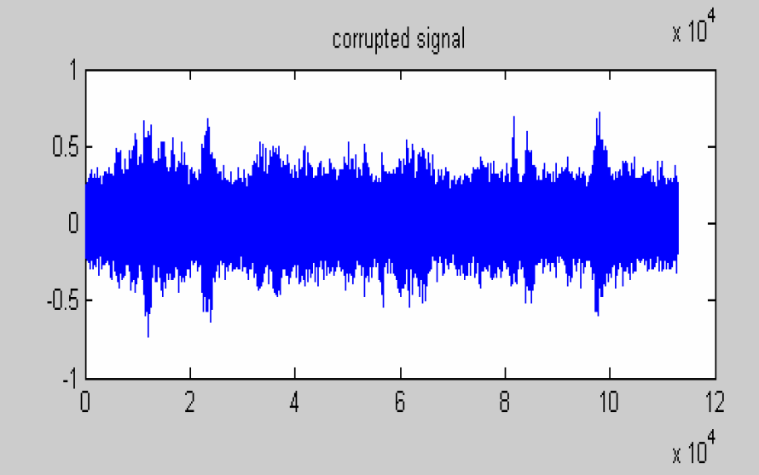

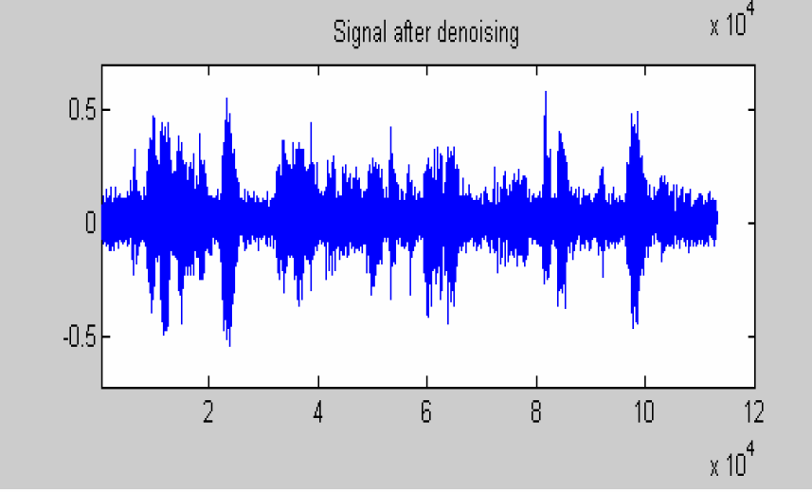

3)Contributions

|  |  |  |
| --- | --- | --- |
| Name | Roll no | Contribution |
| Nikhil Sampangi | S20170010136 | Implementing the Frequency shaping filter which appropriately applies higher gain for higher frequencies and vice-versa, De-noising |
| Kartik Kapoor | S20170010066 | Front-End GUI with two different Methods to run the code: 1) Use pre-recorded audio file 2) Have a live record button |
| Aparna M Nair | S20170020191 | Amplitude Compression to control the overall gain of the speech  File integration and Analysis of signal at every stage |
| Anusha Vullanki | S20170020250 | Amplitude Compression to control the overall gain of the speech  File integration and Analysis of signal at every stage |