Problem Statement:

Approximately 10% of the world’s population (760 million people) suffers from some level of hearing loss, yet only a small percentage of this statistic use a hearing aid. One of the major reasons being the dissatisfaction with hearing aid performance, and the cost associated with a high performance alternatives.

A hearing aid has three basic parts: a microphone, amplifier, and speaker. The hearing aid receives sound through a microphone, which converts the sound waves to electrical signals and sends them to an amplifier. The amplifier increases the power of the signals and then sends them to the ear through a speaker. The traditional hearing aids are of two types:

1) Analog: Analog aids convert sound waves into electrical signals which are then amplified.

2) Digital: Digital aids convert sound waves (Analog signal) into numerical codes(Digital signal) before amplifying them. Since the code also includes information about a sound’s pitch or loudness, the digital aid can be specially programmed to perform certain functions on the input audio signal like noise reduction, signal refining etc. Therefore, A digital hearing aid is more advantageous than an Analog hearing aid.

-through the use of digital signal processing, digital hearing aids offers us what the analog hearing aid can’t offer

- For Example, it can tell the difference between speech and background noise allowing us to amplify one signal while filtering out the other

-flexible gain processing and digital feedback reduction

The main objective of a hearing aid is to fit the dynamic range of speech into the restricted dynamic range of the impaired ear.

Hearing loss is typically measured as the shift in auditory threshold relative relative to that of a normal ear.

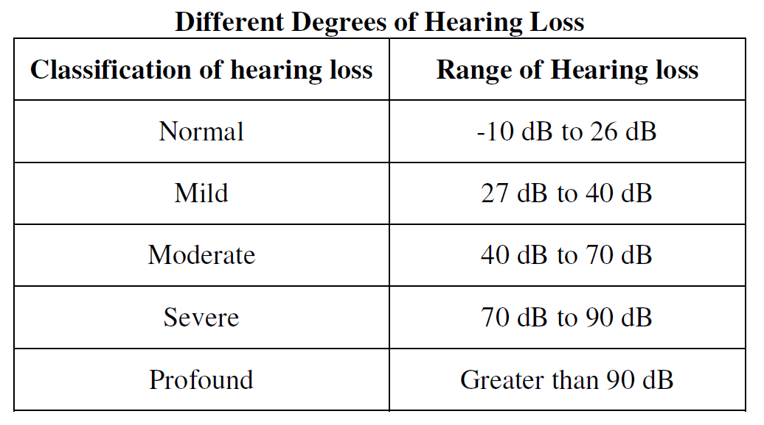

-AWGN has a continuous and uniform frequency spectrum over a specified frequency band and has equal power per hertz of this band. It consists of all frequencies at equal intensity and has a normal (Gaussian) probability density function

-Rather than the hearing aid amplifying all of the signals, we can use a frequency shaper to apply high gain for higher frequencies and vice versa

-Amplitude Compression will ensure that the amplified signal will not exceed saturation power. Saturation power is where the sound signal begins to become uncomfortable.

-Parameters: maximum gain to be applied, saturation power and four frequency values where the gain will change.

Ski slope hearing loss:

When a person has problems hearing high frequency sounds the hearing curve looks like a ski slope in an audiogram and is a special kind of sensorineural hearing loss. It can be difficult to hear children's voices or high-pitched female voices.

The hearing-impaired person can hear without difficulty in a quiet room. But it is very difficult to hear in a noisy place - especially when there are a lot of people talking. Ski slope hearing loss can be hereditary and it can develop over a number of years.

There can be many reasons for why people develop this kind of hearing loss: excessive noise at the work place or during leisure time, side effects of drugs, birth complications - lack of oxygen during birth.

Family members, colleagues, children and others will often tell a person who suffers from ski slope hearing loss that he or she cannot hear in certain situations. Ski slope is a very common kind of hearing loss and many people suffer from untreated ski slope hearing losses.