# DATASET REPORT AND ANALYSIS

Group-51

Kartik Kapoor (20170010066) • Nikhil Sampangi (20170010136)

Aparna M Nair (20170020191) • Anusha Vullanki (20170020250)

DIGITAL HEARING AIDS

Dataset Report:

* We'll need speech(audio) as input for this project.
* We won't be needing a vast dataset of audio files as the aim of the project is to implement a device which can process any input audio given to it.
* Instead we'll have few pre-recorded audio files to test its working
* We'll even have a record option to record the audio and convert it live
* To simulate real life situations, we'll add Adaptive White Gaussian Noise (AWGN) to the input

Problem Description in terms of Dataset:

* In order for the impaired person to comprehend the audio, the input(audio) signal has to be transformed accordingly. The following steps will be performed on it:
  + [ Addition of noise (AWGN) for simulation (won't be required in the final product)]
  + Noise Reduction Filter (using wavelets)
  + Frequency Shaper (according to user's preference)
  + Amplitude Modulation (to ensure the amplified signal will not exceed saturation power)

Initial Analysis:

* Block Diagram of DHA:

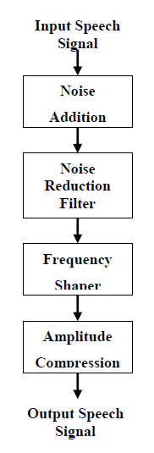

* The traditional Hearing Aid amplifies the power of the input signal and sends it back as output
* We intend to improve these results in our DHA by utilizing the many audio processing functions and techniques offered in MATLAB to making it more superior than others
* The newer Hearing Aids which were implemented using MATLAB are able to refine the sound signal (by applying operations such as noise reduction and improving speech signals) without distorting the sound quality.
* The digitalization of signal in MATLAB makes it possible to precisely analyze and filter the signals.
* 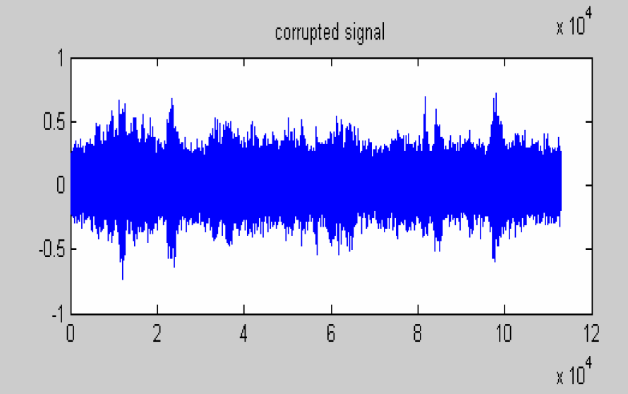Initial Input Signal (After addition of AWGN):
* 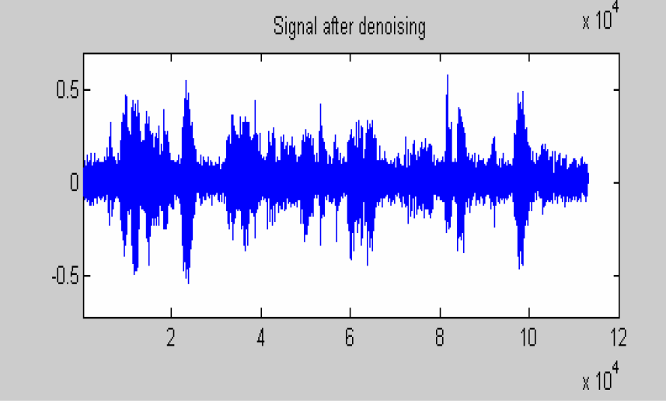Input Signal after de-noising: