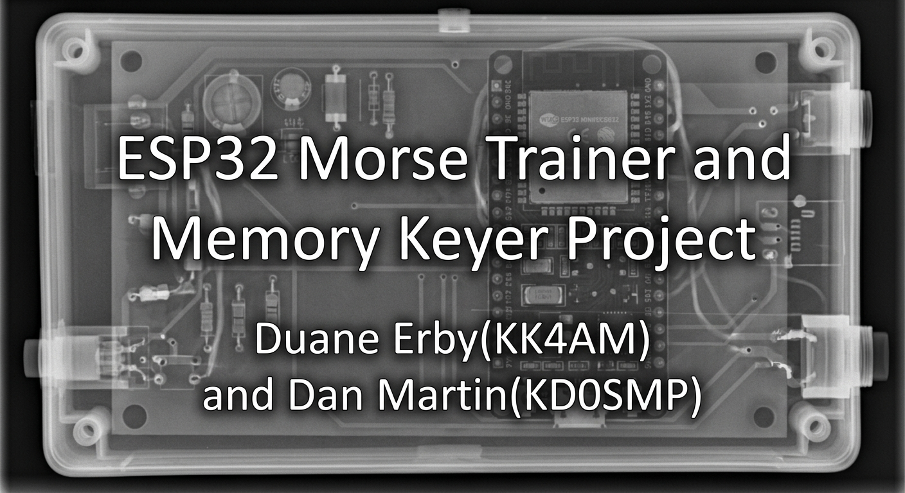

ESP32 CW Trainer

📡

WiFi Setup Guide

Document Type: Setup & Operation Manual

Version: 1.1 (Revised)
Original Design By: Doc. Duane Erby (KK4AM) and Dan Martin (KD0SMP)
Last Updated: 2026

📋 Table of Contents
Section | Page
- Introduction ...………………………………………... | 2
- Quick Start Guide ...………………………………….. | 2
- Hardware Configuration ...…………………………… | 3
- AP Mode Setup ………………………………………. | 3
- STA Mode Setup ……………………………………... | 5
- Changing Between Modes …………………………… | 6
- Troubleshooting ……………………………………… | 8
- Theory of Operation …………………………………. | 10
- Technical Specifications and Schematic …………….. | 13
- Safety & Maintenance ……………………………….. | 17
- Quick Reference Card ……………………………….. | 20
- Revision History ……………………………………... | 21
- References, Credits, and Additional Resources ……… | 21
- License & Disclaimer ………………………………... | 21

1. 🎯 Introduction
The ESP32 CW Trainer is a Morse Code training device implementing the Koch method. It operates as either a WiFi access point or a station on an existing WiFi network. The ESP32 supports dual access modes that can be operated simultaneously.
Functional Modes
1. CW Trainer Mode (Default)
- Koch method training device
- ESP32 sends CW characters over PC, Phone, and/or buzzer
- User recognizes and responds to characters on screen
2. Iambic Keyer Mode
- Six preset message memories
- Selected via GPIO pin 18
- Reed relay contacts for transceiver CW control
- Receive and send practice on the trainer, get on the air with keyer mode
- Operate with iambic key or straight key

2. ⚡ Quick Start Guide
For Immediate Use (AP Mode - No WiFi Network Needed)
- Power on the ESP32 with GPIO 19 open/unconnected
- Connect your phone/computer to WiFi
  - Network: ESP32_Morse_Trainer
  - Password: morse1234
- Browse to: http://192.168.4.1 and the trainer loads in browser
- Start training!
Blue LED Indicator on the ESP32
- Solid: AP is active, ready to connect
- Brief blinks: Device connecting/connected
- Off: Led blinks with morse code, ready to train.

3. 🔧 Hardware Configuration
GPIO Pin Assignments
GPIO Pin | Function | Logic HIGH (Float/Open) | Logic LOW (Ground)
18 | Functional Mode | CW Trainer | Iambic Keyer
19 | WiFi Boot Mode | AP Mode | STA Mode
2 Onboard LED | Status LED | See above | N/A
32 | Paddle dit / straight key | Inactive | Active
33 | Paddle dah | Inactive | Active
(Technical Specifications and Schematic for full pinout information)
Important Notes
⚠️ GPIO 19 is read ONLY at boot time
- Changing the switch requires a reboot to take effect
- Plan your mode before powering on
- Switch SW1: Open – Trainer mode; Closed Keyer mode
⚠️ Thermal Considerations
- AP mode is more power-intensive (ESP32 simulates full router)
- Maximum 4 simultaneous connections recommended
- Provide adequate ventilation
- Monitor board temperature during extended use
- Consider adding heatsink for prolonged operation

4. 📶 AP Mode Setup (Default)
ESP32Connect
While most Integrated Development Environments (IDEs) include a serial monitor or terminal, you will find the ESP32Express program useful for a wide range of functions. It is a zero-installation web application that lets you explore, back up, and manage your ESP32 and ESP8266 right from your browser. There is also an installable version. Its serial terminal is particularly reliable when accessing these esp processors.

Find this tool at https://github.com/Jason2866/WebSerial_ESPTool/tree/development. This YouTube video will acquaint you with this tool: youtu.be/-nhDKzBxHiI
What is AP Mode?
The ESP32 creates its own WiFi network. No internet connection or existing WiFi required. Perfect for field operation or standalone use. A serial terminal is useful, especially for interacting with the Morse Trainer through its command structure (see Verification Methods - Method 1: Serial Monitor in section 6).
Network Information
Parameter | Value
SSID | ESP32_Morse_Trainer
Password | morse1234
IP Address | 192.168.4.1
mDNS Address | http://cwtrainer.local
Max Connections | 4 devices
Step-by-Step Setup
Step 1: Configure Hardware
- Ensure GPIO 19 is open (SW3 set to OPEN)
- Power on the ESP32
Step 2: Connect Your Device
- On your phone, tablet, or computer
- Open WiFi settings
- Find network: ESP32_Morse_Trainer
- Enter password: morse1234
- Wait for connection confirmation
Step 3: Access Web Interface
- Open any web browser
- Enter: http://192.168.4.1
- Alternative (if mDNS supported): http://cwtrainer.local
- The training interface will load, Begin training!
Step 4: Verify Operation
- Blue LED on ESP32 should be solid
- LED blinks briefly when devices connect
- Web interface should be responsive after navigating to http://192.168.4.1
AP Mode Advantages
✅ No existing network required
✅ Works anywhere
✅ Simple setup
✅ Predictable IP address
✅ Isolated from internet (secure)
AP Mode Limitations
⚠️ No internet access
⚠️ Higher power consumption
⚠️ Limited range (typical WiFi)
⚠️ Thermal considerations with multiple connections

5. 🌐 STA Mode Setup
What is STA Mode?
The ESP32 joins your existing WiFi network (home router, phone hotspot, etc.). Behaves like any other WiFi device on your network.
Prerequisites
Before starting, ensure you have:
- ✓ Active WiFi network (router or mobile hotspot)
- ✓ Network name (SSID)
- ✓ Network password
- ✓ Second device available for initial configuration
- ✓ Serial monitor cable (optional but recommended), needed however to retrieve the initial IP Address
First-Time Setup
Step 1: Prepare Your Network
- Turn on your home WiFi router OR
- Enable mobile hotspot on your phone
- Confirm network is broadcasting
- Have SSID and password ready
Step 2: Configure ESP32 Hardware
- Connect GPIO 19 to GND (SW3 closed)
- Power on the ESP32
- Wait 5-10 seconds for boot
Step 3: Connect to Setup Portal
- On your configuration device (phone/laptop)
- Open WiFi settings
- Find network: CW_Trainer_Setup
- Connect using password: morse1234
- Captive portal should open automatically
- If portal doesn't open, browse to: http://192.168.4.1
Step 4: Enter Your Network Credentials
- Portal will display available networks
- Select your network from the list
- Enter your network password carefully
- Click Submit/Connect
- Wait 15-30 seconds
Step 5: Verify Connection
- ESP32 connects to your network
- Check Serial Monitor (115200 baud) for confirmation, use Arduino IDE or ESP32Connect to to your local network
- Verify connection to [your_network_name]! IP Address: 192.168.x.x
- Note the IP address shown for entry into the browser in Step 6
Step 6: Access the Trainer
- Reconnect your device to your normal WiFi the ESP32 is now connected to
- Open browser and enter the IP address from Step 5, OR
- Use: http://cwtrainer.local (if mDNS supported)
- Training interface will load, Begin training!
Setup Portal Configuration Information
Parameter | Value
Setup SSID | CW_Trainer_Setup
Setup Password | morse1234
Portal IP | 192.168.4.1
Portal Timeout | 3 minutes
Subsequent Boots (After Initial Setup)
- Power on ESP32 (GPIO 19 SW3 closed, grounded)
- ESP32 automatically connects (15-20 seconds)
- Check Serial Monitor for assigned IP, enter into browser, OR
- Browse to IP address or http://cwtrainer.local if supported on browser
- No portal configuration needed for subsequent boots, as credentials are saved permanently until you change networks or reset the ESP32
Changing to a Different Network
- Power off ESP32
- Reboot ESP32 in STA mode (GPIO 19 grounded, SW3 Closed)
- If old network unavailable, setup portal reopens after 3 minutes
- Connect to CW_Trainer_Setup again
- Enter new network credentials
- Submit and verify connection ( Get new IP address from Serial Monitor)
STA Mode Advantages
✅ Uses existing network infrastructure
✅ Lower power consumption
✅ Less thermal load
✅ Can access from multiple devices easily
✅ Better range (depends on router)
STA Mode Limitations
⚠️ Requires existing WiFi network
⚠️ IP address may change (use mDNS)
⚠️ Network dependent
⚠️ More complex initial setup

6. 🔄 Changing Between Modes
Switching from AP to STA Mode
- Power off the ESP32
- Connect GPIO 19 to GND (ground)
- Power on the ESP32
- Verify mode via Serial Monitor [WiFi mode: STA (phone wifi or home wifi browser access)]
- Follow STA mode setup procedure
Switching from STA to AP Mode
- Power off the ESP32
- Disconnect GPIO 19 from GND (SW3 open)
- Power on the ESP32
- Verify mode via Serial Monitor [WiFi mode: AP (ESP32 hotspot access for your browser)]
- Connect to ESP32_Morse_Trainer network HTTP//: 192.168.58.4.1
Verification Methods - Method 1: Serial Monitor
- Connect USB cable to computer
- Open Serial Monitor (115200 baud)
- Send command: help: Displays serial monitor commands

=== Commands ===
CHAR:CODE - Add/update morse entry (e.g., 'A:.-')
list - Show all morse table entries
clear - Clear the morse table
test - Test LED and buzzer
mode - Cycle: Koch → Vector → Progmem → Progtable
koch start- Start Koch training session
koch stop - Stop Koch training session
koch pause- Pause Koch session
koch resume- Resume Koch session
koch stat - Show Koch training statistics
koch reset- Reset all Koch progress to defaults
echo start- Start straight-key echo training
echo stop - Stop straight-key echo training
echo stat - Show echo training stats
echo on - Enable real-time character echo
echo off - Disable real-time character echo
buzzer on - Enable ESP32 buzzer during playback
buzzer off- Mute buzzer (phone audio only)
wpm XX - Set speed (e.g., 'wpm 18')
wifi show - Show WiFi connection info
wifi reset - Clear saved WiFi credentials
status - Show current settings
help - Show this message
WORD - Transmit word/phrase in morse
(use space for word gaps)

During Koch training:
Type a single letter to answer
Press ESC or type 'koch stop' + Enter to quit

Prosigns (type as shown, sent as single character):
AA = new line AR = end message AS = wait
BK = break BT = separator CL = closing
CT = start signal DO = shift HH = error
KA = start signal KN = invite TX SK = end contact
SN = understood SOS = distress

Or use special chars: ~ ^ < > [ ] { } # * $ | _ \

Entering “status” or “wifi show” into the serial monitor will display system configuration and the current IP address for entry into the browser.
Verification Methods - Method 2: WiFi networks Scan
- Scan for WiFi networks on your device
- If ESP32_Morse_Trainer visible = AP mode active
- If not visible = likely STA mode

7. 🐛 Troubleshooting
Cannot Connect to ESP32 in AP Mode
Problem: ESP32_Morse_Trainer network not visible
Solutions:
- ✓ Verify GPIO 19 is floating (not grounded)
- ✓ Check power supply is adequate (5V, minimum 500mA)
- ✓ Reboot ESP32
- ✓ Check blue LED is solid (indicates AP active)
- ✓ Move closer to ESP32 (improve signal)
- ✓ Disconnect other devices (max 4 connections)
Problem: Connected to WiFi but cannot browse to 192.168.4.1
Solutions:
- ✓ Verify your device obtained IP address (check WiFi settings)
- ✓ Try http://cwtrainer.local instead
- ✓ Disable mobile data on phone (forces WiFi use)
- ✓ Clear browser cache
- ✓ Try different browser
- ✓ Check firewall settings on device
- ✓ Turn off VPN and try again
Cannot Connect to ESP32 in STA Mode
Problem: Setup portal doesn't appear
Solutions:
- ✓ Verify GPIO 19 is grounded, SW3 is closed
- ✓ Look for CW_Trainer_Setup network (not ESP32_Morse_Trainer)
- ✓ Wait 3 minutes for portal timeout if previously configured
- ✓ Manually browse to 192.168.4.1
- ✓ Reboot ESP32
Note: The captive portal times out after 180 seconds (3 minutes). If the user doesn't complete setup within that window, the ESP32 exits the portal and retries saved credentials in the background with exponential backoff. A reboot is required to reopen the portal.
Problem: ESP32 won't connect to my network
Solutions:
- ✓ Verify network password is correct (case-sensitive)
- ✓ Ensure network is 2.4GHz (ESP32 doesn't support 5GHz)
- ✓ Check router isn't using MAC address filtering
- ✓ Verify network allows new device connections
- ✓ Try mobile hotspot instead to isolate issue
- ✓ Check signal strength (see table below)
Problem: Cannot find ESP32 on network after connection
Solutions:
- ✓ Check Serial Monitor for assigned IP address
- ✓ Try http://cwtrainer.local (requires mDNS support)
- ✓ Use router admin page to find ESP32's IP
- ✓ Disable VPN if active
- ✓ Ensure device is on same network segment
Signal Strength Issues (STA Mode)
RSSI Value | Status | Action
Better than -75 dBm | Good | Normal operation
-75 to -85 dBm | Weak | May drop occasionally, move closer
Worse than -85 dBm | Unreliable | Switch to AP mode or relocate
Check signal strength
- Connect Serial Monitor (115200 baud)
- Send command: help (shows available commands)
- Send command: wifi show
- Read RSSI value
Web Interface Issues
Problem: Interface loads but doesn't respond
Solutions:
- ✓ Refresh browser (Ctrl+F5 or Cmd+Shift+R)
- ✓ Check JavaScript is enabled
- ✓ Try different browser
- ✓ Clear browser cache and cookies
- ✓ Check ESP32 isn't overheating (thermal throttling)
Problem: cwtrainer.local doesn't work
Solutions:
- ✓ Not all devices support mDNS (Bonjour)
- ✓ Use IP address instead
- ✓ iOS/Mac usually support mDNS
- ✓ Android: requires Bonjour app
- ✓ Windows: requires Bonjour service
Serial Monitor Issues
Problem: Cannot connect to Serial Monitor
Solutions:
- ✓ Install CP210x or CH340 USB drivers
- ✓ Select correct COM port
- ✓ Set baud rate to 115200
- ✓ Try different USB cable (some are power-only)
- ✓ Check device manager for port conflicts
Problem: Garbage characters in Serial Monitor
Solutions:
- ✓ Set baud rate to 115200
- ✓ Set line ending to "Both NL & CR"
- ✓ Check USB cable quality
- ✓ Resetting the ESP32
- ✓ Soft Reset (preserves WiFi credentials):
- ✓ Press RESET button on ESP32 board
- ✓ Hard Reset (clears WiFi credentials):
  - Method 1: Flash new firmware
  - Method 2: Use factory reset command via Serial Monitor
  - Method 3: Erase flash memory with esptool:
  - esptool.py --port [COM_PORT] erase_flash
Emergency Recovery
If ESP32 is completely unresponsive
- Power cycle: Disconnect power, wait 10 seconds, reconnect
- Check power supply: Measure voltage (should be 5V ±0.25V)
- Re-flash firmware: Upload fresh firmware via USB
- Check for hardware damage: Look for burnt components, broken traces
- Test with minimal configuration: Disconnect all external connections except power

8. 📚 Theory of Operation
Understanding WiFi Modes
The ESP32 can operate in three WiFi modes
- AP (Access Point) - Creates its own network
- STA (Station) - Joins existing network
- AP+STA - Both simultaneously (advanced use)
This CW Trainer uses modes 1 and 2 separately, not simultaneously.
Access Point (AP) Mode Explained
What it does
- ESP32 acts as a WiFi router (Soft AP)
- Creates local WiFi network
- Assigns IP addresses to connecting devices
- Runs web server for user interface

Network topology
[Your Phone/Computer] <--WiFi--> [ESP32 (192.168.4.1)]
|
[CW Trainer Software]

Technical details
- Network subnet: 192.168.4.0/24
- ESP32 IP: 192.168.4.1 (gateway + server)
- DHCP range: 192.168.4.2 - 192.168.4.10
- Max clients: 4 (hardware limitation)
- Security: WPA2-PSK
- No internet gateway (isolated network)

Use cases
- Field operation without infrastructure
- Demonstrations
- Private training sessions
- When internet isolation is desired
- Emergency communications

Limitations
- Higher CPU usage (routing overhead)
- Increased power consumption
- Thermal concerns with multiple connections
- Limited to WiFi range of ESP32
- No internet access for connected devices
Station (STA) Mode Explained
What it does
- ESP32 joins existing WiFi network
- Behaves like phone or laptop
- Receives IP from network DHCP
- Runs web server accessible from network

Network topology
[Your Phone/Computer] <--WiFi--> [Your Router] <--WiFi--> [ESP32 (192.168.x.x)]
|
[CW Trainer Software]
Technical details
- IP address: Assigned by DHCP (varies)
- Can use mDNS for consistent addressing (cwtrainer.local)
- Requires 2.4GHz WiFi (ESP32 limitation)
- Supports WPA/WPA2 security
- Lower power consumption than AP mode

Use cases
- Home operation
- Office training
- Shared access among multiple users
- When permanent IP/hostname needed
- Leveraging existing network infrastructure

Limitations
- Requires existing WiFi network
- IP address may change (use mDNS)
- Subject to network configuration/restrictions
- Initial setup more complex
- Depends on router range/signal quality

Captive Portal Mechanism (STA Mode)
When first booting in STA mode without saved credentials, the ESP32
- Starts temporary AP: CW_Trainer_Setup
- Waits for device connection
- Serves captive portal webpage
- Scans for available WiFi networks
- Presents network list to user
- Accepts credentials
- Attempts connection to target network
- Saves credentials to flash memory
- Provides feedback (success/failure)

Portal timeout: 3 minutes
- After timeout, ESP32 retries saved credentials in background
- Reboot reopens portal if connection fails
mDNS (Multicast DNS)
What is mDNS?
- Allows use of cwtrainer.local instead of IP address
- Works without DNS server
- Broadcasts hostname on local network

Compatibility
- ✓ iOS/iPadOS: Native support
- ✓ macOS: Native support (Bonjour)
- ✓ Windows: Requires Bonjour service
- ✓ Android: Requires third-party app
- ✓ Linux: Requires Avahi daemon

Benefits
- Consistent address regardless of IP changes
- Easier to remember than IP address
- Professional appearance
Security Considerations
Default Password
⚠️ Default password morse1234 should be changed for security
- Modify in firmware before uploading
- Or implement web-based password change feature

Network Security
- AP mode: WPA2-PSK encrypted
- STA mode: Uses target network's security
- Credentials stored in ESP32 flash (encrypted)
- No credentials exposed in source code (runtime entry)

Best Practices
- Change default password
- Use strong WiFi passwords
- Keep firmware updated
- Don't expose to untrusted networks
- Monitor connected devices in AP mode
Power Consumption
Typical current draw (5V supply)
- Idle (STA mode): ~80mA
- Active training (STA): ~120mA
- AP mode (1 client): ~180mA
- AP mode (4 clients): ~250-300mA

Battery operation considerations
- Use STA mode for longer runtime
- Consider power bank (2000mAh = ~6-10 hours)
- AP mode significantly reduces battery life
- Sleep modes not implemented (trainer requires continuous operation)

9. 📊 Technical Specifications
Hardware Requirements
ESP32 Development Board
- Chip: ESP32-WROOM
- Flash: Minimum 4MB
- RAM: 520KB
- CPU: Dual-core Xtensa 32-bit LX6 (240MHz)

Power Requirements
- Input voltage: 5V via USB or Vin pin
- Operating voltage: 3.3V (regulated on board)
- Current consumption: 80-300mA (mode dependent)
- Recommended power supply: 5V 1A minimum

ESP32-WROOM 30 pin pinout Diagram

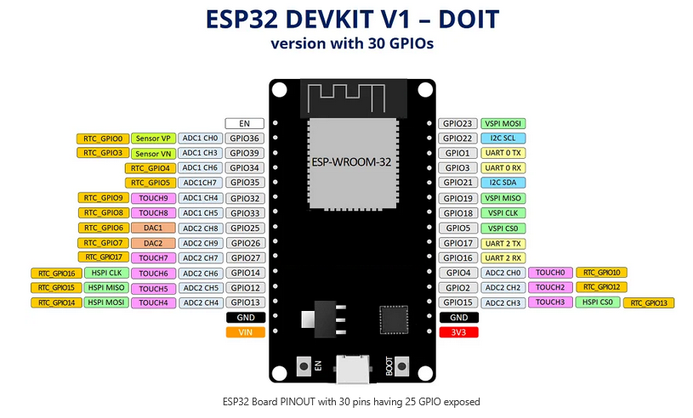

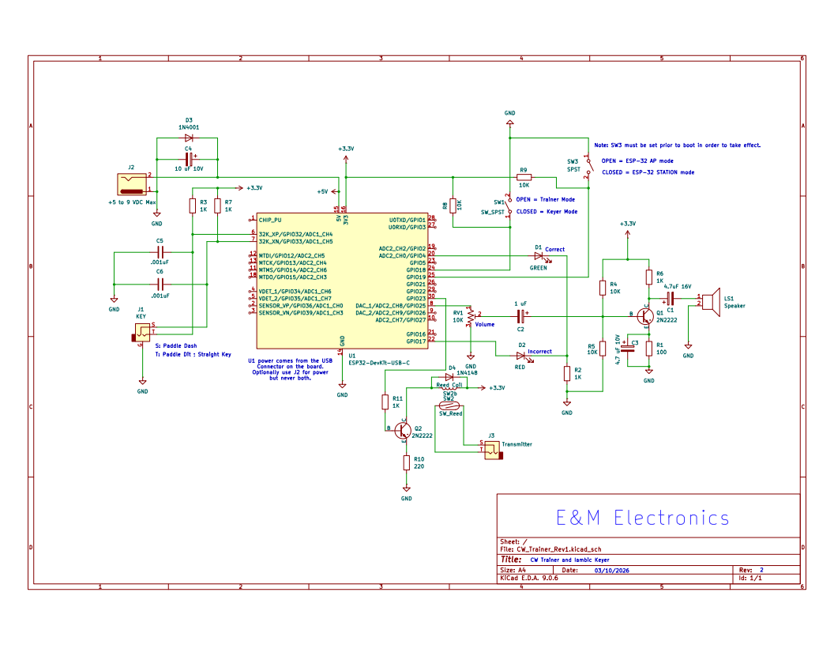
Circuit Schematic

GPIO Connections
Pin | Function | Type | Notes
GPIO 2 | Status LED | Output | Internal blue LED
GPIO 18 | Mode select | Input | Pull-up, read at runtime
GPIO 19 | Boot mode | Input | Pull-up, read at boot

Optional Connections
- Paddle inputs (for Iambic Keyer mode)
- Audio output (for CW tone)
- Serial console (USB, 115200 baud)
- See schematic and Table on Page 3
Software Specifications
Firmware
- Platform: Arduino/ESP-IDF
- Web server: Async HTTP
- WiFi: ESP32 native WiFi stack
- DNS: Captive portal implementation
- mDNS: ESP32 mDNS responder

Network Parameter | AP Mode | STA Mode
SSID | ESP32_Morse_Trainer | User's network
Password | morse1234 | User's password
IP Address | 192.168.4.1 (fixed) | DHCP assigned
Subnet | 192.168.4.0/24 | Network dependent
Gateway | 192.168.4.1 (self) | Router IP
DNS | 192.168.4.1 (captive) | Router DNS
mDNS hostname | cwtrainer.local | cwtrainer.local

Web Interface
- Protocol: HTTP (port 80)
- Technologies: HTML5, CSS3, JavaScript
- Update method: AJAX/WebSocket
- Browser compatibility: Modern browsers (Chrome, Firefox, Safari, Edge)

Serial Console
- Baud rate: 115200
- Data bits: 8
- Parity: None
- Stop bits: 1
- Flow control: None
- Line ending: CR+LF
Performance Specifications
WiFi Performance
- Standard: IEEE 802.11 b/g/n
- Frequency: 2.4GHz only (5GHz not supported)
- Range: ~50m indoor, ~100m outdoor (typical)
- Data rate: Up to 150Mbps (PHY rate)

AP Mode Limits
- Maximum clients: 4 simultaneous
- DHCP pool: 8 addresses (192.168.4.2-9)
- Channel: Configurable (default auto)
- Beacon interval: 100ms

STA Mode
- Connection time: 10-20 seconds (typical)
- Reconnect attempts: Unlimited
- Retry interval: 30 seconds

Web Server
- Maximum connections: 4 simultaneous
- Request timeout: 30 seconds
- Response buffer: 8KB
- WebSocket support: Yes (if implemented)
Operating Environment
Temperature
- Operating: 0°C to 70°C
- Storage: -40°C to 85°C
- ⚠️ Board may heat in AP mode with multiple connections

Humidity
- Operating: 10% to 90% non-condensing
- Storage: 5% to 95% non-condensing

Physical
- Dimensions: ~55mm × 28mm (typical dev board)
- Weight: ~10g
- Mounting: Breadboard compatible, or case

10. ⚠️ Safety & Maintenance
Thermal Management
Normal Operation
- STA mode: Minimal heat generation
- AP mode (1 client): Warm to touch (normal)
- AP mode (4 clients): Hot to touch (monitor closely)

Warning Signs
- Board too hot to touch comfortably
- Unexpected reboots or crashes
- WiFi disconnections under load
- Sluggish web interface response

Cooling Solutions
- Ensure adequate ventilation
- Do not enclose in sealed container
- Consider adding heatsink to ESP32 chip
- Use fan for extended AP mode operation
- Limit to 2 clients if thermal issues occur
- Take breaks in heavy use scenarios
Electrical Safety
Power Supply
- ✓ Use quality 5V USB power supply (1A minimum)
- ✓ Avoid cheap unregulated supplies
- ✗ Do not exceed 5.5V on Vin pin
- ✗ Do not reverse polarity
- ✗ Do not connect 3.3V and 5V simultaneously from different sources

GPIO Protection
- GPIO pins are 3.3V logic ONLY
- Do not connect to 5V signals directly
- Use level shifters for 5V interfacing
- Respect maximum current per pin (12mA recommended, 40mA absolute max)

ESD Protection
- ESP32 is sensitive to static discharge
- Ground yourself before handling
- Use ESD strap when working on circuits
- Store in anti-static bag when not in use
Maintenance
Regular Checks
- Inspect for physical damage
- Check USB connector for looseness
- Verify LED still functions
- Test both AP and STA modes periodically

Software Maintenance
- Keep firmware updated
- Clear flash if experiencing persistent issues
- Backup configuration (if feature exists)
- Document any custom modifications

Cleaning
- Power off before cleaning
- Use compressed air for dust removal
- Isopropyl alcohol (90%+) for stubborn dirt
- Do not use water or wet cleaners
- Allow to dry completely before powering on
Long-Term Storage
Before storing
- Power off device
- Disconnect all cables
- Store in anti-static bag
- Keep in cool, dry location
- Document any configuration details

After long storage
- Inspect for corrosion or damage
- Check power supply voltage before connecting
- Allow board to acclimate to room temperature
- Test basic functionality before full deployment
When to Seek Help
Contact experienced Arduino/ESP32 users if
- Board doesn't power on at all
- Smoke or burning smell occurs (discontinue use immediately)
- Repeated firmware upload failures
- Physical damage to components
- Cannot resolve persistent software issues
Resources
- ESP32 Arduino Forums
- Local amateur radio club (for CW trainer questions)
- ESP32 subreddit
- GitHub issues (if firmware is open source)

11. 📞 Quick Reference Card
(Print out and keep this section for quick access)
AP MODE  - Network: ESP32_Morse_Trainer  - Password: morse1234  - URL: http://192.168.4.1 or http://cwtrainer.local  - GPIO 19: SW3 Open (floating) | Serial Commands Quick Reference  - Baud rate: 115200  - Command: help - Show all commands  - Command: wifi show - Display WiFi status and signal strength
STA MODE SETUP  - Network: CW_Trainer_Setup  - Password: morse1234  - Portal: http://192.168.4.1  - GPIO 19: SW3 closed (Grounded) | Troubleshooting Quick Checks  - ✓ Is power supply adequate? (5V, 1A)  - ✓ Is GPIO 19 in correct position for desired mode?  - ✓ Did you reboot after changing GPIO 19?  - ✓ Is blue LED behaving correctly?  - ✓ Is your target network 2.4GHz (not 5GHz)?  - ✓ Did you wait 15-20 seconds for connection?
STA MODE OPERATION  - Network: Your WiFi network  - URL: Check Serial Monitor for IP, or http://cwtrainer.local  - GPIO 19: SW3 closed (Grounded) | Signal Strength Reference
  RSSI | Status
  > -75 dBm | Good
  -75 to -85 dBm | Weak
  < -85 dBm | Use AP mode
GPIO Pin Quick Reference
Pin | HIGH (Float) | LOW (Ground)
18 | CW Trainer | Iambic Keyer
19 | AP Mode | STA Mode

12. 📝 Revision History
Version | Date | Changes
1.0 | Original | Initial release by Doc. Duane Erby (KK4AM) and Dan Martin (KD0SMP)
1.1 | 2026 | Enhanced documentation: Added troubleshooting, expanded theory section, safety information, technical specifications, formatting improvements

13. 📚 References, Credits, and Additional Resources
Original Design
- Doc. Duane Erby (KK4AM)
- Dan Martin (KD0SMP)

Reference Materials
- https://www.upesy.com/blogs/tutorials/how-create-a-wifi-acces-point-with-esp32
- https://www.come-star.com/blog/wifi-ap-vs-sta-mode-ap-sta-comparison/
- ESP32 Arduino Core Documentation
- ESP-IDF Programming Guide

Additional Resources
- Arduino Forum - ESP32 Section
- Random Nerd Tutorials - ESP32 Projects
- ESP32.net Community Resources

📧 Support & Community - For Questions
- Consult local amateur radio club
- ESP32 Arduino community forums
- GitHub repository (if available)

For Contributions
- Suggestions for improvements to documentation welcome
- Firmware enhancements via pull request (if open source)
- Share your experiences with other operators

14. 📄 License & Disclaimer
Usage: This documentation is provided for amateur radio and educational purposes.
Disclaimer: Use this device and documentation at your own risk. The authors and contributors assume no liability for any damage, injury, or loss resulting from the use of this equipment or information.
Amateur Radio: This device is intended for use by licensed amateur radio operators in accordance with local regulations.
FCC Notice (USA): This is a hobbyist project. Ensure compliance with FCC Part 97 regulations for amateur radio use.
Print Notes
- Print double-sided for paper conservation
- Consider printing Quick Reference Card on cardstock
- Recommended: Bind or place in protective sheet protectors
- Total pages: Approximately approximately 21, depending on printer settings

73 de [KK4AM] - Happy CW Training! 📻
End of Document - ESP32 CW Trainer WiFi Setup Guide v1.1

