ESP32 CW Trainer — WiFi Setup Guide

The Morse Code Trainer as implemented by Doc. Duane Irby and Dan Martin (KD0SMP) operates as either a WiFi access point or a station on a WiFi network. The ESP32 supports this with dual access modes that can be operated simultaneously.

This ESP32 CW Trainer—WiFi setup Guide takes you step-by-step through setup and login procedures. You have a choice of operating in either of two modes, Access Point (AP) and Station (STA), and you should know something about the network elements needed to operate in each. So, following the setup procedure section is a short theory section that provides just enough background information necessary to keep you from getting hopelessly confused. Skip it if you are a network wizard, otherwise do yourself a big favor by at least scanning it before attempting to login.

CW Trainer Login & Operation

This CW Trainer has two functional modes. The default mode is as a CW Trainer implemented as a Koch method training device. As a trainer, the ESP32 sends CW for characters and asks the user to recognize the characters.

The second functional mode is as an Iambic Keyer. Six memories are implemented for preset messaging. GPIO pin 18 selects this functionality.

Iambic Keyer
GPIO 18 | Mode
Logic HIGH  (float open) | CW Trainer
Logic LOW  (ground) | Iambic Keyer

GPIO Pin 19 selects the ESP32 boot mode: either AP or Wifi STA. This switch is read once at boot. A switch change and reboot and is required when changing modes.

Switch 3 Mode Selector Position
GPIO 19 | Mode
Logic HIGH  (float open) | AP
Logical LOW  (ground) | STA

AP Mode (Default) — ESP32 creates its own network, so no internet. User interface is http running Java Script on a browser or serial terminal. First time setup relies on user to provide login credentials. Subsequent connections are automatic.

Step 1 — Power on the ESP32 with GPIO19 pin open or unconnected.

Step 2 — On your phone or computer, connect to this WiFi network:

AP Mode
Network name (SSID) | ESP32_Morse_Trainer
Password | morse1234

Step 3 — Open a browser, enter this URL and go to: http://192.168.4.1 If your device supports mDNS, use alternate http://cwtrainer.local

Step 4 — The blue LED (ESP32 GPIO pin 2) on the board lights solid when the AP is active and blinks briefly each time a device connects. Up to 4 devices can connect simultaneously, but be mindful of the thermal load.

<<<>>>

STA Mode — ESP32 joins an existing WiFi network. User interface is HTTP running Java Script on a browser or serial terminal. First time setup relies on user to provide login credentials. Subsequent connections are automatic.

First-Time Setup

Step 1 — Log into a local WiFi AP before powering on the ESP32. This might be your local computer network board connected to a local WiFi network, or it might be a hotspot on your phone or other device. Your home WiFi network should already be active if you are connecting to that.

Step 2 — Power on the ESP32 with GPIO pin 19 grounded (STA Mode).

Step 3 — On a separate device (laptop or second phone), connect to the temporary setup network:

STA Mode
Network name (SSID) | CW_Trainer_Setup
Password | morse1234

Step 4 — A captive portal page opens automatically. If it does not, browse to 192.168.4.1

Step 5 — In the portal, select your network’s name and enter its password. Submit. These credentials are saved securely on the ESP32 and provided automatically for subsequent logins.

Step 6 — The ESP32 connects and prints its assigned IP to the Serial monitor:

✓ Connected to hotspot! IP Address: 192.168.x.x

Step 7 — On your phone, browse to that IP address, or use this URL

http://cwtrainer.local

Subsequent Boots

Credentials are saved. The ESP32 connects automatically within ~15 seconds. No portal is needed unless the network changes.

If the portal times out (3-minute window): the ESP32 retries saved credentials in the background. Reboot the ESP32 to reopen the portal and enter credentials.

<<<>>>

Changing Modes

1. Flip the physical switch on pin 19 to the desired mode (AP or STA).
2. Reboot the ESP32
3. Confirm in the Serial monitor “Status” option:

WiFi mode: AP (ESP32 hotspot access for your browser), or
WiFi mode: STA (phone wifi or home wifi browser access)

Signal Strength Warning (STA Mode)

Use the “wifi show” command in the serial port for this information. Show the command menu by sending help to the ESP32 through the serial port.

Signal Strength
RSSI | Status
Better than −75 dBm | Good
−75 to −85 dBm | Weak — may drop occasionally
Worse than −85 dBm | Unreliable — use AP mode instead

ESP32 CW Trainer — WiFi Setup Guide — Rev 1.0 — March 2026

<<<>>>

Bare Bones Theory

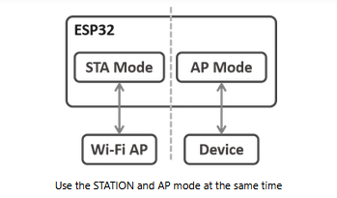
As a WiFi Access Point

In its Access Point (AP) mode, the ESP32 creates a local WiFi network to which devices connect. As with cellular phones, the ESP32 access point simulates a WiFi router in order to share its connection. This is known as Soft AP (for “software” WiFi Access Point).

Unlike a phone or router, however, the ESP32 is not connected to the Internet in its AP mode, not unless it is also and independently connected in its Station (STA) mode. Its AP Mode connectivity, therefore, forms a private WiFi local area network wholly isolated from the Internet.

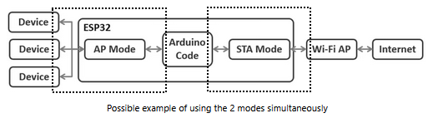

Here are some uses of the Access Point mode:

- Connecting the ESP32 as an Access Point to an external WiFi AP to log devices connected on the ESP32’s AP side into an external network connected to the ESP32’s STA side. This mechanism is commonly used to connect to a home WiFi. Our Morse Trainer implementation uses Arduino Code to execute login handshaking so that private SSID and password credentials are not exposed in software files.
- Having a separate network from your home network, one not connected to the Internet
- Communicating between several ESP32 units over a private WiFi network
- Maintaining a local server on an isolated WiFi network

As a WiFi Station

When using our Morse Trainer in STA mode, a phone, tablet, laptop, computer, or other Internet connected device serves as the Wi-Fi AP. The Arduino Code processor executes the Morse Trainer code on the ESP32, interacting through an HTML user interface with a device logged into the other end of a wireless network, such as your home WiFi network.

The next two figures present another way of looking at the difference between AP and STA modes.

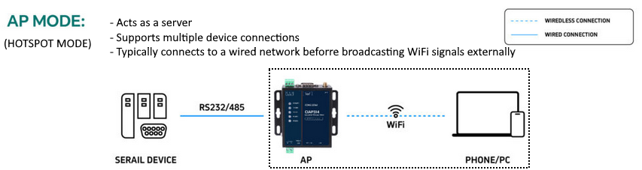
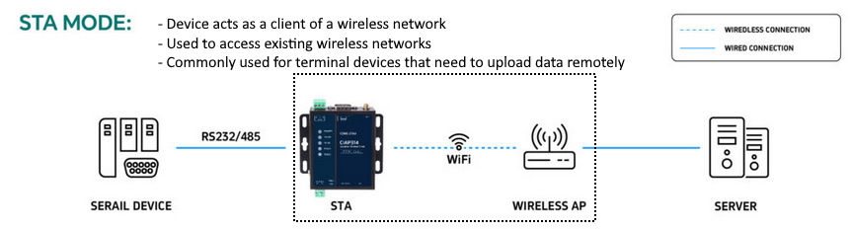

In summary, then, this Morse Trainer operates in either of two user selectable ESP32 WiFi modes:

- Access Point (WIFI_AP): In Access Point mode, the ESP32 behaves like a router implementing a private WiFi network. Other devices can connect to it. In this mode, the ESP32 is not connected to any network other than its own. This mode is more computationally and energy-intensive (the ESP32 board will heat up) since the ESP32 has to simulate a full WiFi router (Soft AP). The latency and the bandwidth will be less efficient than in a classic router. Take care to deal with the thermal load!

- STATION (WIFI_STA): Station mode is used to connect the ESP32 module to any WiFi network. The ESP32 behaves like a phone or computer that is connected to a local router or hotspot.

This bare bones theory material relies heavily on these two sources:
https://www.upesy.com/blogs/tutorials/how-create-a-wifi-acces-point-with-esp32
https://www.come-star.com/blog/wifi-ap-vs-sta-mode-ap-sta-comparison/

# 📝 Review of ESP32 WROOM Dev Kit CW Trainer WiFi Setup Guide

## ✅ **Overall Assessment**
The guide is **well-structured, clear, and comprehensive**. It effectively explains dual WiFi modes (AP/STA) with practical steps, warnings, and theory. The tone is accessible for beginners while providing enough detail for advanced users.

---

## 🎯 **Strengths**

### **Clarity & Organization**
- **Logical flow**: Setup steps → mode switching → theory section
- **Clear visual aids**: Tables for GPIO pin functions (GPIO 18/19)
- **Dual audience approach**: Beginners can follow steps; experts can skip theory

### **Practical Details**
- **Specific credentials provided** (SSID: `ESP32_Morse_Trainer`, Password: `morse1234`)
- **IP addresses and URLs** included for both modes
- **GPIO pin states clearly defined** (HIGH/LOW, float/ground)
- **Thermal warnings** noted for AP mode

### **User Experience Considerations**
- **Captive portal mention** for STA mode setup
- **mDNS support** (`cwtrainer.local`) for easier access
- **Connection limits** (4 devices) and **signal strength guidelines**
- **Troubleshooting tips** (portal timeout handling)

---

## ⚠️ **Areas for Improvement**

### **Minor Issues**
1. **Inconsistent terminology**:
- "CW Trainer" vs. "Morse Code Trainer" vs. "Morse Trainer"
- "Java Script" should be "JavaScript"

2. **Formatting inconsistencies**:
- Mixed use of `<<<>>>` and horizontal rules
- Some sections have extra spacing

3. **Ambiguous phrasing**:
- "First time setup relies on user to provide login credentials" – unclear in AP mode context
- "This might be your local computer network board connected to a local WiFi network" – awkward phrasing

4. **Missing details**:
- No mention of default baud rate for serial monitor
- No hardware setup diagram for GPIO switches

### **Potential Confusions**
- **STA Step 1**: "Log into a local WiFi AP before powering on" – users might think this refers to the ESP32 rather than their device
- **Theory section**: Mentions ESP32 connecting AP to external network simultaneously – not implemented in this guide's setup

---

## 🔧 **Recommendations**

### **Immediate Fixes**
1. **Standardize terminology** throughout
2. **Add serial monitor setup note** (e.g., "Use 115200 baud")
3. **Include simple wiring diagram** for GPIO 18/19 switches
4. **Clarify AP mode credentials**: Are they changeable? How?

### **Enhancements**
1. **Add troubleshooting section**:
- What if `cwtrainer.local` doesn't resolve?
- How to factory reset credentials?
- LED blink patterns explanation

2. **Include safety notes**:
- Power supply requirements
- Antenna handling (if external)

3. **Version control**:
- Add document version to header/footer
- Include change log for future revisions

---

## 📊 **Usability Score**: 8.5/10

### **Breakdown**
- **Clarity**: 9/10
- **Completeness**: 8/10
- **Technical Accuracy**: 9/10
- **Beginner-Friendliness**: 8/10
- **Reference Value**: 9/10

---

## 🏁 **Final Verdict**
This is a **high-quality setup guide** that successfully balances simplicity with technical depth. With minor refinements (particularly in terminology consistency and adding basic troubleshooting), it would be excellent. The dual-mode explanation with practical applications makes it particularly valuable for users exploring ESP32 WiFi capabilities.

**Ready for use as-is, but would benefit from suggested improvements in future revisions.**

