1. We are sorry to say that the video is a little bit long as we can not introduce all our function within 10 minutes.
2. In our system , the <admin> account is belong to Librarian and the <student> account is belong to Member. The password is 123456.

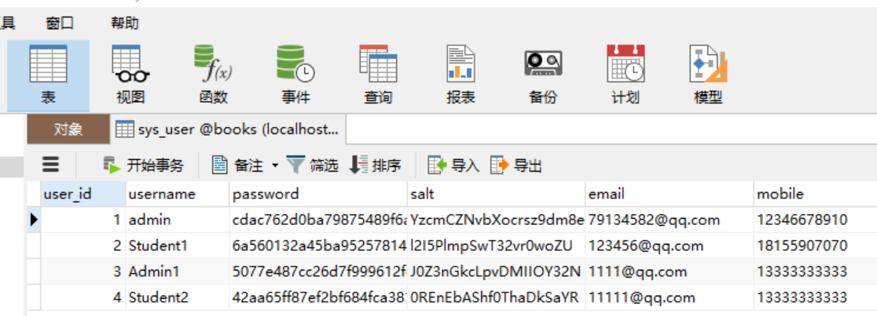

1. There are some improvement for phase 1 and phase 2, please kindly review the final version submitted in December.