Summary Table for Accessibility Conformance Test

Results of the conformance test
This is an example of a template you can use to help with your accessibility evaluation and development of the Barry’s Car Sales website.
Note that the information you will be reporting is in your own words, but will typically be based on the ‘Details’ and ‘Reference’ sections in your WAVE conformance test results report.
Error type  (give a title or name for the identified error – see the results from WAVE for ideas) | Give one or two examples (you can take screenshot(s) of the error as it exists on the webpage) | Why is this considered to be an issue? (Refer to the suggestions from the results from WAVE) | What level of conformance does it break? (Refer to the “standards and guidance” section in WAVE) | What have you done to fix it? (Give a brief summary of how this error was fixed or not, either technically or from a design perspective. See the “how to fix it” section on WAVE for hints. Show a visual example, such as a screenshot, of the result)
Missing alternative text (WAVE error) | index.html: the hatchback image (hatchback.jpg) has no alt text.  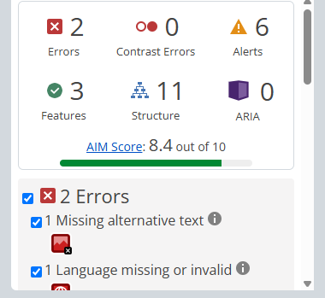 | A screen reader can't describe the image, so blind users miss what the car looks like. | WCAG 1.1.1 Non-text Content, Level A. | Not fixed. Would add alt text that describes the car.
Language missing or invalid (WAVE error) | index.html: the page has no lang attribute.  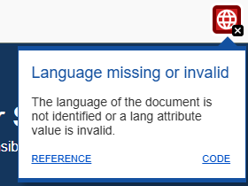 | Screen readers can't tell which language to use, so they may read the page with the wrong pronunciation. | WCAG 3.1.1 Language of Page, Level A. | Not fixed. Would add lang="en" to the <html> tag.
Missing form label (WAVE error) | enquiry.html: WAVE reports 4 errors, all Missing form label, including "Full name" and the checkbox and radio options.  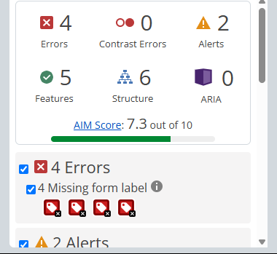 | Without a label, a screen reader user doesn't know what each field is for, and clicking the text beside it does nothing. | WCAG 1.3.1 Info and Relationships, 3.3.2 Labels or Instructions and 4.1.2 Name, Role, Value, all Level A. | Not fixed. Would add a proper label linked to each field, and group the radios in a fieldset with a legend.
Skipped heading level (WAVE alert) | about.html: "Our team" is an h4 straight after the h2. index.html: "Cars currently available" is an h4 after an h2, and WAVE puts its alert icon on it.  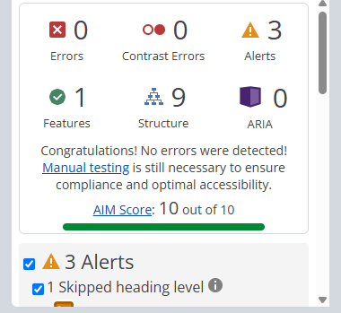   | Screen reader users move around a page by headings, and a skipped level makes the structure confusing. | WCAG 1.3.1 Info and Relationships, Level A. | Not fixed. Would change the h4 to the correct heading level (h3, or h2 for the car list).
Not keyboard accessible (found by manual testing) | index.html: on the 2020 Trail 1.5 card, "Ask about this car" is plain text, not a link. It never gets Tab focus.  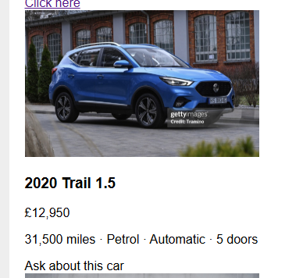 | Keyboard users can't enquire about this car, and it looks like the other cars' links. | WCAG 2.1.1 Keyboard, Level A. | Not fixed. Would turn it into a link to enquiry.html.
Content doesn't reflow when zoomed (found by manual testing) | All pages: at 200% zoom there's sideways scrolling and the blue banner stops short. At 400% the banner gets cut off.  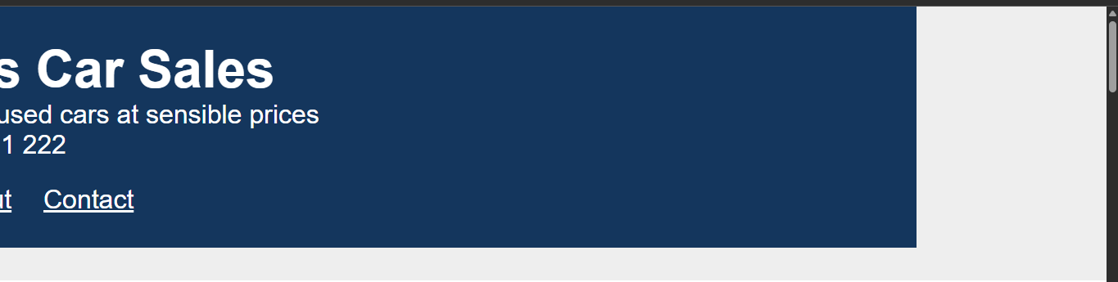 | Fixed widths (900px, 300px, 400px) stop the layout adapting, so users who zoom have to scroll sideways. | WCAG 1.4.10 Reflow, Level AA. | Not fixed. Would use max-width and percentages instead of fixed widths.
Vague link text (found by manual testing) | index.html: "Click here" (hatchback card) and "More" (saloon card). about.html: "Click here". | The link text doesn't say where the link goes or which car it's for. | WCAG 2.4.4 Link Purpose (In Context), Level A (2.4.9 at Level AAA if judged out of context). | Not fixed. Would use descriptive text such as "Enquire about the 2019 Hatch 1.0".
Inconsistent navigation (found by manual testing) | The nav order and wording change between pages.       | Users can't rely on where the links are or what they're called. | WCAG 3.2.3 Consistent Navigation and 3.2.4 Consistent Identification, Level AA. | Not fixed. Would use the same order and labels on all pages: Home, About, Contact.
No current-page indicator (found by manual testing) | All pages: the nav link for the page you're on isn't highlighted. | Users can't tell which page they're on. | WCAG 2.4.8 Location, Level AAA. | Not fixed. Would highlight the current link and add aria-current="page".
Form gives no errors or confirmation (found by manual testing) | enquiry.html: pressing Enter wipes the form with no required-field errors and no confirmation message. "Fields marked in red" relies on colour, and nothing is red. | Users can't tell what went wrong or whether the enquiry was sent, and colour alone marks the important fields. | WCAG 3.3.1 Error Identification (A), 3.3.3 Error Suggestion (AA) and 1.4.1 Use of Color (A). | Not fixed. Would mark required fields in text, show error messages next to the fields, and show a confirmation message.
Data table has no headers (found by manual testing) | about.html: the "Our team" table has no header cells or caption.  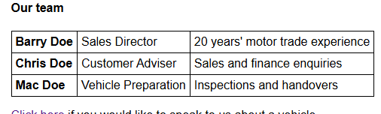 | A screen reader can't tell what each row and column means. | WCAG 1.3.1 Info and Relationships, Level A. | Not fixed. Would add a caption and header cells with scope.

