Summary Table for Usability Evaluation Using Nielsen’s Heuristics

Results of the usability test
This is an example of a template you can use to help with your final report and the usability evaluation using Nielsen’s Heuristics for Barry’s Car Sales website. Refer to Nielsen’s heuristics (see Unit 10.9) and map these to any issues you observe on the given site.

Issue/error number | Severity (0 to 4:  0 = Not important/insignificant  1 = A little important  2 = Important  3 = Very important  4 = Fix immediately) | Heuristic Transgressed/ Supported (name the heuristic(s) that the issue/error relates to) | Where is the issue/error in the application? (Give a screenshot of where it exists on the site) | Why is this an issue or error? (Give a brief explanation of why the issue needs to be fixed from a usability perspective. You can link this to the relevant heuristic(s)) | Remedy (give a brief summary of how this issue/error was fixed or not, either technically or from a design perspective. If you did not fix, explain why)
1 | 2 | Heuristic 4: Consistency and standards | Nav bar at the top of each page. about.html has Contact, Home, About Us; the others differ:  about.html    index.html    enquiry.html   | The order and wording change from page to page, so users can't rely on where things are or what they're called. | Not fixed. Would use the same order and labels on all pages: Home, About, Contact.
2 | 2 | Heuristic 1: Visibility of system status | about.html, nav bar at the top: "About Us" isn't highlighted. | Nothing shows which page you're on, because the current page's link doesn't stay highlighted. | Not fixed. Would highlight the current page's link (e.g. bold or underlined) and add aria-current="page".
3 | 1 | Heuristic 6: Recognition rather than recall | about.html, "Our team" table.  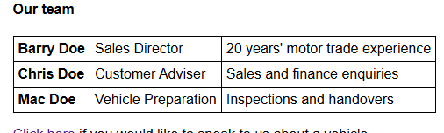 | The table has no header cells or caption, so a screen reader can't tell what each row and column means. | Not fixed. Would add a caption and <th> header cells with scope, or a short heading row.

