Summary Table for Usability Evaluation Using Nielsen’s Heuristics

Results of the usability test
This is an example of a template you can use to help with your final report and the usability evaluation using Nielsen’s Heuristics for Barry’s Car Sales website. Refer to Nielsen’s heuristics (see Unit 10.9) and map these to any issues you observe on the given site.

Issue/error number | Severity (0 to 4:  0 = Not important/insignificant  1 = A little important  2 = Important  3 = Very important  4 = Fix immediately) | Heuristic Transgressed/ Supported (name the heuristic(s) that the issue/error relates to) | Where is the issue/error in the application? (Give a screenshot of where it exists on the site) | Why is this an issue or error? (Give a brief explanation of why the issue needs to be fixed from a usability perspective. You can link this to the relevant heuristic(s)) | Remedy (give a brief summary of how this issue/error was fixed or not, either technically or from a design perspective. If you did not fix, explain why)
1 | 3 | Heuristic 4: Consistency and standards; Heuristic 5: Error prevention | index.html, 2020 Trail 1.5 card: "Ask about this car" is plain text, not a link.  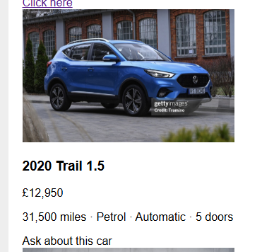 | It looks like the other cars' enquiry links but isn't clickable and never gets keyboard focus, so nobody can enquire about this car. | Not fixed. Would turn it into a proper link to enquiry.html, like the other cards.
2 | 2 | Heuristic 4: Consistency and standards | Nav bar at the top of each page. index.html has Home, About, Contact; the others differ:  index.html    about.html    enquiry.html   | The order and wording change from page to page, so users can't rely on where things are or what they're called. | Not fixed. Would use the same order and labels on all pages: Home, About, Contact.
3 | 2 | Heuristic 1: Visibility of system status | index.html, nav bar at the top: "Home" isn't highlighted. | Nothing shows which page you're on, because the current page's link doesn't stay highlighted. | Not fixed. Would highlight the current page's link (e.g. bold or underlined) and add aria-current="page".
4 | 3 | Heuristic 7: Flexibility and efficiency of use; Heuristic 8: Aesthetic and minimalist design | Whole page at 200% zoom. The blue banner stops short while the page scrolls sideways.  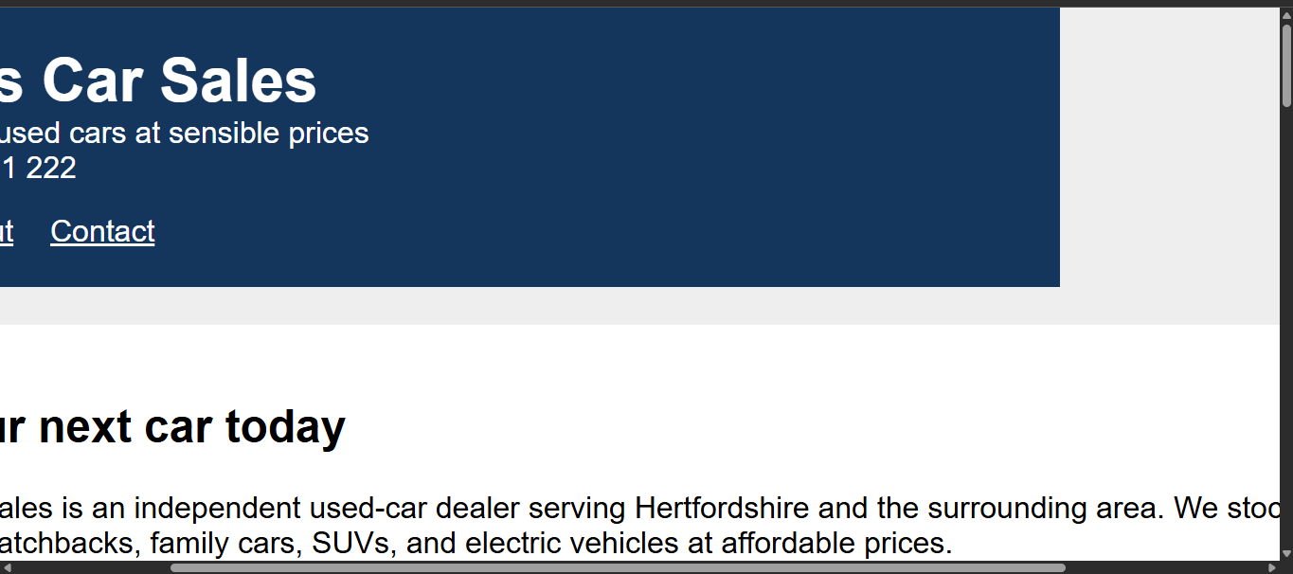 | Sideways scrolling is hard to use, and the banner no longer fits the page. Nothing is cut off or hard to reach. | Not fixed. Would replace the fixed widths with flexible ones (max-width and percentages) so the layout adapts.

