KONKA STB
Upgrade Program Proposal

PRODUCT: KHDT866

Edit： Xiaozhou Lin

Audit：

Approval：
Contents
1、Upgrade Instructions 3
2、KONKA STB Upgrade Range 3
3、Upgrade Steps: 3
4、Hints during Upgrading 5
5、Special Problems and Solutions 8
6、Precautions 8

1、Upgrade Instructions
There is serial number in the flash of the STB. Now all the STBs will be upgraded. The previous software version was 1.00.10 and it will be 1.00.20 when finishing upgrade.

The main change is:
- Add Image adjustment Options
- Correct some French characters

2、KONKA STB Upgrade Range
KONKA STB with the following information shall be upgraded:
Hardware version: 8611.53.47, Software Version: 1.00.10, Last Update: Jun. 27, 2014
The serial number ranges from 2504601- 2506610
(Notice: the range from 2504601- 2506610 is the last 7 number for the STB ID.
E.g. STB ID: FZ140505J2504601，the serial number is：2504601）
When finish upgrading, the information of KONKA STB will be:
Hardware version: 8611.53.47, Software Version: 1.00.20, Last Update: Nov. 07, 2014
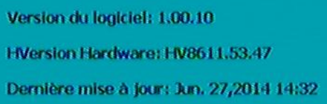

3、Upgrade Steps:
1) Remind the users
In order to remind the customers to know their STB software will be upgraded by sending CA OSD message through the head-end one week in advance. The message content can be as the following:
“Due to business upgrades, part of digital TV set-top boxes will be upgraded recently. Do not power off during the upgrade process!”
2) Upgrade Test
Test the upgrade stream file before to do formal upgrade
Add OTA_For_Customer_HW86115347_SV010020.ts to the servicer, the bandwidth rates is suggested to be about 1 Mbps.
You can test 2 STBs first by doing this: Setting upgrade range (for example: 2504601 and 2504602) and configuring the serial number of the NIT descriptor. For example, 435 MHz (can be changed in NIT descriptor) is configured as below.
Upgrade descriptor can be set as follow:
A127036F5A0B0297C1E0038122FFFFFFFFBB8114758611534700010020002637990026379A000000C8
The serial number:
263799（hexadecimal format）:2504601 （decimal format）
26379A（hexadecimal format）:2504602（decimal format）
The descriptor is hexadecimal format, and the message from the STB OSD is decimal format. You can use the calculators to do such a conversion.
If everything goes well, you can continue to do step 3.

- Upgrade small scale:
Choose 200 STBs to do a small scale upgrade:
Serial number: 2504601 ~2504801.
Configure the serial number of the NIT descriptor.
Upgrade descriptor can be set as follow:
A127036F5A0B0297C1E0038122FFFFFFFFBB81147586115347000100200026379900263861000000C8
The serial number:
00263799（hexadecimal format）: 2504601（decimal format）
00263861（hexadecimal format）: 2504801（decimal format）
With 435 MHz (can be changed in NIT descriptor), and the stream PID: 6000(0x1770), setting the serial number of the upgrade descriptor 2504601 ~2504801. The STBs are under this range can be reset to upgrade. Three days later, if everything goes well, you can continue to step 4.
- The serial number: 00000000-FFFFFFFF.
Configure the serial number of the NIT descriptor.
Upgrade descriptor can be set as follow:
A127036F5A0B0297C1E0038122FFFFFFFFBB811475861153470001002000000000FFFFFFFF000000C8
The whole serial number:
00000000（hexadecimal format）
FFFFFFFF（hexadecimal format）

The stream PID: 6000(0x1770), setting the serial number of the upgrade descriptor 00000000- FFFFFFFF, Whose STBs are under this range can be reset to upgrade.

Note: Do not power off when upgrading.
The STB information should be as follow after upgrading correctly
(check path: Main Menu->Extra->System Information）：
Software version: 1.00.20
Hardware version: HV8611.53.47

4、Hints during Upgrading
Power on the STB. A few seconds later, the upgrade information will be detected and a pop-up tip will be shown. User can choose Yes or Not, as shown below.
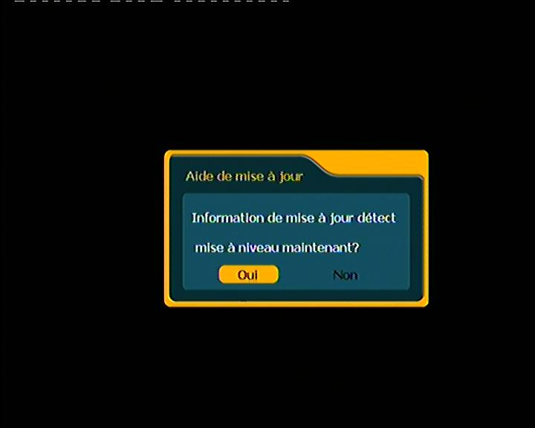
In normal conditions, the interface will be followed by the following messages:
- “OAD Pid 6000 GET OAD UPGRADE INFORMATION” when blue progress bar scrolls from 0% to 100%.
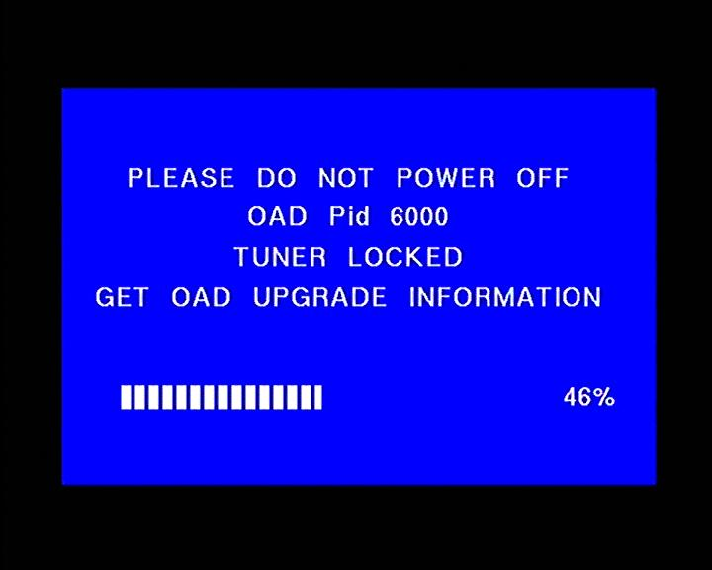
2) “Verifying”;
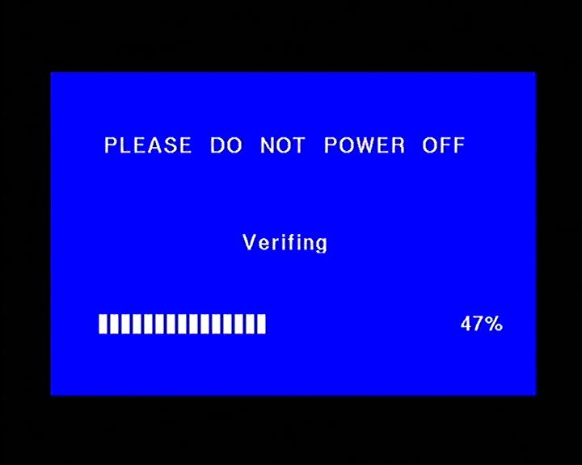
3) “Updating” when blue progress bar scrolls from 0% to 100%.
From the old version to the upgrade version
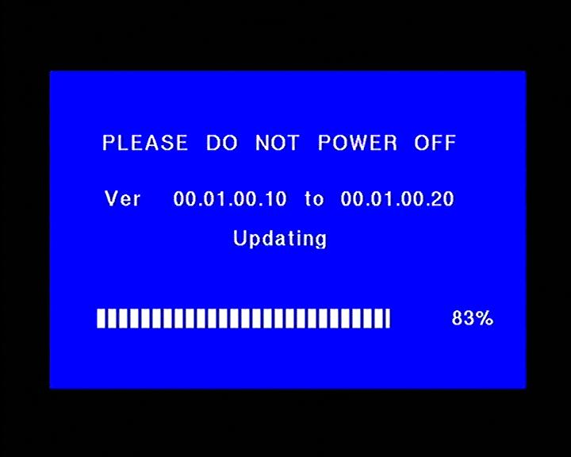
4) Check whether the set-top box software has upgraded successfully. Press“Main Menu”，select“Extra”entry“System information”, if Software Version is 1.00.20, Upgrade successfully.
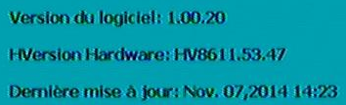

5、Special Problems and Solutions
1) In the process of the upgrade, The STB is searching for data, but the progress bar does not move and show 0%.
Check whether the head-end plays upgrade stream file on correct frequency, recording the upgrade stream and analyze whether its PID is 6000(hex 0x1770).
- In the process of the upgrade，power off suddenly.
Power off when data download, it will remain the old software version when restart.
Power off when burn the flash, it will enter to software upgrade and continue to download upgrade data automatically.
- During the upgrade process, the upgrade progress bar stops in 1-50% and does not move.
This situation may be caused by signal interrupted, do not shut down the STB, check the signal line status first, if the signal is OK it will continue upgrading. If signal line status is not OK, tell the technical staff your problem immediately.

6、Precautions
1） Make sure the bandwidth for the upgrade stream is faster than that of the stream. The bandwidth for the upgrade stream should be about 1 Mbps.
2） The upgrade stream should play for a long time, more than 3 weeks is suggested;
3) If the STB upgrade fails each time, change another box for the customers.
4） If lots of STBs occur abnormal condition, stop the upgrade immediately.
5） When start the upgrade process, please play the TS stream on the PID first, and then the upgrade descriptor. When stop it, please stop the descriptor first, and then the upgrade stream a few days later.

