

# HD Digital Satellite Receiver

***KHDS972S-IR V2.0***

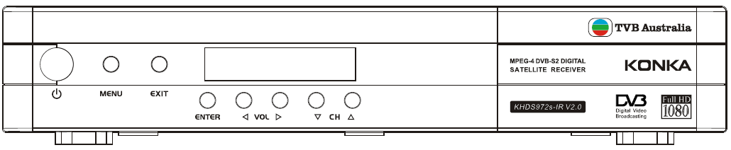

**User Manual**

Keep this manual for future reference

**General Safety**

This STB has been manufactured to meet international safety standards. Please read the following safety precautions carefully. To avoid fire, electric shock or damage:

Do not expose the receiver to rain, humidity or water. Do not put utensils full of water on the receiver, such as vase;

The plug of this unit is used as disconnection device, electric socket shall be installed near the unit for easy disconnecting operation;

Put the unit in dry and ventilate place. To avoid overheating, do not cover the ventilation slots;

Do not try to open it. Inspection and repair can be done only by authorized staff. Any assistance please contact the local distributor.

|  |  |
| --- | --- |
| MAIN SUPPLY | Use only 100-240V AC 50/60Hz |
| CABLE | Use standard certified cables to prevent any malfunction |
| LOCATION | Locate it indoor and be away from potential hazards, such as houseplants, lightning and direct sunlight |
| CLEANING | Disconnect the STB power cord from the wall socket before cleaning it. Use soft damp cloth (no solvents) to dust it |
| OVERLOADING | Don’t overload wall outlets, extension cords or adapters. They can cause fire or electrical shock. |
| VENTILATION | 1. NEVER block ventilation slots of it  2. NEVER place it on soft furnishings or carpets.  3. Ensure that a free airflow is maintained around it.  4. Don’t use or store it under direct sunlight or near a heater.  5. NEVER stack other electronic equipment on the top of it. |
| LIQUIDS | Keep liquids away from it |
| SMALL OBJECTS | Keep coins or other small objects away from it. They can fall through ventilation slots and cause serious damage. |
| ATTACHMENTS | Don’t use any attachments not recommended. They may cause hazards or damage. |
| CONNECTION | Before connecting or disconnecting the cable from the antenna to it, turn off it. Otherwise, the TUNER can be damaged. |
| EARTHING | The cable must be earthed to the system earth for the aerials. The earthing system must comply with SABS061. |
| LIGHTNING | 1. The STB must remain connected at all times to the main power supply.  2. However, the manufacture instructions for safeguarding other equipment connected to STB, TV set, etc., must be followed during lightning storms.  3. Ensure lightning protection devices for the terrestrial antenna, mains and Tuner are installed. |
| REPAIR | 1. Don’t attempt to repair this product by yourself  2. Refer all repairs to qualified service representatives. |

**Packing Accessory List**

Please check whether all of following items included in the package

**◆ Digital Satellite Receiver**

**◆ Remote Control Unit**

**◆ Two AAA Size Batteries**

**◆ User manual**

Contents

HD Digital Satellite Receiver I

Front Panel 1

Rear Panel 1

Remote Control Unit 1

STB Connection 3

Channel Search 3

1. Easy Installation 3

2. Manual Installation 4

3. Blind Scan 4

Basic Operation 4

1. Information Panel 4

2. Change Channels 5

3. Volume Control/Mute 5

4. Soundtrack 5

5. All Channels 5

6. Program Guide (EPG) 5

7. Timer Overview 6

8. Time-shift 6

9. PVR 6

10. USB 6

11. Subtitle/Teletext 6

Main Menu 6

1. Installation 7

2. Channels 7

3. PVR 7

4. Settings 7

5. Extra 7

TROUBLESHOOTING 8

# Front Panel

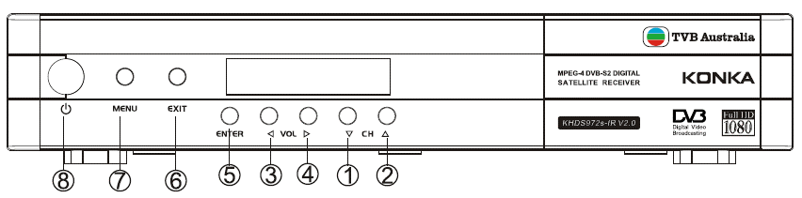

|  |  |
| --- | --- |
| **(1/2) CH ▲/▼** | To change channels or items on the menu. |
| **(3/4) Vol ◀/▶** | Volume control |
| **(5) Enter** | Enter into a menu |
| **(6) EXIT** | Exit to watch program |
| **(7) MENU** | Return to previous menu |
| **(8) STANDBY** | Switch between operation and standby mode |

# Rear Panel

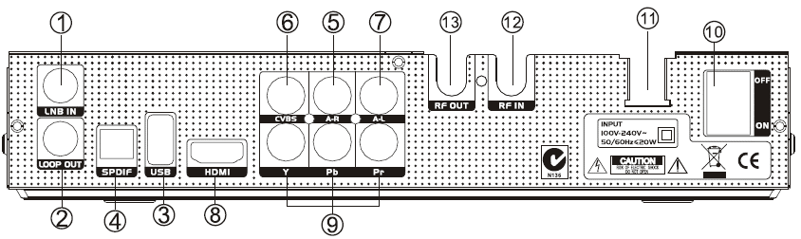

|  |  |
| --- | --- |
| **(1) LNB IN** | Connect to the terrestrial antenna via coaxial cable |
| **(2) LOOP OUT** | Loop out the signal to another STB |
| **(3) USB** | To insert a USB Memory Disk |
| **(4) SPDIF** | Connect to the audio input port of TV/VCR/Hi-Fi audio system. |
| **(5) A-R** | Connect to the audio (R) input port of TV/VCR/Hi-Fi audio system. |
| **(6) CVBS** | Connect to the video input port of TV/VCR. |
| **(7) A-L** | Connect to the audio (L) input port of TV/VCR/Hi-Fi audio system. |
| **(8) HDMI** | Connect to TV via HDMI cable |
| **(9) YPbPr** | Connect to the corresponding component input port of TV. |
| **(10) ON/OFF** | Power on / Switch off |
| **(11)100V-240V 50/60Hz** | Connect to 100V-240V voltage 50/60Hz range AC power |
| **(11) RF IN** | Connect with the antenna signal line. |
| **RF OUT** | Connect to the antenna port of TV. |
|  |  |

# Remote Control Unit

|  |  |
| --- | --- |
| **KEY** | **FUNCTION** |
|  | To turn on/off (standby) |
| **MUTE** | To temporarily cut off the sound |
| **0 – 9** | Use to select the channel or input the numeric |
| **RECALL** | To play previous service |
| **MENU** | To display the main menu on the screen or return to the previous menu |
| **EXIT** | To exit the menu or the screen |
| **OK** | To confirm the menu you choose |
| **PAGE ▲/▼** | Turn page forward/backward |
| **VOL ▲/▼** | To increase or decrease volume levels |
| **▲/▼** | change channels or items on the menu |
| **◀/▶** | To increase or decrease volume levels |
| **EPG** | Into the TV/RADIO program guide |
| **FAV** | Go to favorite channels list |
| **INFO** | show the program information |
| **AUDIO** | Select Audio Language and Track. |
| **SUB** | Select a subtitle to show. |
| **TXT** | Select a teletext to show. |
| **PAUSE** | Start Time-shift or temporarily pause video |
| **TV / RADIO** | To switch between TV program and RADIO |
| **PLAY** | To play the media files |
| **REC** | Start record |
| **STOP** | Stop record or Time-shift |
| **APPL** | Go to the PVR Media menu |
| **FF** | Fast Forward |
| **REW** | Review |
| **Other** | Reservation |

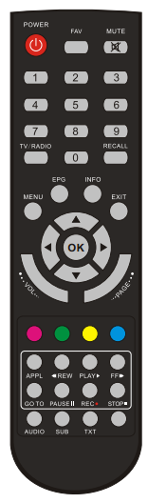

# STB Connection

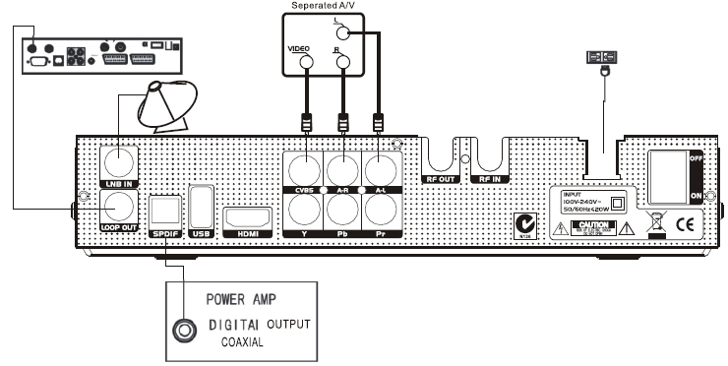

1. **Connect the signal line to the STB via the port of LNB IN.**
2. **Connect STB to a TV set. There are 3 interfaces for choice.**

|  |  |
| --- | --- |
| **AV** | Use an AV cable (Video Jack) to connect the ports of (CVBS + A-L + A-R). |
| **YPbPr** | Use a YPbPr cable to connect the ports of (Y + Pb +Pr) |
| **HDMI** | Use a HDMI cable to connect the port of HDMI. |

1. **Turn on the power and search channels, for watching TV programes**
2. **Connect STB to a HI-Fi System (Optional)**

Connect a RCA stereo cable from **AUDIO L/R** to your Hi-Fi System.

**Or** connect an optical fiber cable from **SPDIF** to your Hi-Fi System.

1. **Loop Through(Optional)**

If another STB need to use the same LNB, please connect the port of **LNB IN** on the second STB to the port of **LOOP OUT**, via the coaxial cable.

# Channel Search

There are 3 ways to search the channels. If the Parental Lock is ON, PIN is need.

## Easy Installation

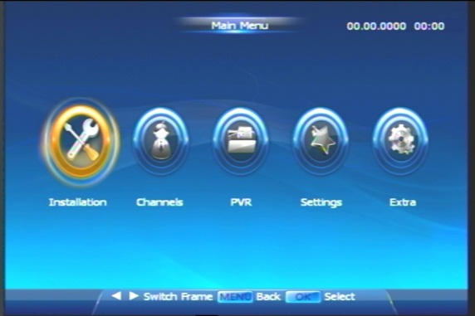 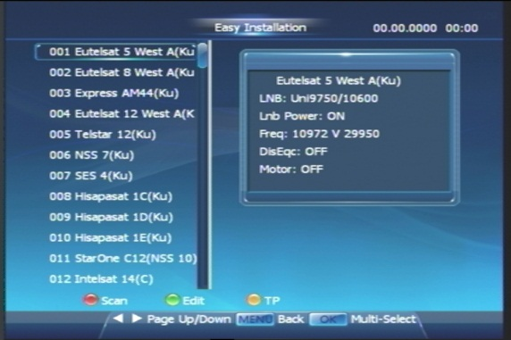

Choose one or more satellites/TPs to scan, and edit them before scanning.

**Multiple-Satellite Selection**:

* Press **OK** button to select or cancel one or more satellite(s).
* Press ● (red) Scan button to begin scan satellite(s) chosen.

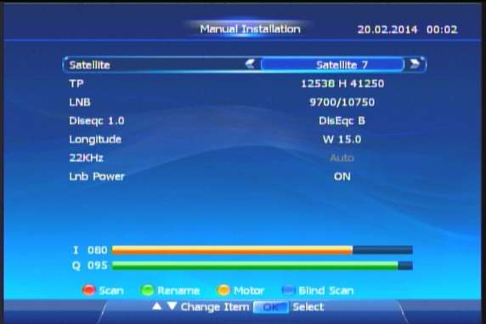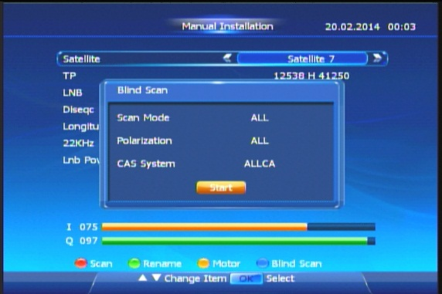

**Satellite Setup**: You can also edit satellites before scanning:

* Press ● (green) Edit button to switch Satellite-Setting Interface focused.
* Here you can change TP, LNB, DisEqC, 22k or LNB power.
* You also can press blue button to start blind scan.

**Multiple-TP Selection and Edition**: STB provides you search TP(s) as well:

* Firstly, press ● (yellow) button to enter TP list of the satellite focused.
* And then you can Add, Edit or Delete TP(s).
* Finally, press ● (red) button to scan TP(s) chosen. (Select multi-TP via **OK** button.

## Manual Installation

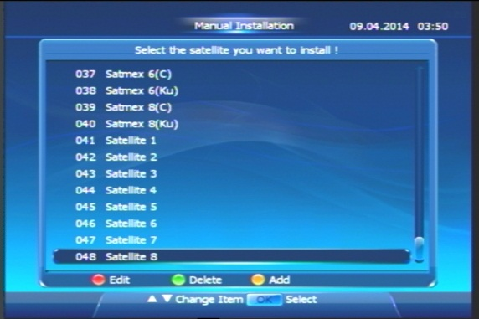 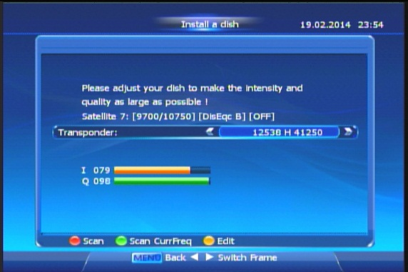

***Adjust Dish***

Press **OK** button to switch Install a dish Interface at Satellite-List.

Here you can adjust your dish and check the quality and intensity of signal. Then press ● (red) button to begin scan directly.

## Blind Scan

Press **OK** button to show satellite list. Choose one and press ● (blue) button to start.

# Basic Operation

There are some basic operations for you to control STB while watching.

## Information Panel

Press **INFO** button to show the program information. Press it again for more detail.

## Change Channels

* Press numeric button **1~9** to directly choose the channel.
* Press **▲** or **▼** button to change PREVIOUS or NEXT channel.
* Press **TV/Radio** button to switch each kind of channels.
* Press **RECALL** button to return to previous channel.

## Volume Control/Mute

* Press the **VOL Up/Down** button or ◀ ▶ button, to adjust the volume level.
* Press **MUTE** button to temporarily cut off the sound. To recovery, press itagain or **VOL Up/Down** button.

## Soundtrack

Press **AUDIO** button to change the Audio Language and sound-track.

## All Channels

You can press **OK** button while watching Program.

**Satellite: (In the Interface of All Channels)**

Press ● (red) button to call a dialog to get the channel list of the satellite selected.

**Sort: (In the Interface of All Channels)**

Press ● (green) button to call a dialog to change classification method.

***HINT****: Program 1~7 are preset, they are always in the list!*

**Favourite: (In the Interface of All Channels)**

You can press● (yellow) button to call a sub-interface. In this sub-interface, you can mark any channel with a specific tag. After marking, you can sort channels with any one of the eight tags.

* Press numeric button **1~8** to mark the channel selected with a favourite tag. Press the same button again can cancel the tag.
* Press● (yellow) again here, you can access to Favlist-Interface.

**FavList**

To access to FavList, you can firstly enter the sub-interface of All Channels. After that, press ● (yellow) again. Besides, you can also press **FAV** button directly while watching TV. In this interface, you can:

* Press **◀** or **▶** button to change Favourite-Group sorted.
* Press ● (green) button (Info) to show the detail program information.

**Find (In the Interface of All Channels)**

* Press● (blue) button to call a keyboard to quickly find Programs.
* Press **◀**, **▶**, **▲** or **▼** button to change a selected button.
* Press **OK** button to choose the button in keyboard.
* Press● (blue) button again to save result and return to All Channels Interface.

After that, Program(s) which matches the conditions will be listed. If you want to return to all-channels list, just press **MENU** button.

## Program Guide (EPG)

Programs navigate through all the positive viewing points.

**Time**

In EPG Interface, press **◀** or **▶** to change time. Press ● (red) button (Time) can change time in different ways as follows

1: Back.

2: Back to current time.

3-4: Forward or backward 30mins.

5-6: Forward or backward 120mins.

7-8: Forward or backward 1 day.

**Single EPG**

***Access*** If you press ● (green) button (Single EPG) in EPG Interface to enter a sub-EPG Interface. Here weekly EPG for single channels showed.

***Area change*** Press ● (red) button to change the type of channel list and press ● (green) button to change the area focused between channel list and event list.

***Book & Prerecord*** you can book or prerecord the events selected.

***Timer-Overview*** Press **OK** button to enter Timer Overview Interface.

**Book**

Press **▲** or **▼** to choose channel and press **◀** or **▶** to choose period to book. After booked, the square will become ***red***.

**Option**

Press ● (blue) button, you can choose a certain group channels.

## Timer Overview

In Single EPG Interface, press **OK** button to cancel or rebook an event.

Press ● (red) button to switch to add a timer and then press ● (red) button to save.

## Time-shift

***Review Missed Scenes***

Press **PAUSE** button to stop and press **PLAY▶** button to start watching. You can pause, review and fast forward within the Program only when there is a time gap between current watching points and live Program point.

***HINT****: If* ***WITHOUT*** *an USB disk,* ***PAUSE||*** *function is to pause the video.*

## PVR

Press **REC**● button to record the current channel. Press **OK** or **▲▼**button to play another channel at the same TP while recording. And Press **STOP**■ button to stop.

Press **PLAY▶** button to enter the record list.

## USB

Press **APPL** button to enter PVR Media Interface (Detail in next chapter).

## Subtitle/Teletext

Press the **SUB**/**TXT** button to show a subtitle / teletext.

# Main Menu

Press **MENU** button while watching Program, you can access to Main Menu Interface. Here you can choose more functions to control your STB.

## Installation

See the previous chapter of **Channel Search**.

## Channels

To manage your services in following ways:

**Organize Services** Use multi-selection via **OK** button. Besides, also press ● (green) button to select all/unselect all/Select Other.

|  |  |
| --- | --- |
| * **Lock** | Lock Channel only or TP |
| * **Skip** | Hide channel(s) in channel lists |
| * **Delete** | Delete channel(s) |
| * **Move** | Change the order of channel lists |
| * **Rename** | Rename a channel |

|  |  |
| --- | --- |
| **Organize Favourites** | (See the previous chapter: All Channels) |
| **Receiver Viewer** | List all logs of watching channels. Press ● (blue) button can Export them into the USB disk. |
| **Delete All Data** | To delete all programs data. |

## PVR

After an USB disk inserted, you can use these functions.

|  |  |
| --- | --- |
| **Playback** | Press **OK** button to play the TS selected. (Full-Screen via **OK/PLAY** button) |
| **MP3** | Press **◀** to return a directory. Press **OK** or **▶** button to open a directory or play a music file .Press **VOL Up/Down** button can adjust the sound level. |
| **Picture** | Press **◀** to return a directory. Press **OK** or **▶** button to open a directory or display the picture selected on full-screen. |
| **Media Play** | Press **◀** to return a directory. Press **OK** or **▶** button to open a directory. And press **OK** button to display full-screen when the video playing. |
| **Time-shift Setting** | Time-shift Always is “No” by default. If it is “Yes”, you can press FF or REW button to activate Time-shift function without press PAUSE|| button (need USB disk). |

## Settings

You can set several items of STB, such as:

|  |  |
| --- | --- |
| **Language** | To choose Menu/Audio/EPG/Subtitle Language of STB |
| **Parental** **Control** | To switch Parental Lock, Set Age Control Time, and change Parental Password. (Tip: The PIN set at the factory is 0000) |
| **Time** **Setting** | To set GMT and wakeup/sleep time of STB |
| **Video** **Setting** | To set the option of screen ration/aspect ratio/resolution/TV system. |
| **OSD** **Setting** | To change options for STB display |
| **Factory** **Reset** | To reset the STB. |
| **UHF Setting** | To set the options of RF output |

## Extra

You can check the CA Status/Email/System Information/Calendar, and play games.

**CA Status** There are 3 items in the CA Status menu:.

|  |  |
| --- | --- |
| **Smart Card Status** | Show the Smart Card Information |
| **SoftCell Service Status** | Show the Descramble/EMM Service status |
| **Loader Status** | Show the Irdeto Load Status and Manufacturer Load Status |

**Email** There is the Email list in this menu.

* Press OK button to check the content of the Email selected.
* Press the RED button to delete an Email and press it again to cancel **Del**.
* Press the GREEN button to delete all Emails in the list.

**System Information** Show the software version, hardware and last update date.

**Games** There are 4 entertaining games.

In NES Emulator, you can download some NES Games (*.nes) into the USB Disk. The STB can run the NES Game from the USB disk.

**Calendar** There is a simple calendar for checking the date**.**

# TROUBLESHOOTING

|  |  |  |
| --- | --- | --- |
| **Problem** | **Possible Cause** | **What to do** |
| How to connect a decoder to the TV |  | (1) Connect one end of the AV leads in the AV output at the back of the decoder and the other end to the AV input on the television  (2) Connect the satellite cable from the wall in the LNB In input of the decoder  (3) Plug in the power cable |
| No TV channel displaying on the screen |  | (1) Decoder settings have to be entered and tuned  (2) Manual search  (3) Antenna set up |
| Blue screen with no sound | Either the decoder is off or you are on the wrong TV channel | Check that all leads and cables are connected properly |
| No sound, only picture | (1) Program is muted  (2) AV cable is loose  (3) Some problem with local channel | (1) Check if the mute button is pressed  (2) Increase the volume from the remote to the maximum  (3) Check if the other local channels have sound  (4) Check the AV Leads |
| Sound coming and no picture | It has gone on to the radio mode | Press the TV button on your remote and the service will start working |
| The STB gets stuck |  | Reboot the decoder by turning off the black button at the back of the decoder for 90sec and turning it back on |
| Not able to change channels | (1) The batteries in your remote control need replacing  (2) The STB gets stuck | See if you are able to change channel from the decoder  -If yes, then change the remote batteries and it should work  -If no, reboot the decoder |
| No signal |  | Check the cable from the wall plate to the LNB In input of the decoder.  If u have a pot plant set up check if the two cable are connected in the door way |

Technical Specifications

|  |  |  |  |  |  |  |  |  |  |  |  |  |  |  |  |  |  |  |  |  |  |  |  |  |  |  |  |  |  |  |  |  |  |  |  |  |  |  |  |  |  |  |  |  |  |  |  |  |  |  |  |  |  |  |  |  |  |  |  |  |  |  |  |  |  |  |  |  |  |  |  |  |  |  |  |  |  |  |  |  |  |  |  |  |  |  |  |  |  |  |  |  |  |  |  |  |  |  |  |  |  |  |  |  |  |  |  |  |  |  |  |  |  |  |  |  |  |  |  |  |  |
| --- | --- | --- | --- | --- | --- | --- | --- | --- | --- | --- | --- | --- | --- | --- | --- | --- | --- | --- | --- | --- | --- | --- | --- | --- | --- | --- | --- | --- | --- | --- | --- | --- | --- | --- | --- | --- | --- | --- | --- | --- | --- | --- | --- | --- | --- | --- | --- | --- | --- | --- | --- | --- | --- | --- | --- | --- | --- | --- | --- | --- | --- | --- | --- | --- | --- | --- | --- | --- | --- | --- | --- | --- | --- | --- | --- | --- | --- | --- | --- | --- | --- | --- | --- | --- | --- | --- | --- | --- | --- | --- | --- | --- | --- | --- | --- | --- | --- | --- | --- | --- | --- | --- | --- | --- | --- | --- | --- | --- | --- | --- | --- | --- | --- | --- | --- | --- | --- | --- | --- | --- | --- |
| |  |  |  | | --- | --- | --- | | 图片1 **SYSTEM** | | | | CPU/Decoder | MSD5043 | | | CPU Speed | 880 DMIPS | | | Flash Memory | 8Mbytes Optional | | | SDRAM | 128M Bytes DDR2 | | | EEPROM | N/A | | | 图片1 **Tuner and Demodulator** | | | | Input Connector | F-Type , Female | | | LoopOut Connector | F-type, Female | | | Input Frequency range  Input Impedance  Modulation | 177.5-858MHz  75Ω  QPSK/8PSK | | | 图片1 **FRONT PANEL** | | | | IR Receiver | 38KHz | | | Control Buttons | STANDBY/CH+/CH- | | | LED | POWER/STANDBY | | | 图片1 **Conditional Access Interface** | | | | Smart Card | One Smart card reader | | | 图片1 **PHYSICAL DIMENSION** | | | | Size (W×D×H) | 170.0x116.0x35.0 mm | | | Weight (net) | 1.2Kg approximate | | | 图片1 **AMBIENT** | | | | Operating Temperature | | -5 - +45℃ | | Storage Temperature | | -25- +55℃ | | |  |  |  | | --- | --- | --- | | 图片1 **REAR PANEL** | | | | RCA Output  USB | 3 RCA(CVBS+Left+Right)  USB2.0 | | | | HDMI | HDMI 1.3 | | | RF Output | UHF RF Ouput | | | 图片1 **MPEG Transport Stream & A/V Decoding** | | | | Video Decoding & Profile Level | ISO/IEC 13818-2, MPEG-2 MP@ML, MPEG-4: ASP@L5 w/o QMC, GMC H.264/ AVC: [HP@L4.0](mailto:HP@L4.0), [MP@L4.0](mailto:MP@L4.0), 3.2 VC-1:AP@L3, AP@L2 | | | Video Aspect Ratio | 4:3, 16:9 | | | Video Resolution | 480i/480p/576i/576p/720P/1080I/1080P | | | Audio Decoding  Audio Mode | MPEG-1 and -2, layer 1 and 2       MPEG-4 HE-AAC V1L1, L2, V2 L2/L4  AAC-LC, WMA, MP3  AC-3,E-AC-3(DD+)  Single Channel /Dual Channel  /Stereo | | | | | 图片1 **POWER SUPPLY** | | | | Input Voltage | | DC 12V 1A | | Power consumption | | Max. 12W | | Stand-by consumption  Type | | Less than 1W  External | | 图片1 **Accessories** | | | | Remote Control Unit | | 1* RCU | | A/V cable | | 1*1.5meter RCA Cable(Optional) | | User manual | | 1*black | |  | |  | |