# HD Digital Cable Receiver

***KHDC862***

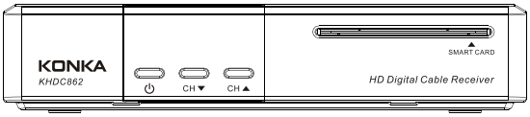

**User Manual**

Keep this manual for future reference

**General Safety**

This STB has been manufactured to meet international safety standards. Please read the following safety precautions carefully. To avoid fire, electric shock or damage:

Do not expose the receiver to rain, humidity or water. Do not put utensils full of water on the receiver, such as vase;

The plug of this unit is used as disconnection device; electric socket shall be installed near the unit for easy disconnecting operation;

Put the unit in dry and ventilate place. To avoid overheating, do not cover the ventilation slots;

Do not try to open it. Inspection and repair can be done only by authorized staff. Any assistance please contact the local distributor.

|  |  |
| --- | --- |
| MAIN SUPPLY | Use only 12V-1A DC power |
| CABLE | Use standard certified cables to prevent any malfunction |
| LOCATION | Locate it indoor and be away from potential hazards, such as houseplants, lightning and direct sunlight |
| CLEANING | Disconnect the STB power cord from the wall socket before cleaning it. Use soft damp cloth (no solvents) to dust it |
| OVERLOADING | Don’t overload wall outlets, extension cords or adapters. They can cause fire or electrical shock. |
| VENTILATION | 1. NEVER block ventilation slots of it  2. NEVER place it on soft furnishings or carpets.  3. Ensure that a free airflow is maintained around it.  4. Don’t use or store it under direct sunlight or near a heater.  5. NEVER stack other electronic equipment on the top of it. |
| LIQUIDS | Keep liquids away from it |
| SMALL OBJECTS | Keep coins or other small objects away from it. They can fall through ventilation slots and cause serious damage. |
| ATTACHMENTS | Don’t use any attachments not recommended. They may cause hazards or damage. |
| CONNECTION | Before connecting or disconnecting the cable from the antenna to it, turn off it. Otherwise, the TUNER can be damaged. |
| EARTHING | The cable must be earthed to the system earth for the aerials. The earthing system must comply with SABS061. |
| LIGHTNING | 1. The STB must remain connected at all times to the main power supply.  2. However, the manufacture instructions for safeguarding other equipment connected to STB, TV set, etc., must be followed during lightning storms.  3. Ensure lightning protection devices for the terrestrial antenna, mains and Tuner are installed. |
| REPAIR | 1. Don’t attempt to repair this product by yourself  2. Refer all repairs to qualified service representatives. |

**Packing Accessory List**

Please check whether all of following items included in the package

**◆ Digital Cable Receiver**

**◆ Remote Control Unit**

**◆ Two AAA Size Batteries**

**◆ User manual**

Contents

HD Digital Cable Receiver I

Front Panel 1

Rear Panel 1

Remote Control Unit 2

STB Connection 2

Channel Search 3

1. Manual Search 3

2. TPList Search 4

3. Full Band Search 4

Basic Operation 4

1. Information Panel 4

2. Change Channels 4

3. Volume Control/Mute 4

4. Soundtrack 5

5. Service List 5

6. Program Guide (EPG) 5

7. Timer Overview 5

8. Time-shift 5

9. PVR 6

10. USB 6

11. Subtitle/Teletext 6

Main Menu 6

1. Installation 6

2. Channels 6

3. Personalization 7

4. Preferences 7

5. Extra 7

TROUBLESHOOTING 7

# Front Panel

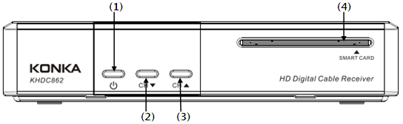

|  |  |
| --- | --- |
|  |  |
| **(1) STANDBY** | Switch between operation and standby mode |
| **(2) CH ▼** | To change channels or items on the menu. |
| **(3) CH ▲** | To change channels or items on the menu. |
| **(4) Smart card slot** | To insert the smart card. |

# Rear Panel

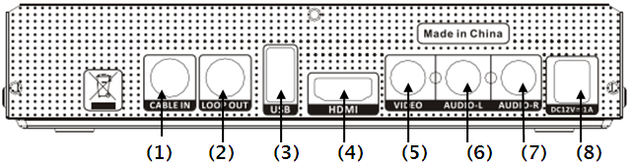

|  |  |
| --- | --- |
| **(1) CABLE IN** | Connect to the terrestrial antenna via coaxial cable |
| **(2) LOOP OUT** | Loop out the signal to another STB |
| **(3) USB** | To insert a USB Memory Disk |
| **(4) HDMI** | Connect to TV via HDMI cable |
| **(5)VIDEO** | Connect to the video input port of TV/VCR. |
| **(6) AUDIO-L** | Connect to the audio (L) input port of TV/VCR/Hi-Fi audio system. |
| **(7) AUDIO-R** | Connect to the audio (R) input port of TV/VCR/Hi-Fi audio system. |
| **(8)DC12V-1A** | Connect to 12V-1A DC power. |

# Remote Control Unit

|  |  |
| --- | --- |
| **KEY** | **FUNCTION** |
|  | To turn on/off (standby) |
| **MUTE** | To temporarily cut off the sound |
| **0 – 9** | Use to select the channel or input the numeric |
| **RECALL** | To play previous service |
| **MENU** | To display the main menu on the screen or return to the previous menu |
| **EXIT** | To exit the menu or the screen |
| **OK** | To confirm the menu you choose |
| **PAGE ▲/▼** | Turn page forward/backward |
| **VOL ▲/▼** | To increase or decrease volume levels |
| **▲/▼** | change channels or items on the menu |
| **◀/▶** | To increase or decrease volume levels |
| **EPG** | Into the TV/RADIO program guide |
| **FAV** | Go to favorite channels list |
| **INFO** | show the program information |
| **AUDIO** | Select Audio Language and Track. |
| **SUB** | Select a subtitle to show. |
| **TXT** | Select a teletext to show. |
| **PAUSE** | Start Time-shift or temporarily pause video |
| **TV / RADIO** | To switch between TV program and RADIO |
| **PLAY** | To play the media files |
| **REC** | Start record |
| **STOP** | Stop record or Time-shift |
| **APPL** | Go to the PVR Media menu |
| **FF** | Fast Forward |
| **Other** | Reservation |

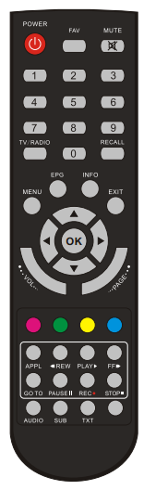

# STB Connection

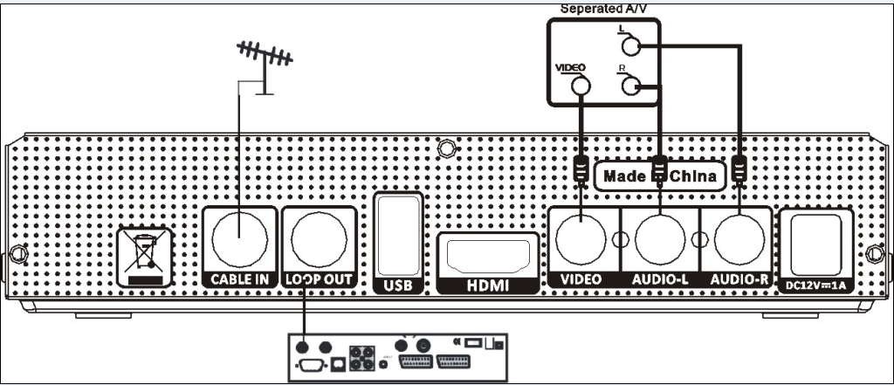

1. **Connect the signal line to the STB via the port of LNB IN.**
2. **Connect STB to a TV set. There are 2 interfaces for choice.**

|  |  |
| --- | --- |
| **AV** | Use an AV cable (Video Jack) to connect the ports of (VIDEO + A-L + A-R). |
| **HDMI** | Use a HDMI cable to connect the port of HDMI. |

1. **Turn on the power and search channels, for watching TV programs**
2. **Connect STB to a HI-Fi System (Optional)**

Connect a RCA stereo cable from **AUDIO L/R** to your Hi-Fi System.

1. **Loop Through(Optional)**

If another STB need to use the same LNB, please connect the port of **LNB IN** on the second STB to the port of **LOOP OUT**, via the coaxial cable.

# Channel Search

There are 3 ways to search the channels. If the Parental Lock is ON, PIN is need.

## Manual Search

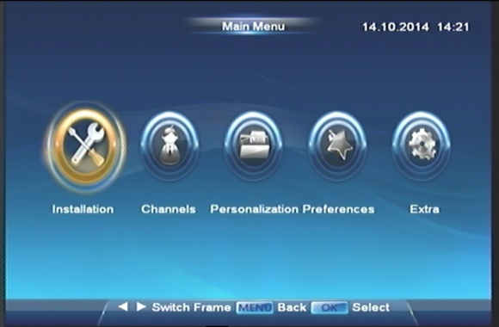 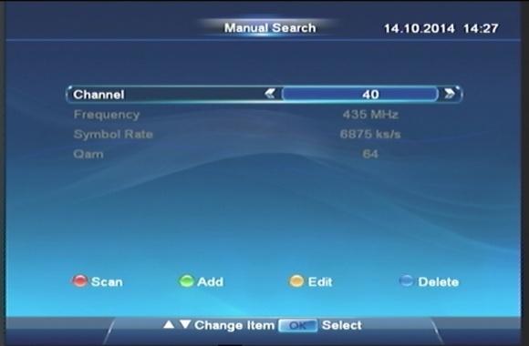

You can Add/Edit/Delete a TP here. Use the color-button hint in the bottom of screen.

You can configure scan parameters here, including Scan mode, Network and CAS System. Press **OK** button, the STB will start scanning.

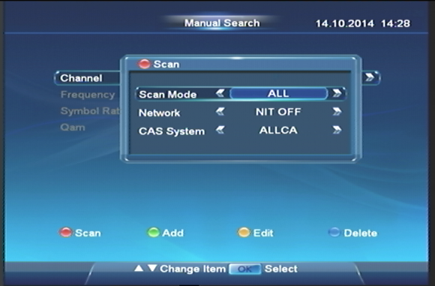 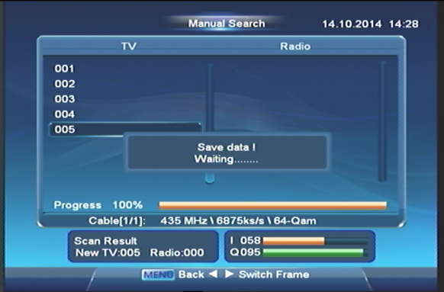

## TPList Search

You can scan TPs by setting a scan-area of TP. You should add TPs in “Manual Search” menu first.

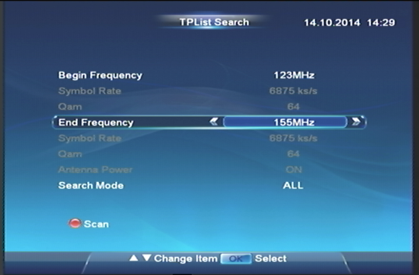 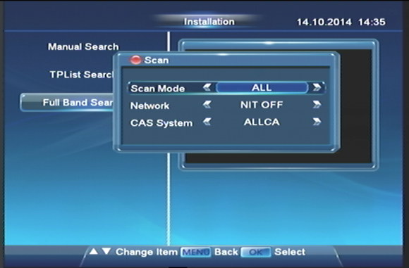

## Full Band Search

Choose Full-band Search, the STB will scan all TPs preset.

# Basic Operation

There are some basic operations for you to control STB while watching.

## Information Panel

Press **INFO** button to show the program information. Press it again for more detail.

## Change Channels

* Press numeric button **1~9** to directly choose the channel.
* Press **▲** or **▼** button to change PREVIOUS or NEXT channel.
* Press **TV/Radio** button to switch each kind of channels.
* Press **RECALL** button to return to previous channel.

## Volume Control/Mute

* Press the **VOL Up/Down** button or ◀▶ button, to adjust the volume level.
* Press **MUTE** button to temporarily cut off the sound. To recovery, press it again or **VOL Up/Down** button.

## Soundtrack

Press **AUDIO** button to change the Audio Language and sound-track.

## Service List

You can press **OK** button while watching Program.

**Info:** Press ●(green) button to call a dialog which display the detailed information of current program.

**Sort:** Press ●(yellow) button to call a dialog to sort services by different methods.

## Program Guide (EPG)

Press **EPG** button to enter this menu. It shows programs navigate through all the positive viewing points.

**Time**

In EPG Interface, press **◀**or **▶** to change time. Press ●(red) button (Time)can change time in different ways as follows

1: Back.

2: Back to current time.

3-4: Forward or backward 30mins.

5-6: Forward or backward 120mins.

7-8: Forward or backward 1 day.

**Single EPG**

***Access*** If you press●(green) button (Single EPG) in EPG Interface to enter a sub-EPG Interface. Here weekly EPG for single channels showed.

***Area change*** Press ●(red) button to change the type of channel list and press ●(green) button to change the area focused between channel list and event list.

***Book & Prerecord*** you can book or prerecord the events selected.

***Timer-Overview*** Press **OK** button to enter Timer Overview Interface.

**Book**

Press **▲** or **▼** to choose channel and press **◀** or **▶** to choose period to book. After booked, the square will become ***red***.

**EPG Language**

Press ●(blue) button, you can check EPG Language of this program.

## Timer Overview

In Single EPG Interface, press **OK** button to cancel or rebook an event.

Press ●(red) button to switch to add a timer and then press ●(red) button to save.

## Time-shift

***Review Missed Scenes***

Press **PAUSE** button to stop and press **PLAY▶** button to start watching. You can pause, review and fast forward within the Program only when there is a time gap between current watching points and live Program point.

***HINT****: If* ***WITHOUT*** *an USB disk,* ***PAUSE||****function is to pause the video.*

## PVR

Press **REC**● button to record the current channel. Press **OK** or **▲▼**button to play another channel at the same TP while recording. And Press **STOP**■ button to stop.

Press **PLAY▶** button to enter the record list.

## USB

After an USB disk inserted, you can press **APPL** button to use these functions.

|  |  |
| --- | --- |
| **Playback** | Press **OK** button to play the TS selected. (Full-Screen via **OK/PLAY** button) |
| **MP3** | Press **◀** to return a directory. Press **OK** or **▶** button to open a directory or play a music file .Press **VOL Up/Down** button can adjust the sound level. |
| **Picture** | Press **◀** to return a directory. Press **OK** or **▶** button to open a directory or display the picture selected on full-screen. |
| **Media Play** | Press **◀** to return a directory. Press **OK** or **▶** button to open a directory. And press **OK** button to display full-screen when the video playing. |
| **Time-shift Setting** | Time-shift Always is “No” by default. If it is “Yes”, you can press FF or REW button to activate Time-shift function without press PAUSE|| button (need USB disk). |

## Subtitle/Teletext

Press the **SUB**/**TXT** button to show a subtitle / teletext.

# Main Menu

Press **MENU** button while watching Program, you can access to Main Menu Interface. Here you can choose more functions to control your STB.

## Installation

Seethe previous chapter of **Channel Search**.

## Channels

To manage your services in following ways:

**Organize Services** Use multi-selection via **OK** button. Besides, also press ●(green) button to select all/unselect all/Select Other.

|  |  |
| --- | --- |
| * **Lock** | Lock Channel only or TP |
| * **Skip** | Hide channel(s) in channel lists |
| * **Delete** | Delete channel(s) |
| * **Move** | Change the order of channel lists |
| * **Rename** | Rename a channel |

|  |  |
| --- | --- |
| **Organize Favourites** | (See the previous chapter: All Channels) |
| **Factory Reset** | Restore to factory settings. |
| **Delete all Data** | To delete all programs data. |

## Personalization

You can change some parameters such as Menu Transparency, Show on Display, Banner Display Time, Channel NO.Type and Time-shift Always.

## Preferences

You can set several items of STB, such as:

|  |  |
| --- | --- |
| **Language** | To choose Menu/Audio/EPG/Subtitle Language of STB |
| **Parental Control** | To switch Parental Lock, Set Age Control Time, and change Parental Password.(Tip: The PIN set at the factory is 0000) |
| **Time Setting** | To set GMT and wake up/sleep time of STB |
| **Video Control** | To set the option of screen ratio/Aspect ratio/Resolution/TV system/Brightness/Contrast/Saturation. |

## Extra

You can check the CA Status/Email/System Information/USB Control/Game/Calendar, and Product Information.

**CA Status** Information and settings for CA System.

**Email** There is the Email list in this menu.

* Press OK button to check the content of the Email selected.
* Press the RED button to delete an Email and press it again to cancel **Del**.
* Press the GREEN button to delete all Emails in the list.

**System Information** Show the software version, hardware and last update date.

**USB Control** Software upgrades by USB or uninstall USB.

**Game** There are 4 entertaining games.

In NES Emulator, you can download some NES Games (*.nes) into the USB Disk. The STB can run the NES Game from the USB disk.

**Calendar** There is a simple calendar for checking the date**.**

**Product Information**

# TROUBLESHOOTING

|  |  |  |
| --- | --- | --- |
| **Problem** | **Possible Cause** | **What to do** |
| How to connect a decoder to the TV |  | (1) Connect one end of the AV leads in the AV output at the back of the decoder and the other end to the AV input on the television  (2) Connect the Cable from the wall in the LNB In input of the decoder  (3) Plug in the power cable |
| No TV channel displaying on the screen |  | (1) Decoder settings have to be entered and tuned  (2) Manual search  (3) Antenna set up |
| Blue screen with no sound | Either the decoder is off or you are on the wrong TV channel | Check that all leads and cables are connected properly |
| No sound, only picture | (1) Program is muted  (2) AV cable is loose  (3) Some problem with local channel | (1) Check if the mute button is pressed  (2) Increase the volume from the remote to the maximum  (3) Check if the other local channels have sound  (4) Check the AV Leads |
| Sound coming and no picture | It has gone on to the radio mode | Press the TV button on your remote and the service will start working |
| The STB gets stuck |  | Reboot the decoder by turning off the black button at the back of the decoder for 90sec and turning it back on |
| Not able to change channels | (1) The batteries in your remote control need replacing  (2) The STB gets stuck | See if you are able to change channel from the decoder  -If yes, then change the remote batteries and it should work  -If no, reboot the decoder |
| No signal |  | Check the cable from the wall plate to the LNB In input of the decoder.  If u have a pot plant set up check if the two cable are connected in the door way |

Technical Specifications

|  |  |  |  |  |  |  |  |  |  |  |  |  |  |  |  |  |  |  |  |  |  |  |  |  |  |  |  |  |  |  |  |  |  |  |  |  |  |  |  |  |  |  |  |  |  |  |  |  |  |  |  |  |  |  |  |  |  |  |  |  |  |  |  |  |  |  |  |  |  |  |  |  |  |  |  |  |  |  |  |  |  |  |  |  |  |  |  |  |  |  |  |  |  |  |  |  |  |  |  |  |  |  |  |  |  |  |  |  |  |  |  |  |  |  |  |  |  |  |  |  |  |  |  |  |  |  |  |  |  |
| --- | --- | --- | --- | --- | --- | --- | --- | --- | --- | --- | --- | --- | --- | --- | --- | --- | --- | --- | --- | --- | --- | --- | --- | --- | --- | --- | --- | --- | --- | --- | --- | --- | --- | --- | --- | --- | --- | --- | --- | --- | --- | --- | --- | --- | --- | --- | --- | --- | --- | --- | --- | --- | --- | --- | --- | --- | --- | --- | --- | --- | --- | --- | --- | --- | --- | --- | --- | --- | --- | --- | --- | --- | --- | --- | --- | --- | --- | --- | --- | --- | --- | --- | --- | --- | --- | --- | --- | --- | --- | --- | --- | --- | --- | --- | --- | --- | --- | --- | --- | --- | --- | --- | --- | --- | --- | --- | --- | --- | --- | --- | --- | --- | --- | --- | --- | --- | --- | --- | --- | --- | --- | --- | --- | --- | --- | --- | --- | --- | --- |
| |  |  | | --- | --- | | 图片1**SYSTEM** | | | CPU/Decoder | MSD5043 | | CPU Speed | 600MHz | | Flash Memory | 8M | | SDRAM | 128M Bytes DDR | | 图片1**Tuner and Demodulator** | | | Tuner | NXP TDA 18250B | | Input Connector | F Connector 169-24 (Female) | | Loopthrough Connector | F Connector 169-24 (Female) | | Input Frequency range | 123-858M | | Input Impedance | 75ohm Unbalanced | | Input Signal Level | -75dBm to -10dBm(Average Power) | | Demodulation | 16/32/64/128/256 QAM | | 图片1**FRONT PANEL** | | | Ir Receiver | 38KHz, NEC format | | Control Buttons | POWER/CH+/ CH- | | LED | Red: Standby Mode; Green: Working | | 图片1**Conditional Access Interface** | | | Smart Card | One Smart card reader for SUMAVISION CAS | |  |  | | 图片1**PHYSICAL DIMENSION** | | | Size (W×D×H) | 170.0x116.0x350 mm | | Weight (net) | 1.0Kg approximate | | 图片1**AMBIENT** | | | Operating Temperature | +5 ℃ - +50℃ | | Storage Temperature | -40℃ - +65℃ | | |  |  |  |  | | --- | --- | --- | --- | | 图片1**REAR PANEL** | | | | | RCA Output | Video: VIDEO output  Audio: R/L output (volume &Mute control) | | | | | HDMI | HDMI 1.3 | | | | USB | 1 USB 2.0 | | | | 图片1**MPEG Transport Stream & A/V Decoding** | | | | | Video Decoding & Profile Level | MPEG-1/2/4: ISO/IEC 13818-2 MPEG-2 MP@HL  H.264: ISO/IEC 14496-10 | | | | | | | Video Aspect Ratio | 4:3, 16:9 Letter box  16:9 Pan scan | | | | Video Resolution | 480i/480p/576i/576p/720p/1080i  /1080Ps | | | | Audio Decoding | MPEG-1 /2, layer 1/2  Mp3, MPEG-4, AC3, DD+ | | | | | Audio Mode | Single Channel /Dual Channel/Stereo | | | | | 图片1**POWER SUPPLY** | | | | | Input Voltage | | DC 12V-1A | | | Power consumption | | Max. 12W | | | Stand-by consumption | | Max.1W | | | Type | | External | | | 图片1**Accessories** | | | | | Remote Control Unit | | | 1* RCU(with battery) | | A/V cable | | | 1*RCA Cable | | User’s manual | | | 1*black & white | |